Overview
The RFC 2889 Broadcasting Latency methodology implements the latency test portion of section 5.10 of the RFC 2889 IETF standard for LAN switch benchmarking. The purpose of this methodology is to determine the latency of the DUT when forwarding broadcast frames.
In this methodology, Spirent TestCenter ports are used to send and receive all frames. The basic algorithm of the test is to send a single test frame from a single Source port to the SUT, which forwards the test frames to the Receive port(s). The latency through the SUT is measured. The exercise is repeated for the specified number of trials, for each frame size. The measured latency for all test frames is expected to be less than the configured maximum latency threshold.
The methodology can work without VLANs, with single VLANs or stacked (QinQ) VLANs.

Topology
The topology for this methodology is shown in the diagram below, consists of:
- Source port, which sends test frames to the SUT
- Receive Port(s), which receive test frames from the SUT
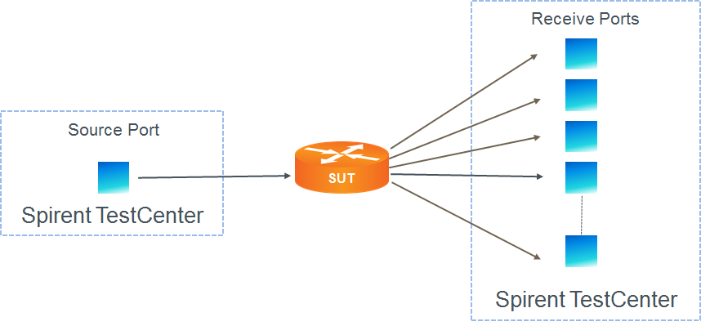

Test Steps
The steps in this methodology are as follows:
- For each of the specified frame sizes, do all of the steps below.
- For configured number of trials, do all of the steps below
- Send a single test frame from the Source Port to the SUT
- On the Receive port(s), measure the latency of all received test frames.
- The test passes only if the latency of all received test frames is less than the configured threshold.

Resources
Standards
- RFC 2544
- RFC 2889

Acronyms
DUT Device Under Test
LAN Local Area Network
MAC Media Access Control
SUT System Under Test
VLAN Virtual Local Area Network

