Overview
The RFC 2889 Forward Pressure methodology implements the forward pressure part of section 5.6 of the RFC 2889 IETF standard for LAN switch benchmarking. The purpose of this methodology is to detect forward pressure, i.e. inter-frame gaps of less than 96 bits.
In this methodology, Spirent TestCenter ports are used to send and receive all frames. The basic algorithm of the test is to send traffic with an inter-frame gap of 88 bits through the DUT, effectively overloading the DUT at a rate of 1 byte per frame.
The methodology can work without VLANs, with single VLANs, or QinQ VLANs.

Topology
The topology for this methodology is shown in the diagram below, consists of:
- West ports, which transmits test frames to the SUT
- East ports, which receive test frames from the SUT
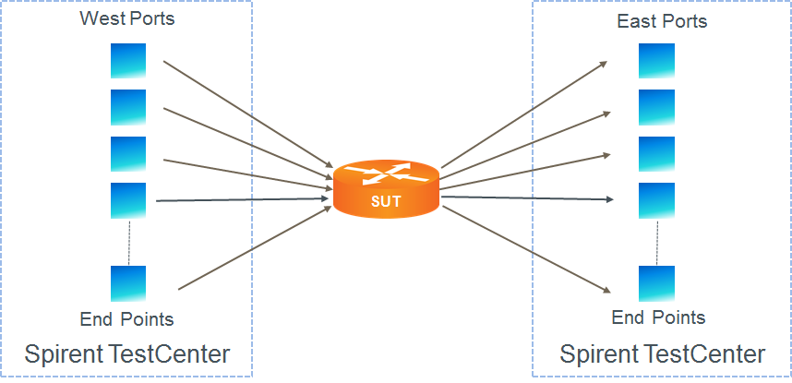

Test Steps
The steps in this methodology are as follows:
- For each configured frame size, perform all of the steps below.
- For the configured number of trials, perform all of the steps below.
- For the configured trial duration, send test frames with the configured inter-frame gap from the west port(s) to the SUT
- The test passes if the minimum detected inter-frame gap is less than the configured threshold inter-frame gap.

Resources
Standards
- RFC 2889

Acronyms
DUT Device Under Test
IFG Inter-Frame Gap
LAN Local Area Network
MAC Media Access Control
SUT System Under Test
VLAN Virtual Local Area Network

