Overview
The RFC 2889 Maximum Forwarding Rate methodology implements the maximum forwarding rate part of section 5.6 of the RFC 2889 IETF standard for LAN switch benchmarking. The purpose of this methodology is to measure the peak value of the forwarding rate.
In this methodology, Spirent TestCenter ports are used to send and receive all frames. The basic algorithm of the test is to send traffic at increasingly higher rates to the DUT, until the DUT is overloaded and begins to drop frames. Traffic may be sent in pair, mesh, or backbone topologies. Traffic may also be sent in one direction, or bi-directionally.
The methodology can work without VLANs, with single VLANs, or QinQ VLANs.

Topology
The topology for this methodology is shown in the diagram below, consists of:
- West ports, which can transmit and/or receive test frames to the SUT
- East ports, which can transmit and/or receive test frames from the SUT
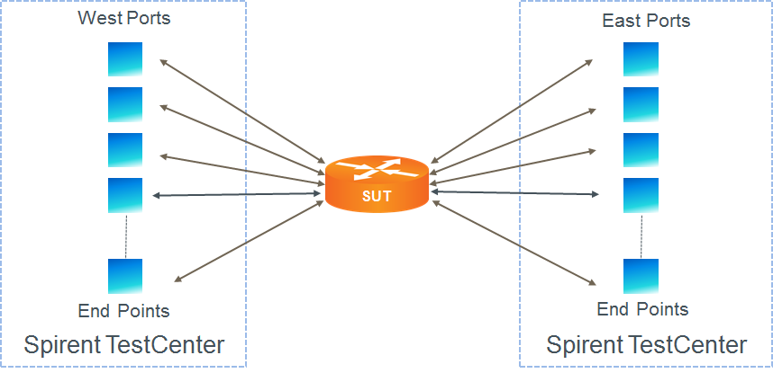

Test Steps
The steps in this methodology are as follows:
- For each configured frame size, perform all of the steps below.
- For the configured number of trials, perform all of the steps below.
- For the configured trial duration, send test traffic at the specified load to the SUT.
- If all test traffic is received on the intended test port(s), then increase the load level by the configured traffic rate resolution, and repeat the previous step; if frames have been dropped, then record the maximum frame rate from the previous trial.
- The test passes if the maximum forwarding rate is greater than or equal to the configured bandwidth test criteria.

Resources
Standards
- RFC 2889

Acronyms
DUT Device Under Test
IFG Inter-Frame Gap
LAN Local Area Network
MAC Media Access Control
SUT System Under Test
VLAN Virtual Local Area Network

