Overview
The RFC 3918 Multicast Latency methodology implements section 5.1 of the IETF 3918 methodology, which describes a procedure for measuring latency. The methodology measures latency from one multicast ingress interface to multiple multicast egress interfaces.
In this methodology, Spirent TestCenter ports are used as multicast sources, multicast receiver(s), and (optionally) monitor interfaces to detect overflow packets. The methodology performs a number of trials, one for each multicast group count, either stepping across a specified range, or as per a specified list of group counts. For each group count, multicast traffic is sent for the specified duration from the multicast sources through the SUT, and to the multicast receivers at the specified load and frame size. Latency is measured for all received multicast packets. It is recommended to perform the test using the maximum aggregated multicast throughput rate.
This methodology works with IPv4, IPv6, or both. Single, or stacked (QinQ) VLANs may also be used. Multicast clients may be IGMPv1, IGMPv2, IGMPv3, MLDv1 or MLDv2.
The methodology produces latency measurements for all iterations.

Topology
The topology for this methodology is shown in the diagram below, consists of:
- A multicast source port group, simulated by Spirent TestCenter ports which generate multicast traffic
- The SUT, which can be any multicast-enabled forwarding device
- A multicast receiver port group, simulated by Spirent TestCenter ports which receive multicast traffic from the SUT
- (optionally) a monitor port, simulated by Spirent TestCenter, to detect any improperly forwarded packets
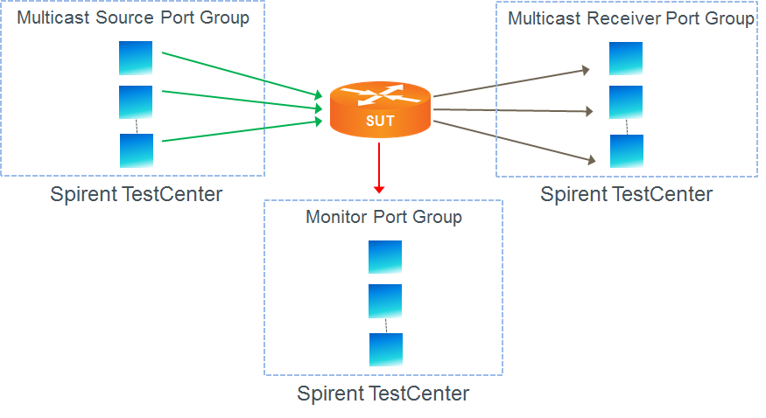

Test Steps
The steps in this methodology are as follows:
- For each group count
  - Multicast receivers join all multicast group(s) using IGMP or MLD.
  - For each traffic load level
    - For each frame size
      - Transmit multicast traffic from the multicast source port group to the SUT.
      - Measure latencies on all forwarded traffic received by the multicast receiver port group.
  - Multicast receivers leave all multicast group(s) using IGMP or MLD.
- The test passes if,
  - The measured latency for all packets is less than the maximum acceptable latency
  - No improperly forwarded multicast frames are received on the monitor port

Resources
IETF RFCs
- RFC 3918: Methodology for IP Multicast Benchmarking
- RFC 2432: Terminology for IP Multicast Benchmarking

Acronyms
DUT Device Under Test
IGMP Internet Group Management Protocol
MLD Multicast Listener Discovery
SUT System Under Test

