Overview
RFC 6349 is an IETF standard for characterizing the performance of TCP. This methodology closely follows the RFC 6349 standard, and each of its sub-sections. Accordingly, the methodology has four key sub-tests:
- Maximum Transmission Unit (MTU) measurement
- Round-Trip Time (RTT) measurement
- Bandwidth Bottleneck (BB) measurement
- TCP Throughput measurement
The first two sub-tests are run serially for each defined connection. The last two sub-tests are run in parallel, i.e. simultaneously, for all connections.
In the TCP throughput measurement sub-test, Spirent TestCenter emulates pairs of TCP clients and servers, which are used to define TCP connections. Spirent TestCenter uses a real, “New Reno” TCP implementation, meaning that the traffic is stateful, connection-oriented, and implements TCP’s sliding window which varies according to congestion experienced in the network.
This methodology works with IPv4, IPv6, or both, and can also work with single or stacked (QinQ) VLANs. Consequently, the methodology can be used to verify network policy, where some connections should be de-prioritized versus high-priority traffic.
The key measurements produced by the test are:
- TCP Throughput (ideal and actual)
- TCP Transfer Time (ideal and actual)
- TCP Transfer Time Ratio
- Re-transmitted Bytes
- TCP Efficiency
As per the RFC 6349 standard, these metrics are provided for a set of maximum window sizes.
This methodology can be run using either physical Spirent TestCenter hardware ports, or virtual Spirent TestCenter ports. However, performance will vary depending on
- the model of Spirent TestCenter port used
- the number of TCP connections in the configuration
- the file transfer size for each connection
Depending on the above criteria, it is possible that line-rate performance may not be achieved. Customers should verify that the particular mix of criteria meets their specific needs before purchasing.

Topology
The topology for this methodology is shown in the diagram below, consists of:
- Multiple TCP servers, emulated by Spirent TestCenter ports
- Multiple TCP clients, also emulated by Spirent TestCenter ports
- The SUT, which can be a firewall or any networking device
TCP servers and clients may be allocated to any available Spirent TestCenter port, up to one TCP server or client per Spirent TestCenter port. This allows for the testing simple single-connection topologies, as well as more complex topologies with multiple connections.
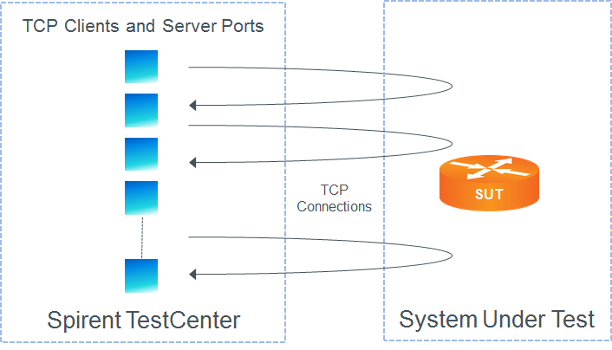

Test Steps
The steps in this methodology are as follows:
- The user defines a number of TCP connections through the user interface.
- Perform the MTU sub-test for each connection by sending frames of incrementally increasing size until fragmentation is observed. The MTU sub-tests are performed serially, i.e. one after the other, for each connection. The MTU sub-test will fail if frames are not detected received frames of any size for any connection – otherwise the sub-test passes.
- Perform the RTT sub-test for each connection by using Two-Way Active Measurement Protocol (TWAMP). The RTT sub-tests are performed serially, i.e. one after the other, for each connection. The RTT test fails if latency is not detected for any connection – otherwise the sub-test passes.
- Perform the BB sub-test for all connections using by gradually increasing the total stateless traffic for all connections, in parallel, until frames are lost. The traffic rate is increased as per the list of bandwidths configured by the user. The BB sub-test fails if frames are not detected if receive frames are not detected for any connection.
- For each window size, perform the TCP Throughput sub-test as follows:
  - In parallel, establishing connections for each client-server pair
  - Transferring the specified data from server to client
  - Adjust the sliding window based using TCP’s slow start, congestion avoidance, fast re-transmit, and fast recovery mechanisms.
  - Close the connection
- The test passes if all of the sub-tests pass, for each connection.

Resources
IETF RFCs
- RFC 6349: Framework for TCP Throughput Testing
Wikipedia
- TCP Article

Acronyms
BB Bandwidth Bottleneck
MTU Maximum Transmission Unit
RFC Request for Comments
RTT Round-Trip Time
TCP Transmission Control Protocol
TWAMP Two-way Active Measurement Protocol

