Overview

A single benchmarking test run is not sufficient to characterize the performance of a virtual environment; multiple test runs are required to measure the best, worst and average performance metrics. Measuring performance consistency in an NFV environment involves running the same benchmarking test such as RFC 2544 throughput test multiple times and comparing analyzing the spread of performance metrics for the multiple runs.

Objective
This test methodology enables the user to run the RFC 2544 forwarding performance test across multiple test runs for evaluating the performance consistency of a virtual environment that may consist of a vSwitch and/or VNFs.

Topology
The topology for this methodology is shown in the diagram below, consists of:
- One or more Spirent TestCenter ports on east and west of the SUT
- vSwitch as SUT
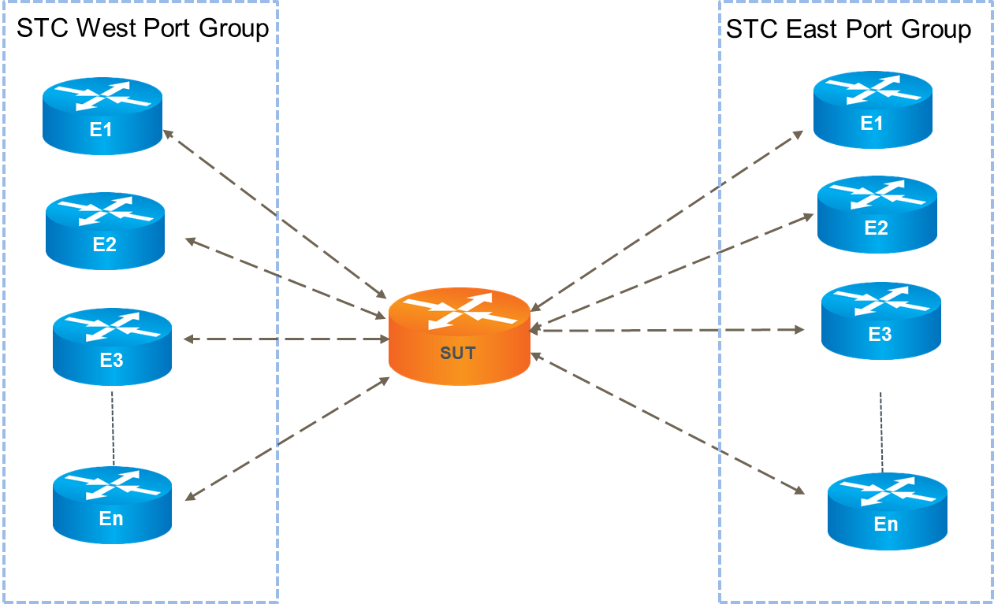

Test Steps
The steps in this methodology are as follows:
- For each of the specified frame sizes, do all of the steps below.
- For configured number of trials, do all of the steps below
- Run RFC 2544 throughput test
- Record throughput performance metrics listed below

Performance Metric | Metric Variations
Throughput | Throughput %, Throughput bps
Latency | Avg. Latency, Min Latency, Max Latency
Jitter | Avg. Jitter, Min Jitter, Max Jitter

Results
This methodology provides the spread in forwarding performance metrics over multiple trials for the specified frame sizes. Each trial passes if the throughput for the given frame size is greater than or equal to the minimum Rx rate. The user may optionally specify a non-zero frame loss tolerance for all iterations.

Resources
Standards
- RFC 2544
- IETF draft RFC Benchmarking Virtual Switches in OPNFV

Acronyms
STC Spirent TestCenter
SUT System Under Test

