Overview
Understanding the performance behavior of a vswitch around the performance limits not only helps characterize performance of the vSwitch but also uncovers the bottlenecks for vSwitch performance
This is where the cause of vSwitch performance limitations can be identified such as queue throttling or efficiency of the hashing algorithm employed at NIC level to distribute incoming traffic across the queues that feed into the compute node.
The offered traffic rate is described as a percentage delta with respect to the DUT’s RFC 2544 Throughput as determined by RFC2544 PacketLoss Ratio test. A delta of 0% is equivalent to an offered traffic rate equal to the RFC 2544 Throughput; A delta of +50% indicates an offered rate half-way between the Throughput and line-rate, whereas a delta of -50% indicates an offered rate of half the maximum rate. Therefore the range of the delta figure is naturally bounded at -100% (zero offered traffic) and +100% (traffic offered at line rate).

Objective
The objective of this methodology is to profile forwarding performance and latency of a vSwitch around the RFC 2544 throughput

Topology
The topology for this methodology is shown in the diagram below, consists of:
- One or more Spirent TestCenter ports on east and west of the SUT
- vSwitch as SUT
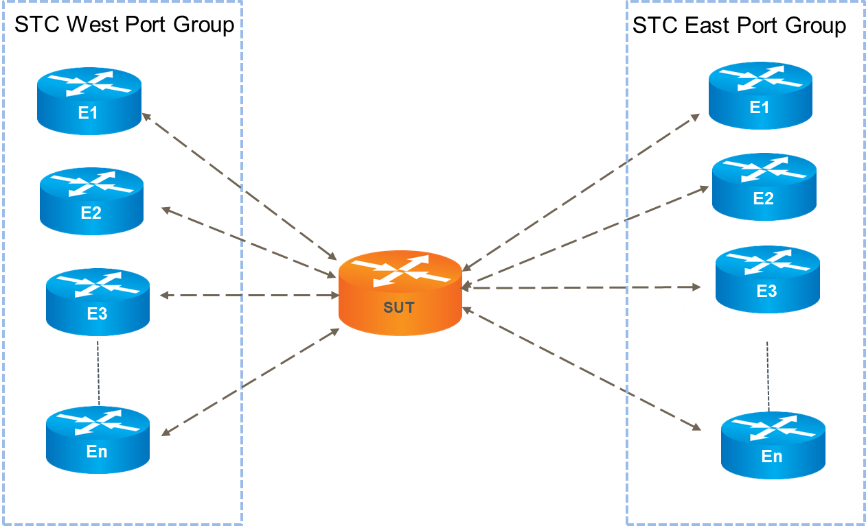

Test Steps
- For each of the specified frame sizes, do all of the steps below.
- Run RFC 2544 throughput test
- Record throughput and latency metrics listed below

Performance Metric | Metric Variations
Throughput | Throughput %, Throughput bps
Latency | Avg. Latency, Min Latency, Max Latency

- Start traffic for STC with -50% delta off the throughput rate for specified amount of time (default 60 seconds, should be user configurable)
- Record the following metrics
  - Forwarding rate in fps and mbps
  - Average latency (in microseconds)
- Repeat the test for other deltas specified in the input parameters

Results
This test methodology provides forwarding rate and latency measurements for the pre-defined delta’s around the performance limits of the vSwitch as determined by RFC 2544 throughput test.

Resources
Standards
- RFC 2544
- IETF draft RFC Benchmarking Virtual Switches in OPNFV

Acronyms
STC Spirent TestCenter
SUT System Under Test

