Overview
The Y.1564 Service Performance methodology implements the service performance test specified in the ITU-T Y.1564 standard, “Ethernet service activation test methodology”, which specifies procedures for validating a SUT’s ability to transport services based on set of acceptance criteria in a service level agreement (SLA).
The Y.1564 service performance methodology tests all services simultaneously at the committed information rate (CIR)
Acceptance criteria for each service are specified by three parameters:
- FLR (frame loss ratio)
- FTD (frame transfer delay)
- FDV (frame delay variation)
In this methodology, Spirent TestCenter ports are used to generate service traffic, as well as measure received traffic. Spirent TestCenter also measures the FLR, FTD and FDV of the received service traffic, and compares the measured values against the acceptance criteria for each service
This methodology works with IPv4, IPv6, or both. The methodology can also work with single or stacked (QinQ) VLANs.

Topology
The topology for this methodology is shown in the diagram below, consists of:
- West Port Group: Spirent TestCenter ports, which transmit and receive test service traffic
- East Port Group: Spirent TestCenter ports, which transmit and receive test service traffic
- The DUT, which is typically a service-aware switch or router
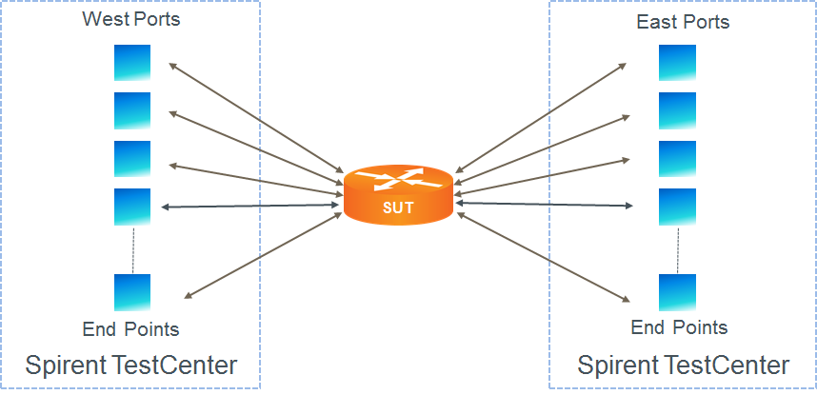

Test Steps
The steps in this methodology are as follows:
- Define a set of stream blocks, one per test service, with the attributes as configured in the methodology.
- Start the Service Performance test, if selected by the user
  - Transmit traffic for all services, simultaneously.
  - On the each of the specified receive ports for each service, measure the FLR, FTD, and FDV.
  - If the maximum measured FLR, FTD or FDV exceeds the acceptance criteria for any service, fail the service performance test.
- The test passes if,
  - All service configuration sub-tests pass
  - The service performance test passes

Resources
Standards
- Y.1564
Wikipedia
- Y.1564 Article

Acronyms
CIR Committed Information Rate
DSCP Differentiated Services Code Point
FDV Frame Delay Variation
FLR Frame Loss Ratio
FTD Frame Transfer Delay
MEF Metro Ethernet Forum
SLA Service Level Agreement
VLAN Virtual Local Area Network

