Overview
The Y.1564 methodology implements the tests specified in the ITU-T Y.1564 standard, “Ethernet service activation test methodology”, which specifies procedures for validating a SUT’s ability to transport services based on set of acceptance criteria in a service level agreement (SLA).
The methodology is implemented according to the Y.1564 standard, which defines two major sections:
- Service Configuration, where services are tested sequentially. The service configuration test is further broken down into five sub-tests:
  - CIR (Committed Information Rate) – Service traffic is increased by step increments from zero to the committed information rate.
  - EIR (Excess Information Rate) – Service traffic is increased beyond the committed information rate, at the excess information rate.
  - Policing Test – Service traffic is transmitted at a rate equal to CIR + 125% of EIR.
  - CBS (Committed Burst Size) – Service traffic is transmitted for short bursts (at line rate) within the committed burst size specified in the SLA.
  - EBS (Excess Burst Size) – Service traffic is transmitted for longer bursts, exceeding the committed burst size specified in the SLA.
- Service Performance, where all services are tested simultaneously at the committed information rate (CIR)
The methodology includes all parts of the above tests, including the color-aware variants of the service configuration sub-tests.
Acceptance criteria for each service are specified by three parameters:
- FLR (frame loss ratio)
- FTD (frame transfer delay)
- FDV (frame delay variation)
In this methodology, Spirent TestCenter ports are used to generate service traffic, as well as measure received traffic. Spirent TestCenter also measures the FLR, FTD and FDV of the received service traffic, and compares the measured values against the acceptance criteria for each service
This methodology works with IPv4, IPv6, or both. The methodology can also work with single or stacked (QinQ) VLANs.

Topology
The topology for this methodology is shown in the diagram below, consists of:
- Multiple Spirent TestCenter ports, which transmit and receive test service traffic
- The DUT, which is typically a service-aware switch or router
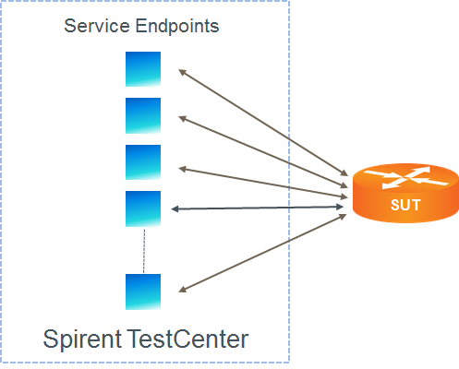

Test Steps
The steps in this methodology are as follows:
- Define a set of stream blocks, one per test service, with the attributes as configured in the methodology.
- Run the Service Configuration test, for each service, sequentially
  - Start the Committed Information Rate sub-test, if selected
    - Ramp up the traffic, from 0% of CIR in the number of steps specified, up to 100% of CIR
    - Measure the minimum, average and maximum values for FLR, FTD, and FDV
    - If the measured maximum values exceed the acceptance criteria for any service, the sub-test fails; otherwise it passes
  - Start the EIR sub-test, if selected
    - Transmit traffic at the EIR rate. If “color-aware” has been selected, transmit “green” frames at the CIR rate, and “yellow” frames at the EIR rate.
    - If “non-color aware” has been selected, measure the FLR, FTD and FDV for all received frames; otherwise, if “color-aware” has been selected, measure the minimum, average and maximum values for FLR, FTD, and FDV for the “green” frames
    - If the measured maximum values exceed the acceptance criteria for any service, the sub-test fails; otherwise it passes
  - Start the policing sub-test, if selected
    - Transmit traffic at the EIR. If non-color-aware has been selected, transmit all frames at CIR + 125% of EIR; otherwise, if “color-aware” has been selected, transmit “green” frames at the CIR rate, and “yellow” frames at 125% of the EIR rate.
    - If “non-color aware” has been selected, measure the FLR, FTD and FDV for all received frames; otherwise, if “color-aware” has been selected, measure the minimum, average and maximum values for FLR, FTD, and FDV for the “green” frames
    - If the measured maximum values exceed the acceptance criteria for any service, the sub-test fails; otherwise it passes
  - Start the CBS sub-test, if selected
    - Throughout the CBS test, transmit a constant stream of traffic at the CIR.
    - Send traffic in repeated line-rate bursts at the committed burst size, for the configured duration
    - Pause burst transmissions for a duration equal to 10 times the burst duration
    - Repeat burst transmissions for the configured number of burst cycles
    - Measure the FLR, FTD and FDV.
    - If the measured maximum values exceed the acceptance criteria for any service, the sub-test fails; otherwise it passes
  - Start the EBS sub-test, if selected
    - If “non-color-aware” has been selected, transmit a constant stream of frames at the CIR+ EIR rate; otherwise, If “color-aware” has been selected, send a constant stream of “green” frames at CIR, and a constant stream of “yellow” frames at EIR.
    - If “non-color-aware” has been selected, send traffic in repeated line-rate bursts at two times the EBS size; otherwise if “color-aware” has been selected, send repeated line-rate bursts of “yellow” frames for two times the EBS size
    - Pause burst transmissions for a duration equal to 10 times the burst duration
    - Repeat burst transmissions for the configured number of burst cycles
    - Measure the FLR, FTD and FDV.
    - If the measured maximum values exceed the acceptance criteria for any service, the sub-test fails; otherwise it passes
    - If “non-color aware” has been selected, measure the FLR, FTD and FDV for all received frames; otherwise, if “color-aware” has been selected, measure the minimum, average and maximum values for FLR, FTD, and FDV for the “green” frames
    - If the measured maximum values exceed the acceptance criteria for any service, the sub-test fails; otherwise it passes
- Start the Service Performance test, if selected by the user
  - Transmit traffic for all services, simultaneously.
  - On the each of the specified receive ports for each service, measure the FLR, FTD, and FDV.
  - If the maximum measured FLR, FTD or FDV exceeds the acceptance criteria for any service, fail the service performance test.
- The test passes if,
  - All service configuration sub-tests pass
  - The service performance test passes

Resources
Standards
- Y.1564
Wikipedia
- Y.1564 Article

Acronyms
CBS Committed Burst Size
CIR Committed Information Rate
DSCP Differentiated Services Code Point
EBS Expected Burst Size
EIR Expected Information Rate
FDV Frame Delay Variation
FLR Frame Loss Ratio
FTD Frame Transfer Delay
MEF Metro Ethernet Forum
SLA Service Level Agreement
VLAN Virtual Local Area Network

