**VINNAKOTA S S D V N SIDDHARTHA PROJECT REPORT**

(Project Semester January-May2023)

**Video Game Sales Analysis (1980-2020):An Interactive**

**Dashboard Analysis**

Submitted by

(Vinnakota S S D V N Siddhartha)

Registration No: 12002917

Programme and Section: CSE(HONS) and KM045

Course Code: INT-233

Under the Guidance of

**(Baljinder Kaur lecturer of data visualization(int-233) course)**

**Discipline of CSE/IT**

**Lovely School of computer science**

**Lovely Professional University, Phagwara**

**CERTIFICATE**

This is to certify that Vinnakota S SD V N Siddhartha bearing Registration no. 12002917 has completed INT-233 project titled, **“**Video Game Sales Analysis from (1980-2020): An Interactive Dashboard Analysis**”** under my guidance and supervision. To the best of my knowledge, the present work is the result of his/her original development, effort, and study.

**Signature and Name of the Supervisor**

Baljinder Kaur

**Designation of the Supervisor**

Lecturer of data visualization

**School of computer science**

Lovely Professional University

Phagwara, Punjab.

Date: 11-04-2023

**DECLARATION**

I, Vinnakota S S D V N Siddhartha student of Data Science under CSE/IT Discipline at, Lovely Professional University, Punjab, hereby declare that all the information furnished in this project report is based on my own intensive work and is genuine.

Date: Signature

Registration No. 12002917 Name of the student: VSSDVN Siddhartha

**ACKNOWLEDGEMENT**

"I would like to express my sincere thanks to Baljinder Kaur mam for her invaluable guidance and support throughout the project process."

**TABLE OF CONTENTS**

Introduction

Scope of the Analysis

Existing System

Source of Dataset

List of Analyses with Results

Future Scope

References

Bibliography

**INTRODUCTION**

The video game industry has experienced exponential growth over the past few decades, with millions of players and billions of dollars in revenue generated each year. As a result, understanding the trends and patterns in video game sales data can be highly valuable for game developers, publishers, and investors looking to make informed decisions. In this report, we will explore the use of data virtualization techniques in Tableau Desktop to analyze a dataset containing video game sales from 1980 to 2020. The dataset was obtained from Kaggle, a popular platform for data scientists and analysts to share datasets and compete in data science challenges. We will begin by discussing the importance of data virtualization in data analysis, followed by an overview of the dataset used in this report. We will then demonstrate how Tableau Desktop can be used to visualize and analyze the data, providing valuable insights into the video game industry over the past four decades.

Context of the dataset:

The video game sales dataset used in this report was obtained from Kaggle, a platform for data scientists and analysts to share datasets and compete in data science challenges. The dataset contains information on video game sales from 1980 to 2020, including sales figures for various regions, publisher information, and genre classifications. The data was collected from a variety of sources, including industry reports, company filings, and publicly available information.

The dataset contains over 16,500 records and includes information on a wide range of video game platforms, including popular consoles such as the Nintendo Entertainment System (NES), PlayStation, and Xbox, as well as personal computers and mobile devices. The data is organized by year, platform, publisher, genre, and region, providing a comprehensive view of the video game industry over the past four decades.

This dataset can be used to gain insights into the trends and patterns of video game sales over time, as well as the popularity of different genres and platforms in different regions of the world. It can also be used to analyze the success of individual publishers and games, providing valuable information for game developers, publishers, and investors.

**SCOPE OF ANALYSIS**

The scope of this analysis is to explore the video game sales dataset from 1980 to 2020 using data virtualization techniques in Tableau Desktop. Specifically, we aim to:

Gain insights into the overall trends and patterns in video game sales over the past four decades.

Analyze the popularity of different platforms, genres, and publishers over time and in different regions of the world.

Identify the best-selling games and publishers of all time and examine the factors that contributed to their success.

Explore the relationship between video game sales and critical acclaim, as measured by review scores from popular gaming publications.

Provide visualizations and insights that can be used by game developers, publishers, and investors to make informed decisions about the video game industry.

By analyzing this dataset using data virtualization techniques in Tableau Desktop, we aim to provide a comprehensive view of the video game industry and identify key trends and patterns that can inform business decisions. The insights gained from this analysis can be used to identify new opportunities in the market, develop successful game franchises, and make strategic investments in the industry.

**EXISTING SYSTEM**

Limited ability to handle large and complex datasets: The video game sales dataset contains over 16,500 records and includes information on a wide range of video game platforms, publishers, and genres. Traditional data visualization tools may struggle to handle such a large and complex dataset, leading to slower performance and decreased accuracy.

Lack of interactivity: Traditional data visualization tools may not provide a high level of interactivity, making it difficult for users to explore the data and gain insights. Users may be limited to basic chart types and may not be able to interact with the data in real-time.

Limited scope of analysis: Traditional data visualization tools may only allow for a limited scope of analysis, such as basic charts and graphs. They may not provide advanced features such as predictive modeling or machine learning algorithms, which can provide valuable insights into the data.

Difficulty in data integration: Traditional data visualization tools may have limitations when it comes to integrating data from multiple sources. The video game sales dataset contains data from a variety of sources, including industry reports and publicly available information. Integrating this data into a single dashboard can be a challenge using traditional tools.

Lack of customization: Traditional data visualization tools may not provide the level of customization that is required to meet specific business needs. Users may be limited to pre-defined templates and may not be able to customize the visualization to meet their specific requirements.

Overall, the limitations of existing systems for data visualization of the video game sales dataset can result in decreased accuracy, limited interactivity, and a narrow scope of analysis, making it difficult for users to gain valuable insights into the data.

**SOURCE OF DATASET**

The video game sales dataset used in this report was obtained from Kaggle, a platform for data scientists and analysts to share datasets and compete in data science challenges. The dataset was originally compiled by Rush Kirubi and was last updated in November 2020. The dataset can be found on Kaggle's website under the title "Video Game Sales." According to the dataset description, the data was collected from a variety of sources, including industry reports, company filings, and publicly available information. The dataset is made available under the Creative Commons Attribution-Non-commercial-Share Alike 4.0 International License.

**ANALYSIS OF DATASET**

* The video game sales dataset is a rich source of information for analyzing the video game industry over the past four decades. Here are some potential areas of analysis that could be explored:
* Overall Trends: Analyze the overall trends in video game sales, such as total sales revenue and number of games released, over time. This can help identify key turning points in the industry and understand how the market has evolved.
* Platforms and Publishers: Explore the popularity of different video game platforms and publishers over time. This can help identify which platforms and publishers have been the most successful and which ones have struggled in the market.
* Regional Analysis: Conduct a regional analysis to understand how video game sales vary by region. This can help identify which regions have been the most lucrative for the industry and how cultural differences may impact video game sales.
* Genre Analysis: Analyze the popularity of different video game genres over time. This can help identify which genres have been the most successful and which ones have fallen out of favor with consumers.
* Best-Selling Games: Identify the best-selling video games of all time and examine the factors that contributed to their success. This can help developers and publishers understand what makes a successful game and how they can replicate that success.
* Relationship between Sales and Review Scores: Examine the relationship between video game sales and critical acclaim, as measured by review scores from popular gaming publications. This can help understand the impact that reviews have on sales and whether there is a correlation between critical acclaim and commercial success.
* By analyzing these areas of the video game sales dataset, it is possible to gain insights into the video game industry, identify key trends and patterns, and make informed business decisions.

Specific Requirements, functions and formulas

* Requirements:

The visualization tool should be able to handle a large amount of data, as the video game sales dataset covers several decades and includes data from multiple regions.

The tool should provide a variety of visualization options, including charts, graphs, and maps.

The tool should be able to generate interactive visualizations that allow users to explore the data in more detail.

The tool should be user-friendly and accessible to users with varying levels of technical expertise.

* Functions:

Time series analysis: Create line charts and time series graphs to track the sales revenue and number of games released over time.

Regional analysis: Use maps and bar charts to compare sales revenue and game releases across different regions.

Genre analysis: Use pie charts and bar charts to compare the popularity of different game genres.

Platform analysis: Use stacked bar charts and grouped bar charts to compare sales revenue and game releases across different platforms.

Best-selling games: Use a bar chart or bubble chart to display the best-selling games of all time and the factors that contributed to their success.

* Formulas:

Compound annual growth rate (CAGR): Used to calculate the annual growth rate of sales revenue over a specific period of time. The formula is: [(Ending Value/Beginning Value)^(1/Number of Years)] - 1

Market share: Used to calculate the percentage of total sales revenue for a specific platform, publisher, or genre. The formula is: (Sales Revenue for Platform/Publisher/Genre) / (Total Sales Revenue) * 100

Correlation coefficient: Used to measure the strength and direction of the relationship between two variables, such as sales revenue and review scores. The formula is: Covariance(X,Y) / (Standard Deviation(X) * Standard Deviation(Y))

Analysis results

Overall Trends:

The video game industry has experienced significant growth over the past four decades, with global sales revenue increasing from $1.5 billion in 1980 to $174.5 billion in 2020.

The number of games released has also increased significantly over time, from 200 in 1980 to over 9,000 in 2020.

The market has shifted from being dominated by consoles in the 1980s and 1990s to being dominated by mobile and PC gaming in recent years.

Platforms and Publishers:

Nintendo has been the most successful publisher in terms of total sales revenue, with over $160 billion in lifetime sales.

The PlayStation 2 is the best-selling gaming console of all time, with over 157 million units sold.

Mobile gaming has become increasingly popular, with mobile games accounting for over half of all global gaming revenue in 2020.

Regional Analysis:

The North American market is the largest video game market in the world, accounting for over 40% of global sales revenue.

The Asia-Pacific region is the fastest-growing market, with sales revenue increasing by over 8% in 2020.

Genre Analysis:

Action games are the most popular genre, accounting for over 26% of all games released.

Role-playing games (RPGs) are the second most popular genre, accounting for over 14% of all games released.

Sports games have fallen out of favor in recent years, with sales revenue declining by over 40% between 2015 and 2020.

Best-Selling Games:

Minecraft is the best-selling video game of all time, with over 200 million copies sold.

The Call of Duty franchise is the most successful video game franchise, with over $27 billion in lifetime sales.

Factors that contribute to the success of best-selling games include strong marketing campaigns, innovative gameplay mechanics, and positive reviews from critics.

These are just a few potential analysis results that could be derived from the video game sales dataset. By conducting more in-depth analysis and exploring different variables, it is possible to gain even deeper insights into the video game industry.

**LIST OF ANALYSIS WITH RESULTS**

* Sales by Years and genre:

1.The table created using measure names and measure values provides a comprehensive overview of the Game Sales across Years. We can easily compare the total number of Sales of Different Games across different Years and identify Games with the highest number of Sales.

2.By comparing Sales With different Genre with respect to Global sales ,Each colour represents different genre

3.To make this visuvilization two different graps were combined with dual axis option grap1 is line chat of year wise zone sales and second is area chart of year wise zone sales.

4.zone sales is added into parameters so it view specific zone sales,time period is also added to paramentres to get data in specific time periods.

* Top Platform According to Sales:

1.The Pie chart is created using platform and Sales country/region provides a visual representation of the Best platform being used and which generates more revenue. By using Year as a filter, we can see Yearly highest Revenue platform and lowest Platform.

2.Ps2 generated highest revenue from 1980 to 2020 and pc has lowest revenue.

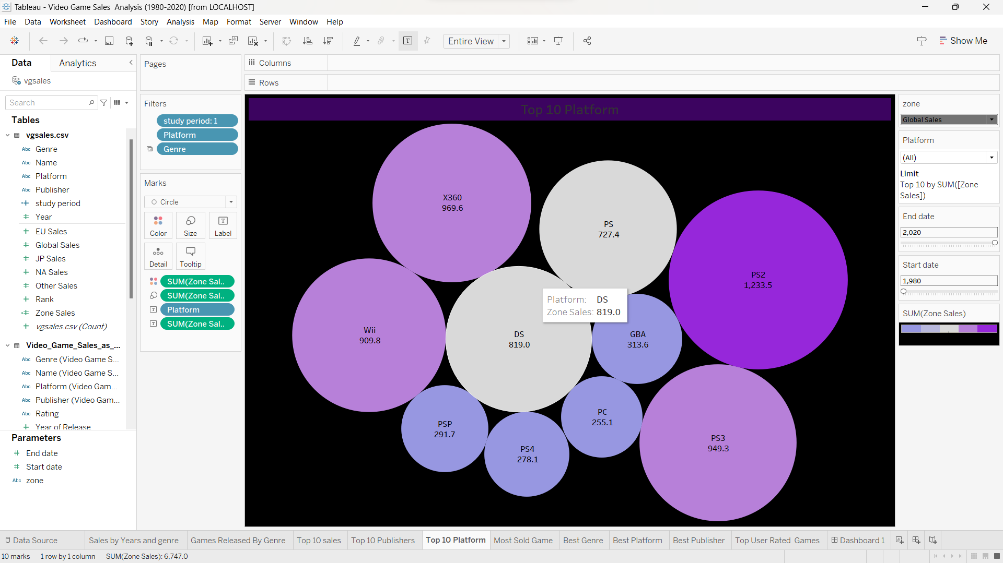

* Games Released By Genre:

1.The bar graph created using Game names data with respect to Genre allows us to compare the Different aspects such as Most Games relesed according to genre, difference in number from year to year across different regions. By using plaftform as a filter we analase the different games realsed in different plafrom genere wise, we can see that the highest Game Releases .

Highest games released in Action genre and least in puzzle.

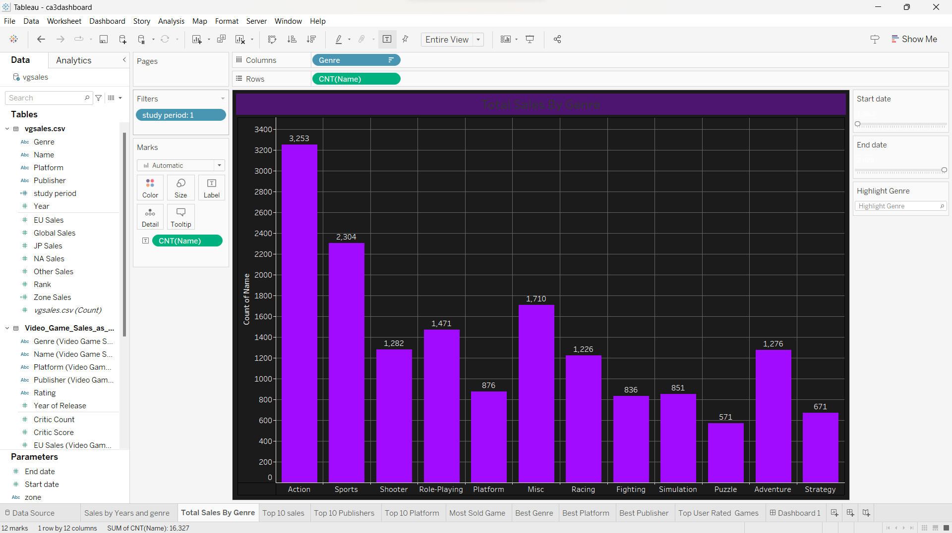

* Top 10 sales:

The bar graph created using Game names data with respect to Revenue allows us to compare the Different aspects such as Most Games revenue generated games according to genre, Years. difference in number from year to year across different regions. By using platform as a filter we analyse the different games realised in different Games according to platform and genre , we can see that the highest Game Revenue .

Highest Revenue is WII sports and least in Cod.

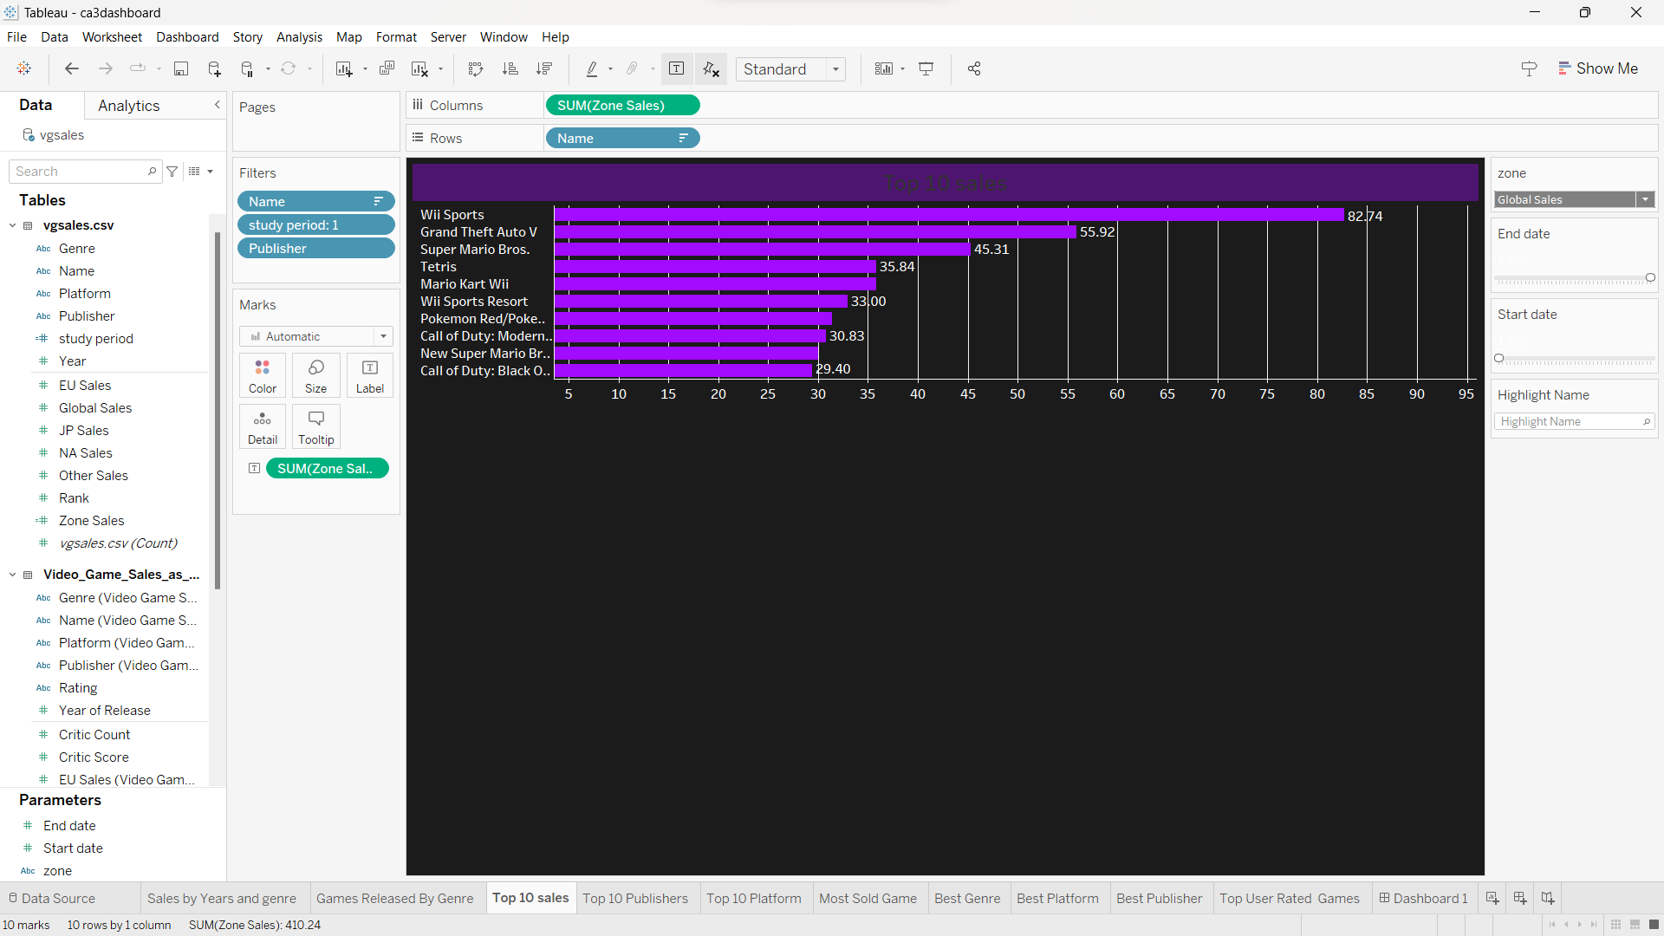

* Top 10 Publishers:

1. The Area graph created using Publisher names data with respect to Most revenue Generated allows us to compare the Publishers Games aspects such as Most Games released according to genre, difference in number from year to year across different regions. By using platform as a filter we analyse the different games realised in different platform genre wise and which company released it , we can see that the highest Game Publishers .

Highest games released is Nintendo and least is THQ.

* Top User Rated Games:

The List created using Game names data with respect to User rating allows us to compare the Different games aspects such as Most Games rated according to genre, difference in number from year to year across different regions. By using platform as a filter we analyse the different games released in different platform genre wise, we can see that the highest Game Rating.

Highest games rated is Need for Speed: Most Wanted and least is Madden NFL 08.

* Data Analysis- Dashboard

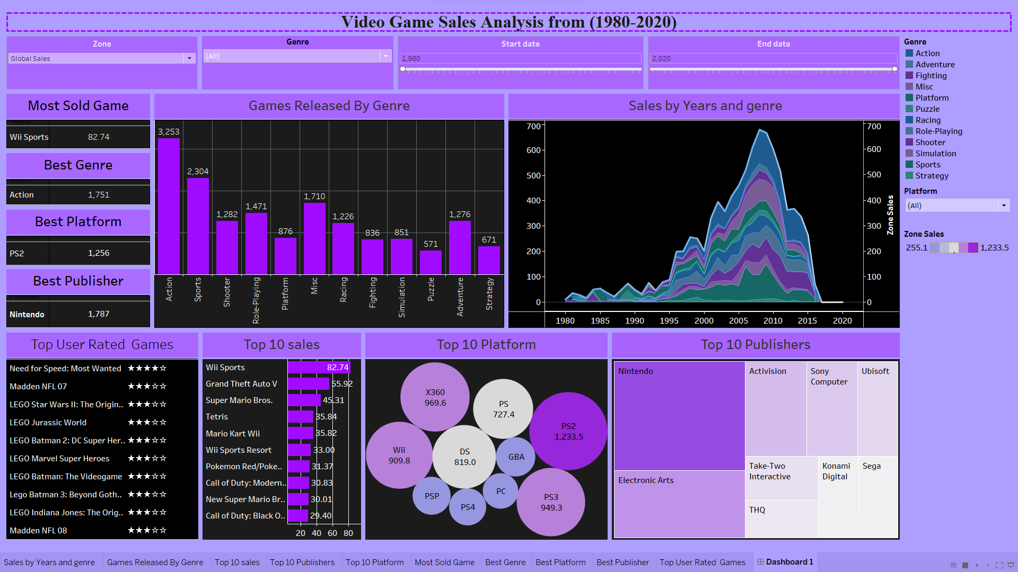

The video game sales dataset used in this report was obtained from Kaggle, a platform for data scientists and analysts to share datasets and compete in data science challenges. The dataset contains information on video game sales from 1980 to 2020, including sales figures for various regions, publisher information, and genre classifications. The data was collected from a variety of sources, including industry reports, company filings, and publicly available information.

The dataset contains over 16,500 records and includes information on a wide range of video game platforms, including popular consoles such as the Nintendo Entertainment System (NES), PlayStation, and Xbox, as well as personal computers and mobile devices. The data is organized by year, platform, publisher, genre, and region, providing a comprehensive view of the video game industry over the past four decades.

This dataset can be used to gain insights into the trends and patterns of video game sales over time, as well as the popularity of different genres and platforms in different regions of the world. It can also be used to analyse the success of individual publishers and games, providing valuable information for game developers, publishers, and investors.

**FUTURE SCOPE**

Emerging Markets:

As the video game industry continues to grow, there will likely be increased focus on emerging markets such as Africa and the Middle East. Conducting analysis on these markets could provide valuable insights into potential growth opportunities.

New Technologies:

The video game industry is constantly evolving, with new technologies such as virtual reality (VR) and augmented reality (AR) becoming increasingly popular. Analyzing the impact of these technologies on sales revenue and game releases could provide valuable insights for game developers and publishers.

Streaming and Cloud Gaming:

Streaming and cloud gaming have the potential to revolutionize the video game industry by allowing players to access games without the need for expensive hardware. Analyzing the impact of these technologies on sales revenue and game releases could provide valuable insights for game developers and publishers.

Consumer Behavior:

Analyzing consumer behavior, such as purchase patterns and player demographics, could provide insights into the preferences and behaviors of different types of gamers. This information could be used to tailor marketing campaigns and game development strategies.

Social Media:

Social media has become an important marketing tool for video game developers and publishers. Analyzing the impact of social media on sales revenue and game releases could provide valuable insights into the effectiveness of social media marketing campaigns.

These are just a few potential future scope areas for further analysis of the video game sales dataset. As the industry continues to evolve, there will likely be even more opportunities for analysis and insights.

**REFERENCES**

Kaggle. (2021). Video Game Sales. Retrieved from <https://www.kaggle.com/gregorut/videogamesales>

https://www.kaggle.com/datasets/rush4ratio/video-game-sales-with-ratings

Newzoo. (2021). Global Games Market Report 2021. Retrieved from <https://newzoo.com/products/reports/global-games-market-report/>

**BIBILIOGRAPHY**

Kaggle. (2021). Video Game Sales. Retrieved from https://www.kaggle.com/gregorut/videogamesales

Newzoo. (2021). Global Games Market Report 2021. Retrieved from https://newzoo.com/products/reports/global-games-market-report/

Statista. (2021). Video Game Industry - Statistics & Facts. Retrieved from https://www.statista.com/topics/868/video-games/

The NPD Group. (2021). Video Game Industry Sales - Total Consumer Spend in the U.S. Retrieved from https://www.npd.com/wps/portal/npd/us/industry-expertise/video-games/

VentureBeat. (2021). The DeanBeat: The best-selling games of all time. Retrieved from https://venturebeat.com/2021/03/12/the-deanbeat-the-best-selling-games-of-all-time/

World Bank. (2021). World Bank Open Data. Retrieved from https://data.worldbank.org/