Prompts to build the interactive web application

Prompt 1 — Create the basic application
Create an interactive educational web application titled “Continuous Probability Distributions: Industry Applications” for undergraduate AIML students.
Build a clean, responsive interface with a home page and three modules:
- Normal Distribution — Manufacturing Quality Control
- Exponential Distribution — Cloud Request Inter-arrival Time
- Central Limit Theorem — Warehouse Processing Time
Use simple language suitable for beginners. Each module must include:
- Industry problem statement
- Input parameters
- Mathematical formula
- Interactive calculation section
- Dynamic visualization
- Interpretation of results
Use Python only if the chosen framework supports it; otherwise use the framework's native numerical and charting libraries. Implement the application using the existing project setup and do not introduce unnecessary dependencies.
For now, create the navigation and page layouts. Do not implement all calculations yet.
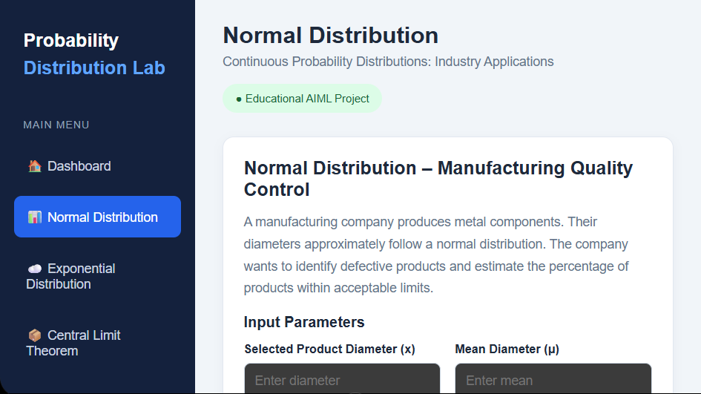

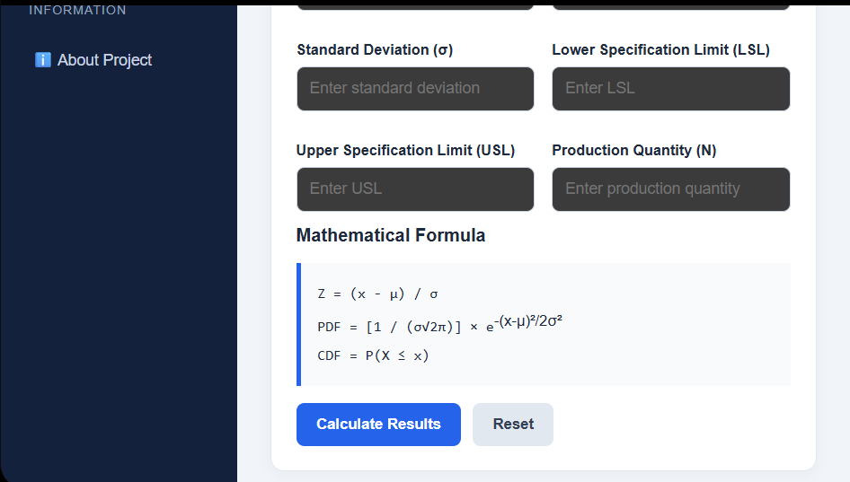
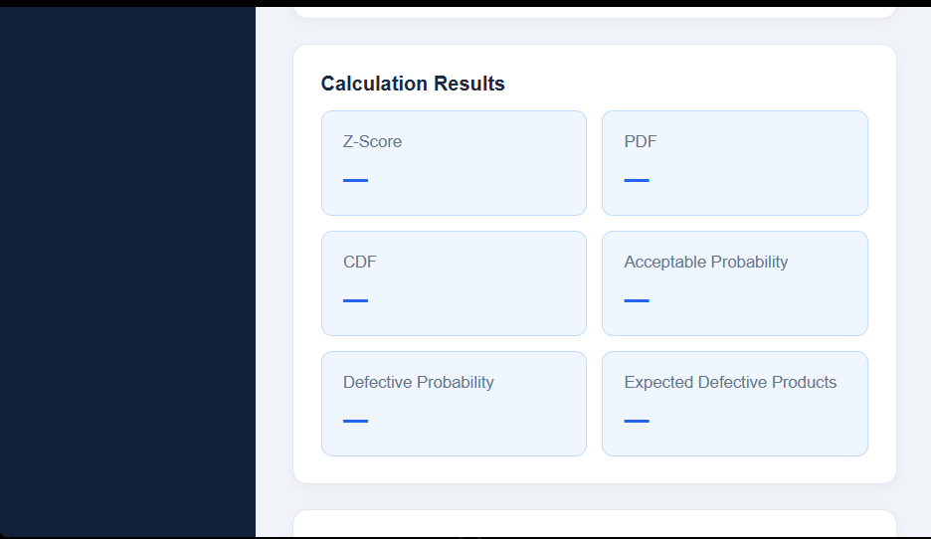
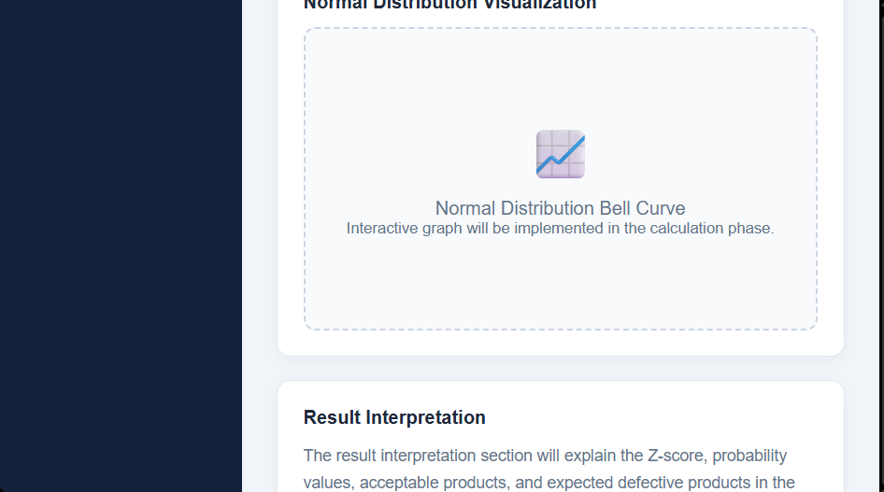
Prompt 2 — Implement the Normal Distribution module
Implement the Normal Distribution — Manufacturing Quality Control module.
Use this illustrative example:
- Target shaft diameter: 10 mm
- Mean diameter μ = 10 mm
- Standard deviation σ = 0.05 mm
- Lower specification limit = 9.90 mm
- Upper specification limit = 10.10 mm
Provide interactive inputs for μ, σ, lower limit, and upper limit.
Calculate:
- Probability density at a selected diameter.
- Probability that diameter lies between the lower and upper specification limits.
- Probability of a diameter below the lower limit.
- Probability of a diameter above the upper limit.
- Expected percentage of defective products.
Use the Normal CDF to calculate interval probabilities. Display a dynamic bell-shaped density curve and shade the acceptable region and the two defective regions in different colors.
When any input changes, update the calculations and graph immediately. Validate that σ is positive and the lower limit is less than the upper limit.
Display formulas, numerical answers, units, and a plain-language quality-control interpretation.

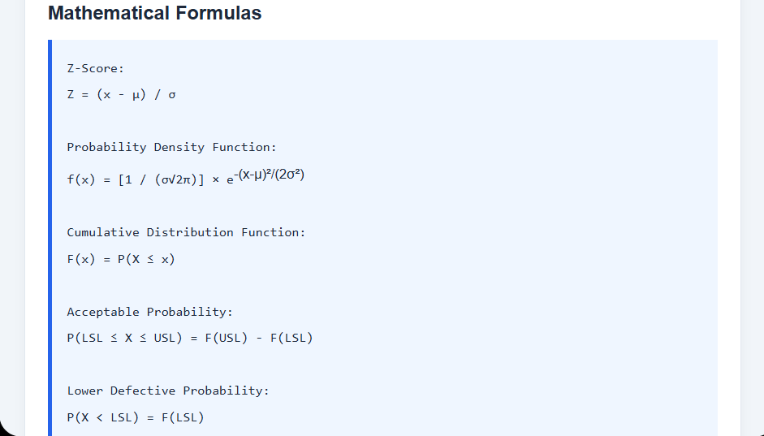
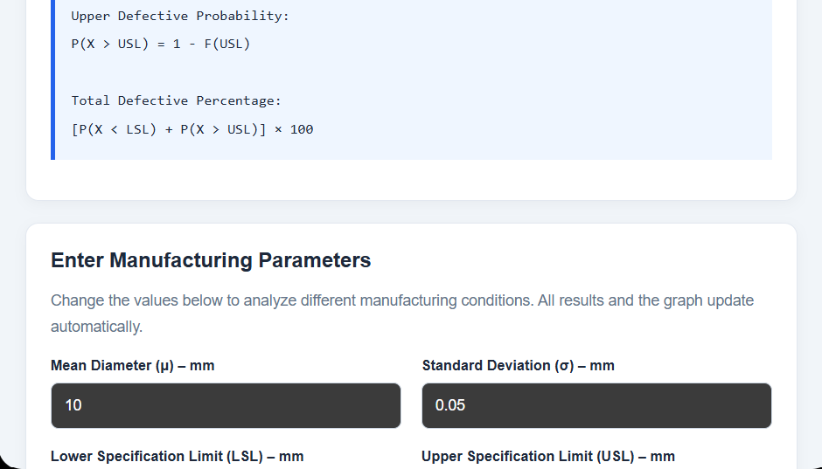
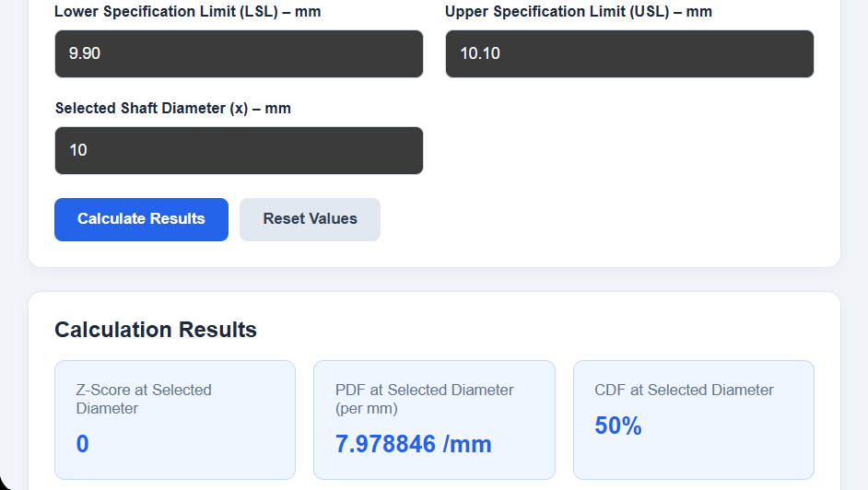

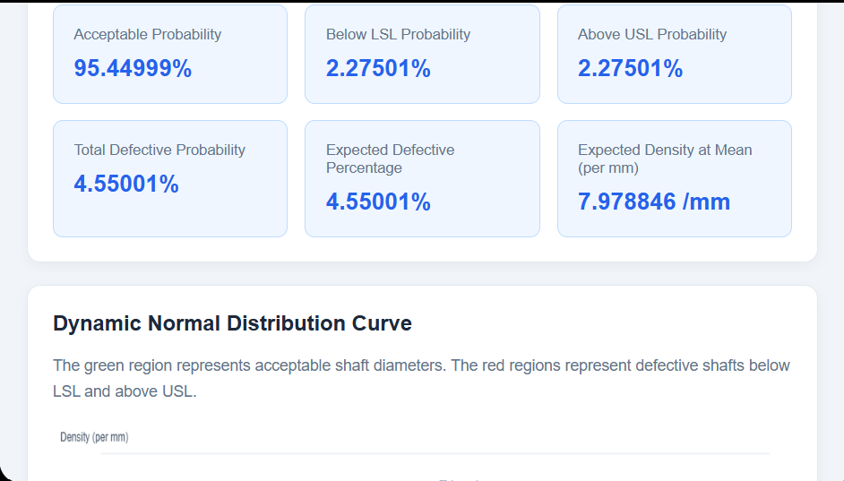
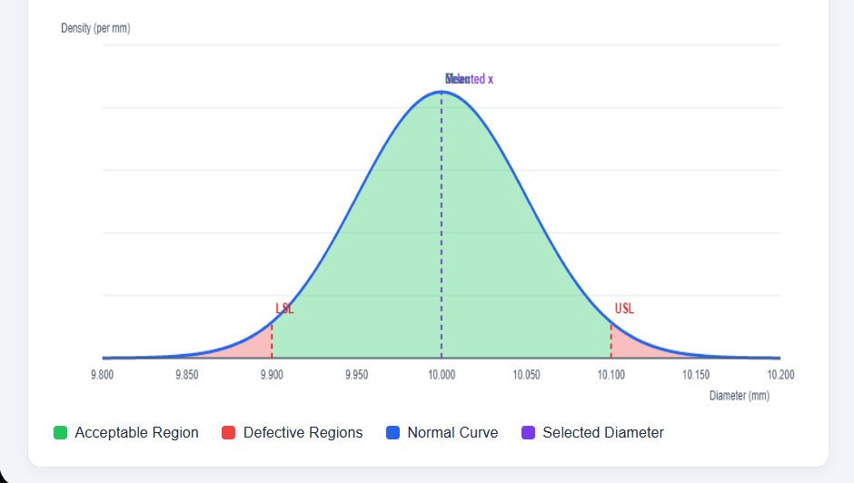
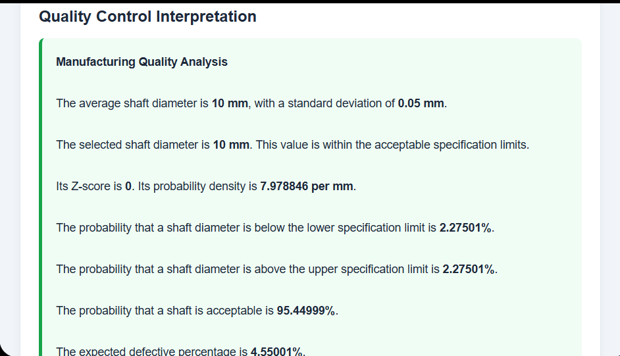
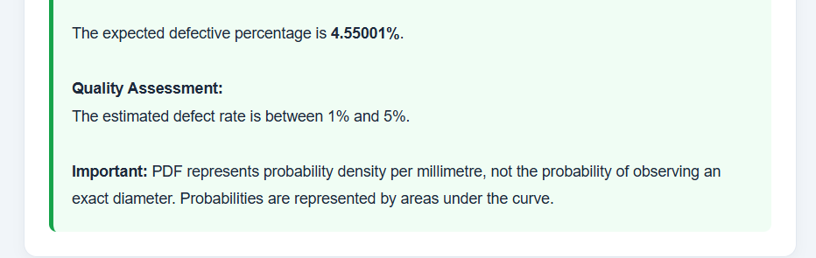

Prompt 3 — Add an interactive Exponential Distribution module
Implement the Exponential Distribution — Cloud Request Inter-arrival Time module.
Use an illustrative Poisson request-arrival rate of λ = 12 requests per minute.
Allow students to change:
- Arrival rate λ in requests per minute
- Time threshold t in seconds
Calculate:
- Mean inter-arrival time = 1/λ.
- Variance of inter-arrival time = 1/λ², using consistent units.
- P(T ≤ t) = 1 − exp(−λt).
- P(T > t) = exp(−λt).
- P(T > t₂ | T > t₁), where t₂ ≥ t₁.
Convert seconds and minutes correctly before calculations. Display the exponential probability density curve and shade the relevant probability region.
Explain the memoryless property in simple language. Validate all inputs and show units beside every result.
Clearly state that the model assumes a constant-rate Poisson arrival process. Do not describe inter-arrival time as equivalent to server response time.


