AZURE CONFIDENTIAL OR ISOLATED COMPUTE DESIGN STUDY
Project No.: 24CC3046-P074 | Team No.: T176 | Section: 52-MA

Project Title: “Azure Confidential or Isolated Compute Design Study”

Mentor: Raju Anitha
Team Members:
Deepamrutha Thota – 2400031965
Vallela Sasidhar Reddy – 2400030273
Devaragatla Siddartha – 2400030127
Jetty Kundhan Yaswanth Sai – 2400032474
Tools:
Visual Studio Code, Microsoft Azure Portal, Postman/Browser, Git and GitHub

1. Abstract
This project focuses on studying and evaluating Azure Confidential and Isolated Compute options for workloads that require enhanced security, privacy, and compliance. The main objective is to analyze different compute isolation options available in Microsoft Azure and identify the most suitable option for protecting sensitive workloads. The study evaluates Azure compute approaches based on security, level of isolation, data protection, compliance requirements, performance, regional availability, and cost. A sample sensitive workload will be evaluated using suitable Azure compute resources to establish a practical comparison between standard and specialized compute environments. The project also documents the security and compliance justification for the selected solution and identifies practical challenges such as limited regional availability of specialized Azure SKUs and the higher cost of specialized compute resources. The final outcome is a practical decision-making approach that helps organizations balance security, privacy, compliance, availability, performance, and cost when designing secure cloud infrastructure for sensitive workloads.

2. Problem Statement
Organizations increasingly process sensitive information in cloud environments, including financial records, healthcare information, customer data, government information, and confidential business data. Conventional cloud compute can provide strong security controls, but highly sensitive workloads may require additional isolation and protection, particularly while data is being processed. The challenge is to select an Azure compute architecture that provides the required level of security and isolation without introducing unnecessary cost, performance overhead, or deployment complexity.
The project therefore addresses the following problem: How can an organization select and design an Azure compute environment that provides appropriate protection and isolation for a sensitive workload while balancing security, compliance, performance, regional availability, and cost?

3. Objectives
1. To study Azure Confidential and Isolated Compute.
2. To assess the alternatives in terms of security, privacy, and compliance.
3. To select the most appropriate compute option based on performance, availability, and cost.
4. To justify the selection based on compliance requirements.
5. To recognize the potential challenges, including the limited availability of specific SKUs and increased costs.
6. To understand how the Azure Confidential and Isolated Compute can provide a secure and compliant environment for the sensitive workloads.

4. Use Cases
Description
Sensitive Banking Workload
Assess options for supporting a sensitive banking/API workload that stores and processes confidential information.
Healthcare Data Processing
Study options for supporting a workload that processes confidential healthcare records.
Government and Public-Sector Applications
Assess approaches to achieving higher isolation levels for apps that store/process government-related information.
Enterprise Confidential Applications
Provide guidance on selecting standard, dedicated, or confidential compute for enterprise-level data processing apps.
Compliance Justification
Document justification for choosing a certain Azure option for a workload that requires a higher level of security.

5. Requirements

5.1 Functional Requirements
- Develop a sample sensitive workload/API that can be deployed in Azure.
- Deploy and test a baseline standard Azure compute environment.
- Evaluate a suitable specialized compute option such as Azure Confidential VM or Dedicated Host, subject to regional/SKU availability.
- Provide secure access to the sample application through browser or Postman.
- Collect and compare security, isolation, performance, availability, and cost observations.
- Document the security and compliance justification for the recommended compute design.

5.2 Non-Functional Requirements
- Security: protect sensitive application data and credentials.
- Isolation: provide stronger workload separation where required.
- Performance: maintain acceptable application response time.
- Availability: consider supported Azure regions and specialized SKU availability.
- Scalability: allow the architecture to be extended for larger workloads.
- Cost efficiency: avoid selecting specialized infrastructure when the workload does not require it.
- Maintainability: keep source code and documentation organized using Git/GitHub.

5.3 Tools and Technologies
- Visual Studio Code – application development and project documentation.
- Microsoft Azure Portal – resource creation, configuration, deployment, monitoring, and management.
- Postman / Web Browser – API and application testing.
- Git / GitHub – source control, collaboration, version history, and project repository.

6. Project Flow
- Define the sensitive workload and security problem.
- Identify security, isolation, compliance, performance, availability, and cost requirements.
- Select Azure compute options for comparison: Standard VM, Dedicated Host, and Confidential VM where supported.
- Check Azure region and SKU availability before deployment.
- Create the Azure resource group and required networking resources.
- Develop the sample application/API in Visual Studio Code.
- Deploy the baseline application on a standard Azure VM.
- Deploy the same workload on the selected specialized compute option.
- Test both environments using Postman and a web browser.
- Collect observations on security controls, response time, resource usage, availability, and estimated cost.
- Prepare a comparison matrix and compliance/security justification.
- Select the recommended architecture and document the final result.
Problem Definition → Requirements → Azure Options → Region/SKU Check → Deployment → Testing → Comparison → Compliance Justification → Final Recommendation

7. Architecture
The proposed architecture uses a simple sensitive workload/API as the demonstration application. A standard VM acts as the baseline, while a Confidential VM or Dedicated Host can be evaluated as the specialized option depending on Azure region and SKU availability. Azure security and management services can be added as required.
Architecture principle: the same sample workload should be tested in the baseline and specialized environments so that the project can compare the practical trade-offs between security/isolation, performance, availability, and cost.

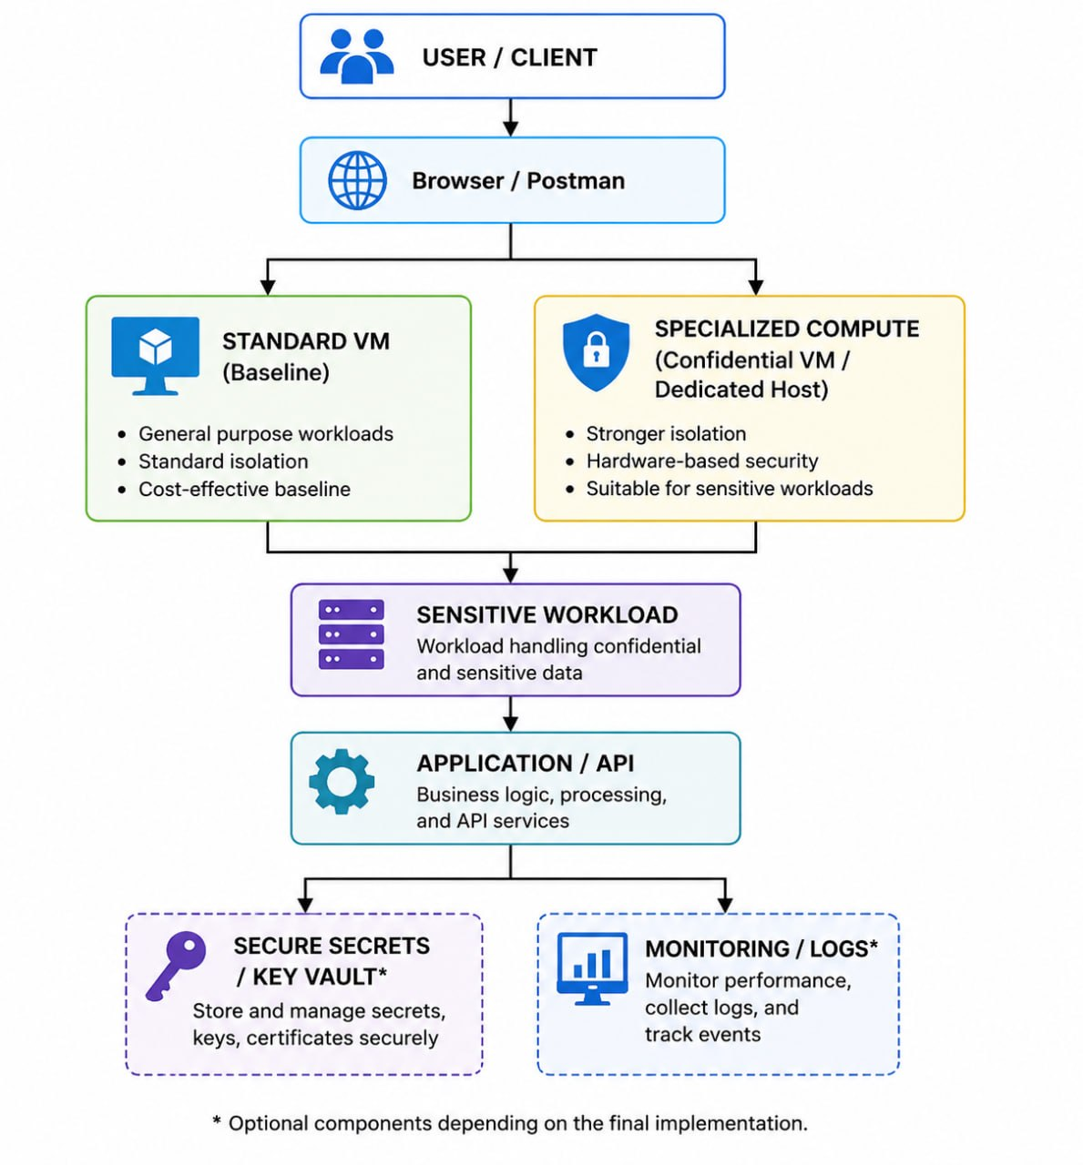

8. Conclusion
The Azure Confidential or Isolated Compute Design Study provides a practical method for selecting cloud infrastructure for sensitive workloads. Instead of assuming that the most specialized compute option is always the best choice, the project evaluates the workload requirements and compares different Azure compute approaches using security, isolation, compliance, performance, availability, and cost as decision factors. The prototype and comparison results will help demonstrate when a standard VM is sufficient and when stronger isolation or confidential computing is justified. The final architecture is intended to provide an appropriate level of protection while avoiding unnecessary cost and complexity. The approach can be extended to banking, healthcare, government, education, and enterprise workloads where secure processing of sensitive information is important.

