LAB 3 – COMPONENT MODELLING & ARCHITECTURAL PATTERN SELECTION
NAME: SIDDU SANGANNA SHIRASAGI
SRN: PES1UG25CS846
Problem Statement: Household Carbon Footprint & Target Tracker System

1. Scenario Review
The system allows a Resident to record monthly electricity, gas and commute consumption, calculate household CO₂e emissions, view historical emissions, set a reduction milestone and track progress. A Sustainability Coach can review a Resident’s emissions history and target progress.

2. Requirements Considered
Type | ID | Requirement
Functional | FR-001 | Calculate total monthly CO₂e from electricity and transport data.
Functional | FR-002 | Record monthly electricity, gas and commute consumption.
Functional | FR-003 | Display monthly CO₂e emissions and historical trend.
Functional | FR-004 | Set a CO₂e reduction milestone and show progress.
Functional | FR-005 | Allow the Sustainability Coach to review emissions history and target progress.
Non-functional | NFR-001 | Annual reduction milestone chart renders in under 200 ms.
Non-functional | NFR-002 | Only the authorized Resident and assigned Sustainability Coach can access household data.

3. Architectural Style Analysis
Architecture | Advantages | Limitations | Decision
Layered | Clear separation of presentation, business logic and data; simple to understand and maintain. | Some communication overhead between layers; less independent scaling. | Selected
Microservices | Independent deployment, scaling and fault isolation. | Adds operational complexity, network communication and data-consistency issues. | Not selected for this scope
Client-Server | Centralised control and straightforward data consistency. | Central server can become a bottleneck and a single point of failure. | Not selected

4. Architecture Selection
Layered Architecture was selected because the system naturally separates into user-facing functions, business processing and persistent data. It gives a practical structure for the current system without introducing the operational complexity of microservices.

5. Components
Component | Responsibility
Resident UI | Resident data entry, emissions and target screens.
Coach UI | Sustainability Coach review screen.
Consumption Manager | Validates and manages monthly consumption records.
CO₂e Calculation Service | Calculates monthly emissions using consumption data and emission factors.
Target & Progress Service | Manages reduction milestones and progress.
Household Data Repository | Stores consumption, emissions and target information.
Emission Factor Service | External service providing conversion/emission factors.

6. Component Diagram
The diagram contains seven components and the main interfaces between them.
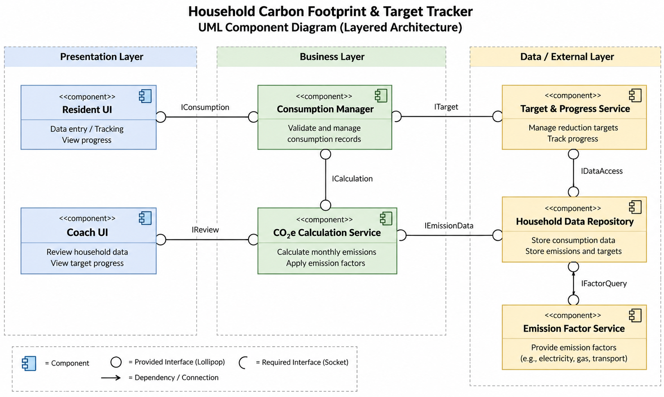

7. Interfaces and Interactions
Interface | Direction | Purpose
Consumption API | Resident UI → Consumption Manager | Monthly electricity, gas and commute data.
Target API | Resident UI → Target & Progress Service | Target and progress requests.
Review API | Coach UI → Target & Progress Service | Review household progress.
Calculation Request | Consumption Manager → CO₂e Calculation Service | Request monthly CO₂e calculation.
Emission Record | CO₂e Calculation Service → Data Repository | Store calculated emissions.
Target Data | Target & Progress Service → Data Repository | Read/write target and progress data.
Factor Query | CO₂e Calculation Service → Emission Factor Service | Obtain emission factors.

8. Security and Performance
Security is addressed by keeping household data behind application components and applying authorization before protected records are returned to the Resident or assigned Sustainability Coach. Performance is supported by separating calculation and data-access responsibilities, helping the system meet the under-200-ms chart-rendering requirement.

