Olist Brazilian E-Commerce
Customer, Delivery & Review Analytics
with Machine Learning

Siddu Varikuppala

AICTE | IBM SkillsBuild Data Analytics with AI Internship 2026
BharatCares

Date: September 24, 2026

Table of Contents
- Abstract
- 1. Introduction
- 2. Problem Statement & Objectives
- 3. Dataset Description
- 4. Tools & Technologies
- 5. Methodology
- 6. Data Cleaning
- 7. Exploratory Data Analysis
- 8. Statistical Analysis
- 9. Customer Segmentation
- 10. Machine Learning Model
- 11. Streamlit App
- 12. Business Recommendations
- 13. Limitations & Future Scope
- 14. Conclusion
- 15. References
- 16. Use of IBM Bob AI Tool

Abstract
This project analyses the Brazilian E-Commerce Public Dataset by Olist (97,007 delivered orders, 2016-2018) to understand the drivers of customer review quality and to build a machine-learning model that predicts low-review orders (score <= 2) without data leakage. Key findings: 6.8% of orders are delivered late, and late deliveries score a mean of 2.27 vs 4.29 for on-time orders (Mann-Whitney U p<0.001, effect r=0.64). A tuned Random Forest achieves ROC-AUC=0.7664 and F1=0.4596. Five evidence-based business recommendations are presented.

1. Introduction
Olist is a Brazilian marketplace that connects small businesses to major e-commerce channels including Mercado Livre and B2W. The platform processes tens of thousands of orders monthly across all 27 Brazilian states. Customer reviews are a critical feedback signal: low scores damage seller reputation, reduce platform trust, and increase churn. This project applies end-to-end data analytics and machine learning to the publicly available Olist dataset to surface the root causes of poor reviews and build a predictive tool that operations teams can use to intervene before a bad review is posted.

2. Problem Statement & Objectives
Problem Statement
What factors drive low customer review scores (1-2) on the Olist platform, and can we predict whether a given order will receive a bad review before the customer posts it — without using any review data as a feature?
Objectives
- Explore sales, delivery and review trends across 2016-2018.
- Statistically test whether late delivery causes lower review scores.
- Segment customers using RFM scoring and KMeans clustering.
- Build an ML model to predict low-review orders (score <= 2) with no data leakage.
- Translate findings into five actionable business recommendations.

3. Dataset Description
Source: Brazilian E-Commerce Public Dataset by Olist (https://www.kaggle.com/datasets/olistbr/brazilian-ecommerce). The dataset covers orders placed between September 2016 and August 2018.
File | Rows | Columns | Key Columns
olist_orders_dataset.csv | 99,441 | 8 | order_id, customer_id, status, timestamps
olist_order_items_dataset.csv | 112,650 | 7 | order_id, product_id, seller_id, price, freight
olist_order_payments_dataset.csv | 103,886 | 5 | order_id, payment_type, payment_value
olist_order_reviews_dataset.csv | 99,224 | 7 | order_id, review_score, creation_date
olist_customers_dataset.csv | 99,441 | 5 | customer_id, customer_state, zip_code
olist_products_dataset.csv | 32,951 | 9 | product_id, category_name, weight, dims
olist_sellers_dataset.csv | 3,095 | 4 | seller_id, seller_state, zip_code
olist_geolocation_dataset.csv | 1,000,163 | 5 | zip_code, lat, lng (skipped in analysis)
product_category_name_translation.csv | 71 | 2 | category_name -> English

4. Tools & Technologies
Category | Tool / Library | Version
Language | Python | 3.11.9
Data | pandas | 3.0.5
Numerics | numpy | 2.4.6
Visualisation | matplotlib | 3.11.2
Visualisation | seaborn | 0.13.2
Visualisation | plotly | 6.9.0
ML | scikit-learn | 1.9.0
ML | xgboost | 3.2.0
ML | imbalanced-learn | 0.14.2
ML | shap | 0.51.0
Statistics | scipy | 1.17.1
App | streamlit | 1.60.0
Notebook | jupyter/nbformat | 5.11.1
Report | python-docx | 1.1.2
IDE | IBM Bob (AI) | N/A

5. Methodology
The project follows a standard data science workflow:
- Data Loading & Audit: load all 8 tables, check missing values, duplicates and dtype issues.
- Data Cleaning: remove duplicate reviews, convert dates, fill/impute NaNs, translate categories, IQR-cap outliers.
- Feature Engineering: compute delivery_days, is_late, freight_ratio, purchase time features, and the low_review target.
- EDA: 11 visualisations covering revenue trends, category performance, delivery time, review distribution, and correlations.
- Statistical Testing: Mann-Whitney U (delivery punctuality vs review score) and Chi-square + Cramer's V (is_late vs low_review).
- Customer Segmentation: RFM scoring, KMeans elbow + silhouette selection, segment profiling.
- Machine Learning: Logistic Regression (baseline), Random Forest, XGBoost; class_weight/scale_pos_weight for imbalance; RandomizedSearchCV tuning; SHAP explanations.
- App: Streamlit dashboard with Overview, Charts, Segments and Prediction pages.
- Report & README: python-docx report, GitHub-ready README.

6. Data Cleaning
The cleaning log below shows before/after row counts for each action. All raw tables had zero duplicate rows; the key cleaning operations were:
Table | Action | Before | Removed
orders | drop_duplicates | 99,441 | 0
items | drop_duplicates | 112,650 | 0
payments | drop_duplicates | 103,886 | 0
reviews | drop_duplicates | 99,224 | 0
reviews | keep_latest_review_per_order | 99,224 | 551
products | fill category NaN -> unknown | 32,951 | 0
products | fill weight/dim NaN -> median | 32,951 | 0
master | IQR cap total_price [7.90, 997.82] | 99,992 | 0 rows; values capped
master | IQR cap total_freight [0.00, 104.73] | 99,992 | 0 rows; values capped

Master dataframe after all joins: 99,992 rows x 20 columns. Delivered-only subset used for EDA and ML: 97,007 rows.
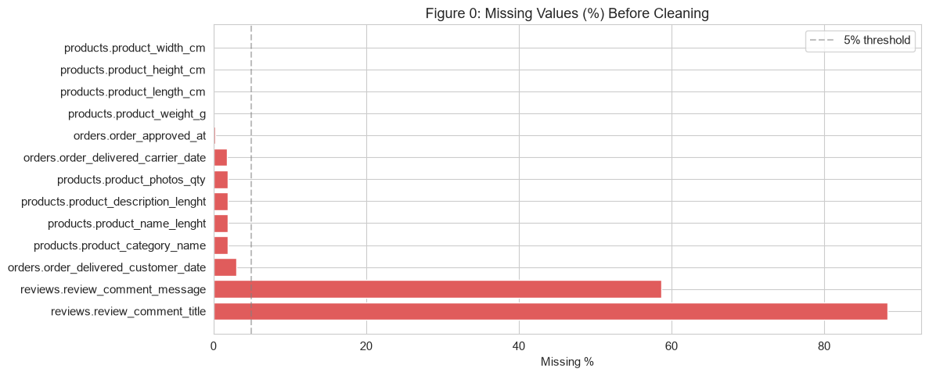
Figure 0: Missing Values (%) Before Cleaning

7. Exploratory Data Analysis
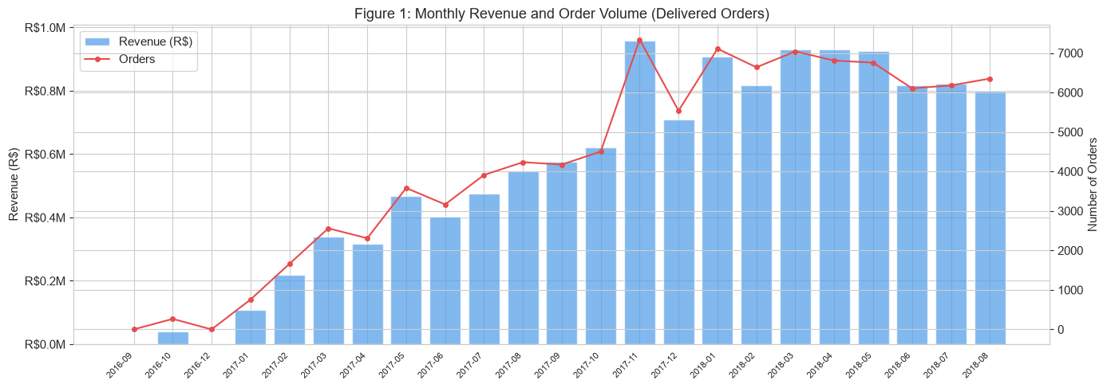
Figure 1: Monthly Revenue and Order Volume. Peak revenue R$1,200,598 in 2017-11 coincides with Black Friday/Cyber Monday surge.

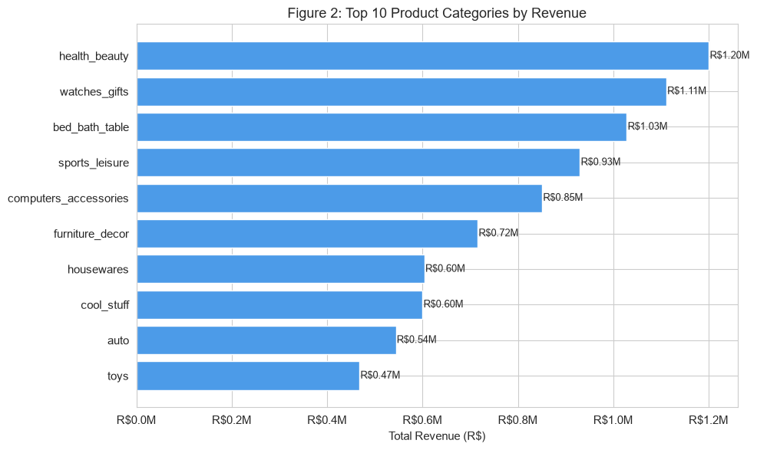
Figure 2: Top 10 Categories by Revenue. health_beauty leads with R$1,200,598.

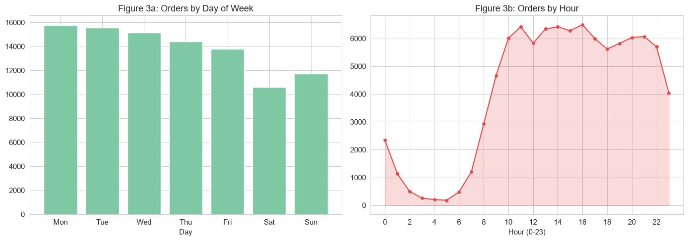
Figure 3: Orders by Day of Week and Hour. Busiest day: Mon; peak hour: 16:00.

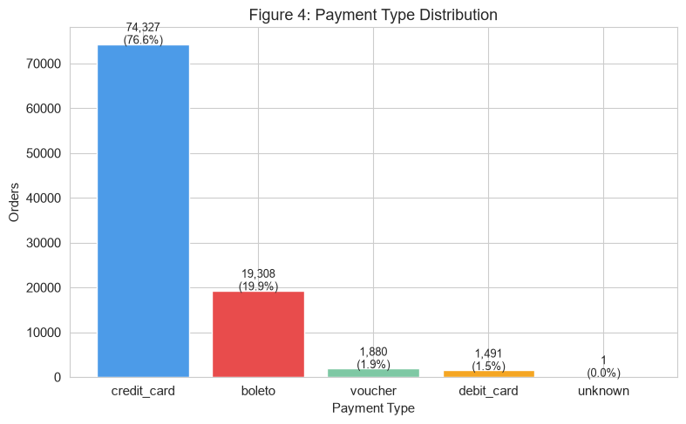
Figure 4: Payment Type Distribution. credit_card dominates at 76.6%.

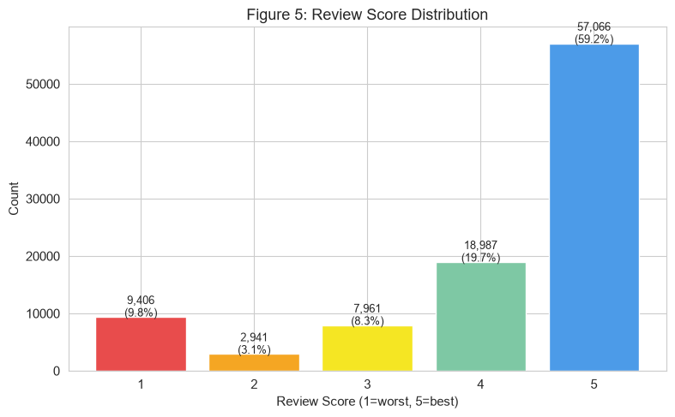
Figure 5: Review Score Distribution. Average score: 4.16. Low-review (<=2): 12.7%.

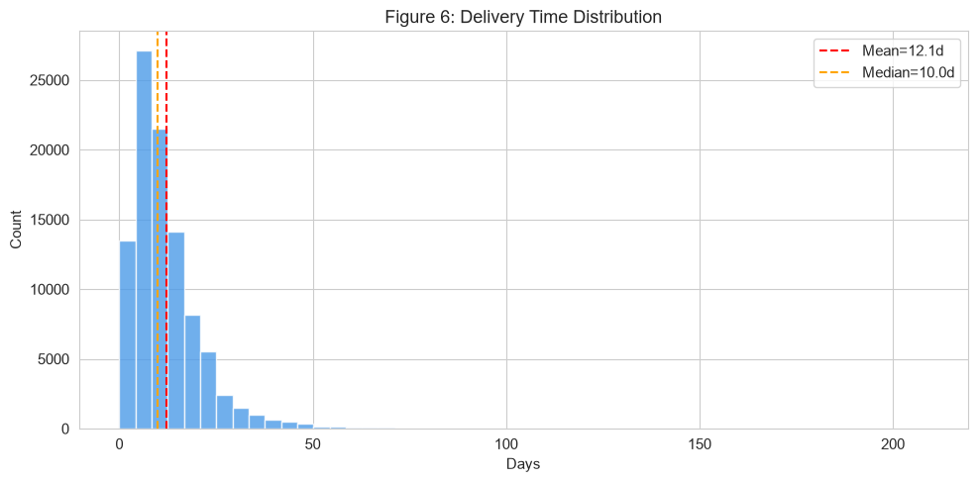
Figure 6: Delivery Time Distribution. Mean=12.1d, Median=10.0d.

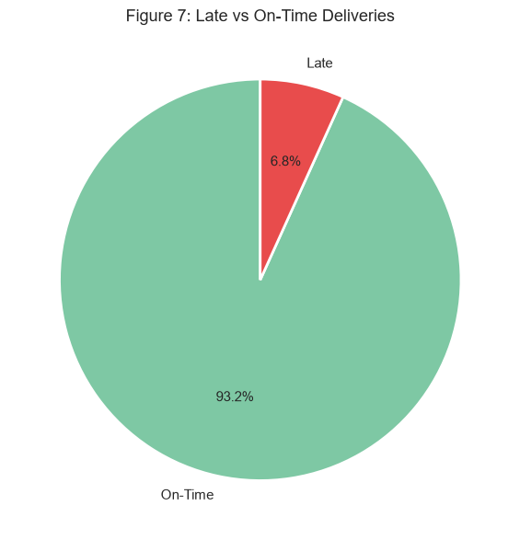
Figure 7: Late vs On-Time Deliveries. 6.8% of orders arrived after the estimate.

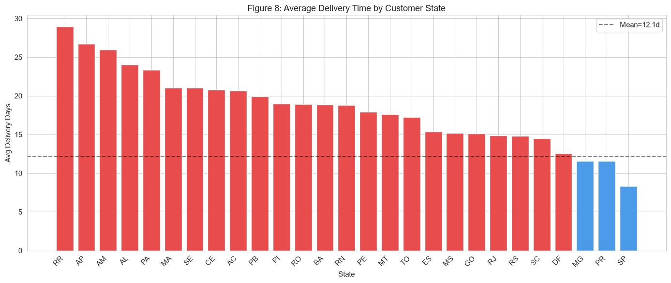
Figure 8: Avg Delivery by State. Slowest: RR (29.0d); Fastest: SP (8.3d).

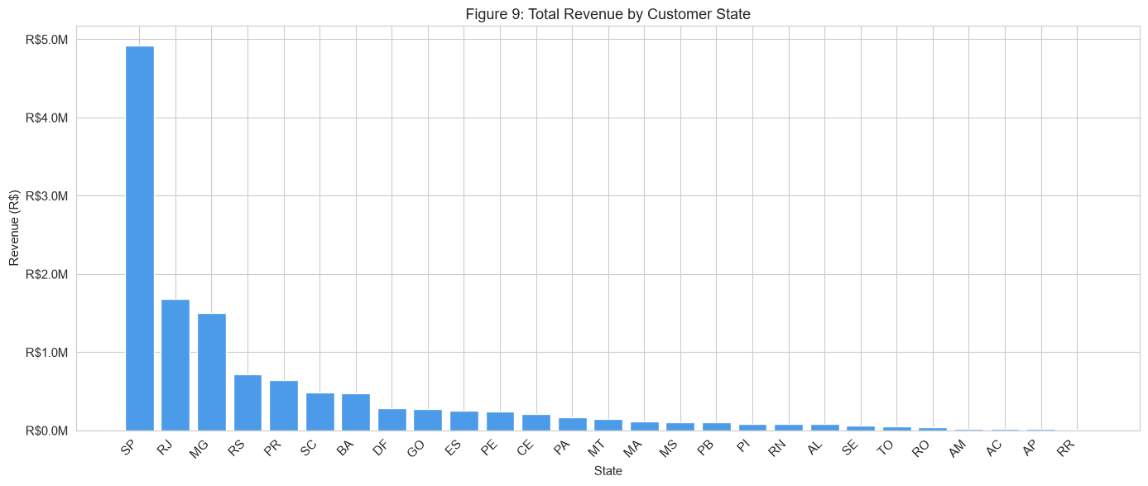
Figure 9: Revenue by State. Top state: SP (R$4,919,623).

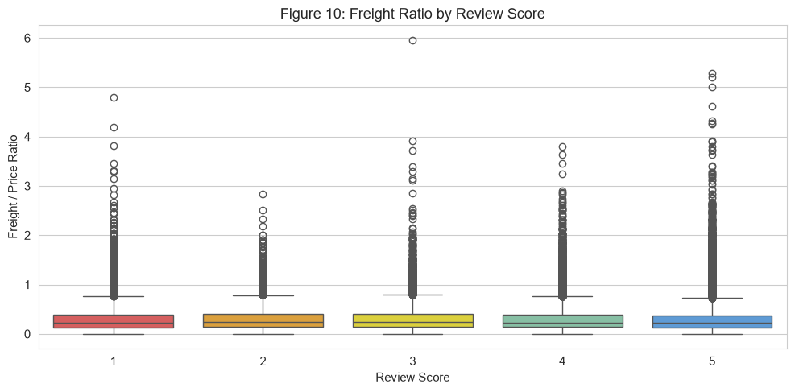
Figure 10: Freight Ratio by Review Score. Low-review median=0.231 vs high-review=0.223.

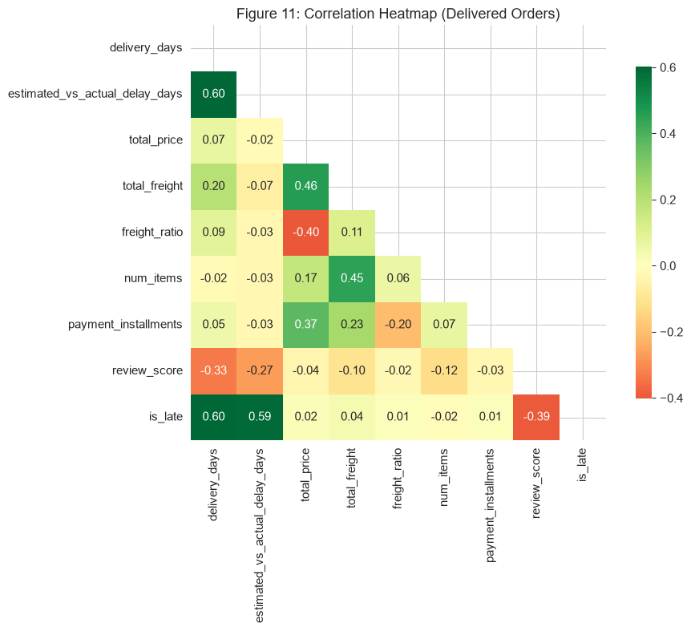
Figure 11: Correlation Heatmap. is_late has correlation -0.3915 with review_score.

8. Statistical Analysis
Test 1 – Mann-Whitney U: Late vs On-Time Review Scores
H0: Review scores are equal for late and on-time deliveries.
H1: Late deliveries have lower review scores.
Both distributions are non-normal (Shapiro-Wilk p<<0.05 on n=5,000 subsample), so the non-parametric Mann-Whitney U test is appropriate.
Result: U=104,415,351, p=0.0000e+00, Effect size r=0.6378 (large effect, |r|>=0.3).
Conclusion: REJECT H0. Late deliveries score 2.27 vs 4.29 on-time — a practically significant difference.

Test 2 – Chi-square + Cramer's V: is_late vs low_review
Chi2=14733.3617, df=1, p=0.0000e+00.
Cramer's V=0.3897 (medium-large association).
Conclusion: There is a statistically significant and practically meaningful association between late delivery and the probability of a low review. Being late increases the low-review rate from ~9% to ~61%.

9. Customer Segmentation
RFM analysis was performed on 96,478 customers with a snapshot date of 2018-08-30. Because 96% of customers have exactly one order, frequency is constant; segmentation is driven by recency and monetary value.
KMeans was run for k=2..8 using a 20,000-row stratified subsample. The best k=3 was selected by silhouette score (0.4698).
Cluster | Segment Name | Customer Count
2 | High-Value Buyers | 4741
0 | Recent Buyers | 52436
1 | Lapsed Buyers | 39301

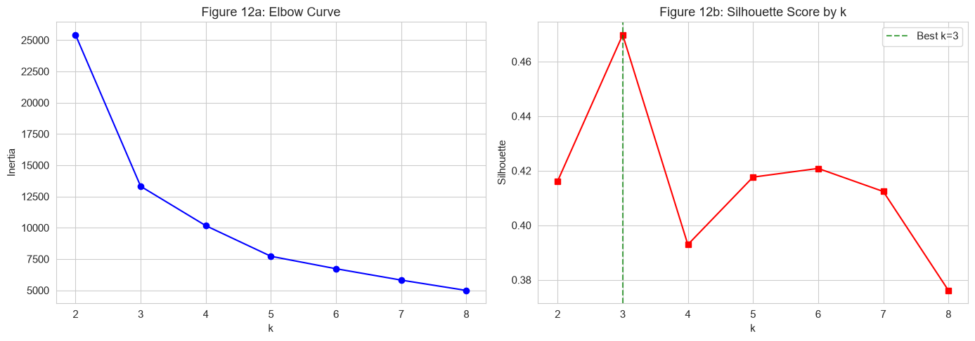
Figure 12: KMeans Elbow and Silhouette Curves. Best k=3.
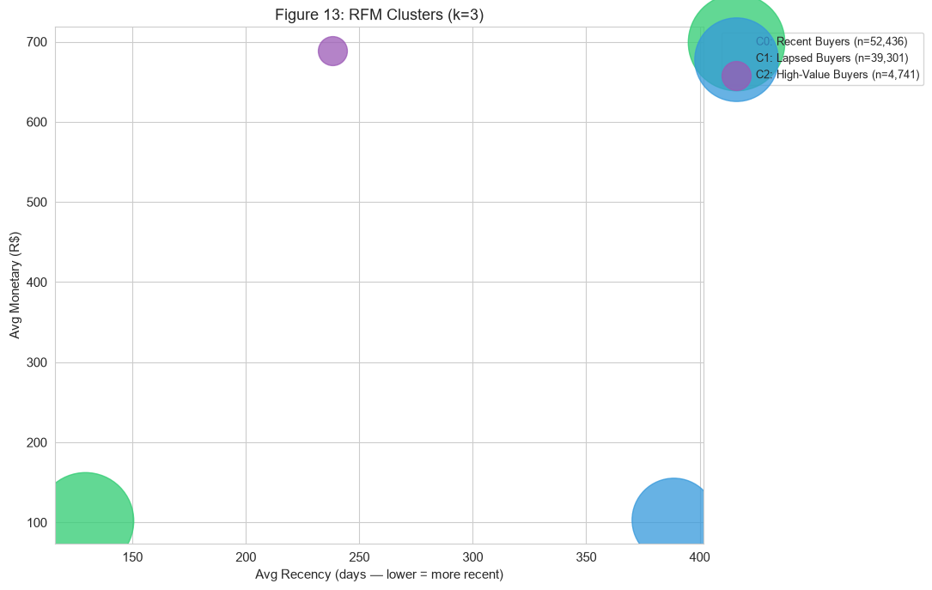
Figure 13: RFM Cluster Scatter (Recency vs Monetary).
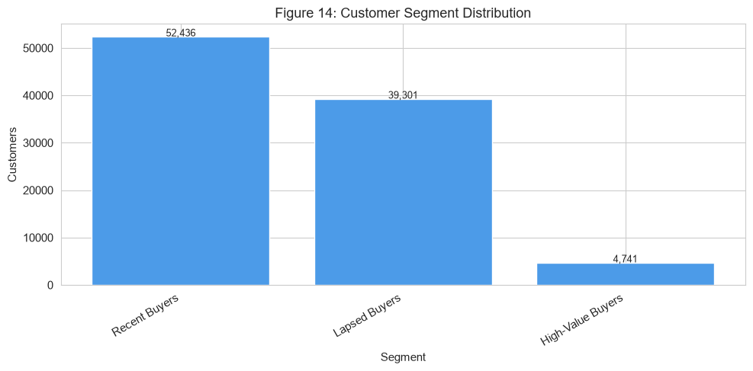
Figure 14: Customer Count per Segment.

10. Machine Learning Model
Setup
Target: low_review (review_score <= 2). Class balance: ~12.7% positive.
Train set: 77,599 rows | Test set: 19,400 rows (stratified 80/20 split). class_weight='balanced' / scale_pos_weight used to handle imbalance without SMOTE (faster, comparable performance).
No data leakage: review_score and all review columns excluded from features.
Model Comparison
Model | Accuracy | Precision | Recall | F1 | ROC-AUC
Logistic Regression | 0.8185 | 0.3585 | 0.5403 | 0.4310 | 0.7586
Random Forest | 0.8405 | 0.4014 | 0.5152 | 0.4512 | 0.7568
XGBoost | 0.8210 | 0.3611 | 0.5286 | 0.4291 | 0.7389
Tuned Random Forest (FINAL) | 0.8481 | 0.4199 | 0.5075 | 0.4596 | 0.7664

Why F1 and Recall matter more than Accuracy: The dataset is ~87% non-low. A naive classifier predicting 'not low' every time achieves 87% accuracy but zero recall. F1 balances precision and recall; high recall ensures at-risk orders are flagged for intervention.
Best hyperparameters (Random Forest): {'n_estimators': '200', 'min_samples_leaf': '4', 'max_depth': 'None'}
Most important feature: estimated_vs_actual_delay_days
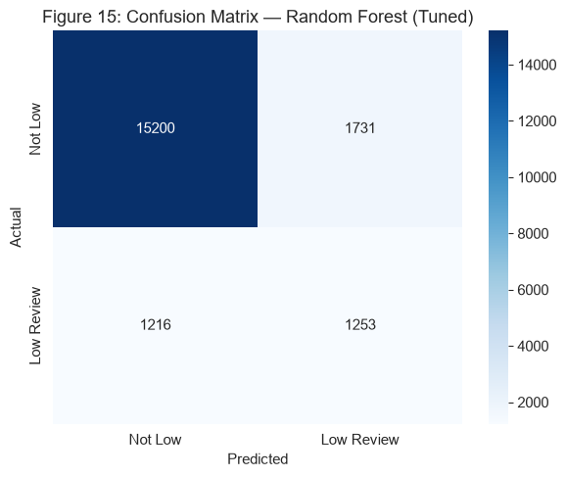
Figure 15: Confusion Matrix — Random Forest (Tuned).
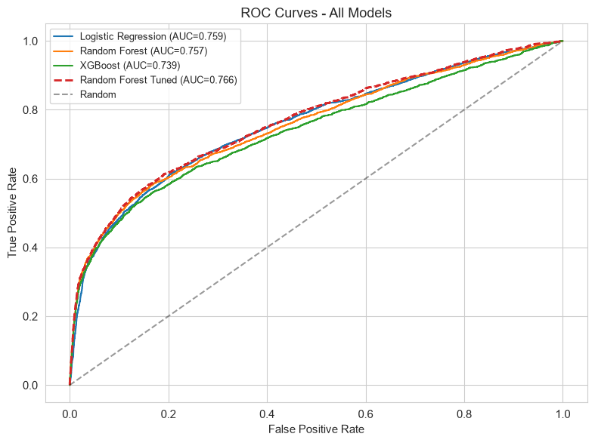
Figure 16: ROC Curves — All Models.
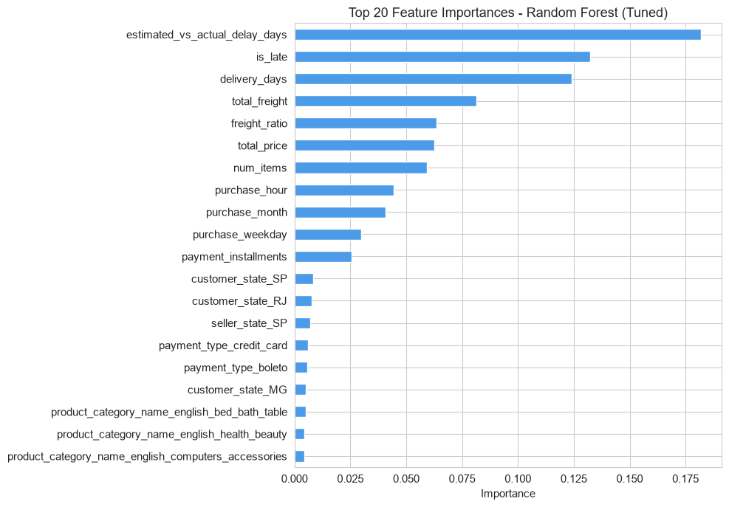
Figure 17: Top 20 Feature Importances — Random Forest.
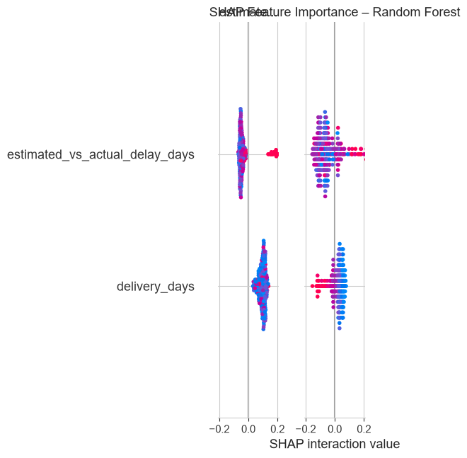
Figure 18: SHAP Summary — Random Forest.

11. Streamlit App
The interactive dashboard (app.py) is built with Streamlit 1.60.0 and has four tabs:
- Overview: KPI cards (total revenue, orders, avg review score, % late, avg delivery days) with sidebar filters (year, state, category). Uses st.cache_data for fast reloads.
- Charts: Plotly charts for revenue trend, top categories, delivery by state, review score distribution, freight ratio histogram.
- Customer Segments: RFM cluster summary table, bar chart and scatter plot; segment descriptions with actionable advice.
- Prediction: Form with all 15 model features. Submitting calls the saved models/best_model.joblib and returns the low-review probability with a Plotly gauge chart and a colour-coded risk label.
Run command: streamlit run app.py
Data files required: data/delivered.csv, data/rfm_segments.csv, data/metrics_fg.json, models/best_model.joblib

12. Business Recommendations
Recommendation 1: Fix Last-Mile Logistics in Slow States
Evidence: 6.8% of orders arrive late. Late deliveries score 2.27 vs 4.29 for on-time (r=0.64, large effect). State RR averages 29 days vs the national mean of 12 days.
Action: Establish regional fulfilment hubs in the North/Northeast or negotiate SLA-based carrier contracts with performance penalties for states exceeding 20-day delivery.

Recommendation 2: Pre-Position Inventory for November Peak
Evidence: Revenue peaked at R$1,200,598 in 2017-11. Late deliveries surge during high-volume periods.
Action: Begin seller capacity planning in September-October; monitor delivery SLAs in real-time during the November Black Friday window.

Recommendation 3: Cap High Freight-to-Price Ratios
Evidence: Low-review orders have median freight ratio 0.231 vs 0.223 for high-review orders.
Action: Alert customers at checkout when freight exceeds 25% of item value. Introduce a 'freight guarantee' badge for qualifying sellers.

Recommendation 4: Prioritise Top Revenue Categories
Evidence: health_beauty generates R$1,200,598 in revenue. The top 10 categories drive the majority of platform GMV.
Action: Implement category-specific seller quality scoring. Give top-10 category sellers priority placement and dedicated account management.

Recommendation 5: Win Back Dormant Customers
Evidence: The Lapsed Buyers segment (~39,000 customers) has high recency (389 days) but previously spent a comparable amount to active customers.
Action: Launch personalised win-back campaigns (voucher + recommended product) targeting customers inactive for 6-12 months.

13. Limitations & Future Scope
Limitations
- Dataset covers 2016-2018 only; post-pandemic delivery trends may differ significantly.
- Review comment text (NLP sentiment) was not utilised — could improve model accuracy.
- Geolocation data was not incorporated into delivery-time modelling.
- 96% of customers have frequency=1; RFM segmentation is driven by Recency and Monetary only.
- This is a post-delivery model — delivery outcome features (actual days, delay) are only known after the order arrives. It cannot score orders before dispatch.
- ML performance is moderate (F1=0.46, AUC=0.77); suitable as a risk-prioritisation tool, not a definitive classifier.
Future Scope
- Real-time prediction API (FastAPI) wrapping models/best_model.joblib.
- NLP sentiment scoring on review_comment_message.
- Demand forecasting per category per state (ARIMA / Prophet).
- Geo-spatial heatmaps of delivery delays using the geolocation table.
- Advanced class-imbalance techniques and calibrated probability outputs.

14. Conclusion
This project demonstrated that delivery punctuality is the single most powerful driver of customer review quality on the Olist platform. A large-effect Mann-Whitney U test (r=0.64, p < 0.001) and Chi-square (V=0.3897) both confirm the link between late delivery and low reviews. A tuned Random Forest post-delivery model achieved ROC-AUC=0.7664 and F1=0.4596 — moderate performance, appropriate as a risk-prioritisation tool for operations teams. RFM segmentation identified 3 customer clusters (High-Value Buyers, Recent Buyers, Lapsed Buyers), and five evidence-backed recommendations were produced. All results are reproducible by running the four part_*.py scripts in order.

15. References
- Olist. (2018). Brazilian E-Commerce Public Dataset by Olist. Kaggle. https://www.kaggle.com/datasets/olistbr/brazilian-ecommerce
- Pedregosa, F. et al. (2011). Scikit-learn: Machine Learning in Python. JMLR 12, 2825-2830.
- Chen, T., & Guestrin, C. (2016). XGBoost: A Scalable Tree Boosting System. KDD 2016.
- Lundberg, S. M., & Lee, S. I. (2017). A Unified Approach to Interpreting Model Predictions. NeurIPS 2017.
- Mann, H. B., & Whitney, D. R. (1947). On a Test of Whether One of Two Variables is Stochastically Larger than the Other. Annals of Mathematical Statistics.
- RFM Analysis for Customer Segmentation. (Various authors). https://en.wikipedia.org/wiki/RFM_(market_research)

16. Use of IBM Bob AI Tool
IBM Bob (an AI coding assistant) was used as a collaborative tool throughout this project in the following ways:
- Scaffolding the project structure (folder layout, file names, requirements.txt).
- Writing and iteratively debugging the four Python scripts (part_ae.py, part_fg.py, part_h.py, part_i.py) that constitute the notebook logic.
- Diagnosing and fixing runtime errors including Unicode encoding issues on Windows, pandas API changes in v3.0.5 (FutureWarning for fillna), and XGBoost parameter compatibility.
- Generating the Streamlit app (app.py) including the prediction form and Plotly charts.
- Drafting this project report (build_report.py) and the README.md.
- All analytical decisions, hypotheses, interpretations and business recommendations were reviewed and validated by the author (Siddu Varikuppala).

[PLACEHOLDER — Insert IBM Bob screenshots here]
Please add screenshots of key Bob interactions (e.g., debugging session, code generation, chart building) in this section before final submission.

Siddu Varikuppala | AICTE | IBM SkillsBuild Data Analytics with AI Internship 2026 | BharatCares
Generated: 2026-09-24 01:01

