31/07/25

Steps to develop Bootstrap

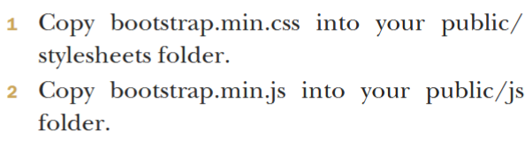

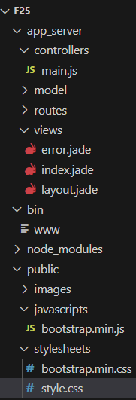

2.OPEN TEXT BOOK and go to page no.401 and make sure that this kind of structure(if you have ran already Express program this kind of parent directories exists) so just copy and paste as per steps given here.

3.go to vs code in terminal

3.go to vs code and in terminal type as follows:

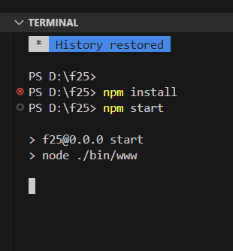

4.go to browser and type localhost:3000

