ROAD TRIP SHARING PLATFORM
UI Design Document — Wireframes & Component Breakdown

1. Overview
This document covers the View layer of the MVC architecture: how the interface was broken into reusable components, the low-fidelity wireframes for each screen, and the visual design system (“Waypoint”) applied on top of them. The fully built, functional version of every screen below ships as working HTML/CSS/JavaScript in the frontend source code, wired to the live REST API.

2. Component Breakdown
The interface is built from a small set of components reused across every page, rather than one-off markup per screen — this keeps the code consistent and easy to extend.
Component | Used on
Navbar (logo, nav links, auth state) | Every page
Hero search panel (keyword input, tag chips) | Browse
World / route map (Leaflet) | Browse (overview), Trip detail (route), Create trip (pin picker)
Trip card (title, route, tags, rating) | Browse grid, My trips grid
Trip stat strip (duration, distance, rating, stops, visibility) | Trip detail
Stop list item (numbered, day badge) | Trip detail, Create trip (draft list)
Comment list + form | Trip detail
Star rating widget | Trip detail
Stepper (numbered step pills) | Create trip
Form field set (label + input + hint/error) | Create trip, Login, Register
Alert banner (error / success) | Login, Register, Create trip
Empty / loading state | Browse, My trips, Trip detail

3. Design System

3.1 Colour palette
A travel-atlas palette: deep pine for primary actions and trust, a muted rust accent for ratings/highlights, warm parchment as the page background instead of stark white.
Pine #2B4036 | Rust #A8512F | Parchment #F3EEE2 | Ink #1A231E

3.2 Typography
Role | Typeface
Headlines (h1–h3) | Fraunces — an editorial serif, giving the app a travel-journal character
UI & body text | Inter — a clean, highly legible sans-serif for forms, labels and data

4. Wireframes
Low-fidelity structure for the four key screens, done before any visual styling — confirming layout and information hierarchy first.

4.1 Browse (home)
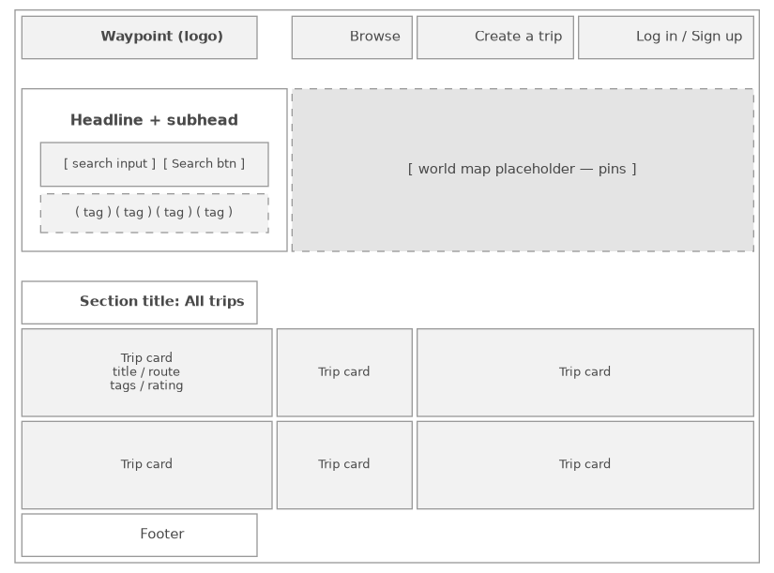
World map as the hero, search + tag filters, trip grid below.

4.2 Trip detail
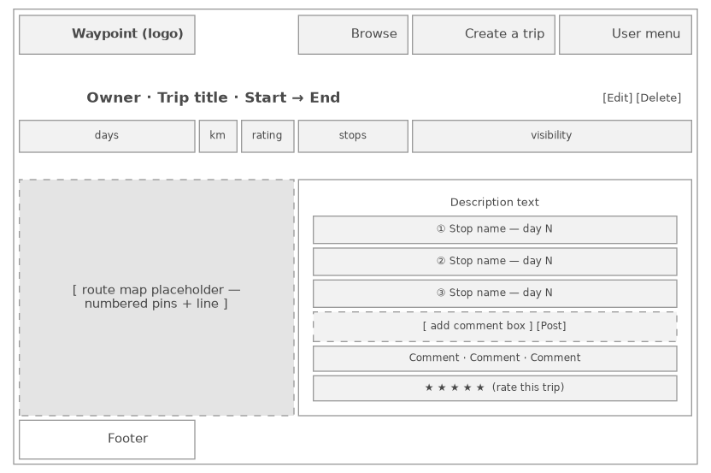
Route map with numbered stops on the left; description, stops, comments and rating on the right.

4.3 Create / edit trip
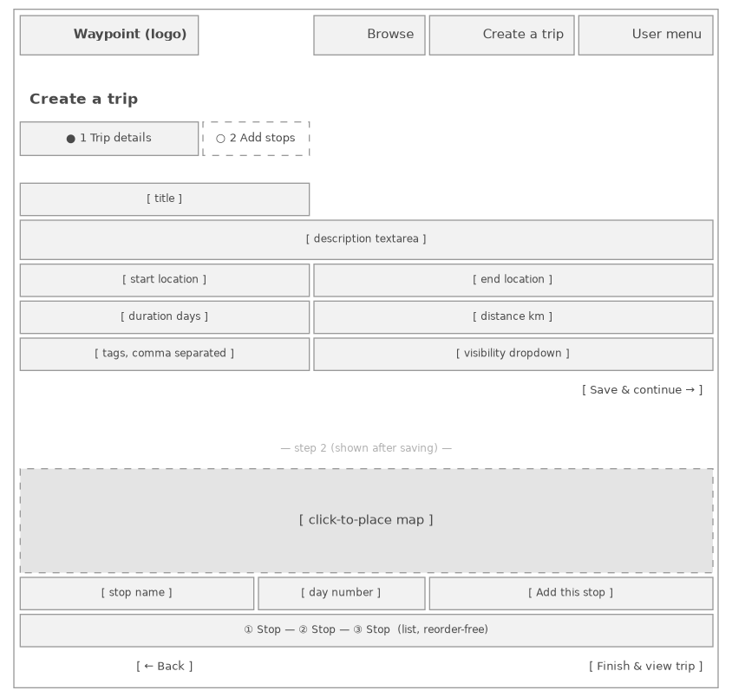
Two-step flow: trip details, then click-to-place stops on a map.

4.4 Login
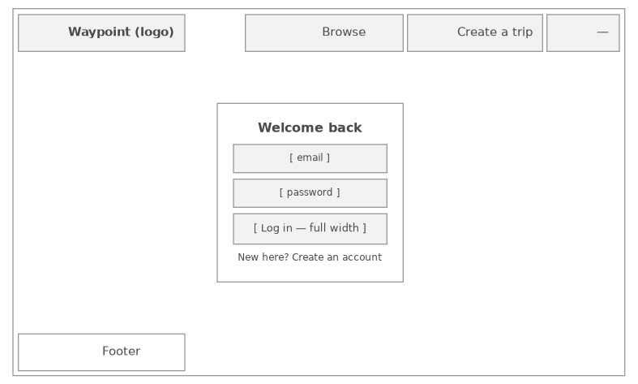
Minimal centred auth card, reused (with different fields) for Sign up.

