PYTHON PROGRAMMING
EXPERIMENT RECORD
10 Beginner-Level Python Experiments

Name: __________________________________________
Roll Number: ___________________________________
Class / Section: _________________________________
Subject: Python Programming
Academic Year: _________________________________

Prepared from the ten Python programs shared in the screenshots.

Contents
Experiment 1: Manufacturing Cost and Profit Analysis
Experiment 2: Travel Budget Calculator
Experiment 3: Shopping Budget Calculator
Experiment 4: Student Performance Comparison
Experiment 5: Number Pattern
Experiment 6: Email Format Validation
Experiment 7: Traffic Flow Analysis
Experiment 8: Examination Eligibility
Experiment 9: Branch Expense Analysis
Experiment 10: Energy Conservation
Each experiment includes: problem statement, objectives, assumptions, algorithm, flowchart, pseudocode, Python code, test cases, sample output and conclusion.

EXPERIMENT 1: Manufacturing Cost and Profit Analysis

1. Problem Statement
Write a Python program to calculate the total manufacturing cost from material, labour and machine costs, and find the profit or loss using the selling price.

2. Objectives
To calculate total cost and profit, and display whether profit has been achieved.

3. Assumptions
- All entered values are whole numbers and are non-negative.
- Selling price and costs are entered in the same currency.

4. Algorithm
1. Start the program.
2. Read material cost, labour cost, machine cost and selling price.
3. Add the three costs to calculate total cost.
4. Subtract total cost from selling price to calculate profit.
5. Display total cost and profit.
6. If profit is greater than zero, display “Profit achieved”; otherwise display “No profit”.
7. Stop.

5. Flowchart
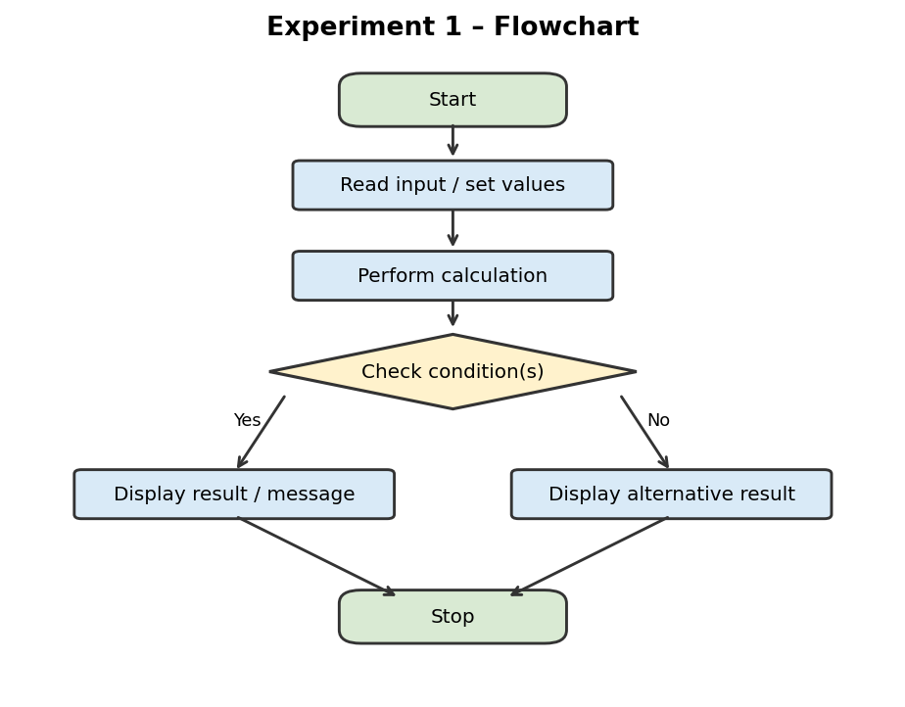
Note: This is a simplified logical flowchart showing the main input, processing, decision and output steps.

6. Pseudocode
START
INPUT material, labour, machine, selling
cost = material + labour + machine
profit = selling - cost
PRINT cost, profit
IF profit > 0: PRINT “Profit achieved”
ELSE: PRINT “No profit”
STOP

7. Python Code
print("Manufacturing Cost")
material = int(input("Enter material cost: "))
labour = int(input("Enter labour cost: "))
machine = int(input("Enter machine cost: "))
selling = int(input("Enter selling price: "))
cost = material + labour + machine
profit = selling - cost
print("Total cost:", cost)
print("Profit:", profit)
if profit > 0:
print("Profit achieved")
else:
print("No profit")

8. Test Cases
Test input (material, labour, machine, selling) | Total cost | Profit | Expected result
1000, 500, 300, 2500 | 1800 | 700 | Profit achieved
1000, 500, 300, 1800 | 1800 | 0 | No profit

9. Sample Output
The following is an illustrative terminal-style preview for the sample test case, not a screenshot captured from a live run.
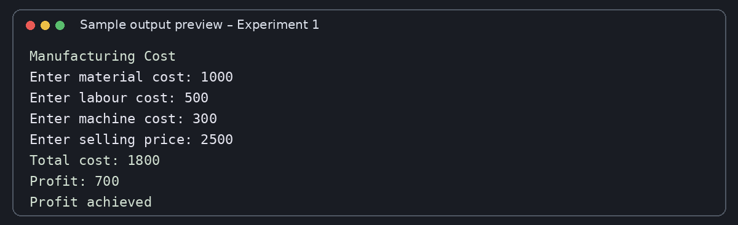

10. Conclusion
The program successfully calculates manufacturing cost and profit. It uses arithmetic operations and an if-else statement to identify whether profit is positive.

EXPERIMENT 2: Travel Budget Calculator

1. Problem Statement
Write a Python program to calculate travel expenses in rupees using hotel, food and transport expenses and an exchange rate, then check whether the total is within the given budget.

2. Objectives
To calculate the total travel expense and compare it with the available budget.

3. Assumptions
- Hotel, food and transport expenses are entered as whole numbers.
- The exchange rate is entered as a whole number, as required by int().
- The converted total and budget are expressed in rupees.

4. Algorithm
1. Start the program.
2. Read hotel, food and transport expenses.
3. Read the exchange rate and budget in rupees.
4. Add the three expenses and multiply the sum by the exchange rate.
5. Display the total expense in rupees.
6. If total expense is less than or equal to the budget, display “Within budget”; otherwise display “Over budget”.
7. Stop.

5. Flowchart
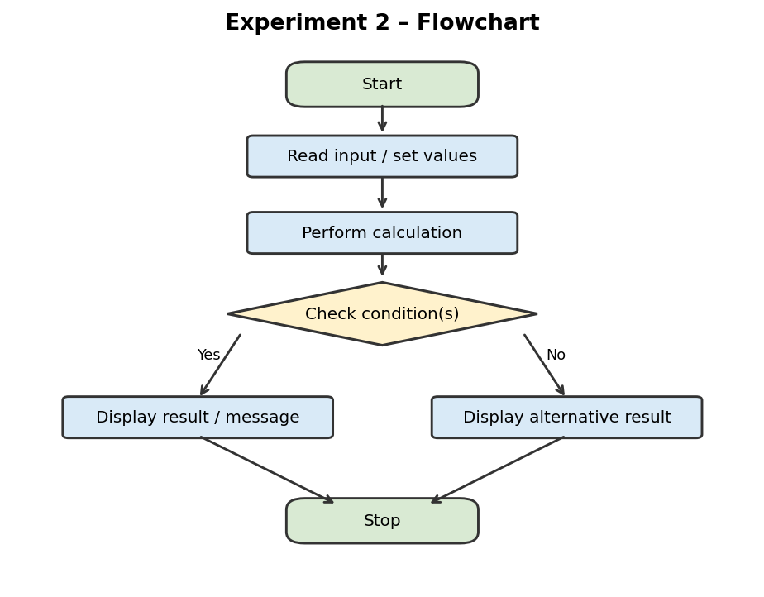
Note: This is a simplified logical flowchart showing the main input, processing, decision and output steps.

6. Pseudocode
START
INPUT hotel, food, transport
INPUT rate, budget
total = (hotel + food + transport) * rate
PRINT total
IF total <= budget: PRINT “Within budget”
ELSE: PRINT “Over budget”
STOP

7. Python Code
print("Travel Budget")
hotel = int(input("Enter hotel expense: "))
food = int(input("Enter food expense: "))
transport = int(input("Enter transport expense: "))
rate = int(input("Enter exchange rate: "))
budget = int(input("Enter budget in rupees: "))
total = (hotel + food + transport) * rate
print("Total expense in rupees:", total)
if total <= budget:
print("Within budget")
else:
print("Over budget")

8. Test Cases
Test input (hotel, food, transport, rate, budget) | Calculated total | Budget | Expected result
100, 50, 30, 80, 16000 | 14400 | 16000 | Within budget
100, 50, 30, 100, 15000 | 18000 | 15000 | Over budget

9. Sample Output
The following is an illustrative terminal-style preview for the sample test case, not a screenshot captured from a live run.
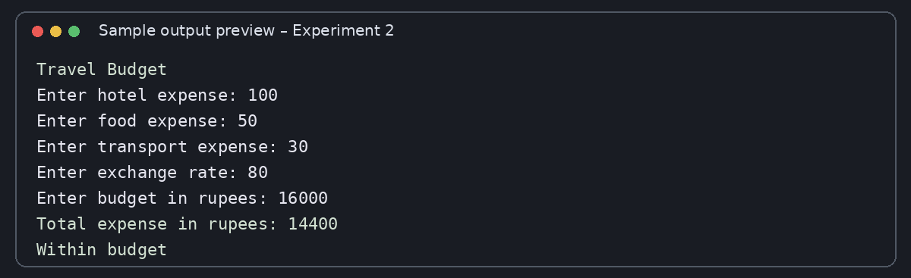

10. Conclusion
The program calculates the converted travel expense and checks it against the budget using an if-else condition.

EXPERIMENT 3: Shopping Budget Calculator

1. Problem Statement
Write a Python program to add the prices of three products and check whether the total price is within the user's budget.

2. Objectives
To calculate the total shopping price and compare it with the budget.

3. Assumptions
- The user enters whole-number product prices and budget.
- All values are in the same currency.

4. Algorithm
1. Start the program.
2. Read the prices of three products.
3. Read the shopping budget.
4. Add the three product prices.
5. Display the total price.
6. If the total is less than or equal to the budget, display “Within budget”; otherwise display “Over budget”.
7. Stop.

5. Flowchart
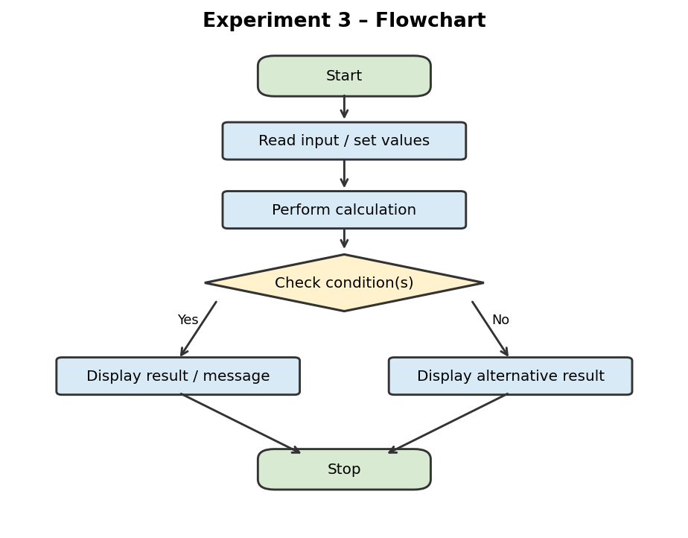
Note: This is a simplified logical flowchart showing the main input, processing, decision and output steps.

6. Pseudocode
START
INPUT p1, p2, p3
INPUT budget
total = p1 + p2 + p3
PRINT total
IF total <= budget: PRINT “Within budget”
ELSE: PRINT “Over budget”
STOP

7. Python Code
print("Shopping Budget")
p1 = int(input("Enter first product price: "))
p2 = int(input("Enter second product price: "))
p3 = int(input("Enter third product price: "))
budget = int(input("Enter your budget: "))
total = p1 + p2 + p3
print("Total price:", total)
if total <= budget:
print("Within budget")
else:
print("Over budget")

8. Test Cases
Test input (p1, p2, p3, budget) | Total price | Budget | Expected result
500, 300, 200, 1200 | 1000 | 1200 | Within budget
500, 400, 300, 1000 | 1200 | 1000 | Over budget

9. Sample Output
The following is an illustrative terminal-style preview for the sample test case, not a screenshot captured from a live run.
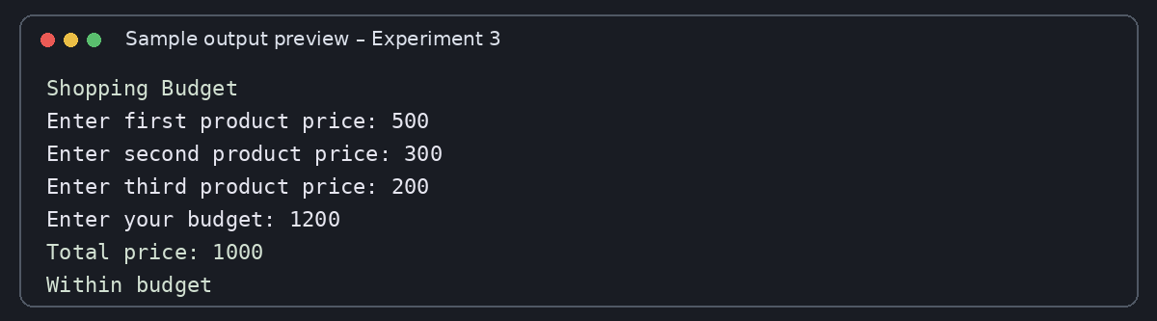

10. Conclusion
The program adds three product prices and determines whether the purchase fits within the given budget.

EXPERIMENT 4: Student Performance Comparison

1. Problem Statement
Write a Python program to compare a student's marks in two exams and display whether the marks improved, decreased or remained the same.

2. Objectives
To find the change in marks between two exams and describe the result.

3. Assumptions
- Marks are entered as whole numbers.
- The two marks are for comparable exams and use the same marking scale.

4. Algorithm
1. Start the program.
2. Read the first exam marks and second exam marks.
3. Calculate the difference by subtracting the first marks from the second marks.
4. Display the change in marks.
5. If the difference is positive, display “Marks improved”.
6. If the difference is negative, display “Marks decreased”.
7. Otherwise, display “Marks remained the same”.
8. Stop.

5. Flowchart
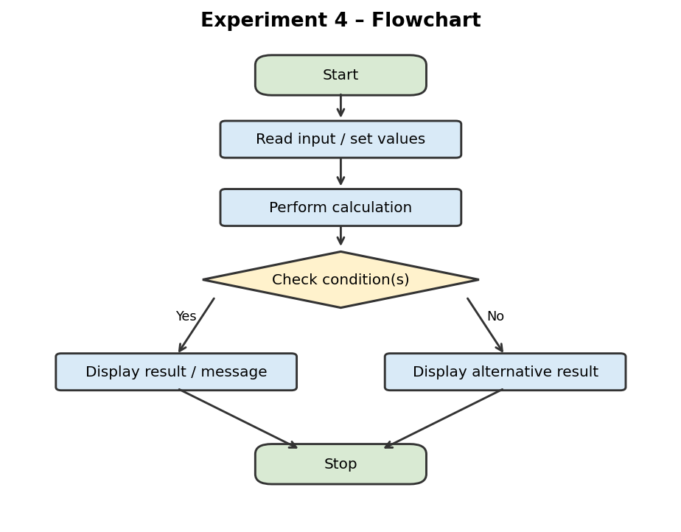
Note: This is a simplified logical flowchart showing the main input, processing, decision and output steps.

6. Pseudocode
START
INPUT mark1, mark2
difference = mark2 - mark1
PRINT difference
IF difference > 0: PRINT “Marks improved”
ELSE IF difference < 0: PRINT “Marks decreased”
ELSE: PRINT “Marks remained the same”
STOP

7. Python Code
print("Student Performance")
mark1 = int(input("Enter first exam marks: "))
mark2 = int(input("Enter second exam marks: "))
difference = mark2 - mark1
print("Change in marks:", difference)
if difference > 0:
print("Marks improved")
elif difference < 0:
print("Marks decreased")
else:
print("Marks remained the same")

8. Test Cases
Test input (mark1, mark2) | Difference | Expected result
60, 75 | 15 | Marks improved
80, 70 | -10 | Marks decreased
70, 70 | 0 | Marks remained the same

9. Sample Output
The following is an illustrative terminal-style preview for the sample test case, not a screenshot captured from a live run.
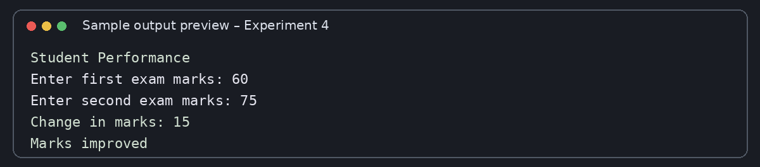

10. Conclusion
The program compares two exam scores and uses if-elif-else conditions to identify the change in performance.

EXPERIMENT 5: Number Pattern

1. Problem Statement
Write a Python program to print an increasing number pattern for a user-specified number of rows.

2. Objectives
To use nested for loops and range() to display a number pattern.

3. Assumptions
- The number of rows entered is a positive integer.
- The pattern starts from 1 in every row and increases up to the row number.

4. Algorithm
1. Start the program.
2. Read the number of rows, n.
3. Run the outer loop from 1 to n.
4. For each row i, run the inner loop from 1 to i.
5. Print j on the same line with a space after it.
6. After the inner loop, move to the next line.
7. Repeat until all rows are printed, then stop.

5. Flowchart
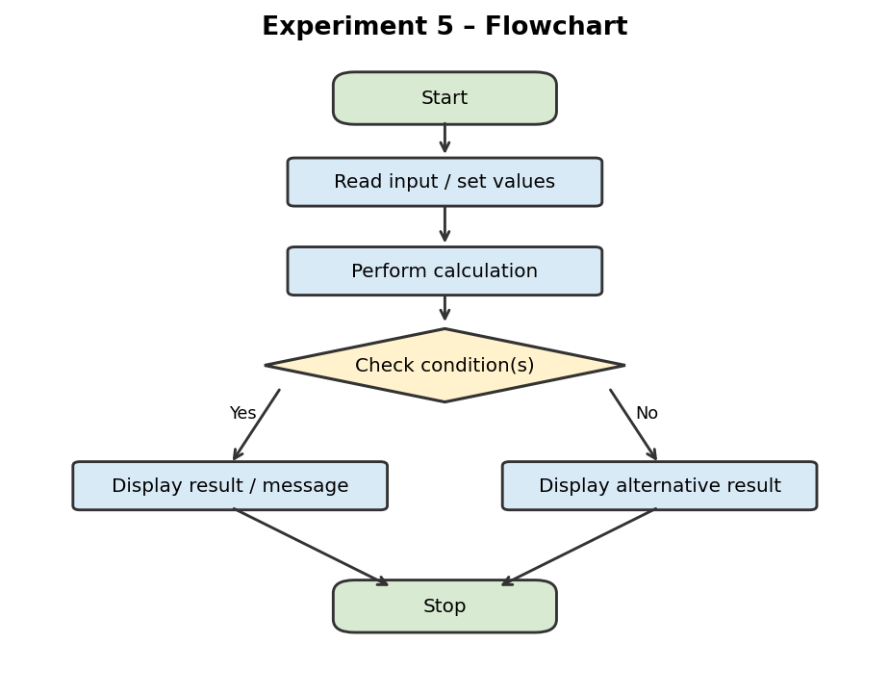
Note: This is a simplified logical flowchart showing the main input, processing, decision and output steps.

6. Pseudocode
START
INPUT n
FOR i = 1 TO n
FOR j = 1 TO i
PRINT j on same line
END FOR
PRINT new line
END FOR
STOP

7. Python Code
print("Number Pattern")
n = int(input("Enter number of rows: "))
for i in range(1, n + 1):
for j in range(1, i + 1):
print(j, end=' ')
print()

8. Test Cases
Test input (n) | Pattern / rows | Expected output
3 | Rows: 3 | 1\n1 2\n1 2 3
4 | Rows: 4 | 1\n1 2\n1 2 3\n1 2 3 4

9. Sample Output
The following is an illustrative terminal-style preview for the sample test case, not a screenshot captured from a live run.
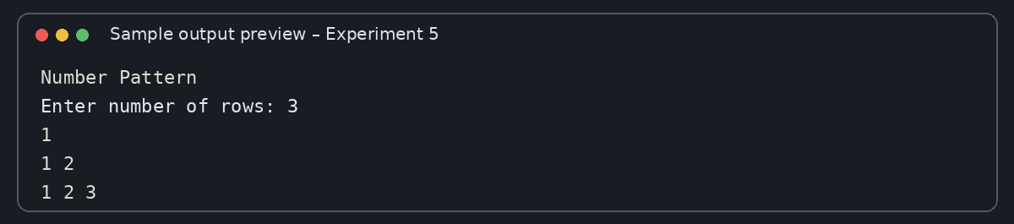

10. Conclusion
The program prints an increasing number pattern by using an outer loop for rows and an inner loop for the numbers in each row.

EXPERIMENT 6: Email Format Validation

1. Problem Statement
Write a Python program to perform a basic check of an email address by checking whether it contains the characters “@” and “.”.

2. Objectives
To practise string membership checking and if-else statements.

3. Assumptions
- The program performs only a simple format check.
- A valid result from this program does not guarantee that the email address exists or is fully valid.

4. Algorithm
1. Start the program.
2. Read an email address as a string.
3. Check whether “@” is present in the email and “.” is present in the email.
4. If both conditions are true, display “Email format looks valid”.
5. Otherwise, display “Invalid email format”.
6. Stop.

5. Flowchart
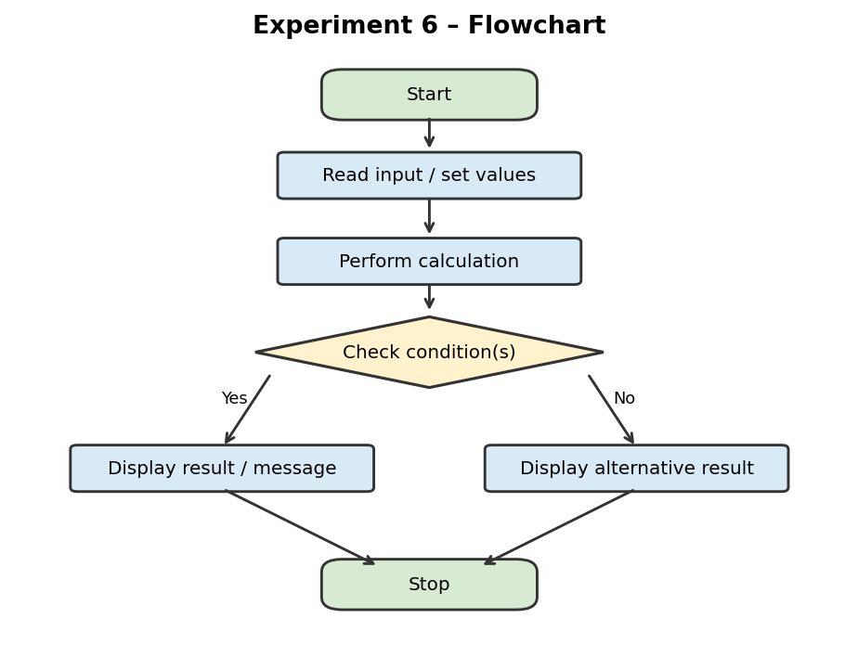
Note: This is a simplified logical flowchart showing the main input, processing, decision and output steps.

6. Pseudocode
START
INPUT email
IF '@' in email AND '.' in email
PRINT “Email format looks valid”
ELSE
PRINT “Invalid email format”
STOP

7. Python Code
print("Email Validation")
email = input("Enter email: ")
if "@" in email and "." in email:
print("Email format looks valid")
else:
print("Invalid email format")

8. Test Cases
Test input (email) | Expected output
student@example.com | Email format looks valid
studentexample.com | Invalid email format
student@examplecom | Invalid email format

9. Sample Output
The following is an illustrative terminal-style preview for the sample test case, not a screenshot captured from a live run.
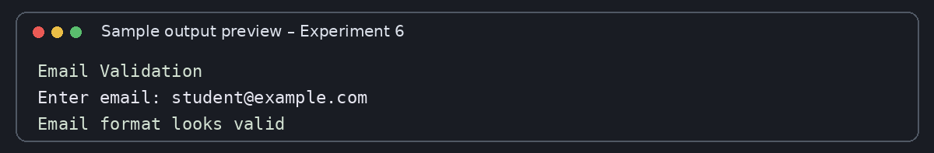

10. Conclusion
The program checks for the presence of “@” and “.” in the entered text. It is a beginner-level check, not a complete email validation system.

EXPERIMENT 7: Traffic Flow Analysis

1. Problem Statement
Write a Python program to classify traffic as low, medium or high based on the number of vehicles.

2. Objectives
To classify a vehicle count using if-elif-else conditions.

3. Assumptions
- The vehicle count is entered as a non-negative whole number.
- Fewer than 50 vehicles means low traffic; 50 to 99 means medium traffic; 100 or more means high traffic.

4. Algorithm
1. Start the program.
2. Read the number of vehicles.
3. If the number is less than 50, display “Low traffic”.
4. Otherwise, if the number is less than 100, display “Medium traffic”.
5. Otherwise, display “High traffic”.
6. Stop.

5. Flowchart
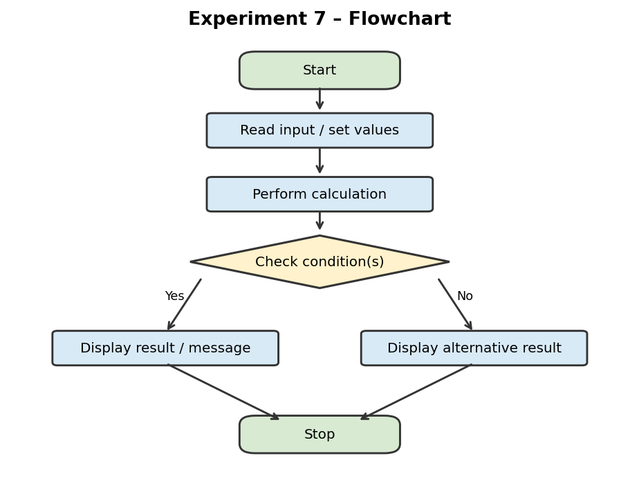
Note: This is a simplified logical flowchart showing the main input, processing, decision and output steps.

6. Pseudocode
START
INPUT vehicles
IF vehicles < 50: PRINT “Low traffic”
ELSE IF vehicles < 100: PRINT “Medium traffic”
ELSE: PRINT “High traffic”
STOP

7. Python Code
print("Traffic Flow Analysis")
vehicles = int(input("Enter number of vehicles: "))
if vehicles < 50:
print("Low traffic")
elif vehicles < 100:
print("Medium traffic")
else:
print("High traffic")

8. Test Cases
Test input (vehicles) | Expected output
35 | Low traffic
75 | Medium traffic
120 | High traffic

9. Sample Output
The following is an illustrative terminal-style preview for the sample test case, not a screenshot captured from a live run.
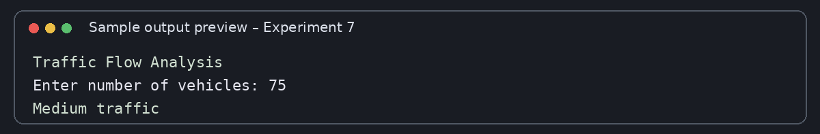

10. Conclusion
The program classifies traffic into three levels using two comparison conditions and an else branch.

EXPERIMENT 8: Examination Eligibility

1. Problem Statement
Write a Python program to check whether a student is eligible for an examination based on attendance and internal marks.

2. Objectives
To apply the logical AND operator to check two eligibility conditions together.

3. Assumptions
- Attendance is entered as a percentage from 0 to 100.
- Internal marks are entered as a whole number.
- The student must have attendance of at least 75 and internal marks of at least 40.

4. Algorithm
1. Start the program.
2. Read attendance and internal marks.
3. Check whether attendance is greater than or equal to 75 AND marks are greater than or equal to 40.
4. If both conditions are true, display “Eligible for exam”.
5. Otherwise, display “Not eligible for exam”.
6. Stop.

5. Flowchart
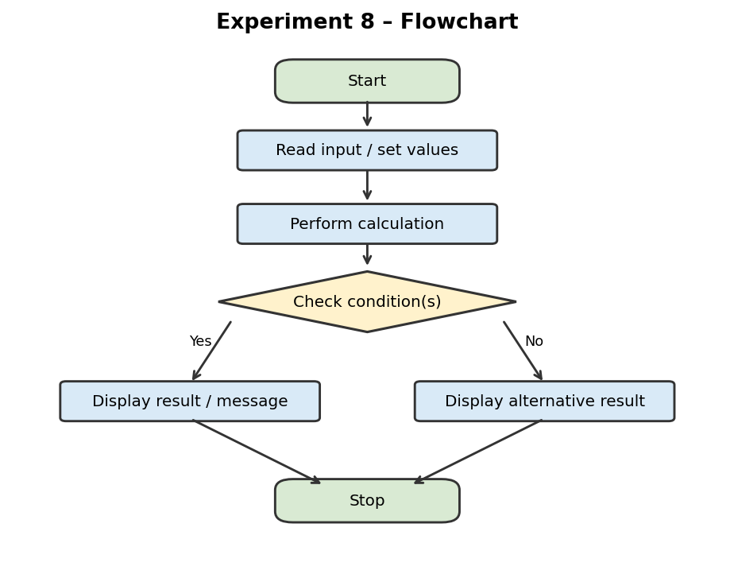
Note: This is a simplified logical flowchart showing the main input, processing, decision and output steps.

6. Pseudocode
START
INPUT attendance, marks
IF attendance >= 75 AND marks >= 40
PRINT “Eligible for exam”
ELSE
PRINT “Not eligible for exam”
STOP

7. Python Code
print("Examination Eligibility")
attendance = int(input("Enter attendance: "))
marks = int(input("Enter internal marks: "))
if attendance >= 75 and marks >= 40:
print("Eligible for exam")
else:
print("Not eligible for exam")

8. Test Cases
Test input (attendance, marks) | Expected output
80, 45 | Eligible for exam
70, 45 | Not eligible for exam
80, 35 | Not eligible for exam

9. Sample Output
The following is an illustrative terminal-style preview for the sample test case, not a screenshot captured from a live run.
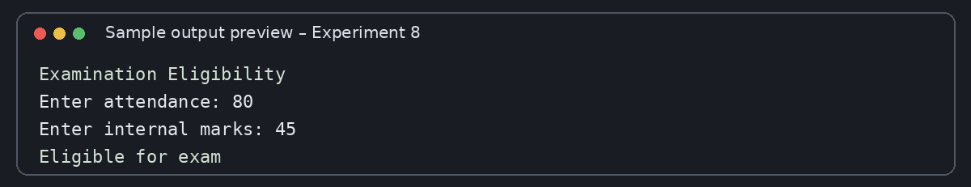

10. Conclusion
The program checks both attendance and internal marks together using the logical AND operator.

EXPERIMENT 9: Branch Expense Analysis

1. Problem Statement
Write a Python program to calculate and compare the total expenses and average expenses of two branches using three expense values for each branch.

2. Objectives
To use lists, sum() and arithmetic comparisons to analyse branch expenses.

3. Assumptions
- Each branch has exactly three expense entries.
- All expense values are non-negative numbers.
- The average is calculated by dividing the total by 3.

4. Algorithm
1. Start the program.
2. Create a list containing three expenses for Branch 1 and another list for Branch 2.
3. Calculate the total of each list using sum().
4. Display both totals.
5. Calculate and display each branch's average by dividing its total by 3.
6. Compare the totals and display which branch has higher expenses, or state that they are equal.
7. Stop.

5. Flowchart
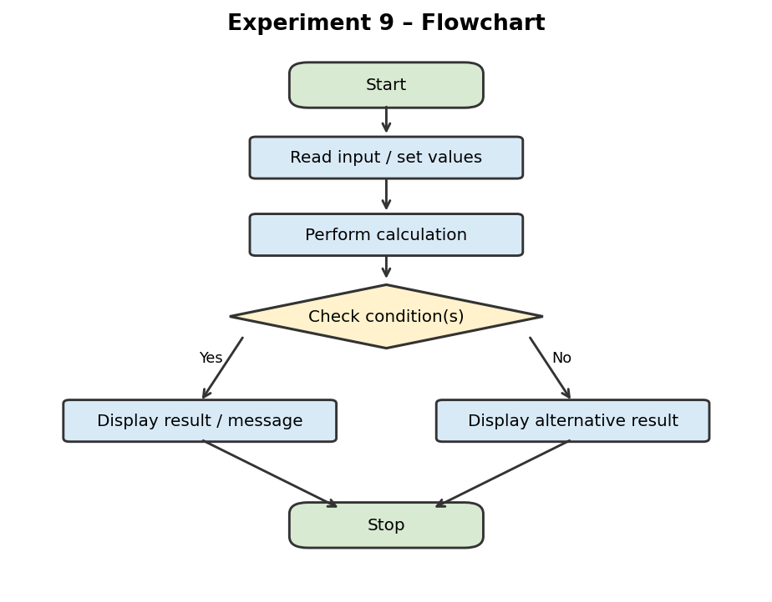
Note: This is a simplified logical flowchart showing the main input, processing, decision and output steps.

6. Pseudocode
START
branch1 = [1000, 2000, 1500]
branch2 = [2500, 3000, 2000]
total1 = SUM(branch1)
total2 = SUM(branch2)
PRINT totals and averages (total / 3)
IF total1 > total2: PRINT Branch 1 higher
ELSE IF total2 > total1: PRINT Branch 2 higher
ELSE: PRINT equal expenses
STOP

7. Python Code
print("Branch Expense Analysis")
branch1 = [1000, 2000, 1500]
branch2 = [2500, 3000, 2000]
total1 = sum(branch1)
total2 = sum(branch2)
print("Branch 1 total:", total1)
print("Branch 2 total:", total2)
print("Branch 1 average:", total1 / 3)
print("Branch 2 average:", total2 / 3)
if total1 > total2:
print("Branch 1 has higher expenses")
elif total2 > total1:
print("Branch 2 has higher expenses")
else:
print("Both branches have equal expenses")

8. Test Cases
Test input | Totals / averages | Expected result
Given lists: [1000, 2000, 1500] and [2500, 3000, 2000] | 4500; 7500 | 1500.0; 2500.0 | Branch 2 has higher expenses

9. Sample Output
The following is an illustrative terminal-style preview for the sample test case, not a screenshot captured from a live run.
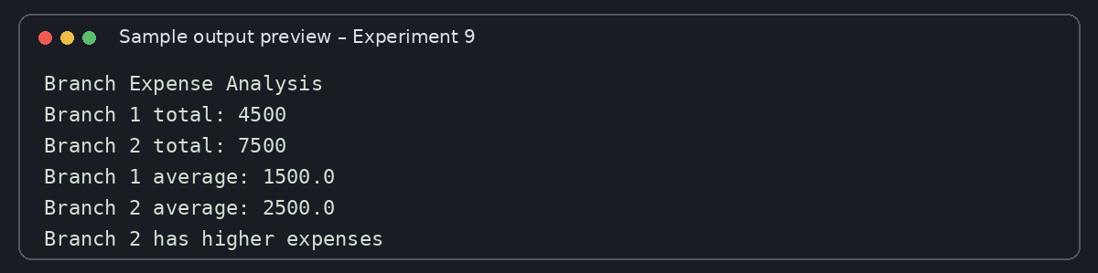

10. Conclusion
The program calculates totals and averages for two branches and compares their total expenses.

EXPERIMENT 10: Energy Conservation

1. Problem Statement
Write a Python program to calculate electricity saved by comparing energy usage before and after conservation measures.

2. Objectives
To calculate the difference between two usage values and check whether energy has been saved.

3. Assumptions
- Before and after usage are entered as whole numbers.
- Both values use the same unit and represent comparable periods.
- A positive difference indicates energy saved.

4. Algorithm
1. Start the program.
2. Read energy usage before and after conservation.
3. Subtract after usage from before usage.
4. Display the electricity saved.
5. If the saved value is greater than zero, display “Energy saved”.
6. Otherwise, display “No energy saved”.
7. Stop.

5. Flowchart
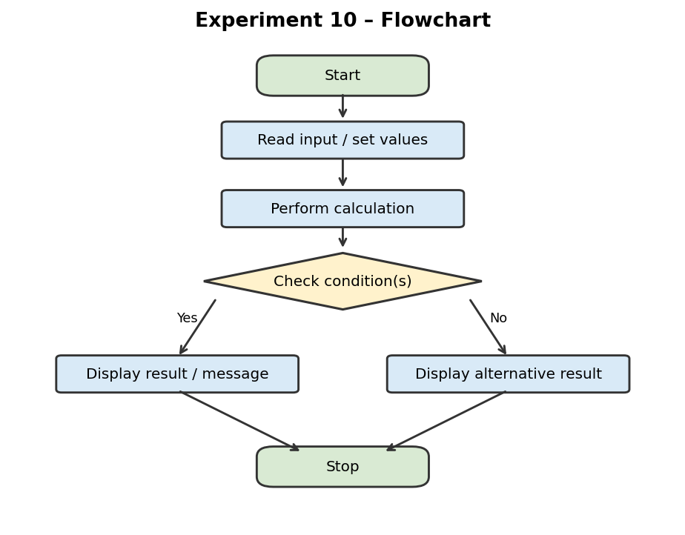
Note: This is a simplified logical flowchart showing the main input, processing, decision and output steps.

6. Pseudocode
START
INPUT before, after
saved = before - after
PRINT saved
IF saved > 0: PRINT “Energy saved”
ELSE: PRINT “No energy saved”
STOP

7. Python Code
print("Energy Conservation")
before = int(input("Enter before usage: "))
after = int(input("Enter after usage: "))
saved = before - after
print("Electricity saved:", saved)
if saved > 0:
print("Energy saved")
else:
print("No energy saved")

8. Test Cases
Test input (before, after) | Saved value | Expected result
500, 350 | 150 | Energy saved
400, 400 | 0 | No energy saved
300, 350 | -50 | No energy saved

9. Sample Output
The following is an illustrative terminal-style preview for the sample test case, not a screenshot captured from a live run.
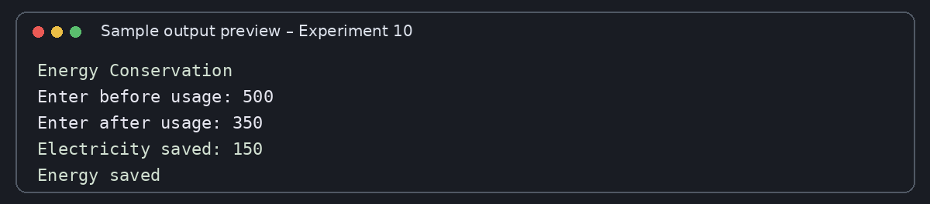

10. Conclusion
The program calculates the difference between before and after usage. A positive result indicates that electricity usage has decreased.

APPENDIX: ORIGINAL CODE SCREENSHOTS
These are the screenshots supplied with the request. They show the Python source code in the editor. The sample output previews in each experiment section are illustrative; capture actual terminal output in your Python IDE if your instructor specifically requires real execution screenshots.

Experiment 1 – Code editor screenshot
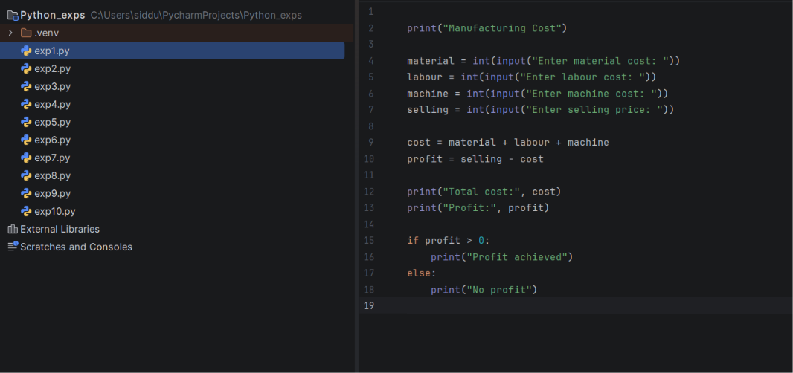

Experiment 2 – Code editor screenshot
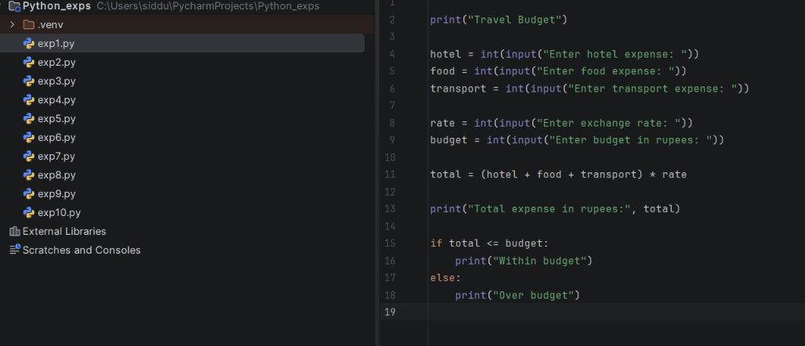

Experiment 3 – Code editor screenshot
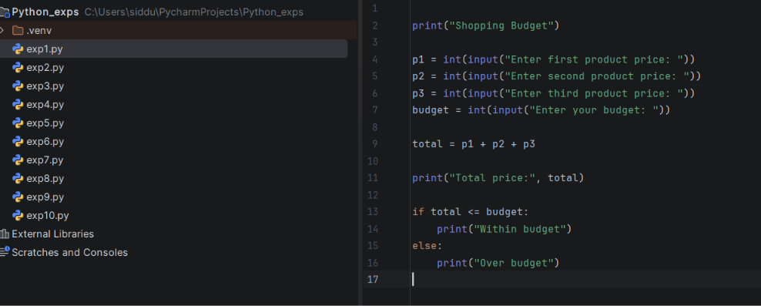

Experiment 4 – Code editor screenshot
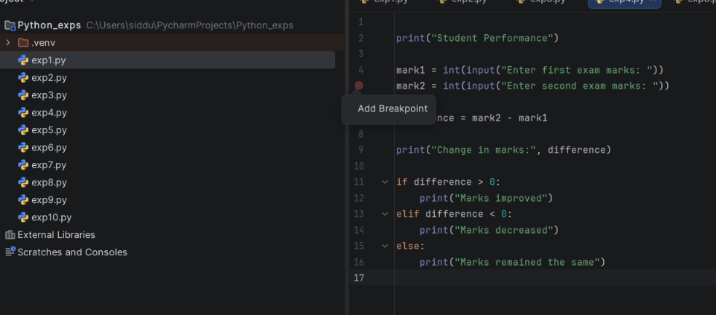

Experiment 5 – Code editor screenshot
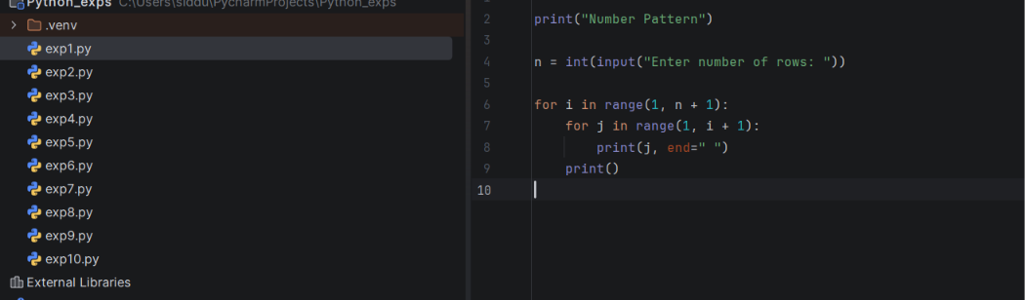

Experiment 6 – Code editor screenshot
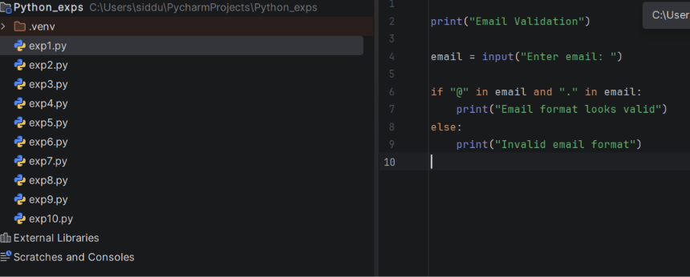

Experiment 7 – Code editor screenshot
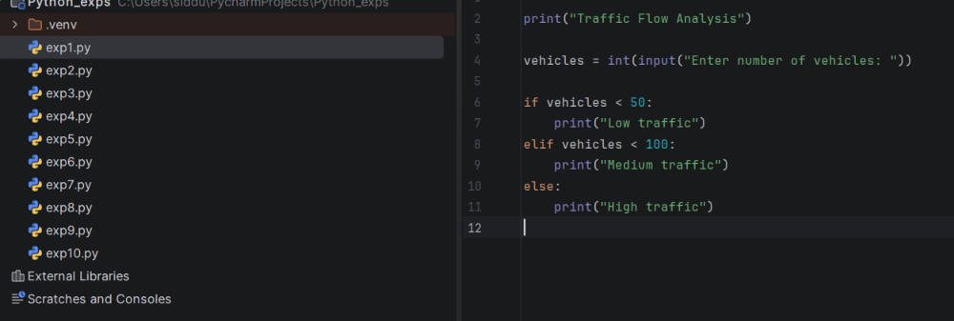

Experiment 8 – Code editor screenshot
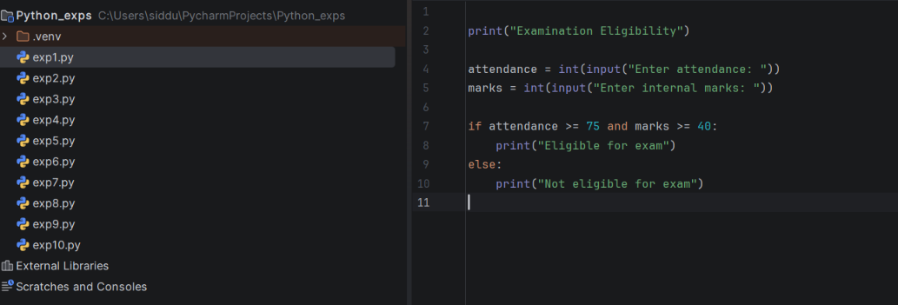

Experiment 9 – Code editor screenshot
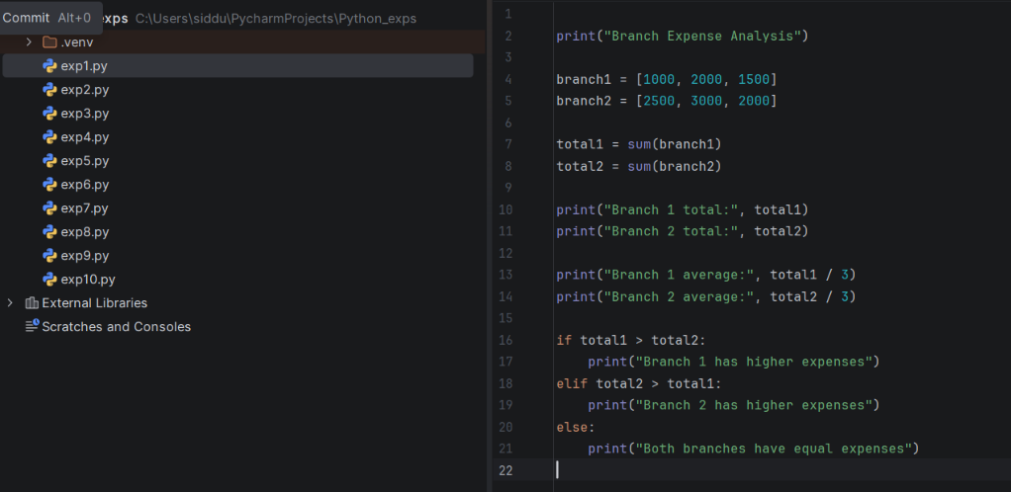

Experiment 10 – Code editor screenshot
