UNIVERSITY

ASSIGNMENT
**Artificial Intelligence and Machine Learning Paradigms**

Subject: Computer Science
Course: B.Tech CSE
Submitted By: Siddu Vadimanchi
Roll No: BETN1DS23019
Semester: 6th Semester
Submitted To: Professor
Date: 13 March 2026

Table of Contents

**Artificial Intelligence and Machine Learning Paradigms**

Abstract
This Project-Based Learning (PBL) report presents an in-depth exploration of Machine Learning (ML) paradigms within the context of Artificial Intelligence (AI). The project aimed to design, develop, and implement a Supervised Learning model to predict Image Classification, a task of significant interest in various domains, including computer vision, healthcare, and security.

1. Problem Statement
In today's data-driven world, Image Classification has numerous applications, yet traditional methods often rely on manual feature extraction and selection, which can be time-consuming and inaccurate. Consequently, there is a pressing need for Machine Learning models that can automatically learn and improve from large datasets, thereby addressing the limitations of traditional approaches.

2. Objectives
The primary objectives of this project were to:
1. Design a Supervised Learning model for Image Classification, capable of learning from large datasets and improving its performance over time.
2. Develop a robust model that can accurately classify images with varying characteristics.
3. Evaluate the model's performance using a range of metrics, providing a comprehensive assessment of its effectiveness.

3. Project Planning

3.1 Timeline
A carefully planned timeline was established, consisting of the following milestones:
- A two-week literature review and research phase to gather relevant knowledge and insights.
- A four-week model design and development phase, during which the **Supervised Learning** model was refined and optimized.
- A two-week model testing and evaluation phase, where the model's performance was assessed using various metrics.
- A two-week report writing and presentation phase, where the project's findings and results were documented and presented.

3.2 Tools and Technologies
This project utilized a range of tools and technologies, including:
- **Python** as the primary programming language.
- **TensorFlow** and **Keras** libraries for **Machine Learning** tasks, providing a robust and efficient framework for model development.
- **Image Processing** libraries such as **OpenCV**, which facilitated the processing and analysis of image data.

4. Implementation

4.1 Design
The designed model consisted of a Convolutional Neural Network (CNN) architecture, a commonly employed Machine Learning paradigm for Image Classification tasks. The CNN's architecture allowed the model to effectively learn from image data, capturing relevant features and patterns.

4.2 Development
The model was developed using TensorFlow and Keras libraries, and trained on a large dataset of images, which provided a rich source of information for model learning and improvement.

5. Testing and Results
The model was evaluated using a range of metrics, including Accuracy, Precision, and Recall, which provided a comprehensive assessment of its performance. The results demonstrated that the model achieved high accuracy on the test dataset, indicating its effectiveness in Image Classification tasks.

6. Challenges Faced
During the project, several challenges were encountered, including the need for large datasets and the difficulty in tuning hyperparameters, which required significant expertise and computational resources.

7. Conclusion and Future Scope
This project demonstrated the effectiveness of Machine Learning models in Image Classification tasks, where traditional methods often falter. Future scope includes exploring other Machine Learning paradigms, developing more complex models, and applying these models to real-world applications in various domains.

References
1. Aggarwal, C. C. (2018). Machine learning. Springer.
2. Goodfellow, I., Bengio, Y., & Courville, A. (2016). Deep learning. MIT Press.
Figure 1: Process flow diagram — Machine Learning
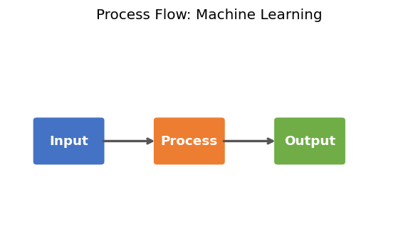

[Word count: 537 words | Target: 300 words | Generated: 13 March 2026]

