For the production of a Diagnostic tool for identifying a certain disease, there is a membrane at the heart of the setup which is loaded with chemical moieties (Biomarkers) that characteristically identify the patient’s Human serum sample as either **True** or **False**.

In this system, Human serum is manually pipetted and filled at the sides of the electrochemical chamber and then a Picoammeter/Voltage source (**Keithley 6487)** turned on to perform some volumetric readings, that is record the current through the system with a triangular(or any waveform) voltage applied from -1 to 1 V.

**Fig. 1: This explains the measurement setup where in Human serum is filled on the sides of the chambers and a cathode and anode are manually inserted and then Voltage source is turned on to take the readings**.

One problem in the system is that it is highly manual in nature which is highly inefficient for producing large amount of samples, testing on large scale and also several human errors are introduced. Therefore, automation is the key to solve this problem.

In order to automate this process, we plan to integrate a Robotic arm - Auto sampler CTC Pal HTS to do the Pipetting and handling of the chemicals to fill the electrolytic chambers on the side. This Auto sampler should automatically trigger the Voltage source to take the readings, acquire and process the data and store it in a common shared cloud folder.

We would be utilizing an Arduino to accomplish this. The whole project is undertaken by me to realize better research output in my lab.

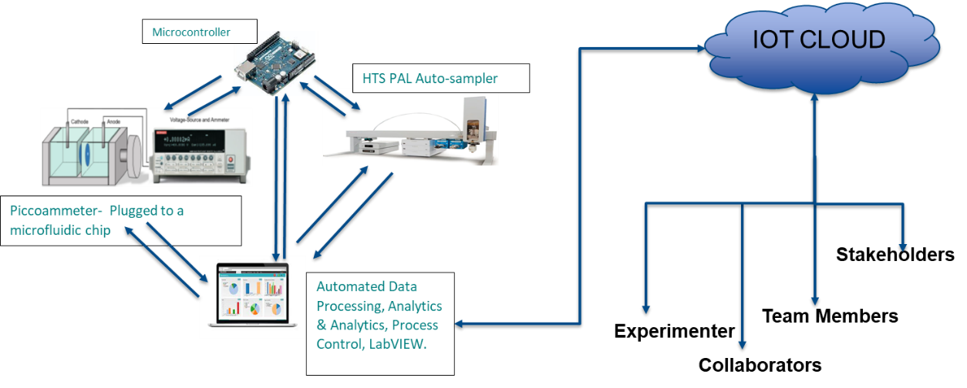

**Fig. 2: Schematics of the proposed system.**

**User Experience:**

1. The User utilizes a LabVIEW interface/user form created to interact with the system and also the CTC PAL auto sampler has its own software (Cycle composer) to give commands to perform in the lab.
2. When the user appends commands to do in a sequence and as soon as the serum is physically filled in the chamber, the Voltage source is triggered to do the reading.
3. Also the finished reading is stored as notepad file in a specified OneDrive folder.
4. When all the readings are done, the data is processed and several calculations are done on it to generate a file excel report in the same OneDrive folder.
5. The system should be able to be handled remotely.

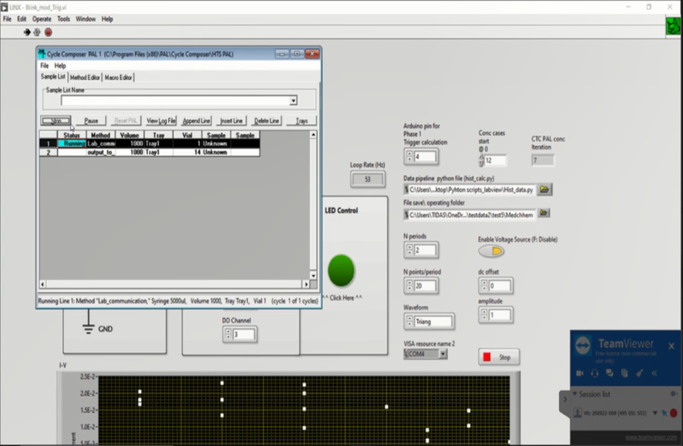

**Fig. 3: User form to interact with for the User.**