For the production of a Diagnostic tool for identifying a certain disease, there is a membrane at the heart of the setup which is loaded with chemical moieties (Biomarkers) that characteristically identify the patient’s Human serum sample as either **True** or **False**.

In this system, Human serum is manually pipetted and filled at the sides of the electrochemical chamber and then a Picoammeter/Voltage source (**Keithley 6487)** turned on to perform some volumetric readings, that is record the current through the system with a triangular(or any waveform) voltage applied from -1 to 1 V.

**Fig. 1: This explains the measurement setup where in Human serum is filled on the sides of the chambers and a cathode and anode are manually inserted and then Voltage source is turned on to take the readings**.

|  |  |  |  |
| --- | --- | --- | --- |
| Design options | 1. Rasberry Pi + Ethernet   (Sockets) | 1. Arduino + Serial-I2C communication | Arduino + Ethernet (Socket) |
| Cost | USD 50 | USD 50 | USD 50 |
| Size | small | small | Small |
| Difficulty | Hard | Hard | Hard |
| Knowledge | Knowledge from course | Knowledge from course | Knowledge from course |
| Security | Possible issues | Possible issues | Possible issues |
| Time | Fast | Fast | Fast |
| I/O Pins | >10 | >10 | >10 |
| User Friendliness | Low | High | Low |

One problem in the system is that it is highly manual in nature which is highly inefficient for producing large amount of samples, testing on large scale and also several human errors are introduced. Therefore, automation is the key to solve this problem.

In order to automate this process, we plan to integrate a Robotic arm - Auto sampler CTC Pal HTS to do the Pipetting and handling of the chemicals to fill the electrolytic chambers on the side. This Auto sampler should automatically trigger the Voltage source to take the readings, acquire and process the data and store it in a common shared cloud folder.

We would be utilizing an Arduino to accomplish this. The whole project is undertaken by me to realize better research output in my lab.

Option 2 is chosen since it most user friendly option in this case to establish, it can easily be linked with LabVIEW Modules so that the end user(i.e Chemists) do not have to deal with the backend code environment or Linux environment. Instead a Windows based Graphic user interface can be easily realized for which Chemists can easily be trained to use a mouse and User form to design complex experimental lab tasks as well as take measurements.

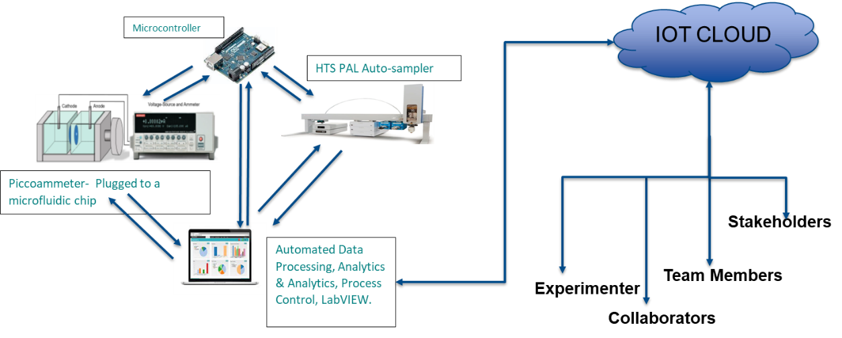

**Fig. 2: Schematics of the proposed system.**