1. 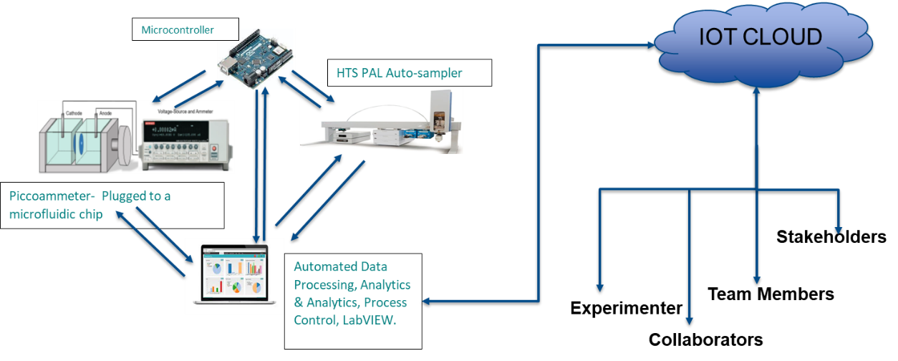**Component Testing :**

Figure 1: Schematics of the proposed system.

1. HTS PAL Autosampler: Test HTS Pal Autosampler with varied commands from the software downloaded on the software.
2. Keithley Model 6487 (Voltage Source): Develop and set up SCPI program commands to configure, zero check and run a voltage sweep on Tektronix Keithley 6487 picoammeter/voltage source. Developed the LABVIEW script to integrate voltage sweep based on input from the user along a set a amplitude, current range and setup.
3. Arduino Testing: Set up and developed instrumentation to trigger protocol to establish back & forth communication between CTC PAL and Keithley 6487 based on CTC protocols to trigger and attain an overall synchronized system using I2C/ seriel communication . Also, significant troubleshooting for exception system scenarios is accounted for and implemented.
4. Automatic Saving: Design of automated trigger signal based saving of data readings in a nomenclature way with option to store as TXT, CSV or MySQL file. Subsequent integration with LabVIEW and Hardware.
5. Automatic Data Accumulator: Automated trigger based Data querying protocol for Data implementation, aggregation, normalization and Conversion. Subsequent integration with LabVIEW and Hardware.
6. **Integration Testing:**
7. Automated Data Engineering for ML: Extracting, Processing, Calculation and Reporting of 10 + Machine learning features from the accumulated data into a data frame format that can be stored as TXT,CSV or MySQL file. This requires the scripting a custom calculation library named ‘Hysteresis’. Subsequent integration with LabVIEW, Arduino Software and Hardware.
8. Overall Integration Testing: Overall integration and synchronization of setup with LabVIEW, Arduino, Arduino IDE and Hardware. This overall system is tested, implemented and validated.