USE CASE- Add New Loans SPECIFICATION

Use-case No. | UC BL.1 | Use-case Version |  | 1.0
Use-case Name | Add New Loans
Author | LinhLLL
Date | 08/09/2012 | Priority | High
Actor:
User
Summary:
User can add new loan.
Goal:
Allow user input detail information of loan.
Triggers
Touch “Vay nợ” icon, thirst icon at the bottom of screen.
Preconditions:
Accessed to application
Post Conditions:
<List the required post-conditions for using this case>
Main Success Scenario:

Step | Actor action | System response
1 | Touch “Vay nợ” icon, thirst icon at the bottom of screen | Display “Vay” tab includes list of borrowing money
2 | Touch create icon at the top- right of screen | Display create screen
3 | Enter data into mandatory fields | Display all entered data  - If entered name is not available in mobile contact, display pop-up to add new contact
4 | Touch save icon at the top- right of screen | - Return “Vay” screen  - Show message: “Saved”  - Display all saved data

Step | Actor action | System response
1 | Touch “Vay nợ” icon, thirst icon at the bottom of screen | Display “Vay” tab includes list of borrowing money
2 | Touch create icon at the top- right of screen | Display create screen
3 | Enter data into mandatory fields | Display all entered data
4 | Touch cancel icon besides save icon | - Return “Vay” screen  - Nothing is added

Alternative Scenario:
Step | Actor action | System response
1 | Touch “Vay nợ” icon, thirst icon at the bottom of screen | Display “Vay”tab includes list of borrowing money
2 | Touch create icon at the top- right of screen | Display create screen
3 | Touch “Vay” toggle | Change “Vay” to “Cho vay”
4 | Enter data into all fields | Display all entered data  - If entered name is available in mobile contact, system can be automatic display phone number and address
5 | Touch save icon at the top- right of screen | - Return “Vay” screen  - Show message: “Saved”  - Display all saved data

Exceptions:
Step | Actor action | System response
1 | Touch “Vay nợ” icon, thirst icon at the bottom of screen | Display “Vay”tab includes list of borrowing money
2 | Touch create icon at the top- right of screen | Display create screen
3 | Touch “Vay” toggle | Change “Vay” to “Cho vay”
4 | Enter data into all fields except “Ngày bắt đầu” và “Ngày đáo hạn” field | Display all entered data  - If entered name is available in mobile contact, system can be automatic display phone number and address
5 | Touch save icon at the top- right of screen | - Show message: “Bạn phải nhập ngày đáo hạn!”  - Return create screen

Step | Actor action | System response
1 | Touch “Vay nợ” icon, thirst icon at the bottom of screen | Display “Vay”tab includes list of borrowing money
2 | Touch create icon at the top- right of screen | Display create screen
3 | Touch “Vay” toggle | Change “Vay” to “Cho vay”
4 | Enter data into all fields except “Lãi suất” và “Ngày đáo hạn” field | Display all entered data  - If entered name is available in mobile contact, system can be automatic display phone number and address
5 | Touch save icon at the top- right of screen | - Return “Vay” screen  - Show message: “Saved”  - Display all saved data

Relationships:
Business Rules:
No | Rule Description
1 | In order to add borrowing money, user must accessed application
2 | In order to save data, user must enter data into mandatory field

Screen:
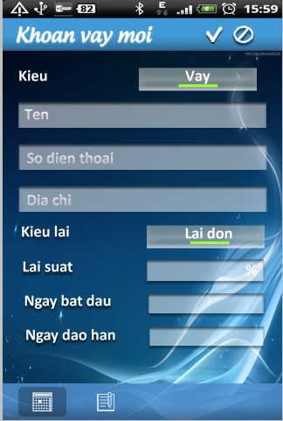

USE CASE- Edit Loans SPECIFICATION

Use-case No. | UC BL.2 | Use-case Version |  | 1.0
Use-case Name | Edit Loans
Author | LinhLLL
Date | 08/09/2012 | Priority | High
Actor:
User
Summary:
User can edit information of loan.
Goal:
Allow user edit detail information of loan.
Triggers
Touch “Vay nợ” icon, thirst icon at the bottom of screen.
Preconditions:
Accessed to application
Post Conditions:
<List the required post-conditions for using this case>
Main Success Scenario:

Step | Actor action | System response
1 | Touch “Vay nợ” icon, thirst icon at the bottom of screen | Display “Vay”tab includes list of borrowing money
2 | Choose one borrowing money in list of borrowing money | Display detail information screen
3 | Touch edit icon at the top- right of screen | Display edit screen
4 | Change all of data in fields | Display all data is changed
5 | Touch save icon at the top- right of screen | - Return “Vay” screen  - Show message: “Saved”  - Display all saved data

Step | Actor action | System response
1 | Touch “Vay nợ” icon, thirst icon at the bottom of screen | Display “Vay”tab includes list of borrowing money
2 | Choose one borrowing money in list of borrowing money | Display detail information screen
3 | Touch edit icon at the top- right of screen | Display edit screen
4 | Change all of data in fields | Display all data is changed
5 | Touch cancel icon besides save icon | - Return “Vay” screen  - Nothing is changed

Alternative Scenario:
Step | Actor action | System response
1 | Touch “Vay nợ” icon, thirst icon at the bottom of screen | Display “Vay”tab includes list of borrowing money
2 | Choose one borrowing money in list of borrowing money | Display detail information screen
3 | Touch edit icon at the top- right of screen | Display edit screen
4 | Touch “Vay” toggle | Change “Vay” to “Cho vay”
5 | Change data in all fields | Display all changed data
6 | Touch save icon at the top- right of screen | - Return “Vay” screen  - Show message: “Saved”  - Display all saved data

Step | Actor action | System response
1 | Touch “Vay nợ” icon, thirst icon at the bottom of screen | Display “Vay”tab includes list of borrowing money
2 | Choose one borrowing money in list of borrowing money | Display detail information screen
3 | Touch edit icon at the top- right of screen | Display edit screen
4 | Clear data in “Lãi suất” field | “Lãi suất” is empty field
5 | Clear data in “Ngày đáo hạn” | “Ngày đáo hạn” is empty field
6 | Touch save icon at the top- right of screen | - Return “Vay” screen  - Show message: “Saved”  - Display all saved data

Exceptions:
Step | Actor action | System response
1 | Touch “Vay nợ” icon, thirst icon at the bottom of screen | Display “Vay”tab includes list of borrowing money
2 | Touch create icon at the top- right of screen | Display create screen
3 | Touch “Vay” toggle | Change “Vay” to “Cho vay”
4 | Clear data in one of field below:  - “Tên”  - “Tổng tiền”  - “Ngày bắt đầu”  - “Ngày kết thúc” | Display all empty field
5 | Touch save icon at the top- right of screen | - Display message:”Xin hãy nhập dữ liệu vào các ô đang bị bỏ trống! Xin cảm ơn!”

Step | Actor action | System response
1 | Touch “Vay nợ” icon, thirst icon at the bottom of screen | Display “Vay”tab includes list of borrowing money
2 | Choose one borrowing money in list of borrowing money | Display detail information screen
3 | Touch edit icon at the top- right of screen | Display edit screen
5 | Clear data in “Ngày đáo hạn” | “Ngày đáo hạn” is empty field
6 | Touch save icon at the top- right of screen | - Show message:”Để tính được lãi suất bạn phải nhập vào ngày đáo hạn!”

Relationships:
UC BL.1, UC BL.4
Business Rules:

No | Rule Description
1 | In order to add borrowing money, user must accessed application
2 | In order to save data, user must enter data into mandatory field

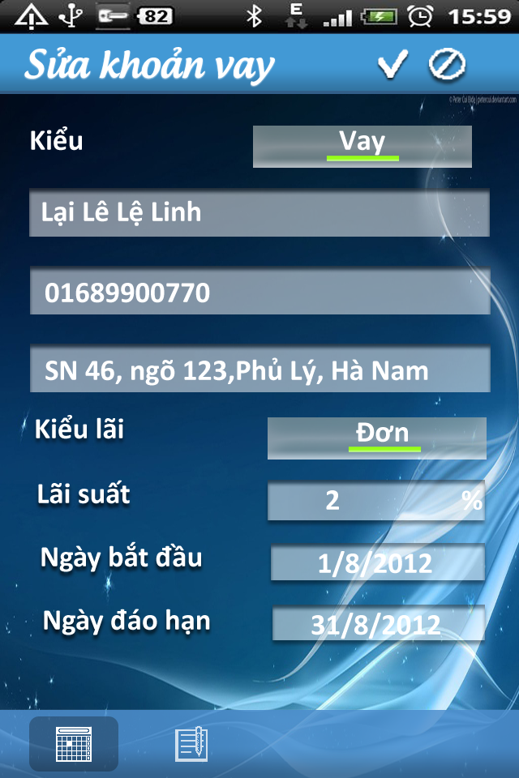
Screen:

USE CASE- Delete Loans SPECIFICATION

Use-case No. | UC BL.2 | Use-case Version |  | 1.0
Use-case Name | Delete Loans
Author | LinhLLL
Date | 08/09/2012 | Priority | High
Actor:
User
Summary:
User can delete loan.
Goal:
Allow user delete loan.
Triggers
Touch “Vay nợ” icon, thirst icon at the bottom of screen.
Preconditions:
Accessed to application
Post Conditions:
<List the required post-conditions for using this case>
Main Success Scenario:

Step | Actor action | System response
1 | Touch “Vay nợ” icon, thirst icon at the bottom of screen | Display “Vay”tab includes list of borrowing money
2 | Long click on one borrowing in list borrowing | Display menu includes:  - “Thêm mới”  - “Chỉnh sửa”  - “Xóa”
3 | Touch “Xóa” | Show pop-up confirm includes:  - Message: “Bạn muốn xóa kế hoạch này không?”  - 2 buttons: “Có” and “Không”
4 | Touch “Có” button | - Clear borrowing  - Show message: “Đã xóa”

Step | Actor action | System response
1 | Touch “Vay nợ” icon, thirst icon at the bottom of screen | Display “Vay”tab includes list of borrowing money
2 | Long click on one borrowing in list borrowing | Display menu includes:  - “Thêm mới”  - “Chỉnh sửa”  - “Xóa”
3 | Touch “Xóa” | Show pop-up confirm includes:  - Message: “Bạn muốn xóa kế hoạch này không?”  - 2 buttons: “Có” and “Không”
4 | Touch “Không” button | - Return “Vay” screen

Alternative Scenario:
Exceptions:
Relationships:
UC BL.1, UC BL.2
Business Rules:

No | Rule Description
1 | In order to add borrowing money, user must accessed application
2 | In order to save data, user must enter data into mandatory field

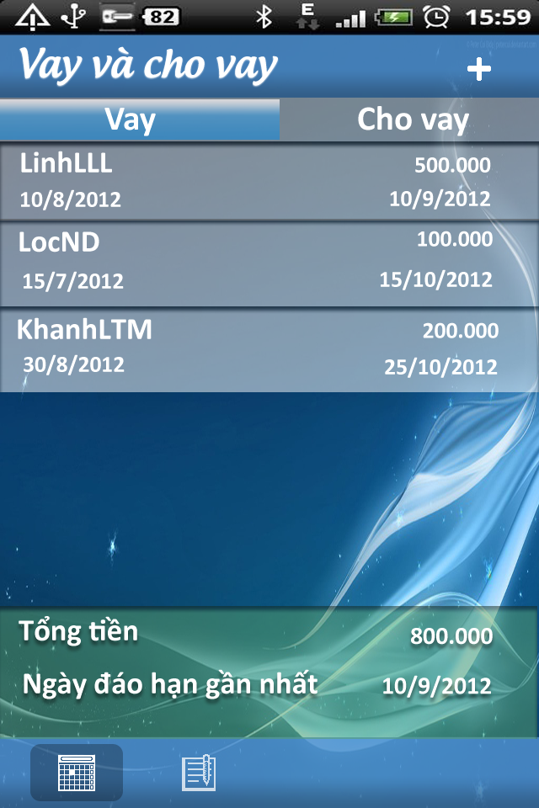
Screen:

USE CASE- View and Warning loans SPECIFICATION

Use-case No. | UC BL.4 | Use-case Version |  | 1.0
Use-case Name | View and Warning loans
Author | LinhLLL
Date | 08/09/2012 | Priority | High
Actor:
User
Summary:
User can view list of loans or loan detail.
Goal:
Allow user view loan.
Triggers
Touch “Vay” icon, thirst icon at bottom of screen.
Preconditions:
Accessed to application
Post Conditions:
<List the required post-conditions for using this case>
Main Success Scenario:

Step | Actor action | System response
1 | Touch thirst icon at bottom of screen | Display “Vay” screen includes list of information below:  - Each borrowing includes information below:  + “Tên”  + “Số điện thoại”  + “Địa chỉ”  + “Kiểu lãi”  + “Lãi suất”  + “Ngày bắt đầu”  + “Ngày đáo hạn”
2 | Touch “Cho vay” tab | - Display “Cho vay” screen includes list of lending  - Each lending includes information below:  + “Tên”  + “Số điện thoại”  + “Địa chỉ”  + “Kiểu lãi”  + “Lãi suất”  + “Ngày bắt đầu”  + “Ngày đáo hạn”

Alternative Scenario:

Step | Actor action | System response
1 | Touch thirst icon at bottom of screen | Display “Vay” screen includes list of information below:  - Each borrowing includes information below:  + “Tên”  + “Số điện thoại”  + “Địa chỉ”  + “Kiểu lãi”  + “Lãi suất”  + “Ngày bắt đầu”  + “Ngày đáo hạn”
2 | Touch “Cho vay” tab | - Display “Cho vay” screen with content “No data”

Step | Actor action | System response
1 | Touch thirst icon at bottom of screen | Display “Vay” screen with content “No data”
2 | Touch “Cho vay” tab | Display “Cho vay” screen includes list of information below:  - Each lending includes information below:  + “Tên”  + “Số điện thoại”  + “Địa chỉ”  + “Kiểu lãi”  + “Lãi suất”  + “Ngày bắt đầu”  - + “Ngày đáo hạn”

Step | Actor action | System response
1 | Touch thirst icon at bottom of screen | Display “Vay” screen with content “No data”
2 | Touch “Cho vay” tab | - Display “Cho vay” screen with content “No data”

Exceptions:
Relationships:
UC BL.1, UC BL.2, UC BL.3
Business Rules:
No | Rule Description
1 | In order to delete schedule, user must accessed application
2 | In order to delete schedule, “Schedule” screen must have at least one schedule

Screen:
