USE CASE- Create Schedule SPECIFICATION

Use-case No. | UC002.1 | Use-case Version |  | 1.0
Use-case Name | Create Schedule
Author | LinhLLL
Date | 08/09/2012 | Priority | High
Actor:
User
Summary:
User can create budget, detail expense for current week or month.
Goal:
Allow user create budget and plan schedule.
Triggers
Touch “Schedule” tab.
Preconditions:
Accessed to application
Post Conditions:
<List the required post-conditions for using this case>

Main Success Scenario:

Step | Actor action | System response
1 | Touch “Kế hoạch” tab | Display “Tháng” screen
2 | Touch create icon at the top- right concern of screen | Display create screen
3 | Touch “Tháng” toggle | Change toggle “Tháng” to “Tuần”
4 | Enter data into “Tổng ngân sách” field | Display entered data
5 | Touch save icon at the top- right concern of screen | - Return “Tháng” screen  - Show message “Saved”  - Display saved data

Step | Actor action | System response
1 | Touch “Kế hoạch” tab | Display “Tháng” screen
2 | Touch create icon at the top- right concern of screen | Display create screen
3 | Enter data into all fields | Display all entered data
4 | Touch cancel icon beside save icon | - Return “Tháng” screen

Alternative Scenario:
Step | Actor action | System response
1 | Touch “Kế hoạch” tab | Display “Tháng” screen
2 | Touch create icon at the top- right concern of screen | Display create screen
3 | Enter data into “Ăn uống” field on screen | Display entered data
4 | Touch plus icon beside “Ăn uống” field | Display:  - Default combobox is: “Ăn uống”  - One field
5 | Touch combobox “Ăn uống” | Display list options:  - Điện  - Nước  - Nhà  - Sinh nhật  - Tiệc tùng  - Khác
6 | Choose “Điện” option | Display combobox value is “Điện”
7 | Enter data into new field | Display entered data
8 | Touch save icon at the top- right concern of screen | - Return “Tháng” screen  - Show message “Saved”  - Display saved data

Step | Actor action | System response
1 | Touch “Kế hoạch” tab | Display “Tháng” screen
2 | Touch create icon at the top- right concern of screen | Display create screen
3 | Touch first date field | Choose desired time
4 | Enter data into “Tổng ngân sách” field | Display entered data
5 | Touch save icon | - Return “Tháng” screen  - Show message “Saved”  - Display saved data

Exceptions:

Step | Actor action | System response
1 | Touch “Kế hoạch” tab | Display “Tháng” screen
2 | Touch create icon at the top- right concern of screen | Display create screen
3 | Touch first date field | Choose desired time
4 | Enter data into “Tổng ngân sách” field | Display entered data
5 | Enter data into “Ăn uống” field on screen | Display entered data
6 | Touch plus icon beside “Ăn uống” field | Display:  - Default combobox is: “Ăn uống”  - One field
7 | Enter data into new field | Display entered data
5 | Touch save icon | If total of detail budget greater than “Tổng ngân sách” display:  - Message:” Tổng chi phí của bạn đã vượt quá ngân sách đề ra, bạn muốn tăng thêm ngân sách không?”  - 2 buttons: “Có” and “Không”
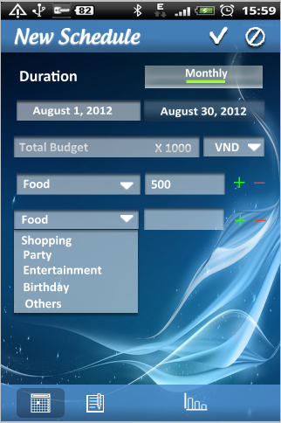
Relationships:
<List the relationships that use case relates to>
Business Rules:
No | Rule Description
1 | In order to create new schedule, user must accessed application
2 | In order to save schedule, user must enter data into mandatory field
Screen:

USE CASE- Edit Schedule SPECIFICATION

Use-case No. | UC002.2 | Use-case Version |  | 1.0
Use-case Name | Edit Schedule
Author | LinhLLL
Date | 08/09/2012 | Priority | High
Actor:
User
Summary:
User can edit monthly or weekly budget, detail expense for user’s schedule which they created.
Goal:
Allow user edit budget and plan schedule.
Triggers
Touch “Schedule” tab.
Preconditions:
Accessed to application
Post Conditions:
<List the required post-conditions for using this case>
Main Success Scenario:

Step | Actor action | System response
1 | Touch “Kế hoạch” tab | Display “Kế hoạch” screen
2 | Choose one schedule in list schedule on screen | Display detail information of schedule
3 | Touch edit icon at the top- right of screen | Display edit screen
4 | Edit data in all fields | All data is changed
5 | Touch save icon at the top- right of screen | - Return “Tháng” screen  - Show message “Saved”  - Display saved data

Step | Actor action | System response
1 | Touch “Kế hoạch” tab | Display “Kế hoạch” screen
2 | Choose one schedule in list schedule on screen | Display detail information of schedule
3 | Touch edit icon at the top- right of screen | Display edit screen
4 | Edit data in all fields | All data is changed
5 | Touch cancel icon beside save icon | - Return “Tháng” screen  - No data is edited

Alternative Scenario:

Exceptions:

Step | Actor action | System response
1 | Touch “Kế hoạch” tab | Display “Kế hoạch” screen
2 | Choose one schedule in list schedule on screen | Display detail information of schedule
3 | Touch edit icon at the top- right of screen | Display edit screen
4 | Edit data in all fields | All data is changed
5 | Touch save icon at the top- right of screen | If total of detail budget greater than “Tổng ngân sách” display:  - Message:” Tổng chi phí của bạn đã vượt quá ngân sách đề ra, bạn muốn tăng thêm ngân sách không?”  - 2 buttons: “Có” and “Không”

Step | Actor action | System response
1 | Touch “Kế hoạch” tab | Display “Tháng” screen
2 | Touch create icon at the top- right concern of screen | Display create screen
3 | Touch first date field | - Choose desired time  - If desired time coincides with available time, show:  + Message: “Thời gian này đã có lịch! Xin vui lòng chọn lại!”

Relationships:
<List the relationships that use case relates to>
Business Rules:

No | Rule Description
1 | In order to edit schedule, user must accessed application
2 | In order to edit schedule, “Kế hoạch” screen must have at least one schedule
3 | In order to save schedule, user must enter data into at least one field
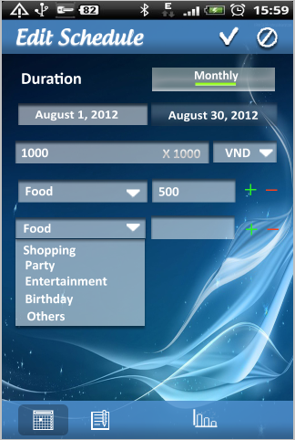
Screen

USE CASE- Delete Schedule SPECIFICATION

Use-case No. | UC002.3 | Use-case Version |  | 1.0
Use-case Name | Delete Schedule
Author | LinhLLL
Date | 08/09/2012 | Priority | High
Actor:
User
Summary:
User can delete schedule.
Goal:
Allow user delete schedule.
Triggers
Touch “Schedule” tab.
Preconditions:
Accessed to application
Post Conditions:
<List the required post-conditions for using this case>
Main Success Scenario:

Step | Actor action | System response
1 | Touch “Kế hoạch” tab | Display “Tháng” screen
2 | Long click on one schedule in list schedule | Display menu includes:  - “Thêm mới”  - “Chỉnh sửa”  - “Xóa”
3 | Touch “Xóa” | Show pop-up confirm includes:  - Message: “Bạn muốn xóa kế hoạch này không?”  - 2 buttons: “Có” and “Không”
4 | Touch “Có” button | - Clear schedule  - Show message: “Đã xóa”

Step | Actor action | System response
1 | Touch “Schedule” tab | Display “Tháng” screen
2 | Long click on one schedule | Display menu includes:  - Thêm mới  - Chỉnh sửa  - Xóa
3 | Touch “Xóa” | Show pop-up confirm includes:  - Message: “Bạn muốn xóa kế hoạch này không?”  - 2 buttons: “Có” and “Không”
4 | Touch “Không” button | - Return “Tháng” screen

Alternative Scenario:
Exceptions:
Relationships:
Business Rules:

No | Rule Description
1 | In order to delete schedule, user must accessed application
2 | In order to delete schedule, “Schedule” screen must have at least one schedule

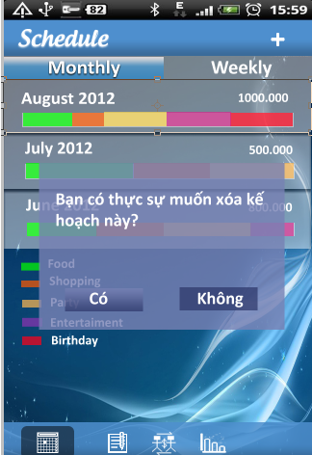
Screen:

