PERSONAL FINANCE MANAGEMENT

System Design Document

Original Plan Date: 09/17/2012

Revision Date: 09/17/2012

Revision: 1.1.1

Revision History
Revision Number | Date | Comment
1.0 | September 17, 2012 | Create new document
1.1.0 | September 21, 2012 | Update document:  - Reorder parts in Software Design section  - Update Data repository package  - Add architecture design
1.1.1 | October 1st, 2012 | - Update context diagram

Table of Contents
Revision History 2
Table of Contents 3
Document Overview 4
Scope 4
Audience 4
Related DocumENTATIon 4
Document Conventions 4
System Overview 4
Description 4
System Architecture 4
Software Architecture 5
Hardware Architectures 5
Hardware Design 5
Hardware Components 5
Computer Systems 5
Peripherals 5
Networks 5
Project Specific hardware items (e.g. Sensors, Transducers, Robotics, Enclosure Design) 6
Hardware Integration 6
Logical Design 6
Physical Design 6
Software Design 6
Software Integration 6
1. Software context diagram 6
2. Software package diagram 7
Software Packages 10
1. PRESENTATION PACKAGE 10
2. DATAREPOSITORY PACKAGE 11
3. COMMON PACKAGE 11
Data / Database / Files 13
Data Flow Diagrams 13
Database Design 13
Files 13
Registry / System Parameters 13
System Interfaces 14
{XYZ Interface} 14
System Performance 14
Glossary / Terminology 14

Document Overview
This is a technical blueprint for the project.
This document has been developed by PFM Group for Personal Finance Management Project.

Scope
Provide a summary of models and versions of hardware and software to which this documentation relates.

Audience
Skills required and assumptions.

Related DocumENTATIon
List related documents including supplier documentation, test plans and results as appropriate for this document; List any naming standard or common business process documents to guide. List any supporting Interface Control documents. Indicate how to obtain all documents.
Other system documentation for this system should include:

Document Conventions
Describe what diagrammatic notation has been used in this document to represent the architectural views. Use of the Unified Modeling Language (UML) is strongly encouraged. If UML is not used then please provide a detailed legend in this section for all symbols and semantics.

System Overview
This section deals with a summary of the overall system design aspects.

Description
A brief functional description with key concepts: Provide a top-level description of the system and its major external interfaces to aid the reader in understanding what the software is to accomplish.

System Architecture
This section includes high level overview of system including references to the items covered in System Architecture Document – SAD, and interfaces to other items such as hardware, peripherals and systems integration. If the hardware design is following architectural standards and buses, these are to be included here.

Software Architecture
This section outlines the software architecture established for the project. Provide references to the System Architecture Document and a brief summary of the software architectures.

Hardware Architectures
This section outlines the hardware architecture established for the project. The platforms, networks, peripherals and hardware integration should be summarized.

Hardware Design
In the following sections provide detailed discussion on the design and integration aspects for each hardware component. Discuss the hardware design criteria and approach including at least the internal system hardware components, customization, environmental requirements, target location, physical dimensions, configuration parameters, integration requirements, and other potential design information.

Hardware Components
Discuss the hardware design criteria and approach including hardware components make/model, customization, environmental requirements, target location, physical dimensions, configuration parameters, integration requirements, and other potential hardware design information; if different, note recovery hardware components.

Computer Systems
Include all platform types, hardware standards, buses, operating systems, systems scripts and related utilities. Address availability requirements (High availability – MTTR, MTBF, Fault resilience, fault tolerance, hot standby, multiple processors, UPS). Address performance requirements (cache, memory and other special I/O ports, etc.).

Peripherals
List all peripheral devices and associated components involved: Address buses, standards (such as SCSI, Fiber Channel, SAN, NAS, etc.)

Networks
Describe routers, bridges, gateways and other network components. Summarize data rates that this network is capable of supporting. List all protocols used (such as FDDI, Ethernet, T1, ATM, OC12, Sonnet, DWDM optical communications interfaces, etc., as applicable to design activity.)

Project Specific hardware items (e.g. Sensors, Transducers, Robotics, Enclosure Design)
Describe as applicable to design activity. Refer to Device Installation Manuals of Suppliers to avoid redundancy.

Hardware Integration

Logical Design
Provide a logical view of the hardware component integration including associated topology.

Physical Design
Provide a detailed design view of the cabling and connectors required for providing hardware integration.

Software Design
Software and integration related detailed design aspects to be included here that are not already in the SAD. Discuss all internal software components, including COTS and their configuration. Provide detailed design for all software components being built including software integration.

Software Integration

Software context diagram
This diagram represents the actors outside the system that could interact with it. This diagram is the highest level view of system.

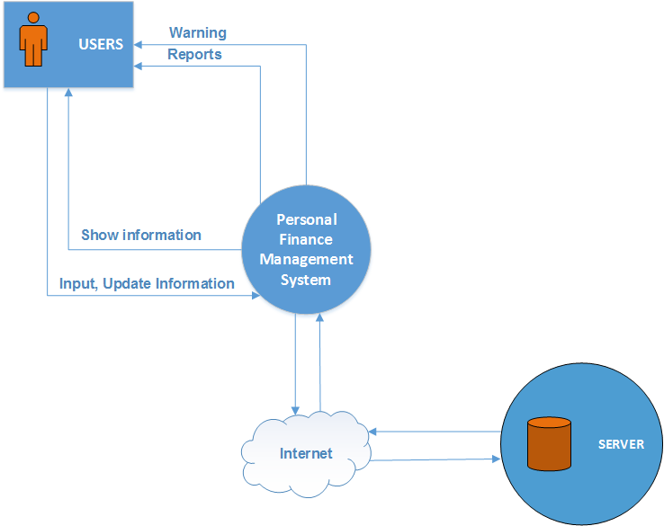
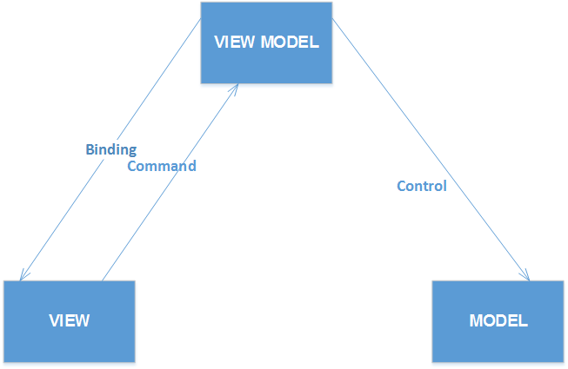

Architecture design
This part describes about architecture design of this system. This system uses MVVM model. This model includes 3 parts: Model, View and View Model. The Model is used to contain data of object. The View represents UI of object. For last one, the View Model will control business problems of object.

Software package diagram
This diagram depicts the dependencies between the packages that make up a model. The Personal Finance Management System includes 3 packages: Presentation, Repository and Common. The relationship between packages is described as below diagram:

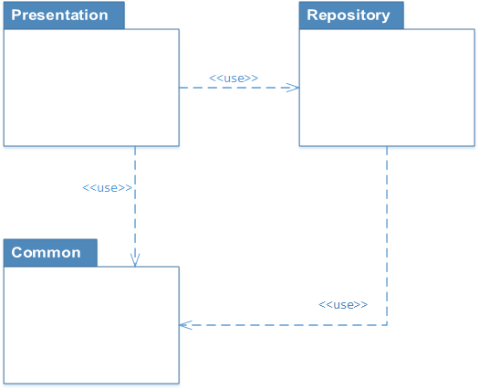

Software Packages

PRESENTATION PACKAGE
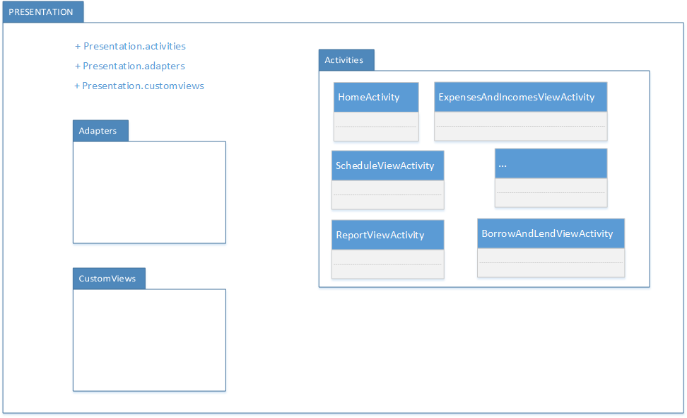
This package contains classes that will be used to help user can interact with Personal Finance Management System. This package includes the activities, custom views, adapters…

DATAREPOSITORY PACKAGE
This package will get data and transfer them to Presentation package. It includes: Data Manager, BorrowingAndLendingRepository…
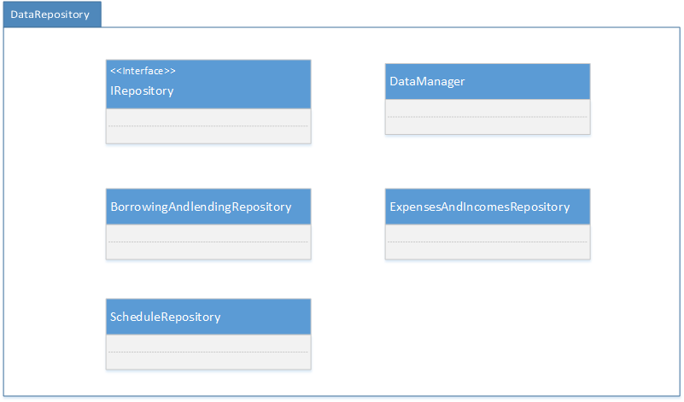

COMMON PACKAGE
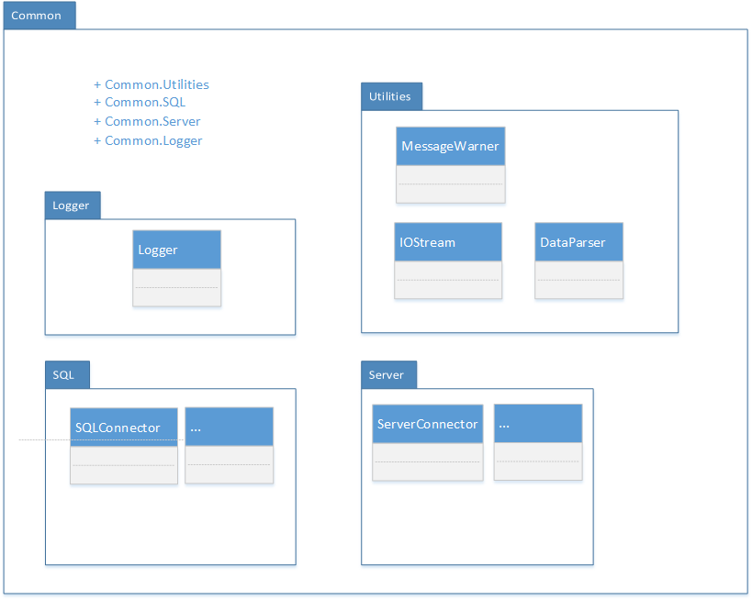
This contains common functions which can be used by all packages in the application. It contains functions which are used throughout the application like function for getting the response from server for a request, logging etc. This package contains functions which relates to the business of application or utilities that help application works easily.

Data / Database / Files
Include overview of Software Modules to Data / Repositories Linkages.

Data Flow Diagrams
Provide different levels of DFDs: summary of top-level, system level (between system(s)/user/ device), for each major software module, and one-layer inside the software module.

Database Design
List and describe tables, fields, and entity relationships (also known as data dictionary and logical/ physical database design), schema, query language, key and indices, data management functions.
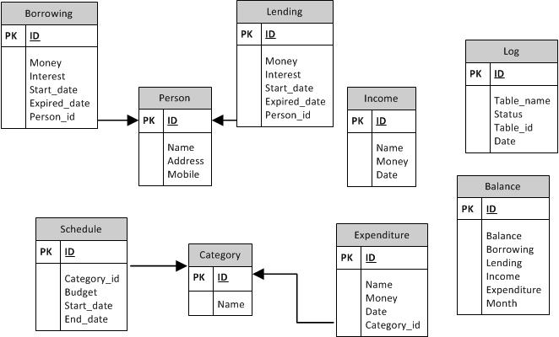

Files
Refer to Configuration Management/Data related Templates that document the directory structure and location of all files. Those Templates provide a summary list of all files and describe each data and configuration file and their formats.

Registry / System Parameters

System Interfaces
Define all external interactions between this system and other systems. Provide definition of the software and hardware interfaces between this system and other systems.

{XYZ Interface}
Include subsystems interfaces (for development, test and production). Repeat as needed. Name each section after the interface. Include description, hardware interrupts, triggering event, message protocol (or file format) and handshaking, record definitions /data definitions, timing restrictions/frequency, queuing/buffering, error identification /handling /recovery, priority, flow-control, data transfer rate, security and capacity /volume. Include additional software interface design aspects, such as the protocols or other interfaces (e.g., EAI) related to design as applicable.

System Performance
Include all capacity and sizing calculations. Show how to calculate file and database sizes, system limits, and expected response times. Include reference to performance related executable architectures from System Architecture Document.

Glossary / Terminology

