**Solution Sheet**

1. Which model have you used for probability prediction? Explain your model.

I have used the gaussian naive bayes classifier for predicting the probability .

As there are about 3000 record having null values so for missing filling I have used the forward filling method to fill the NaN values.many of the columns are categorial data so I have changed them to numerical data. After this I have use the minmaxscaler to normalize the data. After this chi square used for feature selection. My model gives the the accuray of 85%.

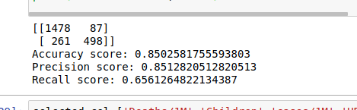

1. Which model have you used for Diuresis Time series prediction? Explain your model.

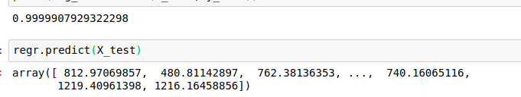For Diuresis Time Series prediction I have used the linear regression to predict the target values and I have trained the model on the basis of previous date values and getting the accuracy of about 99%.