Other fixed assets should show notes – there are cases where notes become a number plus a letter with ot without bracket – in the last run it was 16(a) against right of use assets.
Other Fixed assets is showing a formula on the front-end which does not even tally with the number it is showing. The number it has populated is correct.
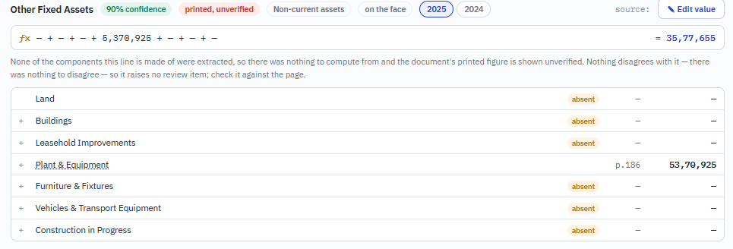

All the items where there is an add on items seem to not be showcasing well, can you check
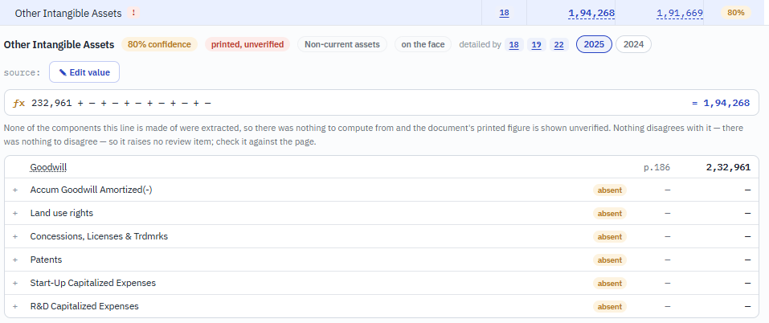

Same error that we identified for gross fixed assets Depreciation and net fixed assets is also there in Trade receivables (Gross_, Alow for doubtful accounts and Net trade receivables. Please fix the same

