1)What is Cartesian product of the table

🡪

Cartesian product in SQL is a term from the set theory of mathematics. However, we can also find this term in SQL database manuals. What does it mean, and how should we work with it? Let’s learn it.

A Cartesian product of two sets X and Y, denoted X × Y, is the set of all ordered pairs where x is in X and y is in Y

In terms of SQL, the Cartesian product is a new table formed of two tables. If those tables have 3 and 4 lines respectively, the Cartesian product table will have 3×4 lines. Therefore, each row from the first table joins each row of the second table. You get the multiplication result of two sets making all possible ordered pairs of the original sets’ elements.

The Cartesian product involves a large number of computational operations that are usually redundant. Thus, for large tables, we recommend using the qualifier operators.

**How to Implement a Cartesian Product in SQL?**

Implementing a Cartesian Product in SQL is possible with the CROSS JOIN operator that returns the cross product of two tables.

Let’s have a look at the example in the below image. Two corresponding tables state the *color* and *size* values. Because there is no JOIN condition, all rows (2) from the color table are joined to all rows (4) from the size table, generating 8 rows as the result.

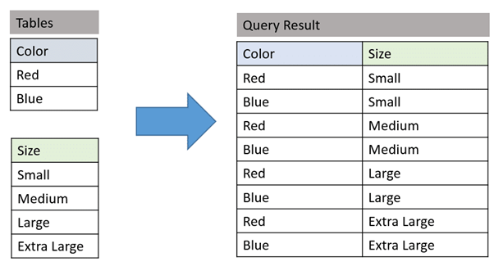

The CROSS JOIN method applies to many situations. For instance, we need to have the full salary data of an office for a month. Even if month X has no salary, you can cross-combine Offices with a table of all Months.

Note: In practice, the Cartesian product of tables isn’t common. We might want to connect all employees with all departments, but it is reasonable only if everyone works according to a single plan, and their work affects all departments. Connecting all employees/departments with all locations is complete nonsense.

Still, sometimes the database contains tables with only one row for storing some constants (e.g., company name). Here, we can connect such tables to any query using the Cartesian product operation.

## Using the Cartesian Product SQL in Practice

The Cartesian product SQL is useful when:

* the JOIN condition is omitted;
* the JOIN condition is invalid;
* all rows in the first table are concatenated with all rows in the second table.

Cartesian product of tables becomes more common if it is necessary to select only those records that match each other. We can do it by specifying the selection condition using ON, USING, or WHERE.

Sometimes, Cartesian products occur due to an error in the query text. The primary method of joining tables is an inner or natural join operation.