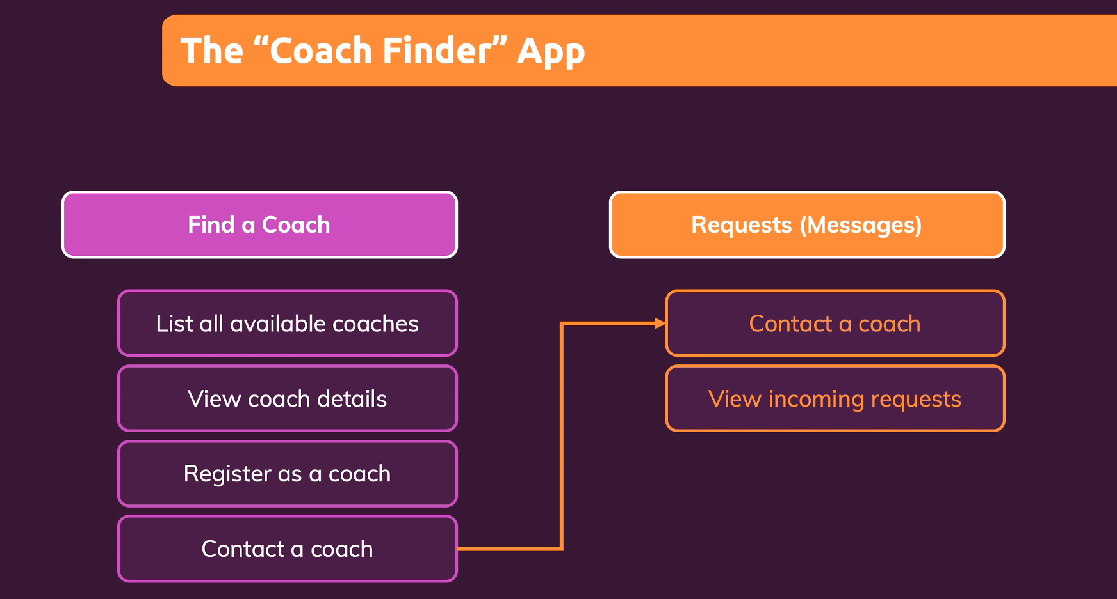

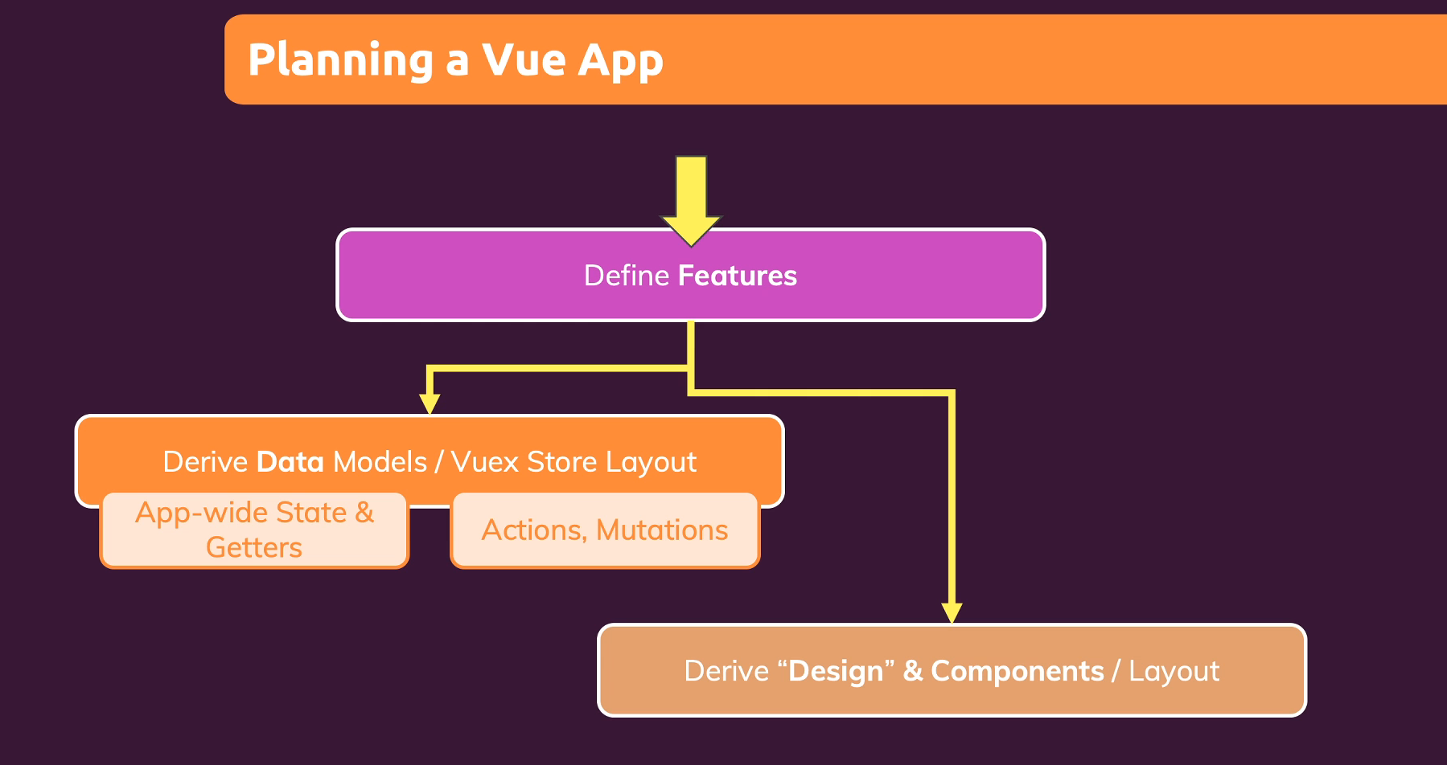

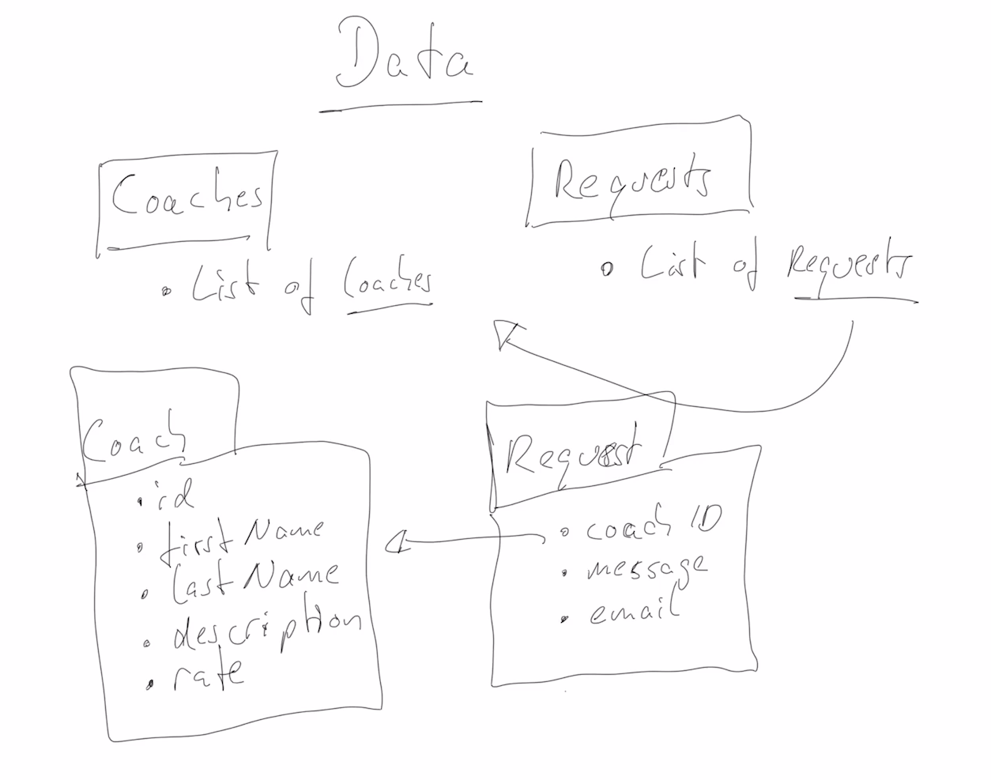

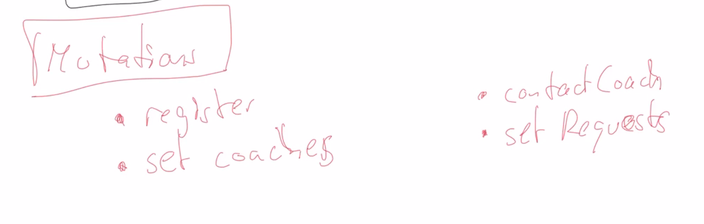

We will probably have a Vuex module for coaches and a module for requests.

We will have a getter to fetch all coaches, and a getter to fetch all requests.

**Layout**

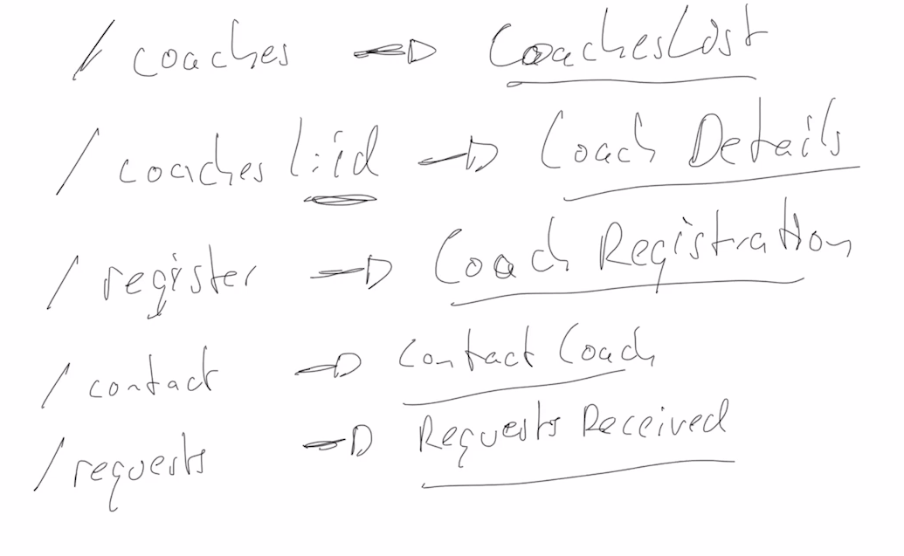

So far, 5 pages, and every page will be a component because you load components with the Vue Router.

