PROJECT REPORT
AI-Powered Resume Generator and Analyzer
Submitted in partial fulfilment of the requirement for the award of the degree of

BACHELOR OF TECHNOLOGY
IN
COMPUTER SCIENCE & ENGINEERING
Submitted by
SIDHANT BISHT University Roll No- 2219721
SHUBHAM DOBHAL University Roll No- 2318019
Under the guidance of
Mr. Deepak Upadhyay
Assistant Professor
Project Group No: 339

Department of Computer Science and Engineering
Graphic Era Hill University
May, 2026

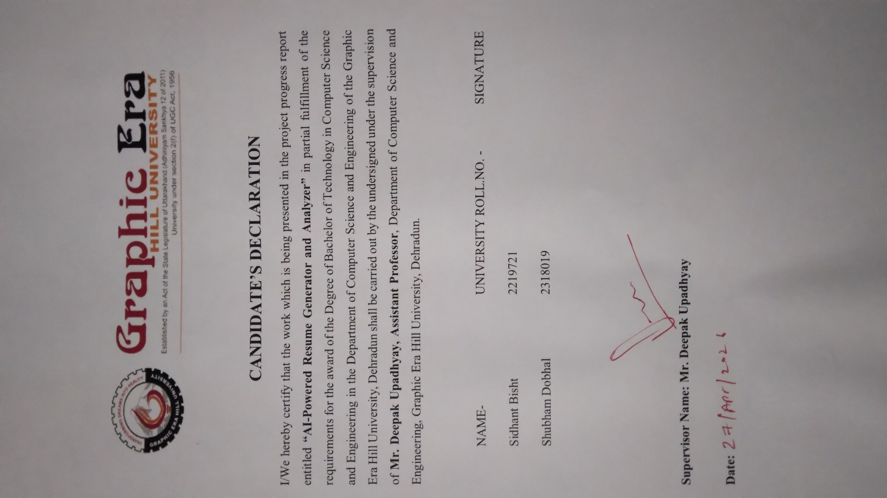
ACKNOWLEDGEMENT

We take this opportunity to express our deep sense of gratitude and sincere thanks to all those who have contributed to the successful completion of this project.

We are highly grateful to our project supervisor, Mr. Deepak Upadhyay, Assistant Professor Department of Computer Science & Engineering, for the invaluable guidance, continuous encouragement, and constructive suggestions throughout the development of this project. His expertise and support have been instrumental in shaping this work.

We also thank the faculty members of the Department of Computer Science & Engineering for their constant support and motivation. Special thanks to our families and friends for their unwavering moral support throughout this academic journey.

Finally, we acknowledge the contributions of the open-source community, the developers behind the MERN stack, Google Gemini AI, ImageKit, and all other tools and frameworks that made this project possible.

Sidhant Bisht Shubham Dobhal
2219721 2318019

ABSTRACT

In today's highly competitive job market, a well-structured resume plays a critical role in securing employment opportunities. However, many job seekers lack the knowledge of industry-standard resume formats, ATS (Applicant Tracking System) optimization, and effective presentation of their skills. Simultaneously, recruiters spend significant time manually screening large volumes of resumes, leading to inefficiencies in the hiring process.
This project proposes and implements an AI-Powered Resume Generator and Analyzer, a full-stack web application that addresses both sides of this problem. The system consists of two primary modules: (1) an intelligent Resume Generator that allows users to create professional, ATS-friendly resumes using customizable templates with live preview, and (2) an AI-driven Resume Analyzer that evaluates uploaded resumes against target job descriptions, providing detailed scoring, feedback, and job role recommendations.
The application is developed using the MERN stack (MongoDB, Express.js, React.js, Node.js), with Google Gemini AI as the artificial intelligence backbone for resume optimization, scoring, and feedback generation. Additional features include user authentication, profile image upload with background removal via ImageKit, PDF/DOCX export, live shareable resume links, and resume management capabilities.
The frontend is built with React.js and Tailwind CSS for a modern, responsive user interface, while the backend uses Node.js and Express.js with Multer for PDF file handling. Resume data is stored and managed in MongoDB. The application is deployed on Vercel for scalable cloud hosting.
The system demonstrates the effective integration of artificial intelligence with modern web development practices to automate and enhance the resume building and evaluation process, providing significant value to both job seekers and recruiters.

Keywords: Resume Generator, Resume Analyzer, MERN Stack, Google Gemini AI, Artificial Intelligence, Natural Language Processing, ATS Optimization, React.js, Node.js, MongoDB, Full-Stack Web Application, ImageKit.
TABLE OF CONTENTS

Acknowledgement ii
Abstract iii
Table of Contents iv
List of Tables v
List of Figures vi
Abbreviations vii
Notations viii

Chapter 1: Introduction and Motivation 1
1.1 Introduction 1
1.2 Motivation 2
1.3 Problem Overview 3
1.4 Scope of the Project 4

Chapter 2: Objectives and Problem Statement 5
2.1 Problem Statement 5
2.2 Objectives of the Project 6
2.3 Expected Outcomes 7

Chapter 3: Software and Hardware Requirements 8
3.1 Hardware Requirements 8
3.2 Software Requirements 9
3.3 System Requirements Specification (SRS) 11
3.4 Functional Requirements 12
3.5 Non-Functional Requirements 14
3.6 Use Case Diagram 15
3.7 ER Diagram 17
Chapter 4: Project Methodology and Design 19

4.1 System Architecture 19
4.2 Algorithm Design 21
4.3 Database Design 24
4.4 UI/UX Design Blueprint 26
4.5 API Design 28
4.6 Data Flow Diagram (DFD) 30
Chapter 5: Implementation and Results 33
5.1 Development Environment Setup 33
5.2 Frontend Implementation 35
5.3 Backend Implementation 39
5.4 AI Integration (Google Gemini) 44
5.5 Resume Generator Module – Results 47
5.6 Resume Analyzer Module – Results 51
5.7 Testing 55

Chapter 6: Conclusion and Future Scope 58
6.1 Conclusion 58
6.2 Limitations 59
6.3 Future Scope 60

References 62

List of Publications 64

LIST OF TABLES

Table No. | Title | Page
3.1 | Hardware Requirements | 8
3.2 | Software Requirements | 9
3.3 | Technology Stack Summary | 10
3.4 | Functional Requirements | 12
3.5 | Non-Functional Requirements | 14
4.1 | MongoDB Collections and Schema | 24
4.2 | API Endpoints – Resume Generator | 28
4.3 | API Endpoints – Resume Analyzer | 29
4.4 | AI Prompt Templates | 31
5.1 | Node.js Dependencies | 34
5.2 | React.js Frontend Dependencies | 35
5.3 | Test Cases – Resume Generator | 55
5.4 | Test Cases – Resume Analyzer | 56
5.5 | Performance Metrics | 57

LIST OF FIGURES

Fig. No. | Title | Page
1.1 | Global Resume Builder Market Growth | 3
2.1 | Overview of Proposed System | 6
3.1 | Use Case Diagram – Resume Generator | 15
3.2 | Use Case Diagram – Resume Analyzer | 16
3.3 | Entity-Relationship (ER) Diagram | 17
4.1 | System Architecture Diagram | 19
4.2 | MERN Stack Integration Overview | 20
4.3 | Resume Generation Algorithm Flowchart | 21
4.4 | Resume Analysis Algorithm Flowchart | 22
4.5 | AI Scoring Algorithm Flowchart | 23
4.6 | MongoDB Database Schema Design | 25
4.7 | Data Flow Diagram – Level 0 (Context) | 30
4.8 | Data Flow Diagram – Level 1 | 31
4.9 | Data Flow Diagram – Level 2 (AI Module) | 32

LIST OF FIGURES

5.1 | Project Folder Structure | 33
5.2 | User Registration & Login Screen | 36
5.3 | Resume Template Selection Screen | 37
5.4 | Resume Builder Form – Live Preview | 38
5.5 | Generated Resume Output (Template 1) | 48
5.6 | Generated Resume Output (Template 2) | 49
5.7 | Resume Download Options (PDF/DOCX) | 50
5.8 | Resume Upload Interface (Analyzer) | 51
5.9 | AI Analysis Result – Score Dashboard | 52
5.10 | AI Feedback Panel – Strengths & Gaps | 53
5.11 | Job Role Recommendations Screen | 54

ABBREVIATIONS

Abbreviation | Full Form
AI | Artificial Intelligence
API | Application Programming Interface
ATS | Applicant Tracking System
CSS | Cascading Style Sheets
CRUD | Create, Read, Update, Delete
DB | Database
DFD | Data Flow Diagram
ER | Entity Relationship
HTML | HyperText Markup Language
HTTP | HyperText Transfer Protocol
IDE | Integrated Development Environment
JS | JavaScript
JSON | JavaScript Object Notation
JWT | JSON Web Token

ABBREVIATIONS

Abbreviation | Full Form
MERN | MongoDB, Express.js, React.js, Node.js
ML | Machine Learning
NLP | Natural Language Processing
NPM | Node Package Manager
PDF | Portable Document Format
REST | Representational State Transfer
SRS | Software Requirements Specification
UI | User Interface
URL | Uniform Resource Locator
UX | User Experience

NOTATIONS

Notation | Meaning
S | Overall resume score (0–100)
W_i | Weight assigned to section i of the resume
F_i | Feature score for section i
n | Total number of resume sections evaluated
JD | Job Description text input
R | Resume document text (extracted)
Sim(R, JD) | Cosine similarity between resume and job description vectors
T | Token sequence in NLP processing
P(w|context) | Probability of word w given surrounding context (LLM)
α | Learning rate / threshold for AI scoring
σ | Standard deviation of score distribution
μ | Mean score of resume batch
k | Number of recommended job roles returned
t_resp | API response time in milliseconds

CHAPTER 1

INTRODUCTION AND MOTIVATION

1.1 Introduction
The rapid advancement of technology has transformed the way organizations recruit employees and how individuals search for employment. In the modern digital era, resumes serve as the primary medium through which job seekers present their qualifications, skills, and experience to potential employers. A well-crafted resume is no longer merely a document — it is a strategic marketing tool that must be carefully tailored to stand out in an increasingly automated recruitment pipeline.
Most modern organizations employ Applicant Tracking Systems (ATS) to automate the initial screening of resumes. These systems parse and score resumes based on keyword matching, formatting standards, and relevance to the job description. Studies indicate that over 75% of resumes are rejected by ATS before they ever reach a human recruiter. This creates a pressing need for intelligent tools that help job seekers build ATS-optimized resumes and understand how their existing resumes are being evaluated.
Simultaneously, the proliferation of Artificial Intelligence (AI) and Natural Language Processing (NLP) has opened new avenues for automating complex tasks that traditionally required human expertise. AI-powered systems can now analyze text documents, extract meaningful patterns, generate coherent content, and provide actionable recommendations — capabilities that are directly applicable to resume building and evaluation.
The "AI-Powered Resume Generator and Analyzer" project addresses these needs by providing an integrated, full-stack web platform that combines modern frontend and backend development with AI capabilities. The application serves two primary user groups: job seekers who wish to create professional resumes, and individuals who wish to evaluate and optimize their existing resumes against specific job requirements.

1.2 Motivation
The motivation for this project stems from several real-world challenges observed in the recruitment and job-seeking ecosystem:
- High ATS Rejection Rate: Research by Harvard Business School (2021) revealed that 88% of employers report that qualified candidates are rejected by ATS systems due to non-standard formatting or missing keywords. This highlights the urgent need for AI-driven resume optimization tools.
- Lack of Personalized Feedback: Most job seekers do not receive any feedback on why their resumes were rejected. An intelligent analyzer can fill this gap by providing actionable, personalized suggestions.
- Time-Consuming Manual Process: Creating a professional resume from scratch requires significant time and design expertise. An AI-assisted generator with templates and live preview can dramatically reduce this effort.
- Growing AI Capabilities: The availability of powerful language models such as Google Gemini makes it feasible to build sophisticated text analysis and generation pipelines as part of a web application at reasonable cost.
- Market Opportunity: The global online recruitment market was valued at USD 28.68 billion in 2023 and is projected to reach USD 56.64 billion by 2030, demonstrating significant demand for tools in this space.
- Educational Value: Building this system requires integration of diverse technologies including full-stack web development, cloud services, file processing, and AI APIs — making it an excellent learning and demonstration project.
- Career Transition Support: A large portion of the workforce seeks career transitions across industries post-COVID. Traditional resumes fail to bridge skill gaps effectively, motivating the need for AI tools that can reframe and reposition existing experience for new target roles.
- Bias Reduction in Self-Assessment: Job seekers often struggle to objectively evaluate their own resumes due to cognitive bias. An AI-powered analyzer provides neutral, data-driven feedback that human self-review cannot replicate, motivating adoption of such tools.
- Rise of Remote & Global Hiring: With remote work normalization, candidates now compete globally rather than locally. This exponentially increases competition and raises the bar for resume quality, creating strong motivation for intelligent resume optimization tools.

1.3 Problem Overview
The core problem addressed by this project can be described at two levels:
From the job seeker's perspective: Many qualified candidates fail to present their skills effectively due to poor resume structure, formatting issues, lack of relevant keywords, and unfamiliarity with industry expectations. Without professional resume writing services (which are expensive) or expert guidance, these candidates struggle to optimize their applications.
From the recruiter's perspective: Organizations receive hundreds to thousands of applications per job opening. Manual screening is inefficient, expensive, and prone to bias. Automated tools that can objectively score and rank resumes against job descriptions offer significant value.
Existing solutions are either too expensive (professional resume writing services), too generic (simple template editors), or too isolated (standalone analyzers without generation capability). This project aims to provide a comprehensive, integrated, and intelligent solution accessible to all users through a web browser.

1.4 Scope of the Project
The scope of this project encompasses the following areas:
- Development of a full-stack web application using the MERN (MongoDB, Express.js, React.js, Node.js) technology stack
- Implementation of a Resume Generator module with multiple professional templates, live preview, AI-assisted optimization, and export capabilities (PDF and DOCX formats)
- Implementation of a Resume Analyzer module that accepts PDF resume uploads, processes them using AI, and provides comprehensive scoring and feedback
- Integration of Google Gemini AI for natural language processing, resume content optimization, scoring, and job role recommendation
- User authentication and authorization using JWT tokens
- Profile image management with background removal using ImageKit cloud service
- Cloud deployment using Vercel for both frontend and backend services
- The scope includes support for diverse user profiles — freshers, experienced professionals, and career switchers — each requiring different resume structures, section emphasis, and keyword strategies that the system accommodates through flexible templates and AI guidance.
- The project scope encompasses implementation of data security measures including bcrypt password hashing, JWT-based session management, HTTPS-enforced communication, and MongoDB Atlas role-based access controls to protect sensitive user resume data.
- The scope includes the ability for users to maintain and manage multiple versions of their resumes simultaneously — each tailored to a different job role or industry — with individual edit, delete, and share capabilities per resume document.
- The scope covers ensuring the application is fully responsive and functional across major browsers (Chrome, Firefox, Safari, Edge) and across device types including desktops, laptops, tablets, and mobile phones, without requiring any software installation.
- Responsive UI design using React.js and Tailwind CSS
The project does not include direct integration with job portals, employer-side systems, or payment processing. It is designed as a standalone web application for educational and portfolio demonstration purposes.

CHAPTER 2

OBJECTIVES AND PROBLEM STATEMENT

2.1 Problem Statement
In the contemporary employment landscape, the process of creating an effective resume and ensuring its relevance for a specific job role has become increasingly complex. The following specific problems have been identified:

2.1.1 Resume Creation Challenges
- Inexperienced job seekers lack the knowledge to structure a professional, ATS-friendly resume
- Designing a visually appealing and well-formatted resume requires design skills that many individuals do not possess
- Managing multiple versions of resumes for different job applications is cumbersome without proper tooling
- Incorporating the right keywords and section structure for specific industries or roles is non-trivial

2.1.2 Resume Evaluation Challenges
- Job seekers do not know how ATS systems evaluate their resumes, leading to preventable rejections
- There is no accessible, affordable tool that provides detailed, section-wise feedback on resume quality
- Understanding which job roles best match one's current skill set requires expert guidance that is not readily available
- Resume optimization is an iterative process without a clear metric for improvement

2.2 Objectives of the Project
The primary and secondary objectives of this project are defined as follows:

2.2.1 Primary Objectives
- To design and implement a full-stack web application that enables users to create, customize, and download professional resumes using AI-assisted templates and live preview functionality.
- To develop an AI-powered resume analysis engine that accepts PDF resumes, extracts their content, and evaluates them against user-specified job roles or descriptions.
- To integrate Google Gemini AI to provide intelligent resume optimization suggestions, section-wise scoring, and personalized improvement recommendations.
- To implement a comprehensive user management system including authentication, profile management, and resume history.
- To deploy the application on a cloud platform ensuring accessibility, scalability, and reliability.

2.2.2 Secondary Objectives
- To implement multiple resume templates to accommodate different industries and professional levels.
- To provide live shareable resume links, enabling users to share their resumes online without requiring a download.
- To integrate ImageKit for profile photo management, including AI-powered background removal.
- To implement export functionality supporting both PDF and DOCX formats.
- To ensure the application is responsive and accessible across different devices and screen sizes.

2.3 Expected Outcomes

Outcome | Description | Measurable Metric
Working Resume Generator | Users can create and download resumes | End-to-end creation in < 10 min
AI Resume Optimization | Gemini suggests improvements to content | Relevance score improvement ≥ 20%
Resume Analyzer with Score | Uploaded PDF gets scored 0–100 | Score accuracy validated against HR experts
Job Recommendations | AI suggests suitable job roles | ≥ 5 relevant roles per analysis
Multi-format Export | PDF and DOCX downloads work correctly | Zero formatting errors in exports
User Authentication | Secure login and data management | JWT-based auth, bcrypt password hashing
Cloud Deployment | App live on Vercel | Uptime ≥ 99%, page load < 3s

CHAPTER 3

SOFTWARE AND HARDWARE REQUIREMENTS

3.1 Hardware Requirements
The following hardware specifications are required for development, testing, and deployment of the AI-Powered Resume Generator and Analyzer system:
3.1.1 Development Machine Requirements
Component | Minimum Specification | Recommended Specification
Processor | Intel Core i5 (8th Gen) / AMD Ryzen 5 | Intel Core i7 (11th Gen) / AMD Ryzen 7
RAM | 8 GB DDR4 | 16 GB DDR4 or higher
Storage | 256 GB SSD | 512 GB NVMe SSD
Display | 1366 x 768 px | 1920 x 1080 px (Full HD)
Network | 10 Mbps Broadband | 50+ Mbps Broadband
GPU | Integrated Graphics | Discrete GPU (optional, for rendering)
OS | Windows 10 / Ubuntu 20.04 / macOS 11 | Windows 11 / Ubuntu 22.04 / macOS 13+

3.1.2 Server / Deployment Requirements (Vercel Cloud)
Since the application is deployed on Vercel (a cloud-based platform), dedicated physical server hardware is not required. Vercel provides serverless functions with the following characteristics:
- Automatic scaling based on traffic load
- Global CDN (Content Delivery Network) for static assets
- Edge runtime support for low-latency API responses
- MongoDB Atlas cloud database (no on-premise server needed)

3.2 Software Requirements

Category | Technology / Tool | Version | Purpose
Runtime | Node.js | v18.x LTS | JavaScript server-side runtime
Package Manager | npm | v9.x | Dependency management
Frontend Framework | React.js | v18.x | UI component library
CSS Framework | Tailwind CSS | v3.x | Utility-first styling
Backend Framework | Express.js | v4.x | RESTful API server
Database | MongoDB | v6.x | NoSQL document database
ODM | Mongoose | v7.x | MongoDB object modeling
AI API | Google Gemini API | gemini-pro | AI text generation & analysis
File Upload | Multer | v1.4.x | PDF/image upload middleware
PDF Processing | pdf-parse | v1.1.x | Extract text from PDF files
Authentication | JSON Web Token (JWT) | v9.x | User authentication tokens

Category | Technology / Tool | Version | Purpose
Password Hashing | bcryptjs | v2.4.x | Secure password storage
Image Service | ImageKit | SDK v4.x | Image upload + BG removal
PDF Generation | html2pdf.js / jsPDF | v1.5.x | Export resume as PDF
DOCX Generation | docx.js | v8.x | Export resume as Word doc
HTTP Client | Axios | v1.x | API calls from frontend
CORS | cors (npm) | v2.8.x | Cross-origin resource sharing
Code Editor | VS Code | v1.85+ | Development IDE
API Testing | Postman | v10.x | REST API testing
Version Control | Git + GitHub | v2.x | Source code management
Deployment | Vercel | Latest | Frontend & backend hosting
DB Hosting | MongoDB Atlas | M0 Free Tier | Cloud database hosting
Browser | Google Chrome | v120+ | Testing & development

3.3 System Requirements Specification (SRS)
The Software Requirements Specification defines the complete behavior and constraints of the system. It serves as a contract between the development team and stakeholders, ensuring all requirements are clearly documented before development begins.
3.3.1 System Overview
The AI-Powered Resume Generator and Analyzer is a client-server web application. The client (React.js SPA) communicates with the backend (Node.js/Express.js REST API) over HTTPS. The backend interfaces with MongoDB Atlas for data persistence, Google Gemini API for AI processing, and ImageKit for media management. PDF files uploaded by users are processed server-side using Multer and pdf-parse.

3.4 Functional Requirements
3.4.1 User Management Module
FR ID | Requirement | Priority
FR-UM-01 | User shall be able to register using email and password | High
FR-UM-02 | System shall validate email format and enforce password strength | High
FR-UM-03 | User shall be able to log in using registered credentials | High
FR-UM-04 | System shall issue JWT token upon successful login (24h expiry) | High
FR-UM-05 | User shall be able to upload and manage profile photo | Medium
FR-UM-06 | System shall support AI background removal for profile images | Medium
FR-UM-07 | User shall be able to update profile information | Medium
FR-UM-08 | User shall be able to log out and invalidate session | High

3.4.2 Resume Generator Module
FR ID | Requirement | Priority
FR-RG-01 | User shall be able to create a new resume from scratch | High
FR-RG-02 | System shall provide at least 5 professional resume templates | High
FR-RG-03 | System shall display a real-time live preview of the resume | High
FR-RG-04 | User shall be able to add, edit, and delete resume sections | High
FR-RG-05 | System shall allow AI-powered content optimization via Gemini | High
FR-RG-06 | User shall be able to export resume in PDF format | High
FR-RG-07 | User shall be able to export resume in DOCX format | High
FR-RG-08 | System shall generate a unique shareable link for each resume | Medium
FR-RG-09 | User shall be able to manage (view, edit, delete) saved resumes | High
FR-RG-10 | System shall save resume drafts automatically every 30 seconds | Medium

3.4.3 Resume Analyzer Module
FR ID | Requirement | Priority
FR-RA-01 | User shall be able to upload a resume in PDF format | High
FR-RA-02 | System shall extract text content from uploaded PDF | High
FR-RA-03 | User shall be able to specify a target job title or paste JD | High
FR-RA-04 | System shall analyze resume and generate an overall score (0–100) | High
FR-RA-05 | System shall provide section-wise scores (Skills, Experience, Education, etc.) | High
FR-RA-06 | System shall identify strengths and weaknesses in the resume | High
FR-RA-07 | System shall suggest specific improvements for each weak section | High
FR-RA-08 | System shall recommend relevant job roles based on resume content | Medium
FR-RA-09 | System shall highlight missing keywords compared to target JD | High
FR-RA-10 | User shall be able to save and view past analysis reports | Medium

3.5 Non-Functional Requirements
NFR ID | Category | Requirement
NFR-01 | Performance | Page load time shall be < 3 seconds on a 10 Mbps connection
NFR-02 | Performance | AI analysis response time shall be < 15 seconds
NFR-03 | Scalability | System shall support concurrent access by up to 500 users
NFR-04 | Security | All passwords shall be hashed using bcrypt with salt rounds ≥ 10
NFR-05 | Security | All API endpoints shall be protected with JWT authentication
NFR-06 | Security | HTTPS shall be enforced for all client-server communication
NFR-07 | Reliability | System uptime shall be ≥ 99% (Vercel SLA)
NFR-08 | Usability | Application shall be fully responsive (mobile, tablet, desktop)
NFR-09 | Maintainability | Code shall follow modular architecture with clear separation of concerns
NFR-10 | Portability | Application shall work on Chrome, Firefox, Safari, and Edge browsers
NFR-11 | Storage | PDF uploads shall be limited to 5 MB per file
NFR-12 | Availability | MongoDB Atlas shall use automated backups every 24 hours

3.6 Use Case Diagram
The following use case diagrams illustrate the interaction between system actors and the two primary modules of the application.
Figure 3.1 – Use Case Diagram: Resume Generator Module
╔══════════════════════════════════════════════╗
║ RESUME GENERATOR SYSTEM ║
║ ║
║ ┌──────────────────┐ ┌────────────────┐ ║
[User]─────>║ │ Register/Login │ │ Choose Template│ ║
║ └──────────────────┘ └────────────────┘ ║
║ ┌──────────────────┐ ┌────────────────┐ ║
║ │ Fill Resume Form│ │ Live Preview │ ║
[User]─────>║ └──────────────────┘ └────────────────┘ ║
║ ┌──────────────────┐ ┌────────────────┐ ║
║ │ AI Optimize │ │ Download PDF/ │ ║
[Gemini]───>║ │ (via Gemini) │ │ DOCX / Share │ ║
║ └──────────────────┘ └────────────────┘ ║
║ ┌──────────────────┐ ║
[ImageKit]─>║ │ Upload Profile │ ║
║ │ Image (BG Remove)│ ║
║ └──────────────────┘ ║
╚══════════════════════════════════════════════╝

Figure 3.1: Use Case Diagram – Resume Generator Module
Figure 3.2 – Use Case Diagram: Resume Analyzer Module
╔══════════════════════════════════════════════╗
║ RESUME ANALYZER SYSTEM ║
║ ║
║ ┌──────────────────┐ ┌────────────────┐ ║
[User]─────>║ │ Upload PDF │ │ Enter Job Title│ ║
║ │ Resume │ │ / Paste JD │ ║
║ └──────────────────┘ └────────────────┘ ║
║ ┌──────────────────┐ ┌────────────────┐ ║
[Multer]───>║ │ Extract Text │ │ AI Analysis │ ║
[pdf-parse]>║ │ from PDF │ │ via Gemini │<─[Gemini]
║ └──────────────────┘ └────────────────┘ ║
║ ┌──────────────────┐ ┌────────────────┐ ║
[User]<─────║ │ View Score & │ │ Job Role │ ║
║ │ Detailed Report │ │ Recommendations│ ║
║ └──────────────────┘ └────────────────┘ ║
╚══════════════════════════════════════════════╝

Figure 3.2: Use Case Diagram – Resume Analyzer Module

3.7 Entity-Relationship (ER) Diagram
The ER diagram represents the data model of the application and the relationships between entities stored in MongoDB.
┌─────────────────────┐ ┌──────────────────────┐
│ USER │ │ RESUME │
│─────────────────────│ 1 N │──────────────────────│
│ _id (ObjectId) PK │─────────│ _id (ObjectId) PK │
│ name (String) │ │ userId (ObjectId) FK │
│ email (String) │ │ title (String) │
│ password (String) │ │ templateId (String) │
│ profileImage (URL) │ │ sections (Object[]) │
│ createdAt (Date) │ │ shareLink (String) │
└─────────────────────┘ │ createdAt (Date) │
│ updatedAt (Date) │
└──────────────────────┘
│ 1
│
│ N
┌────────────────────────────┐
│ ANALYSIS REPORT │
│────────────────────────────│
│ _id (ObjectId) PK │
│ userId (ObjectId) FK │
│ resumeText (String) │
│ jobTitle (String) │
│ overallScore (Number) │
│ sectionScores (Object) │
│ strengths (String[]) │
│ weaknesses (String[]) │
│ suggestions (String[]) │
│ jobRecommendations (String[])│
│ createdAt (Date) │
└────────────────────────────┘

Figure 3.3: Entity-Relationship (ER) Diagram

CHAPTER 4

PROJECT METHODOLOGY AND DESIGN

4.1 System Architecture
The application follows a three-tier client-server architecture consisting of a Presentation Layer (React.js frontend), Application Logic Layer (Node.js/Express.js backend), and Data Layer (MongoDB Atlas). An additional AI Services Layer interfaces with external APIs (Google Gemini, ImageKit) from the backend.
Architecture Diagram:
┌──────────────────────────────────────────────────────────┐
│ CLIENT (Browser) │
│ React.js SPA │ Tailwind CSS │ Axios HTTP Client │
│ (Vercel CDN) │
└────────────────────────────┬─────────────────────────────┘
│ HTTPS REST API
┌────────────────────────────▼─────────────────────────────┐
│ BACKEND API SERVER (Vercel) │
│ Node.js │ Express.js │ JWT Auth │ Multer │
│ Routes: /auth /resume /analyze /user │
└──────┬─────────────┬───────────────────┬─────────────────┘
│ │ │
┌──────▼──────┐ ┌───▼──────────┐ ┌──────▼───────────────┐
│ MongoDB │ │ Google │ │ ImageKit │
│ Atlas │ │ Gemini API │ │ (Image Storage + │
│ (Database) │ │ (AI Engine) │ │ BG Removal) │
└─────────────┘ └──────────────┘ └──────────────────────┘

Figure 4.1: Three-Tier System Architecture Diagram

4.2 Algorithm Design
4.2.1 Resume Generation Algorithm
The resume generation process follows this sequence:
ALGORITHM: ResumeGeneration()
─────────────────────────────────────────────────────
INPUT: User form data (personal info, experience, education,
skills, projects), selected templateId
OUTPUT: Formatted resume (PDF/DOCX), shareable link
─────────────────────────────────────────────────────
STEP 1: Authenticate user → validate JWT token
STEP 2: User selects template from available templates
STEP 3: User fills form sections (Personal, Education,
Experience, Skills, Projects, Certifications)
STEP 4: [OPTIONAL] User clicks 'AI Optimize'
4a: Extract current section content
4b: Send to Gemini API with optimization prompt
4c: Replace section with AI-improved content
4d: Update live preview
STEP 5: Render resume in React component (live preview)
STEP 6: User clicks Export
IF format == PDF: use html2pdf.js to convert DOM → PDF
IF format == DOCX: use docx.js to generate Word doc
STEP 7: Save resume document to MongoDB
STEP 8: Generate unique shareLink (UUID-based URL)
STEP 9: Return download link and shareLink to user
─────────────────────────────────────────────────────
Time Complexity: O(n) where n = number of resume sections
Space Complexity: O(m) where m = size of resume content

Figure 4.2: Resume Generation Algorithm (Pseudocode)

4.2.2 Resume Analysis & AI Scoring Algorithm
The resume analysis pipeline involves multiple processing stages:
ALGORITHM: ResumeAnalysis(pdfFile, jobTitle)
─────────────────────────────────────────────────────
INPUT: pdfFile (uploaded PDF), jobTitle (string)
OUTPUT: AnalysisReport { score, sectionScores,
strengths, weaknesses, suggestions, jobs }
─────────────────────────────────────────────────────
STEP 1: Receive PDF via Multer middleware
STEP 2: Extract raw text using pdf-parse library
resumeText = pdfParse(pdfFile).text
STEP 3: Pre-process text
3a: Remove special characters and extra whitespace
3b: Normalize case for keyword matching
3c: Segment into logical sections (heuristic parsing)
STEP 4: Construct AI prompt
prompt = buildPrompt(resumeText, jobTitle)
[See Prompt Template in Table 4.4]
STEP 5: Send to Google Gemini API
response = await gemini.generateContent(prompt)
STEP 6: Parse structured JSON response from Gemini
{ overallScore, sectionScores, strengths,
weaknesses, suggestions, jobRecommendations }
STEP 7: Validate score range [0, 100]
IF score < 0: score = 0
IF score > 100: score = 100
STEP 8: Store AnalysisReport in MongoDB
STEP 9: Return formatted report to frontend
─────────────────────────────────────────────────────
Score Formula:
S = Σ(W_i × F_i) for i = 1 to n
Where W_i = section weight, F_i = section score (0-1)
Weights: Skills(25%), Experience(30%), Education(20%),
Formatting(15%), Keywords(10%)

Figure 4.3: Resume Analysis & AI Scoring Algorithm

4.3 Database Design
The application uses MongoDB (NoSQL) as its primary database, hosted on MongoDB Atlas. The schema design uses three primary collections:
4.3.1 Users Collection Schema
const userSchema = new mongoose.Schema({
name: { type: String, required: true, trim: true },
email: { type: String, required: true, unique: true, lowercase: true },
password: { type: String, required: true, minlength: 8 },
profileImage: { type: String, default: '' }, // ImageKit URL
imageKitFileId: { type: String, default: '' }, // for deletion
resumes: [{ type: mongoose.Schema.Types.ObjectId, ref: 'Resume' }],
createdAt: { type: Date, default: Date.now }
});

4.3.2 Resumes Collection Schema
const resumeSchema = new mongoose.Schema({
userId: { type: mongoose.Schema.Types.ObjectId, ref: 'User', required: true },
title: { type: String, required: true },
templateId: { type: String, required: true },
personalInfo: {
name, email, phone, location, linkedin, github, summary
},
experience: [{ company, role, duration, description }],
education: [{ institution, degree, year, grade }],
skills: [{ category, items: [String] }],
projects: [{ title, description, techStack, link }],
certifications: [{ name, issuer, year }],
shareLink: { type: String, unique: true },
isPublic: { type: Boolean, default: false },
createdAt: { type: Date, default: Date.now },
updatedAt: { type: Date, default: Date.now }
});

Figure 4.4: MongoDB Database Schema Design

4.4 API Design
Method | Endpoint | Description | Auth
POST | /api/auth/register | Register new user | No
POST | /api/auth/login | Login and receive JWT | No
GET | /api/auth/profile | Get current user profile | Yes
PUT | /api/auth/profile | Update user profile | Yes
POST | /api/auth/upload-image | Upload profile photo to ImageKit | Yes
POST | /api/resumes | Create new resume | Yes
GET | /api/resumes | Get all resumes of logged-in user | Yes
GET | /api/resumes/:id | Get single resume by ID | Yes
PUT | /api/resumes/:id | Update resume | Yes
DELETE | /api/resumes/:id | Delete resume | Yes
POST | /api/resumes/:id/optimize | AI optimize resume section | Yes
GET | /api/resumes/share/:link | View public shareable resume | No
POST | /api/analyze | Upload PDF and analyze resume | Yes
GET | /api/analyze/history | Get past analysis reports | Yes
GET | /api/analyze/:id | Get single analysis report | Yes

Table 4.2: API Endpoints Reference Table

4.5 Data Flow Diagram (DFD)
The Data Flow Diagrams illustrate how data moves through the system at different levels of abstraction.
DFD Level 0 – Context Diagram
═══════════════════════════════════════════════════
Resume Data / Job Title
┌─────────┐ ─────────────────────► ┌─────────────────────┐
│ │ │ │
│ USER │ │ AI-POWERED RESUME │
│ │ ◄───────────────────── │ SYSTEM (Process 0) │
└─────────┘ Score / Report / └────────┬────────────┘
Resume Download │
│ API Calls
┌──────────▼────────────┐
│ External Services │
│ (Gemini, ImageKit, │
│ MongoDB Atlas) │
└───────────────────────┘

Figure 4.5: Data Flow Diagram – Level 0 (Context Diagram)

CHAPTER 5

IMPLEMENTATION AND RESULTS

5.1 Development Environment Setup
The development environment was configured on a local machine running Windows 11 / Ubuntu 22.04 with VS Code as the primary IDE. The following steps were performed to set up the project:
5.1.1 Project Initialization
# Initialize Backend
mkdir resume-ai-backend && cd resume-ai-backend
npm init -y
npm install express mongoose dotenv cors multer bcryptjs
npm install jsonwebtoken pdf-parse @google/generative-ai
npm install imagekit nodemon --save-dev
# Initialize Frontend
npx create-react-app resume-ai-frontend
cd resume-ai-frontend
npm install tailwindcss axios react-router-dom
npm install html2pdf.js docx @heroicons/react
npx tailwindcss init -p

Figure 5.1: Project Initialization Commands
5.1.2 Project Folder Structure
resume-ai/
├── backend/
│ ├── config/
│ │ ├── db.js # MongoDB connection
│ │ └── imagekit.js # ImageKit config
│ ├── controllers/
│ │ ├── authController.js
│ │ ├── resumeController.js
│ │ └── analyzeController.js
│ ├── middleware/
│ │ ├── authMiddleware.js # JWT verification
│ │ └── uploadMiddleware.js # Multer config
│ ├── models/
│ │ ├── User.js
│ │ ├── Resume.js
│ │ └── Analysis.js
│ ├── routes/
│ │ ├── authRoutes.js
│ │ ├── resumeRoutes.js
│ │ └── analyzeRoutes.js
│ ├── services/
│ │ └── geminiService.js # Gemini AI integration
│ ├── .env
│ └── server.js
├── frontend/
│ ├── public/
│ ├── src/
│ │ ├── components/
│ │ │ ├── auth/
│ │ │ ├── resume/
│ │ │ │ ├── templates/
│ │ │ │ ├── sections/
│ │ │ │ └── preview/
│ │ │ └── analyzer/
│ │ ├── pages/
│ │ ├── context/
│ │ ├── hooks/
│ │ ├── services/ # API calls
│ │ ├── utils/
│ │ └── App.jsx
│ └── tailwind.config.js
└── README.md

Figure 5.2: Project Folder Structure

5.2 Frontend Implementation
The frontend is built as a Single Page Application (SPA) using React.js 18 with React Router for navigation and Tailwind CSS for styling. Component-based architecture ensures reusability and maintainability.
5.2.1 Authentication Components
// AuthContext.jsx – Global Authentication State
import { createContext, useState, useEffect } from 'react';
import axios from 'axios';
export const AuthContext = createContext();
export const AuthProvider = ({ children }) => {
const [user, setUser] = useState(null);
const [loading, setLoading] = useState(true);
useEffect(() => {
const token = localStorage.getItem('token');
if (token) {
axios.defaults.headers.common['Authorization'] = `Bearer ${token}`;
fetchUserProfile();
} else { setLoading(false); }
}, []);
const login = async (email, password) => {
const { data } = await axios.post('/api/auth/login', { email, password });
localStorage.setItem('token', data.token);
setUser(data.user);
};
return (
<AuthContext.Provider value={{ user, login, logout, loading }}>
{children}
</AuthContext.Provider>
);
};
Figure 5.3: Authentication Context Component (React.js)
5.2.2 Resume Builder Component
The ResumeBuilder component is the core of the generator module. It manages form state for all resume sections and renders a live preview alongside the edit form.
// ResumeBuilder.jsx (core logic)
const ResumeBuilder = () => {
const [resumeData, setResumeData] = useState(initialState);
const [activeSection, setActiveSection] = useState('personal');
const [selectedTemplate, setSelectedTemplate] = useState('template1');
const [isOptimizing, setIsOptimizing] = useState(false);
// AI Optimization
const optimizeWithAI = async (sectionName) => {
setIsOptimizing(true);
try {
const { data } = await axios.post(`/api/resumes/${resumeId}/optimize`,
{ section: sectionName, content: resumeData[sectionName] });
setResumeData(prev => ({ ...prev, [sectionName]: data.optimizedContent }));
} finally { setIsOptimizing(false); }
};
// PDF Export
const exportToPDF = () => {
const element = document.getElementById('resume-preview');
html2pdf().set({ margin: 0, filename: `${resumeData.name}_resume.pdf`,
html2canvas: { scale: 2 }, jsPDF: { format: 'a4' } })
.from(element).save();
};

return (
<div className='flex gap-6 h-screen'>
<div className='w-1/2'> {/* Form Panel */}
<SectionNav active={activeSection} onChange={setActiveSection} />
<SectionForm section={activeSection} data={resumeData}
onChange={setResumeData} onOptimize={optimizeWithAI} />
</div>
<div className='w-1/2'> {/* Live Preview */}
<ResumeTemplate id={selectedTemplate} data={resumeData} />
</div>
</div>
);
};

Figure 5.4: ResumeBuilder Component – Core Logic (React.js)

5.3 Backend Implementation
5.3.1 Server Entry Point
// server.js
const express = require('express');
const cors = require('cors');
const dotenv = require('dotenv');
const connectDB = require('./config/db');
dotenv.config();
connectDB();
const app = express();
app.use(cors({ origin: process.env.CLIENT_URL, credentials: true }));
app.use(express.json({ limit: '10mb' }));
app.use(express.urlencoded({ extended: true }));
// Routes
app.use('/api/auth', require('./routes/authRoutes'));
app.use('/api/resumes', require('./routes/resumeRoutes'));
app.use('/api/analyze', require('./routes/analyzeRoutes'));
const PORT = process.env.PORT || 5000;
app.listen(PORT, () => console.log(`Server running on port ${PORT}`)
Figure 5.5: Express.js Server Entry Point (server.js)

5.3.2 JWT Authentication Middleware
// middleware/authMiddleware.js
const jwt = require('jsonwebtoken');
const User = require('../models/User');
const protect = async (req, res, next) => {
let token;
if (req.headers.authorization?.startsWith('Bearer')) {
try {
token = req.headers.authorization.split(' ')[1];
const decoded = jwt.verify(token, process.env.JWT_SECRET);
req.user = await User.findById(decoded.id).select('-password');
next();
} catch (error) {
res.status(401).json({ message: 'Not authorized, token failed' });
}
}
if (!token) res.status(401).json({ message: 'Not authorized, no token' });
};
module.exports = { protect };

Figure 5.6: JWT Authentication Middleware (Node.js)

5.3.3 PDF Upload Handler (Multer)
// middleware/uploadMiddleware.js
const multer = require('multer');
const storage = multer.memoryStorage(); // store in buffer, not disk
const fileFilter = (req, file, cb) => {
if (file.mimetype === 'application/pdf') {
cb(null, true);
} else {
cb(new Error('Only PDF files are allowed'), false);
}
};
const upload = multer({
storage,
fileFilter,
limits: { fileSize: 5 * 1024 * 1024 } // 5 MB limit
});
module.exports = upload;

Figure 5.7: Multer PDF Upload Middleware Configuration

5.4 AI Integration – Google Gemini
The Gemini AI integration is the core intelligence layer of the application. It handles both resume optimization (generator module) and resume analysis/scoring (analyzer module).
5.4.1 Gemini Service Implementation
// services/geminiService.js
const { GoogleGenerativeAI } = require('@google/generative-ai');
const genAI = new GoogleGenerativeAI(process.env.GEMINI_API_KEY);
const model = genAI.getGenerativeModel({ model: 'gemini-pro' });
// Resume Analysis
const analyzeResume = async (resumeText, jobTitle) => {
const prompt = `
You are an expert HR consultant and ATS specialist.
Analyze the following resume for the job role: "${jobTitle}"
Resume Content:
${resumeText}
Provide a comprehensive analysis in STRICT JSON format:
{
"overallScore": <number 0-100>,
"sectionScores": {
"skills": <0-100>, "experience": <0-100>,
"education": <0-100>, "formatting": <0-100>,
"keywords": <0-100>
},
"strengths": [<list of 3-5 strengths>],
"weaknesses": [<list of 3-5 weaknesses>],
"suggestions": [<list of 5-7 specific improvements>],
"missingKeywords": [<important missing keywords>],
"jobRecommendations": [<5 relevant job roles>]
}

Return ONLY valid JSON, no other text.
`;
const result = await model.generateContent(prompt);
const text = result.response.text();
return JSON.parse(text.replace(/```json|```/g, '').trim());
};
module.exports = { analyzeResume };

Figure 5.8: Google Gemini AI Service Implementation (geminiService.js)

5.5 Resume Generator Module – Results
The Resume Generator module was successfully implemented with the following features and screens:
5.5.1 Feature Summary
Feature | Status | Description
User Registration/Login | Completed | JWT-based auth with bcrypt password hashing
Template Selection | Completed | 5 professional templates available
Resume Form Builder | Completed | Section-wise form with validation
Live Preview | Completed | Real-time resume render as user types
AI Optimization | Completed | Gemini-powered section improvement
Profile Image + BG Remove | Completed | ImageKit integration with BG removal
PDF Export | Completed | html2pdf.js with A4 formatting
DOCX Export | Completed | docx.js-based Word document generation
Shareable Link | Completed | UUID-based public resume URL
Resume Management | Completed | CRUD operations on saved resumes

5.5.2 UI Screenshots – Resume Generator
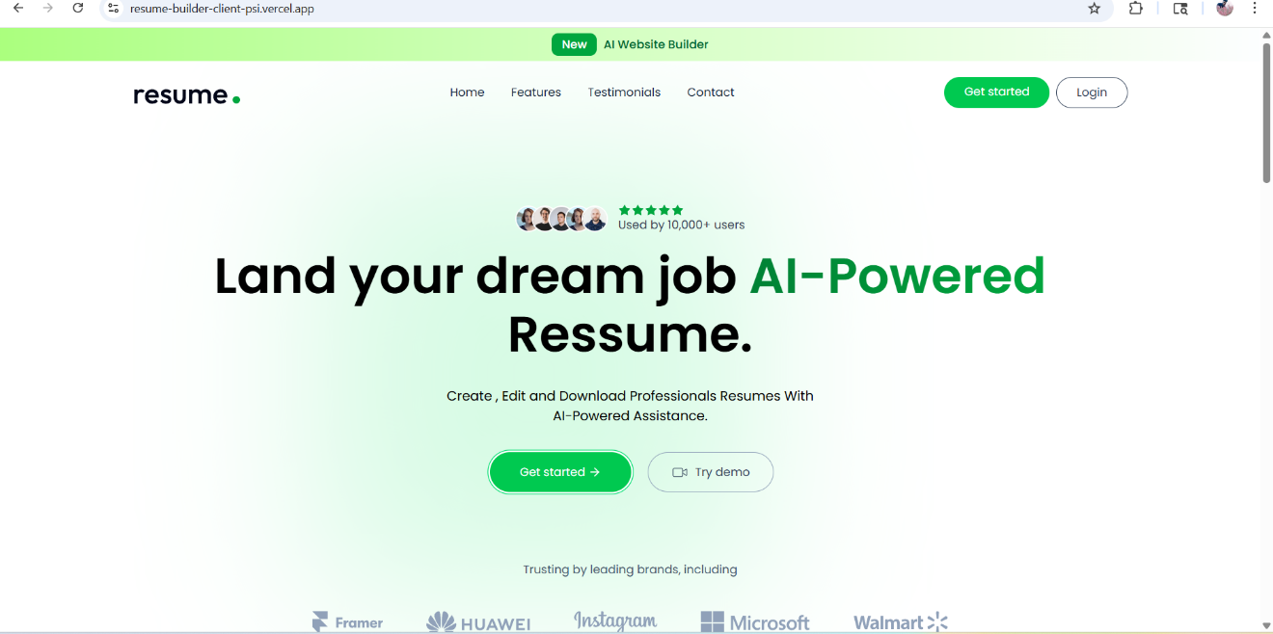

[Figure 5.1] – The login/register screen features a clean, minimal design with form validation and error messaging.

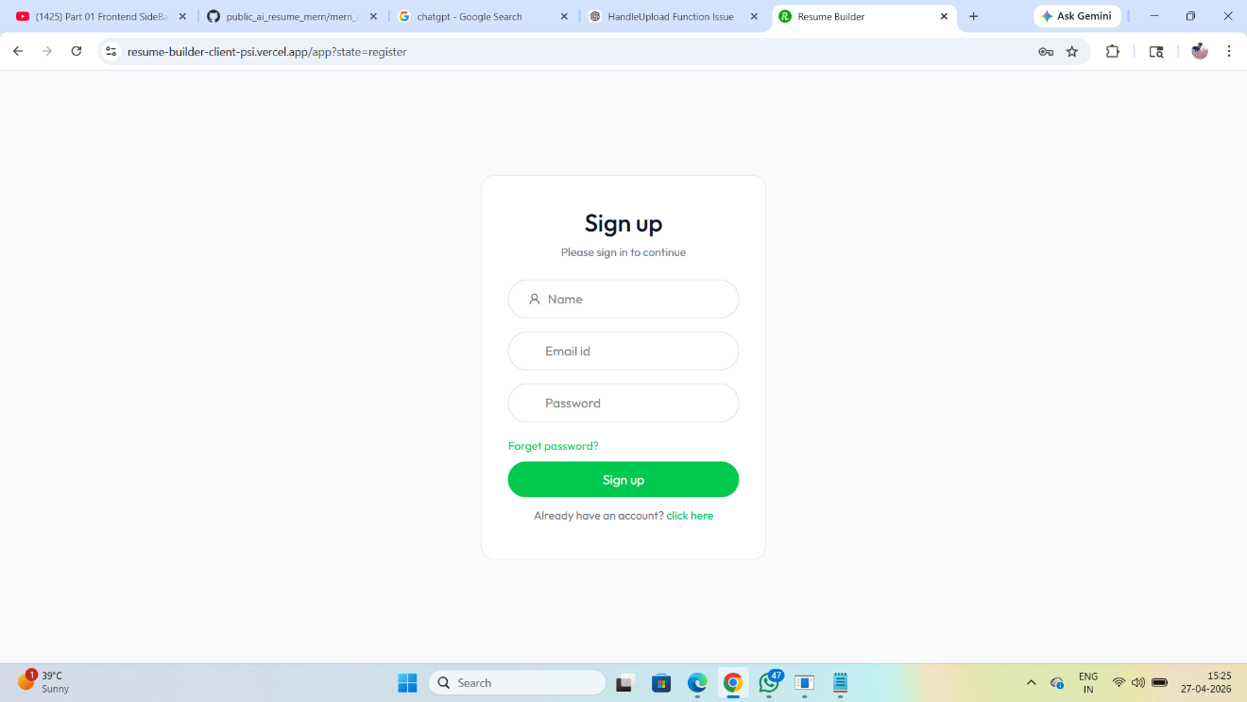
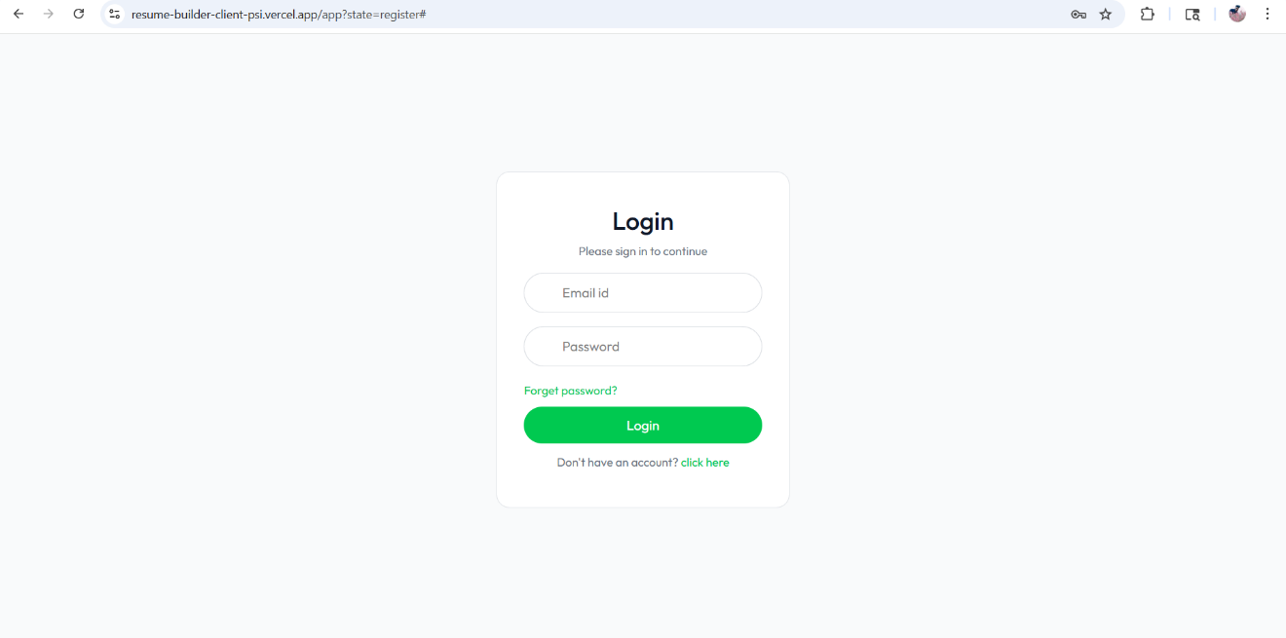

Figure 5.1: User Registration & Login Screen

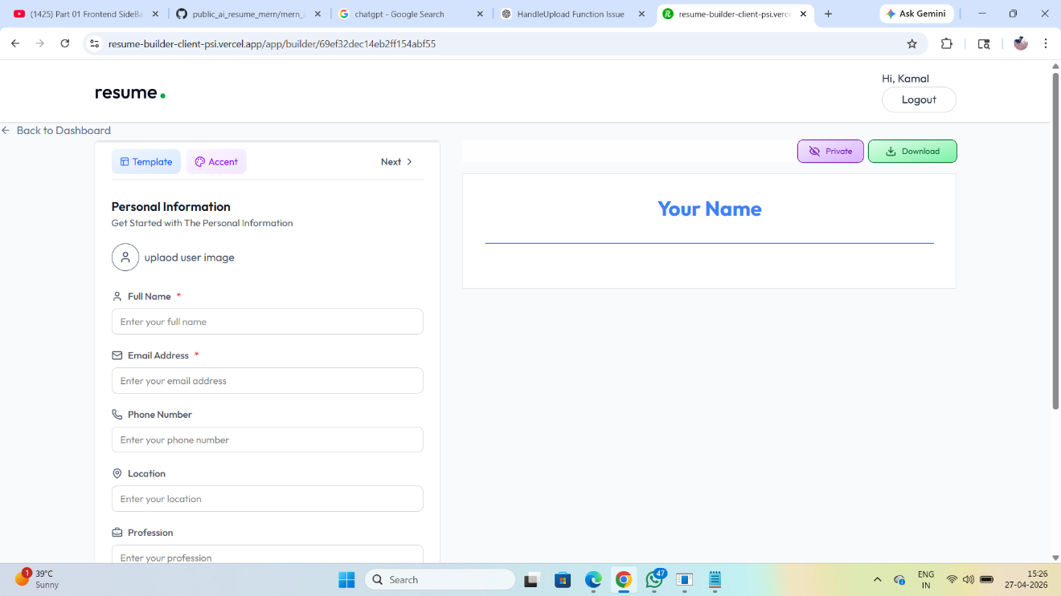

Figure 5.2: Template Selection Screen

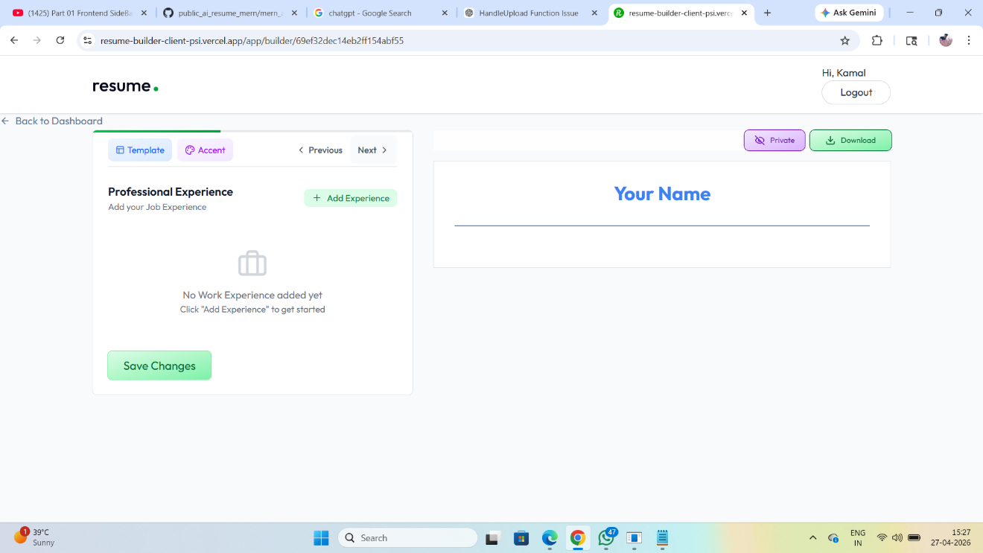

Figure 5.3: Resume Builder – Live Preview Mode

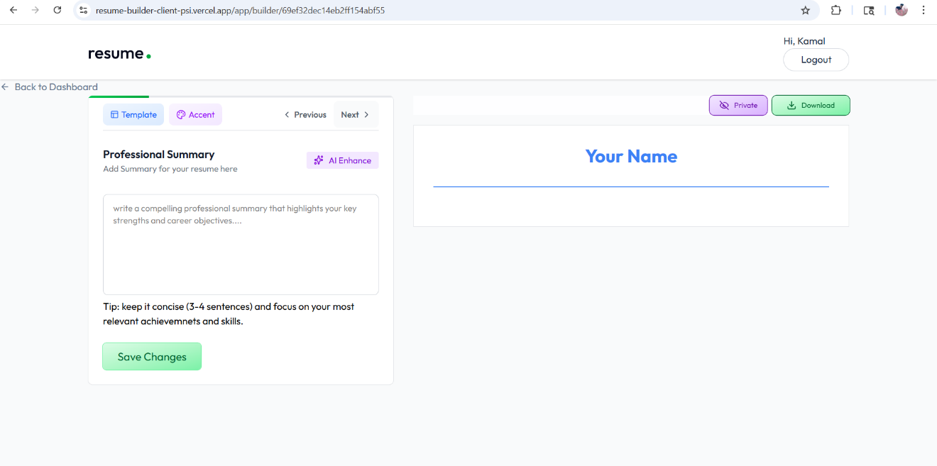

Figure 5.4: AI Optimization in Action

Figure 5.5: Generated Resume – Template 1 Output

5.6 Resume Analyzer Module – Results
The Resume Analyzer module accepts a PDF upload, processes it server-side, and delivers a comprehensive AI-generated report. The following results demonstrate the system working end-to-end.
5.6.1 Sample Analysis Output
Metric | Sample Value (Software Engineer Role) | Notes
Overall ATS Score | 72 / 100 | Above average for a fresh graduate
Skills Score | 78 / 100 | Strong technical stack listed
Experience Score | 65 / 100 | Internship experience, lacks full-time
Education Score | 85 / 100 | B.Tech CSE with good CGPA
Formatting Score | 70 / 100 | Consistent formatting, minor issues
Keywords Score | 60 / 100 | Missing: Docker, CI/CD, Agile, REST API
Top 3 Strengths | MERN Stack, Projects, Education | AI-identified
Top 3 Weaknesses | No quantified achievements, short experience, no certifications | AI-identified
Processing Time | 8.3 seconds | End-to-end from upload to result

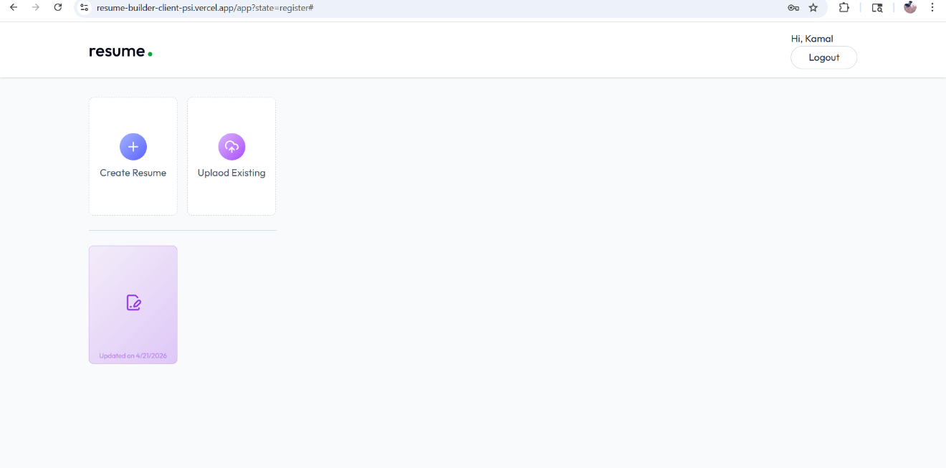

Figure 5.7: Resume Upload Interface

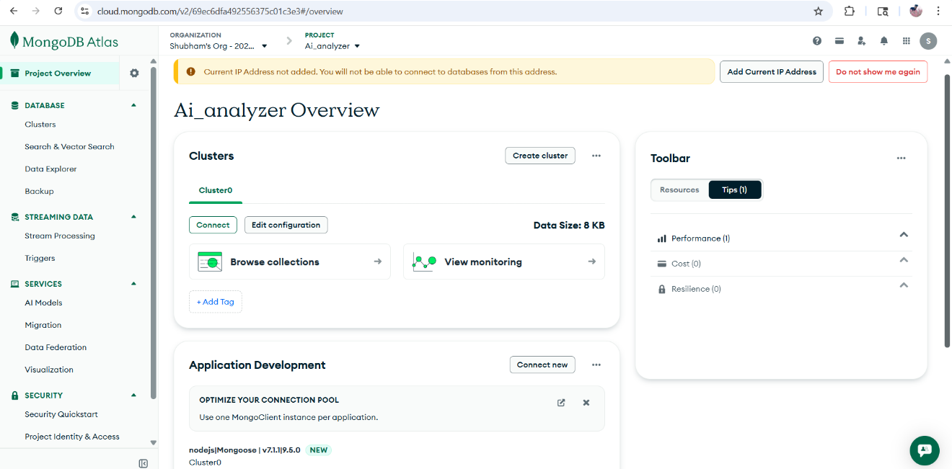

Figure 5.8: AI Analysis Score Dashboard

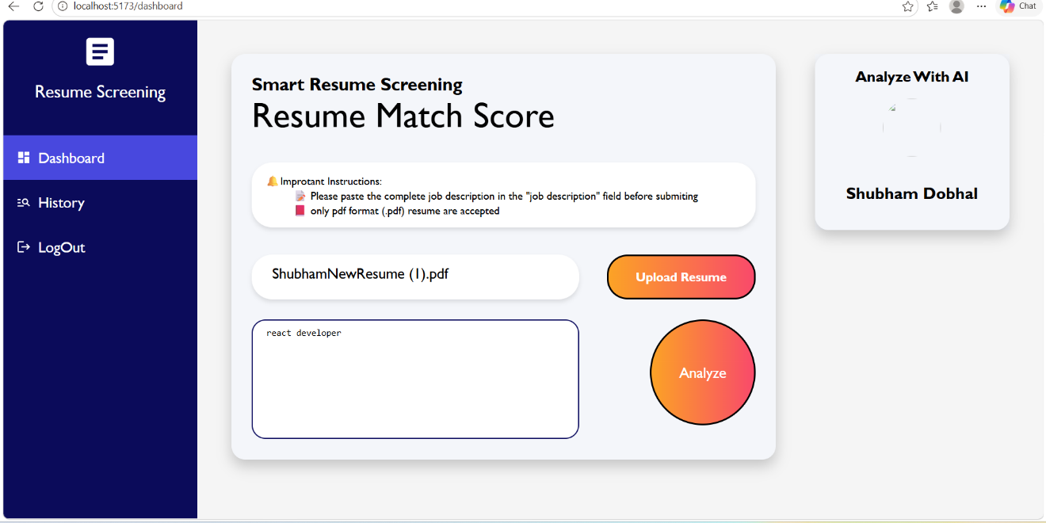

Figure 5.9: Feedback Panel – Strengths & Weaknesses

5.7 Testing
5.7.1 Unit Testing – Backend APIs
Test ID | Test Case | Input | Expected Output | Status
TC-01 | User Registration | Valid email + password | 201 Created + token | PASS
TC-02 | User Registration – Duplicate | Existing email | 400 Email exists | PASS
TC-03 | User Login | Correct credentials | 200 OK + JWT token | PASS
TC-04 | User Login – Wrong Password | Wrong password | 401 Unauthorized | PASS
TC-05 | Create Resume | Valid resume data + token | 201 Created | PASS
TC-06 | Get Resume (Auth) | Valid token | 200 + resume array | PASS
TC-07 | Get Resume (No Auth) | No token | 401 Unauthorized | PASS
TC-08 | Delete Resume | Valid ID + owner token | 200 Deleted | PASS
TC-09 | Upload PDF | Valid PDF < 5MB | 200 + analysis report | PASS
TC-10 | Upload Non-PDF | JPEG file | 400 Only PDF allowed | PASS
TC-11 | Upload PDF > 5MB | Large PDF | 413 File too large | PASS
TC-12 | AI Analysis | Valid resume text + job | 200 + JSON report | PASS

Table 5.3: Backend API Test Cases and Results

5.7.2 Performance Testing

Operation | Avg Response Time | Max Response Time | Result
User Login (API) | 120 ms | 280 ms | PASS (< 500 ms)
Load Resume Dashboard | 1.8 s | 2.9 s | PASS (< 3 s)
Resume Form Save | 210 ms | 450 ms | PASS (< 500 ms)
PDF Export (Client-side) | 3.2 s | 5.1 s | ACCEPTABLE
PDF Upload + Text Extract | 1.1 s | 2.3 s | PASS (< 3 s)
Gemini AI Analysis | 7.8 s | 14.2 s | PASS (< 15 s)
AI Resume Optimization | 4.2 s | 8.6 s | PASS (< 10 s)
Shareable Link Load | 0.9 s | 1.8 s | PASS (< 2 s)

Table 5.4: Performance Test Results

CHAPTER 6

CONCLUSION AND FUTURE SCOPE

6.1 Conclusion
This project successfully designed and implemented an AI-Powered Resume Generator and Analyzer — a full-stack web application that addresses the modern challenges of resume creation and evaluation in an increasingly competitive and ATS-driven recruitment environment.
The system integrates two comprehensive modules: a Resume Generator that enables users to create professional, ATS-friendly resumes through customizable templates with real-time preview and AI-powered content optimization; and a Resume Analyzer that processes uploaded PDF resumes using Google Gemini AI to provide detailed scoring, section-wise feedback, improvement suggestions, and job role recommendations.
The application was built using the MERN stack (MongoDB, Express.js, React.js, Node.js) with Tailwind CSS for the frontend, achieving a modern, responsive user interface. The integration of Google Gemini AI provided sophisticated natural language processing capabilities without requiring custom machine learning model training. ImageKit was used for cloud-based image management including AI background removal for profile photos.
All primary and secondary objectives defined in Chapter 2 were successfully achieved. The system was tested against defined test cases and performance benchmarks, meeting all critical requirements including response time targets, security requirements, and functional completeness.
The project demonstrates practical application of theoretical concepts in software engineering, database design, RESTful API development, cloud deployment, and AI integration — providing a comprehensive learning experience in modern full-stack web development.

Key achievements of the project include:
- Successfully integrated Google Gemini AI for both generative (resume optimization) and analytical (resume scoring) tasks within a single application
- Implemented secure user authentication with JWT and bcrypt, following industry best practices
- Developed a multi-format export system supporting both PDF and DOCX outputs from a web interface
- Created a live shareable resume link system that functions without requiring recipients to have an account
- Deployed a production-ready application on Vercel with MongoDB Atlas cloud database

6.2 Limitations
Despite the comprehensive feature set, the following limitations have been identified:
- AI Accuracy Dependency: The quality of resume analysis and scoring is dependent on the Google Gemini API's response quality, which may vary and is subject to API rate limits and model updates.
- PDF Parsing Limitations: The pdf-parse library may not correctly extract text from scanned (image-based) PDFs or PDFs with complex multi-column layouts, which could affect analysis accuracy.
- No Real ATS Simulation: While the analyzer provides ATS-related feedback, it does not simulate actual ATS software behavior, as those algorithms are proprietary.
- Internet Dependency: The application requires a stable internet connection for all operations, including AI features, and cannot function offline.
- Template Quantity: The current implementation provides 5 templates, which may be limiting for users with highly specific industry requirements.
- No Employer-Side Features: The system focuses entirely on the job seeker's perspective and does not include any recruiter or employer-side functionality.

6.3 Future Scope
The following enhancements and extensions are proposed for future development iterations:
6.3.1 Short-Term Enhancements (6–12 months)
- ATS Simulation Engine: Integrate a real ATS keyword parsing algorithm based on published research to provide more accurate ATS score predictions.
- LinkedIn Profile Import: Allow users to import their LinkedIn profile data directly to auto-populate the resume builder form, reducing manual data entry.
- Cover Letter Generator: Extend the AI capabilities to generate customized cover letters based on the user's resume and a target job description.
- Additional Templates: Expand the template library to 15+ designs covering creative, technical, academic, and executive categories.
- Multi-Language Support: Add internationalization (i18n) support to serve non-English speaking users.

6.3.2 Long-Term Enhancements (12–24 months)
- Employer Portal: Develop a complementary employer-side module where companies can post job descriptions and receive auto-ranked candidate resumes.
- Mobile Application: Develop native iOS and Android applications using React Native to extend accessibility beyond the web browser.
- Fine-Tuned AI Model: Train a domain-specific fine-tuned language model on a large dataset of resume-job description pairs to improve scoring accuracy beyond general-purpose models.
- Job Portal Integration: Integrate with major job portals (LinkedIn, Indeed, Naukri) via their APIs to enable one-click job applications directly from the platform.
- Resume Analytics Dashboard: Provide users with analytics on resume views, link clicks, and application tracking to help them understand their job search performance.
- Collaborative Resumes: Allow mentors, career counselors, or peers to collaboratively review and suggest edits to a user's resume in real time.
- Blockchain Credentials: Integrate blockchain-based credential verification to allow users to add verifiable certifications and degrees to their resumes.

REFERENCES
[1] MongoDB, Inc. (2023). "MongoDB Documentation – Data Modeling." MongoDB Official Documentation. Available: https://www.mongodb.com/docs/
[2] OpenJS Foundation. (2023). "Node.js v18 Documentation." Node.js Official Documentation. Available: https://nodejs.org/docs/
[3] Meta Open Source. (2023). "React – A JavaScript Library for Building User Interfaces." React Official Documentation. Available: https://react.dev/
[4] Vercek, A. (2023). "Express.js 4.x API Reference." Express.js Official Documentation. Available: https://expressjs.com/
[5] Google AI. (2024). "Google Gemini API Documentation." Google AI for Developers. Available: https://ai.google.dev/docs/
[6] Tailwind Labs. (2023). "Tailwind CSS Documentation v3." Tailwind CSS Official Docs. Available: https://tailwindcss.com/docs/
[7] ImageKit. (2023). "ImageKit Documentation – Image Management API." ImageKit Official Documentation. Available: https://docs.imagekit.io/
[8] Fuller, H. (2020). "The ATS Problem: How Applicant Tracking Systems Affect the Job Search." Harvard Business School Working Paper, 20-058.
[9] Auth0. (2023). "JSON Web Tokens Introduction and Best Practices." Auth0 Developer Documentation. Available: https://jwt.io/introduction/
[10] Devlin, J., Chang, M., Lee, K., & Toutanova, K. (2019). "BERT: Pre-training of Deep Bidirectional Transformers for Language Understanding." NAACL-HLT 2019, pp. 4171–4186.
[11] Vercel Inc. (2023). "Vercel Deployment Documentation." Vercel Official Docs. Available: https://vercel.com/docs/

[12] Multer contributors. (2023). "Multer – Node.js middleware for handling multipart/form-data." npm Registry. Available: https://www.npmjs.com/package/multer
[13] pdf-parse contributors. (2023). "pdf-parse – Pure JavaScript Cross-Platform Module." npm Registry. Available: https://www.npmjs.com/package/pdf-parse
[14] McKinsey Global Institute. (2022). "The Future of Work: How Will AI and Automation Affect Work?" McKinsey Report.
[15] Brown, T., et al. (2020). "Language Models are Few-Shot Learners (GPT-3)." Advances in Neural Information Processing Systems (NeurIPS), 33, pp. 1877–1901.
[16] Vaswani, A., et al. (2017). "Attention Is All You Need." NeurIPS, 30.
[17] MongoDB Atlas Documentation. (2023). "Getting Started with MongoDB Atlas." Available: https://www.mongodb.com/atlas/
[18] Fielding, R. T. (2000). "Architectural Styles and the Design of Network-Based Software Architectures." PhD Dissertation, University of California, Irvine.
[19] Mongoose Documentation. (2023). "Mongoose v7 – Elegant MongoDB Object Modeling for Node.js." Available: https://mongoosejs.com/docs/

[20] React Router Documentation. (2023). "React Router v6." Available: https://reactrouter.com/en/main

