**# dataParser**

**Steps to run this application:**

Download the source code from GitHub.

Open node js command prompt and run npm i command.

Run npm start. Now the app is listening to the: 3333 port number.

**Postman configuration:**

Open postman tool and change method to POST.

Now add the api endpoints in the url bar and add request body as json object under body.

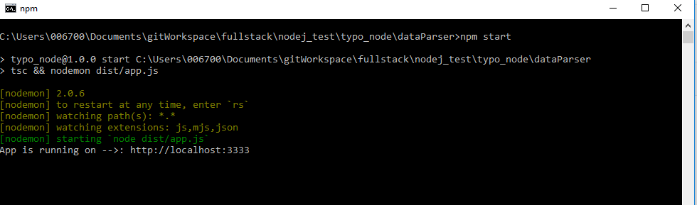

Request Body:

{

data: “JOHN0000MICHAEL0009994567”

}

**/api/v1/parse:**

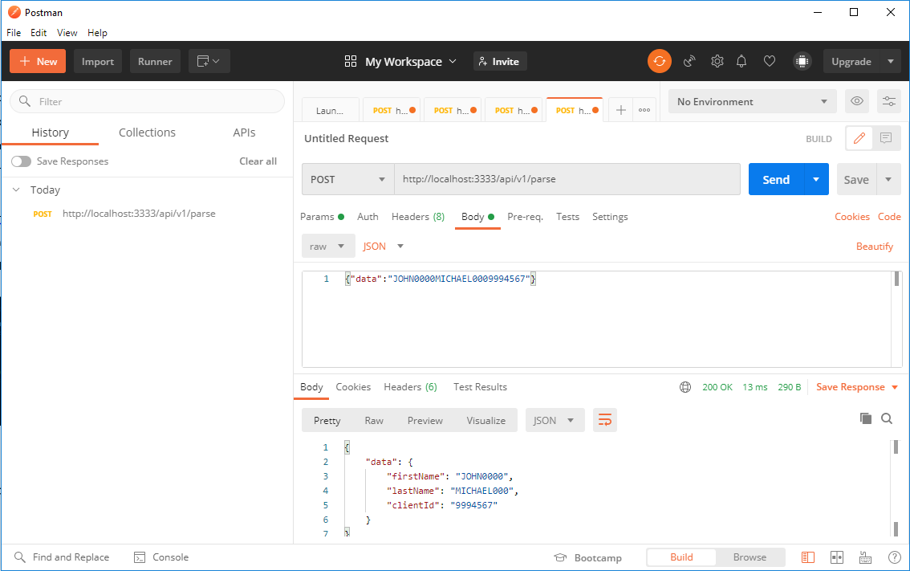

**/api/v2/parse:**

