STARTUP VALIDATION REPORT
Farm Equipment Rental Platform for Smallholder Farmers, India
A mobile marketplace connecting tractor & equipment owners with small farmers who cannot afford to buy machinery outright
Prepared for: Sidh (Founder)
Prepared by: AI Startup Advisory — Validation Desk
Date: June 22, 2026
Verdict: CONDITIONAL GO — Validate Before You Build

Table of Contents

Executive Summary
This report evaluates a proposed mobile platform connecting small and marginal farmers in India with owners of tractors and farm equipment, on a rental basis. The underlying problem — unaffordable mechanization for India's smallholders — is real, large, and well-documented. However, the category is not empty: it already has an organized, OEM-backed market leader (Trringo, by Mahindra & Mahindra), a VC-funded “Farming-as-a-Service” competitor (EM3 Agri Services), several regional players, and a free government-subsidized alternative (Custom Hiring Centres). The opportunity is real, but a generic, undifferentiated rental app is unlikely to win. A focused, hyperlocal wedge is recommended.
Metric | Finding
Problem Validation Score | 8.0 / 10 — strongly validated by public data
Founder-Market Fit Score | 3.6 / 10 — weak on domain expertise, network & validation
TAM (India, illustrative) | ~$4.6–4.9 Bn Gross Transaction Value (bottom-up estimate)
SAM (5 priority states, Yr 1-3) | ~$340–380 Mn GTV
SOM (Year 3, realistic) | ~$22–28 Mn GTV (~0.5–1% of SAM)
Competitive Intensity | High — 1 OEM-backed leader, 1 VC-funded challenger, free govt. alternative
Overall Verdict | CONDITIONAL GO — run a 30-day low-cost validation before building
Table 1: Executive scorecard. Full methodology and assumptions in each section below.

1. Problem Validation
8/10 — Strongly Validated
The core problem statement — small farmers cannot afford to own expensive machinery — is one of the most extensively documented structural issues in Indian agriculture, not an assumption that needs to be taken on faith.

What the data confirms
- India has roughly 146 million operational landholdings, and small & marginal farms (under 2 hectares) make up about 86% of them — over 125 million households.
- The average landholding has shrunk from 1.08 hectares in 2016–17 to just 0.74 hectares in 2021–22, making individual ownership of a tractor or harvester progressively less economical.
- India's farm mechanization rate is estimated at roughly 40–47%, compared with about 95% in the US, 80% in Russia, and 75% in Brazil — a persistent, multi-decade gap, not a temporary dip.
- The Government of India has had to build over 18,800 Custom Hiring Centres, 16,700+ farm machinery banks and 400+ hi-tech hubs specifically because private ownership doesn't work for this segment — itself a strong signal of unmet demand.
- Multiple independent, VC-backed and OEM-backed companies (Trringo, EM3, Gold Farm) have been built and funded around exactly this problem since 2013–2016, and the global “farming-as-a-service” / rental category continues to attract capital a decade later.

Problem severity assessment
Dimension | Rating | Notes
Frequency | Medium | Seasonal — 2–4 critical windows/year (sowing, harvest) per crop cycle
Willingness to pay | Medium-High | Farmers already pay informal contractors / CHCs — spend exists, just informal
Urgency | High | Missing a sowing/harvest window directly costs yield and income
Current alternatives | Several, weak | Word-of-mouth borrowing, local contractor calls, queueing at CHCs
Net read: the problem is real and severe, but it is already being addressed — imperfectly — by incumbents and government infrastructure. This shifts the validation question from “does this problem exist” (yes) to “why would a farmer switch to a new app” (open, see Section 4 & 5).

2. Founder-Market Fit Score
3.6/10 — Needs Strengthening Before Building
Founder-market fit is currently the weakest part of this idea's validation profile — not because the founder lacks ability, but because the answers provided show real gaps in domain depth, on-ground network, and existing proof points. This is fixable, but should be addressed before capital or months of build time are committed.
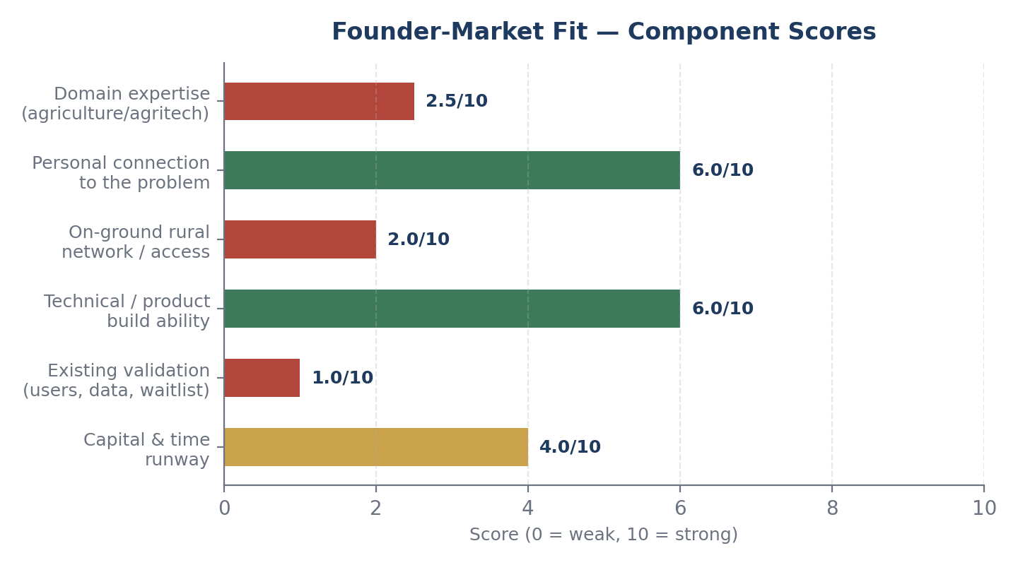
Figure 1: Founder-market fit, scored against six standard VC diligence dimensions (0–10 scale).
Dimension | Score | Why
Domain expertise | 2.5/10 | No stated agriculture, agritech, or rural-operations background yet
Personal connection | 6.0/10 | “Seen and felt the problem” is genuine motivation, but currently undefined — strengthen with specifics
On-ground rural network | 2.0/10 | No mentioned village-level contacts, FPOs, equipment owners, or distribution partners
Technical/product ability | 6.0/10 | Mobile platform is buildable; engineering/product execution risk is moderate, not the bottleneck
Existing validation | 1.0/10 | Idea stage — zero interviews, users, or waitlist signal so far
Capital & time runway | 4.0/10 | Not specified in inputs — assume early-stage/self-funded; flag as open risk
Recommendation: close the validation and network gaps (Sections 13–14) before the domain-expertise gap becomes a fatal flaw. The fastest fix is not a course or certification — it's 25–30 real farmer conversations and a handful of equipment-owner conversations, in person, in the target district.

3. TAM, SAM, SOM Analysis
The global farm equipment rental market was valued at roughly $60–61 billion in 2025, projected to reach $89–112 billion by 2034–2035 (CAGR ~4.4–6.1%, depending on source). Asia-Pacific is the largest region (~35% share, ~$21.3 billion in 2025), with India repeatedly cited as a primary growth driver alongside China, due to its enormous base of small landholders and active government mechanization push.
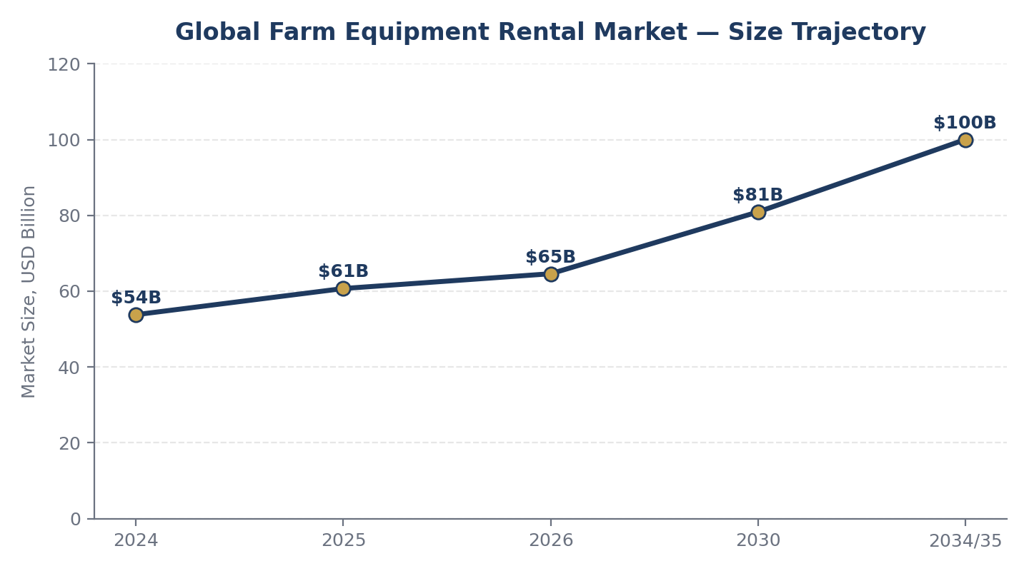
Figure 2: Global farm equipment rental market size trajectory (blended estimate across IMARC, Precedence Research, Mordor Intelligence, Fact.MR).

Bottom-up India estimate (illustrative)
No public report isolates an India-only rental GTV figure, so the estimate below is built bottom-up from farm-count and spend assumptions. Treat it as a directional planning tool, not a market-research-grade number — validate the per-farm spend assumption directly with farmers in Week 1 of the action plan (Section 14).
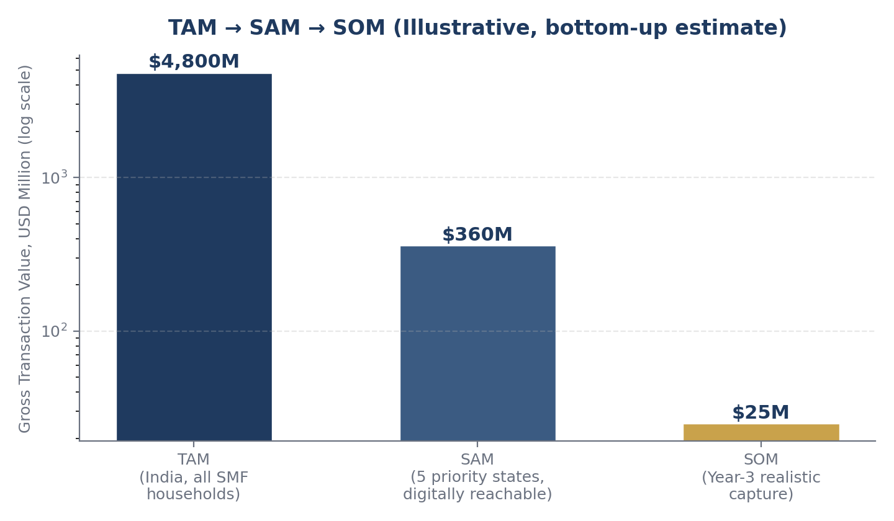
Figure 3: TAM → SAM → SOM funnel, illustrative bottom-up estimate (log scale).
Layer | Population | Est. GTV | Key assumption
TAM | ~100M small/marginal farm HH, India-wide | ~$4.6–4.9 Bn/yr | ~₹4,000/farm/yr average rental spend across all mechanized operations
SAM | ~50M HH in 5 priority states (UP, Bihar, MP, Maharashtra, Rajasthan) × ~15% realistically digital-reachable | ~$340–380 Mn/yr | Smartphone access + willingness to try a digital booking channel within 5 years
SOM | ~0.5–1% of SAM captured by Year 3 | ~$22–28 Mn/yr GTV | Single-state or multi-district density-first rollout, not a national launch
Platform revenue is a take-rate of GTV (most rental marketplaces in this space monetize at roughly 8–15% commission), not the GTV itself — so Year-3 realistic platform revenue on the SOM above would be in the rough range of $1.8–4.2 million annually, before factoring in operating costs.

4. Competitor Analysis
This is the single most important section to internalize: this is not a blank market. At least three well-capitalized or government-backed alternatives already serve the exact target customer.
Player | Model | Backing | Strength / Weakness
Trringo | On-demand tractor & implement rental, franchisee network, fixed rates with trained operators | Mahindra & Mahindra (OEM) | + Deep capital, manufacturer trust, pan-India reach  – Slower digital innovation, less self-serve in many regions
EM3 Agri Services | “Farming-as-a-Service” — pay-per-use, end-to-end mechanized operations via app | VC-funded ($3.3M + $10M rounds, Aspada / GIF) | + Holistic service beyond pure rental, sticky model  – Concentrated in central India, limited recent visible scale-up
Gold Farm | Tech-driven equipment marketplace with strong on-ground logistics support | Private, multi-state | + Strong on-ground execution and logistics  – Lower brand recognition outside core states
Government CHC network | 18,800+ Custom Hiring Centres, state apps (Punjab Ag. Univ., Bihar pilot, Tamil Nadu E-Vadagai) | Central + state govt., subsidized | + Free or near-free to farmer, trusted institution  – 50km radius limits, inconsistent UX, slow booking
Regional apps | KhetiGaadi, KisanRaja, Sonalika Agro, Agrorent, JFarm — fragmented, state/district-level | Mostly bootstrapped | + Local trust, niche focus  – Low funding, limited scale, weak brand
Table: competitive landscape, India farm equipment rental, 2026.
Implication: competing head-on as “yet another rental app” against an OEM-backed leader and a free government channel is a weak position. Differentiation has to come from depth of execution in a narrow geography, a different business model layer (Section 6 & 12), or a wedge the incumbents are not optimizing for.

5. Market Gap Analysis
Despite real competition, India's mechanization rate is still only ~40–47%, against 75–95% in comparable economies. That gap means total addressable demand is larger than what current players have managed to capture — there is room, but it has to be won on execution, not on “building the first app.”
- Geographic gap: most digital platforms cluster in Maharashtra, Punjab, and parts of central India; large smallholder populations in eastern UP, Bihar, West Bengal, and the North-East remain underserved by app-based options.
- Trust/UX gap: most target farmers are not native app users — a booking flow built around WhatsApp, IVR/voice call, or a village-level human agent will likely out-convert a pure self-serve app in Tier 3/4 geographies.
- Operator trust gap: verified, insured, trained operators are weakly standardized outside Trringo's network — a credible safety/insurance layer is a real differentiator, not a feature checkbox.
- Bundled-service gap: EM3's FaaS model (rental + advisory + post-harvest) is proven but only regionally deep — a single-district, fully bundled “do everything for this farm” model is still open.
- Supply-side gap: medium/large farmers (4–10 ha) with idle equipment between seasons are an underused supply pool in many districts — a hyperlocal “idle-tractor aggregator” model can win on density before it needs to win on brand.

6. Ideal Customer Profile (ICP)

Primary ICP — Demand side (the renter)
Attribute | Profile
Landholding | Small/marginal, under 2 hectares (the ~86% majority segment)
Geography | High-density smallholder states first: Uttar Pradesh, Bihar, Madhya Pradesh, Maharashtra
Crop pattern | Cereal-dominant (paddy/wheat) with 2–3 mechanization-dependent windows per year
Equipment ownership | None owned; currently borrows informally or hires a local contractor / CHC
Digital access | Basic smartphone in household (often used by a younger family member), active WhatsApp user

Secondary ICP — Supply side (the equipment owner)
Medium farmer or local contractor owning 1–2 tractors/implements (4–10 ha equivalent capacity), with idle equipment time between his own usage windows, seeking incremental income — the actual supply liquidity engine of the marketplace.

7. Buyer Persona
“Ramesh” — Demand-side Persona | Details
Age / Location | 42, small village in eastern Uttar Pradesh
Land | 1.2 hectares, grows wheat (rabi) and paddy (kharif)
Today's workaround | Borrows a neighbor's tractor when free, or calls a known local contractor and negotiates by phone/in person
Device | Shares a basic Android phone with his son; comfortable with WhatsApp and calls, not with most other apps
Trust signal | Word-of-mouth from neighbors carries far more weight than any advertisement
Price sensitivity | High — will compare against the free/subsidized CHC rate before paying a platform
Critical moment | The 7–10 day sowing/harvest window — equipment availability matters more than price at the margin

8. Customer Pain Points
- Equipment is unavailable exactly when needed — demand spikes hard during sowing/harvest, supply doesn't flex.
- No price transparency — contractor rates are negotiated case-by-case, often inflated for less-connected farmers.
- Operator skill and equipment damage risk — no verification standard for who's driving the tractor.
- Distance to the nearest CHC or reliable contractor can be significant in remote villages.
- No fallback if booked equipment breaks down mid-task, during a time-critical window.
- Cash-based, informal payment — no receipts, no recourse if shortchanged or overcharged.

9. Buying Triggers & Objections

Triggers
- Sowing or harvest season approaching (the only real urgency window).
- A neighbor's positive word-of-mouth after using the service.
- Crop-sale or loan-disbursement timing, when cash is briefly available.
- Government scheme awareness drives or CHC capacity being full.

Objections
- “This app is for my son, not for me” — low personal digital literacy.
- “I don't trust paying online for something I haven't seen yet.”
- “What if the tractor doesn't actually show up on time?”
- “The government centre is free/cheaper — why would I pay you?”
- “I already have a guy I call.” — existing informal relationship is sticky.

10. Customer Journey
Awareness | Consideration | Trial | First Use | Repeat | Advocacy / Churn
Village agent or neighbor mentions the service | Compares price vs. local contractor and CHC | Books one low-stakes job first (e.g. small plot) | Judges on punctuality, operator skill, fair pricing | Books again next season if trust was earned | Refers neighbors, or churns back to old contractor on any failure
The pivotal moment is “First Use”: a single late arrival, breakdown, or price surprise will likely cause permanent churn back to the informal system, given how thin the trust margin is for a first-time digital booking.

11. Risk Assessment
Risk | Likelihood | Impact | Mitigation
Incumbent competition (Trringo/EM3/CHC) | High | High | Win one district fully before expanding; differentiate on trust/operator-verification, not just app UX
Low digital literacy / app adoption | High | Medium | WhatsApp/voice-call-first booking; village-level human agents as the actual interface
Thin unit economics (low ticket, high logistics cost) | High | High | Density-first rollout to cut dead-mileage; bundle services to raise basket size
Seasonal demand concentration | Medium | Medium | Diversify crop/equipment mix and states with staggered sowing/harvest calendars
Operator/equipment liability (accidents, damage) | Medium | High | Operator verification program; partner with an insurer for a basic liability product
Capital intensity if owning a fleet | High | High | Stay asset-light: pure marketplace, never own tractors directly
Regulatory / subsidy dependency | Low-Med | Medium | Build value (trust, speed, verification) independent of any specific subsidy scheme

12. Pivot Opportunities
- B2B2C: white-label the booking/dispatch layer for FPOs (4,000+ registered Farmer Producer Organizations) and existing CHCs, instead of competing directly for farmer attention.
- Narrow to one crop-cluster or one district and out-execute incumbents on density and response time before expanding.
- Equipment financing/insurance layer: usage data from rentals can feed underwriting for micro-leasing or crop-machinery insurance products.
- Sell a supply-tracking / dispatch SaaS layer to existing players (CHCs, smaller regional rental businesses) rather than competing with them head-on.
- WhatsApp- or IVR-only booking product for the large segment of farmers who will never comfortably self-serve through an app.
- Bundle rental with advisory and post-harvest services (EM3's FaaS model), but executed hyper-locally in a single district rather than spread thin regionally.

13. Go / No-Go Recommendation
CONDITIONAL GO — Validate Before You Build
The underlying problem is large and genuinely unsolved at scale — mechanization in India still lags comparable economies by 30–55 percentage points, and government infrastructure alone hasn't closed that gap. That is a real reason to keep working on this.
However, building a full-featured generic rental app right now, without first talking to farmers and equipment owners on the ground, carries high risk of building something Trringo, EM3, or the local CHC already do better and cheaper. The recommendation is not “stop” — it is “do not write production code yet.”

Conditions to convert this to a full GO
- Complete the 30-day validation plan below and find at least one wedge (geography, crop, or service layer) where you can credibly out-execute the incumbents.
- Get 10+ real farmers to say they would pay for and actually use a manual/no-code version of the service — not hypothetical interest, an actual booking.
- Identify a concrete answer to “why not the free government CHC” for your specific target customer.

14. 30-Day Action Plan
Week | Focus & Tasks
Week 1 | Conduct 25–30 in-person/phone interviews with small farmers in one target district.  Validate: current spend on rental/mechanization, biggest frustration, willingness to pay for a faster/more reliable option, and awareness of CHCs/Trringo/EM3 in that area.
Week 2 | Interview 10–15 equipment owners (tractor/implement owners, local contractors) about idle time and willingness to list on a platform for a cut of bookings.  Mystery-shop the 2–3 nearest real alternatives (CHC, Trringo, local contractor) to learn actual on-ground pricing and turnaround time.
Week 3 | Build a manual/no-code MVP: a WhatsApp number or simple phone line + a spreadsheet-based booking and dispatch system — no app yet.  Run a real pilot with paying bookings in one village or crop cluster.
Week 4 | Measure: completed bookings, repeat usage, referral/word-of-mouth signal, and real unit economics (cost to serve a booking vs. revenue captured).  Make the Go/No-Go call on building the actual app, based on real data rather than the assumptions in this report.
Closing note: this report is a structured starting point built from public market data and the inputs provided, not a substitute for direct customer discovery. Every number above — especially the TAM/SAM/SOM estimates — should be treated as a hypothesis to test in Week 1, not a fact to build a pitch deck around.

