BUSINESS STRATEGY & INVESTMENT REPORT
Farm Equipment Rental Platform for Smallholder Farmers, India
Can this become a sustainable, fundable business — not just a validated problem?
Prepared for: Sidh (Founder)
Prepared by: AI Co-Founder & Growth Strategy Desk
Source: Day 23 Customer & MVP Blueprint (June 22, 2026)
Verdict: VALIDATE — Real Problem, Unproven Business Model

Table of Contents

Startup Summary & Assumptions

What this is, in 8 bullets
- A mobile/WhatsApp marketplace connecting India's 125M+ small/marginal farmers (renters) with equipment owners who have idle tractors and implements (supply).
- Core problem: farmers can't afford to own machinery; mechanization in India sits at ~40–47% vs 75–95% in comparable economies.
- MVP is deliberately not an app: a WhatsApp/voice-call booking flow with a human dispatcher matching demand to listed supply in ONE district.
- Monetization: 8–12% commission on each booking's transaction value, charged to the equipment owner, not the farmer.
- Already-validated insight: the problem is real (Problem Severity 80/100), but Customer Clarity (55), PMF Potential (42), and MVP Readiness (38) are all unproven.
- Direct competitors already exist: Trringo (Mahindra-backed), EM3 Agri Services (VC-funded), and free government Custom Hiring Centres (CHCs).
- Go-to-market is hyperlocal and human-powered: village agents and word-of-mouth, not paid digital acquisition.
- Stated ambition: a real startup, not a side project — founder explicitly wants VC-scale impact, not a lifestyle business.

Extracted assumptions
Dimension | Assumption as stated in the Blueprint
Customer | Small/marginal farmer (demand) + medium farmer/contractor (supply); both reachable via WhatsApp/voice
MVP | Manual WhatsApp/call dispatch in one district; no app, no owned fleet at this stage
Value proposition | Faster, more reliable, fairly-priced access to machinery than informal contractors; incremental income for idle-equipment owners
Pricing | 8–12% commission, paid by the owner per completed booking — untested, 3 price points to be trialed
Revenue model | Take-rate on Gross Transaction Value (GTV); no other stated revenue line
GTM | Village agents + word-of-mouth + district-first density, not paid acquisition or app-store discovery

1. Business Reality Check
Question | Honest Answer
Who pays? | The equipment owner pays the commission — not the farmer directly. Revenue exists only if owners keep transacting through the platform repeatedly.
Why do they pay? | Because the platform brings them demand (bookings) they would not otherwise reach — incremental income on an idle asset is the only reason to tolerate a fee.
How is it discovered? | Entirely offline-to-online: village agents and neighbor word-of-mouth. There is no stated digital acquisition channel — discovery is slow and hard to systematize at scale.
Biggest growth risk? | The model depends on a human dispatcher per district — this does not scale the way a self-serve app does. Growth requires hiring/training a dispatcher in every new district, one at a time.
Biggest monetization risk? | Disintermediation: once a farmer and an owner are matched once, nothing stops them from transacting directly next season to avoid the fee — the single largest threat to recurring revenue in this model.
Weakest assumptions to validate? | Owners will tolerate an 8–12% fee rather than negotiate around the platform after the first match  Average per-farm rental spend (~₹4,000/yr) used in the TAM model  Dispatcher cost per booking is lower than commission earned per booking
Net read: this is a real problem with a fragile revenue model. Every dollar of revenue depends on (a) owners not cutting the platform out after the first transaction, and (b) a manual dispatcher operation staying cheaper than what it earns — neither has been tested.

2. Executive Summary
The underlying demand is genuine and well-documented: India's mechanization gap is structural, not cyclical. But “people need this” is not the same claim as “people will pay a marketplace fee for this, repeatedly, instead of going around it.” This report's central finding is that the business's hardest problem is not customer acquisition — it is retention and fee-capture in a market built on informal, cash-based, trust-driven relationships that are easy to disintermediate.
The recommendation is not to abandon the idea, but to treat the next 30–60 days as a test of the business model itself — specifically, whether owners will keep paying a commission after the first booking — rather than only testing whether farmers will book at all.

3. Business Model Canvas
Customer Segments | Value Propositions | Channels
Small/marginal farmers, <2 ha  Medium farmers/contractors with idle equipment | On-time, fairly-priced machinery access  Incremental income on idle assets | Village agents  Word-of-mouth  WhatsApp Business
Customer Relationships | Revenue Streams | Key Resources
Human dispatcher (trust broker)  Repeat-season relationship | 8–12% commission per booking (owner-paid) | Dispatcher(s)  Verified operator network  Village agent relationships
Key Activities | Key Partners | Cost Structure
Manual matching/dispatch  Operator verification  Owner & farmer recruitment | Village agents  Possible FPO partnerships  Insurance partner (later) | Dispatcher salary/time  Agent incentives  Verification costs

4. Revenue & Pricing Strategy
Single revenue line: commission on GTV, paid by the supply side. This is the right party to charge (farmers are more price-sensitive and have a free government alternative), but the rate itself is unvalidated.
Price point to test | Owner-side logic | Risk
6–8% | Lower friction to first listing, easier to win initial supply | May be too thin to cover dispatcher cost per booking
8–12% | Matches stated hypothesis; comparable to other rental marketplaces | Untested whether owners tolerate this after first match
12%+ | Improves unit economics fastest if it holds | Highest disintermediation risk — owners most likely to go around it
Recommendation: launch at the lower end of the range (6–8%) during the pilot to remove price objection as a variable, and measure repeat-booking-through-platform rate before ever raising it.

5. Go-To-Market Strategy
- Phase 1 — Single district: win density before brand. Recruit 5–10 equipment owners and run real, paid bookings with one human dispatcher.
- Phase 2 — Trust compounding: use the first 15–20 successful bookings as the word-of-mouth engine — no paid acquisition until organic referral rate is measured.
- Phase 3 — Adjacent district expansion: only after Phase 1 proves owners keep paying the commission on repeat bookings, not just the first one.
- Distribution channel priority: village agents > word-of-mouth > WhatsApp Business presence > (much later) any app-store/digital channel.

6. Customer Acquisition Strategy
Channel | Role & Cost Profile
Village agents | Primary channel — low cash cost, high trust, slow to scale; pay small per-booking referral incentive
Word-of-mouth | Free but entirely dependent on flawless first-use experience — the real growth engine if it works
Mystery-shop & direct outreach | Used to recruit initial equipment-owner supply directly, not farmers
Govt./FPO partnerships | Longer-term, low-cost distribution if Farmer Producer Organizations can be co-opted rather than competed with

7. First 100 Users Plan
Stage | Plan
Wk 1–2 | 25–30 farmer + 10–15 owner interviews to confirm willingness to pay and list
Wk 2 | Recruit and verify 5–10 equipment owners as initial supply
Wk 3 | Run 15+ real, paid bookings through the WhatsApp/call dispatcher in one village/cluster
Wk 4+ | Convert word-of-mouth referrals to grow from ~30 to 100 real, paying users within the district
The goal of the first 100 users is not vanity adoption — it's proof that at least 25% of them book a second time through the platform rather than going direct to the same owner.

8. Competitive Position & Moat
There is currently no defensible moat. Trringo has OEM capital and brand trust; EM3 has a VC-funded head start and a broader FaaS bundle; government CHCs are free. The only realistic moat available to a new entrant is execution-based and earned over time:
- District-level supply density — having more verified, reliable equipment available faster than anyone else in one specific area.
- A verified-operator trust layer — weak industry-wide, and the most plausible wedge given how much trust drives this category.
- Deep village-agent relationships — slow to build, but also slow for a larger competitor to replicate cheaply.
None of this exists yet. It is a hypothesis about where a moat could be built, not a current advantage.

9. Reverse SWOT Analysis
A reverse SWOT looks for the hidden flip side of each standard quadrant — where a strength conceals a risk, and a threat conceals an opportunity.
Quadrant | The Hidden Flip Side
Strength → hidden weakness | Real, severe problem (Strength) makes it easy to mistake “people need this” for “people will pay a recurring fee for this” — the actual unvalidated claim.
Weakness → hidden strength | No app, no funding, no team (Weakness) forces a cheap, manual, district-first test — exactly the right-sized experiment for this stage, not a compromise.
Opportunity → hidden threat | Large addressable market (Opportunity) invites premature multi-state ambition — the real threat is expanding before the disintermediation question is answered in even one district.
Threat → hidden opportunity | Free government CHCs (Threat) are also inconsistent and slow — a partnership or white-label layer for CHCs/FPOs could turn the biggest competitor into a distribution partner instead.

10. Investor One-Liner & 30-Second Pitch

Investor one-liner
“A trust-first, WhatsApp-native marketplace bringing affordable mechanization to India's 125 million smallholder farmers, monetized through a per-booking commission on idle farm equipment.”

30-second founder pitch
“Eighty-six percent of India's farmers can't afford a tractor, and the apps and government programs that exist today still leave most of them underserved. We're building a WhatsApp-first booking layer that connects them directly with nearby equipment owners who have idle machinery — starting with one district, a human dispatcher, and a simple commission model, so we can prove farmers will book and owners will keep paying before we build anything more complex.”

11. Founder Action Sheet — Top 10 Actions
# | Action
1 | Pick one pilot district and commit to it for the full 30–60 day test — resist the urge to spread thin
2 | Run 25–30 farmer interviews focused on actual past spend, not hypothetical interest
3 | Run 10–15 equipment-owner interviews testing reaction to a real commission rate, not a hypothetical one
4 | Launch at the lowest tested commission rate (6–8%) to remove price as a pilot variable
5 | Track every booking's source: first-match vs. repeat-through-platform vs. suspected disintermediation
6 | Build one simple anti-disintermediation lever (e.g., owner incentive for booking through platform, fast payment, dispute protection)
7 | Recruit and verify 5–10 equipment owners as initial pilot supply
8 | Run 15+ real, paid bookings and measure the 25%+ repeat-through-platform target explicitly
9 | Calculate true dispatcher cost per booking against commission earned — confirm unit economics are positive before any hiring
10 | Make the Go/No-Go call on raising capital or expanding districts based on the repeat-and-retention data, not on booking count alone

12. Investment Scorecard (0–100)
Score | Value | Reasoning
Business Viability | 45 | Real demand and a workable asset-light model, but disintermediation risk is structural, not incidental
Revenue Potential | 38 | Take-rate squeezed between a free government alternative and a high disintermediation risk on the supply side
GTM Strength | 50 | Cheap, plausible hyperlocal channel, but inherently slow and dispatcher-dependent to scale
Competitive Strength | 30 | No moat exists yet against an OEM-backed leader, a VC-funded challenger, and a free government option
Investor Readiness | 25 | Pre-revenue, idea-stage, no pilot data — not fundable in current form regardless of market size
Average | 37.6 | Below the threshold most early-stage investors would engage with — pilot data is the unlock, not a better deck

13. Visual Dashboard
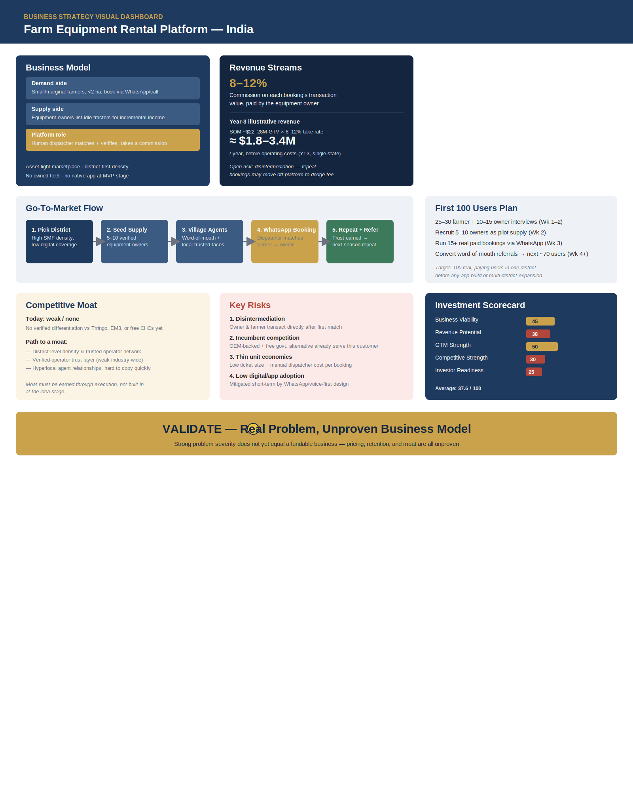
One-page visual summary: business model, revenue streams, GTM flow, first-100-users plan, competitive moat, key risks, scorecard, and final verdict.

14. Sustainability Verdict
VALIDATE — Real Problem, Unproven Business Model
This is not yet a sustainable business — it is a well-documented problem paired with an unproven revenue mechanism. The mechanization gap is real, but the commission model rests on owners not disintermediating the platform after the first match, and no evidence yet exists either way. Sustainability hinges on one specific, testable number: the percentage of bookings that happen a second time through the platform rather than directly between the same farmer and owner — everything else in this report is downstream of that single metric.

