In Automation testing framework I have used Extent Reporting which will provide detailed HTML report as below.

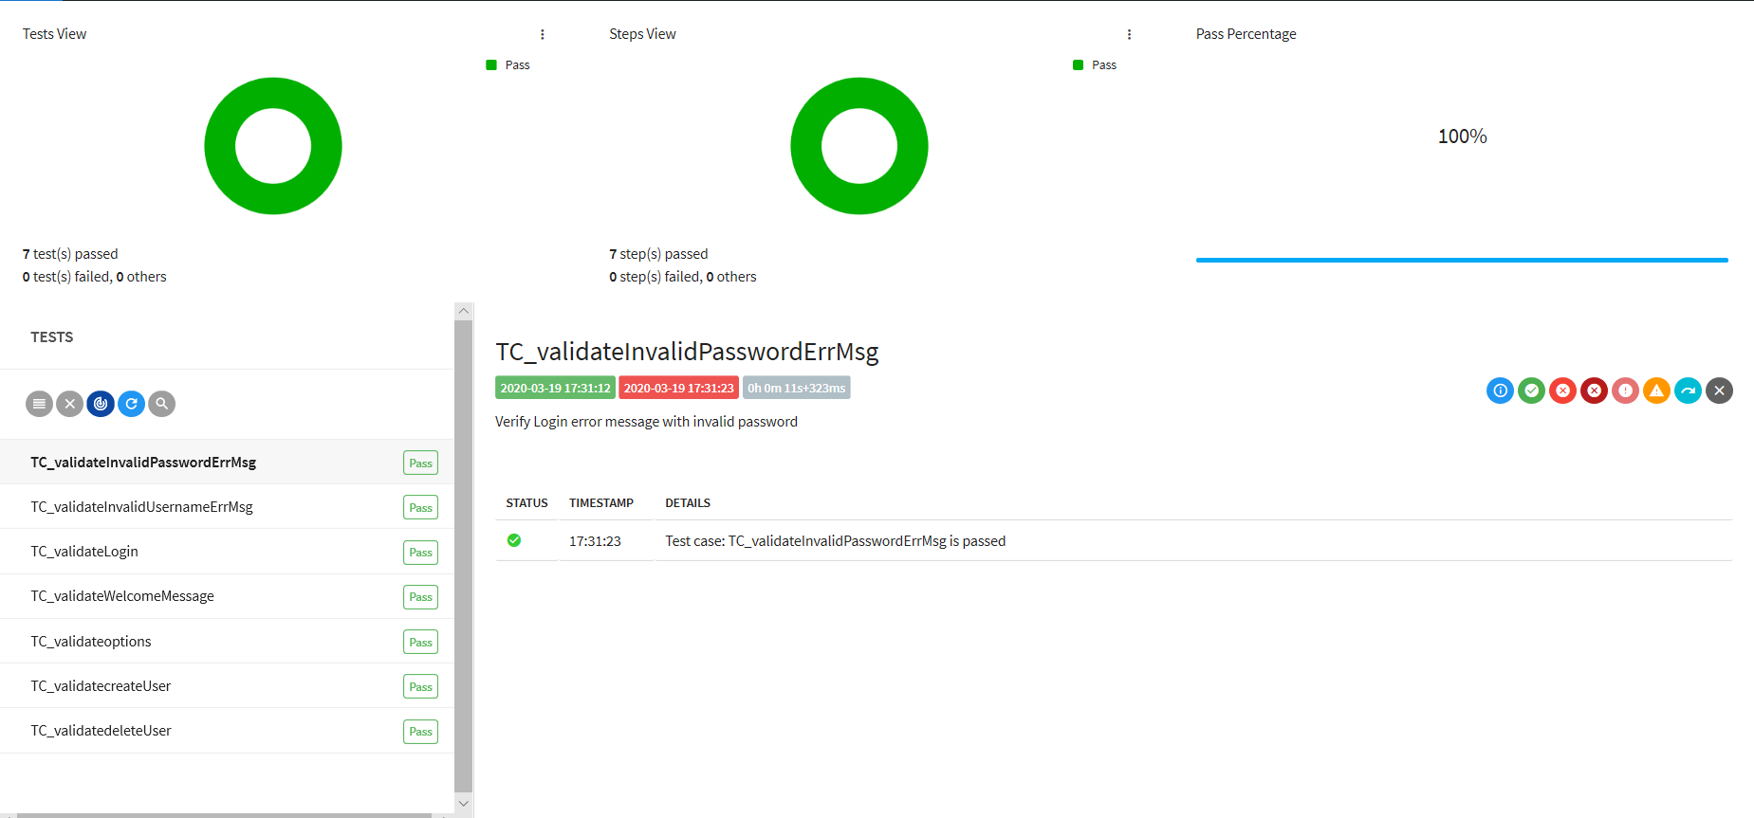

Note: Above is the real time execution done for the 7 automated test script

**Result metrics with Template**

* ***Execution Report:***



* ***Defects Report:***

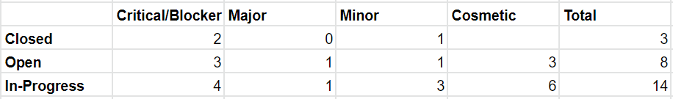

Note: All data are randomly generated.