

Change Management

Version: | 20.17.02

Table of Contents

1. Mission 3
2. Description 3
2.1 Change Registration 5
2.2 Change Planning 7
2.3 Change Approval 9
2.4 Infrastructure Change Implementation 11
2.5 Application Change Implementation 13
2.6 Planned Change Closure 15
2.7 Emergency Change Implementation 17
2.8 Emergency Change Closure 19
3. Scope 21
4. Roles and Responsibilities 21
5. KPIs 22
6. Beneficiaries 23
7. Owner 24

Mission
The mission of the Change Management process is to implement changes in the most efficient manner, while minimizing the negative impact on customers when changes are implemented.

Description
The Change Management process consists of eight procedures: six for implementing planned changes, and two for implementing emergency changes.

Change Registration is used by change coordinators when they are dealing with change requests.

Change Planning is used by change coordinators and specialists to prepare the implementation plans for planned changes.

Change Approval is used by the change manager and change approvers (that is, customer representatives and service owners) to approve planned changes.

Infrastructure Change Implementation is used by specialists to implement infrastructure changes.

Application Change Implementation is used by specialists, release administrators, customer representatives and change coordinators to implement application changes.

Planned Change Closure is used by specialists when they perform a final production test after a change has been implemented and by change coordinators when they close out a change.

Emergency Change Implementation is used by specialists and release administrators to implement changes to resolve incidents.

Emergency Change Closure is used by specialists and change coordinators to complete and close out emergency changes.

For details about these procedures, click on the boxes that represents the procedures. The graphical representation of a procedure appears with its description in the right-hand pane.

Change Management Process
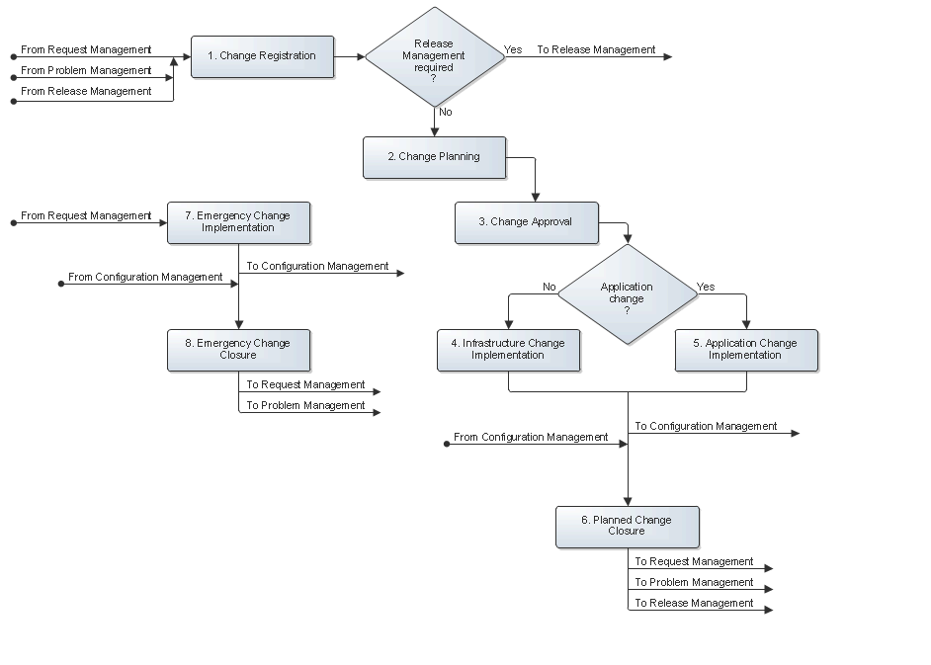

Change Registration
The change coordinator receives the change requests for the services that the change coordinator coordinates the changes of. The change requests can originate from four sources:
- Request Management, in the form of requests
- Problem Management, in the form of problems with the status "Change Requested"
- Release Management, in the form of documents that detail the requirements

Upon receiving a change request, the change coordinator determines whether it can be added to a change that has already been registered. If this is the case, the change coordinator links the change request to the existing change to optimize efficiency.
If the change request asks for the implementation of a standard change, the change coordinator uses the change template that w0as created for the standard change to register a new change, and links the request to it. The change coordinator subsequently follows the workflow that was copied from the template to get the change implemented.
If the change request is not a request for a standard change, the change coordinator checks the request to ensure that it does not conflict with internal standards or policies. If it does conflict, the change request is rejected and the requester is informed of the internal standard or policy that the request conflicts with.
If there is no conflict, the change coordinator determines whether the change implementation really needs to be coordinated by Change Management. This is only necessary when the implementation has one of the following effects:

- A service is unavailable or degraded during service hours.
- The functionality of a service changes
- The CMDB to requires an update.
If the change can be implemented without the involvement of Change Management, the change coordinator rejects the change request and informs the requester that Change Management is not required.
If it has been determined that Change Management is required for the implementation of the requested change, the change coordinator determines whether the change request should be passed on to Release Management. Release Management is not required if the change request asks for the prevention or fix of a problem, provided that:
- The change implementation can be coordinated by a single change coordinator
- The implementation will not cause the functionality of the service to become different
- No additional funding is required to complete the implementation
If Release Management is not required, or if the change request originated from Release Management, the change coordinator registers a new change and ensures that the requirements of the request are linked to it. All other change requests are assigned to Release Management.
The Change Registration procedure is presented on the next page.
Procedure 1, Change Registration
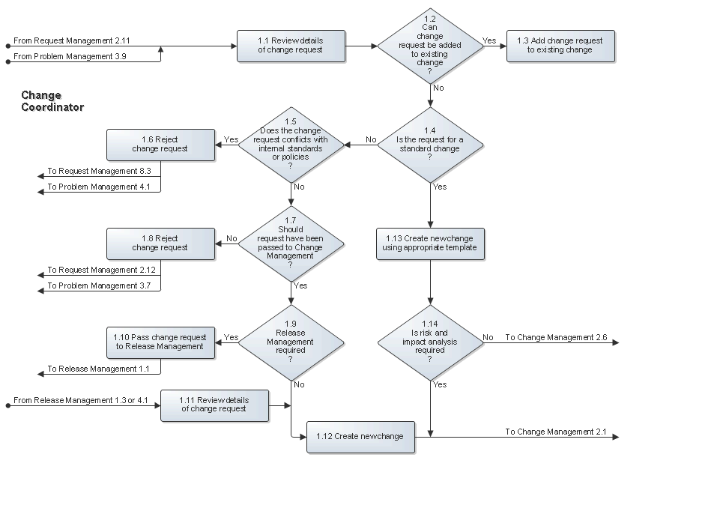

Change Planning
After having registered the change, the change coordinator starts the risk and impact analysis phase to gather the necessary information so that a change implementation plan can be created that minimizes both the risk of failure and the impact on the customers.
The change coordinator creates a separate risk and impact task for each question that needs to be answered.
If a new service instance is to be built, or if an existing service instance is likely to require a modification in order to satisfy the change requirements, the change coordinator also assigns a risk and impact task to the availability manager for the creation of a new, or the modification of an existing, service instance design.
Whenever the change coordinator can answer a question, the change coordinator completes the risk and impact task. Risk and impact tasks that cannot be answered by the change coordinator are assigned to the most appropriate specialist within the group of the change coordinator group, or to another group.
Using the answers of the risk and impact tasks, the change coordinator adjusts the change plan that was copied from the template when registering the change to ensure that the risk of failure and the impact on the customers is minimized.
Procedure 2, Change Planning
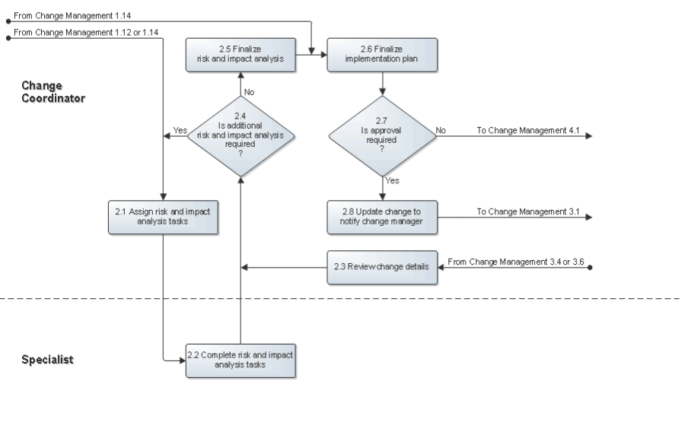

Change Approval
After the risk and impact analysis has been completed and the implementation plan has been developed, the change manager reviews the change. If the change manager finds the change to be in conflict with internal standards or policies, the change manager informs the change coordinator that the change cannot be implemented.
If the change is not in conflict with any internal standards or policies, the change manager reviews the risk and impact analysis and the implementation plan. The change manager checks the plan to ensure that appropriate precautions have been planned to minimize both the risk of failure and the impact on the customers, and that the timing of the implementation does not conflict with other planned changes or planned events.
If the risk and impact analysis is found to be insufficient, the change manager requests additional analysis from the change coordinator. Similarly, if the planning does not adequately address the risk of failure or the impact on the customers, or if the planning conflicts with other planned changes or events, the change manager requests an adjustment of the implementation plan from the change coordinator.
On the other hand, if the risk and impact analysis and the planning of the implementation appear to be in order, the change manager determines the approval that is required for the change.
Approval is required from the representatives of customers who will be affected by the change implementation, if it will cause:
- A service is unavailable or degraded during service hours
- The functionality of a service changes
Approval from the service owner is sufficient if these conditions do not apply to the planned implementation.
If the change is rejected by an approver, the change manager finds out why. The change manager asks the change coordinator to perform additional risk and impact analysis or to adjust the planning if that was the reason why the change was rejected.
If the change was rejected for any other reason, the change manager informs the change coordinator that the change cannot be implemented.

The Change Approval procedure is presented on the next page.

Procedure 3, Change Approval
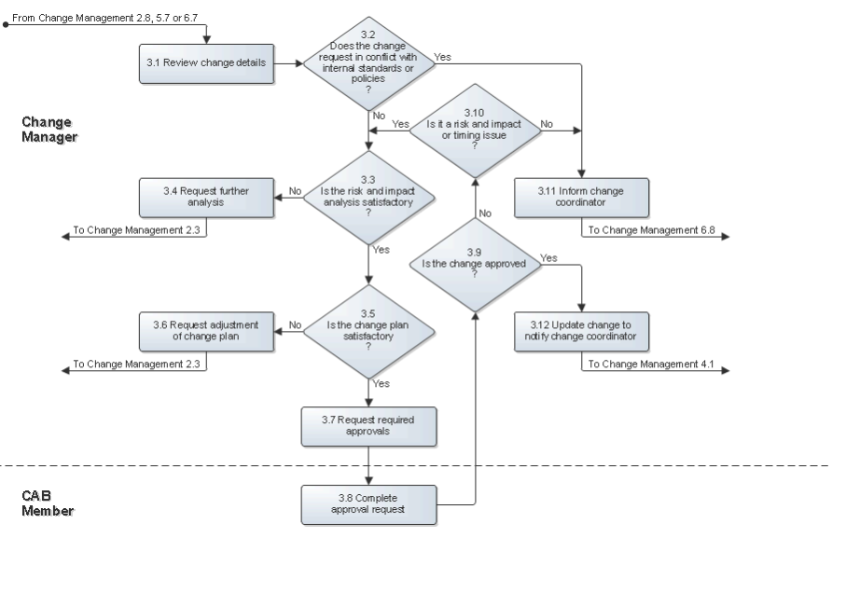

Infrastructure Change Implementation
The first implementation tasks are assigned after the change has been approved. If it concerns an application change, the implementation continues in Procedure 5, Application Change Implementation.
If the change is an infrastructure change, the specialists prepare the implementation to ensure operational readiness. This could involve ordering hardware, configuring a test environment, performing tests, and so on.
When everything is ready, the specialists implement the change in accordance with the change plan.

The Infrastructure Change Implementation procedure is presented on the next page.

Procedure 4, Infrastructure Change Implementation
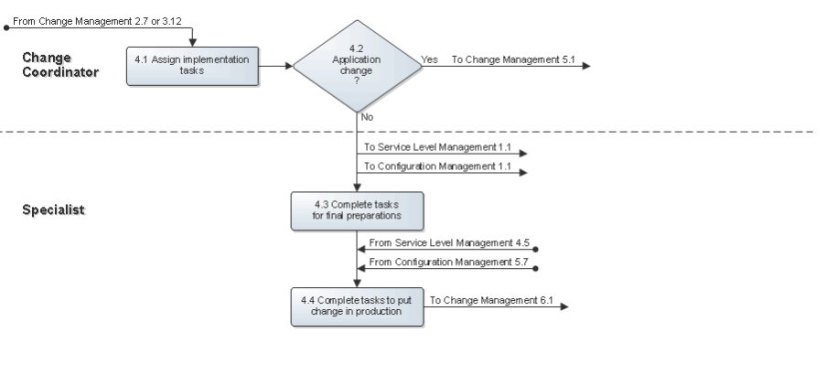

Application Change Implementation
After the first implementation tasks of the application change have been assigned, one or more specialists develop the new release in the development environment. The new release is tested by the specialists to ensure that the change requirements have been met. This is done in a separate test environment if one has been made available for this purpose. Otherwise, the tests are performed in the development environment. The (automated) scripts for regression testing are also updated and run by the specialists if such scripts are available for the application. The specialists fix any errors that were encountered during the tests in the development environment.
Once the specialists have confirmed that the change requirements have been met and that no new bugs have been introduced, the release administrator transfers the new release to the test environment where the customer representatives ensure that it gets tested.
The change coordinator creates and assigns additional tasks if the new release did not pass customer testing, so that the new release can be corrected. If these additional tasks caused the transfer to production to be rescheduled, the change will need to be approved again.
Once the new release has passed customer testing, the specialists ensure that everything is ready to take the new release into production (that is, ensure operational readiness). This could involve user training, the addition of storage capacity to the production and continuity environments, ordering additional software licenses, and so on.
Finally, the release administrator transfers the new release into production.

The Application Change Implementation procedure is presented on the next page.

Procedure 5, Application Change Implementation
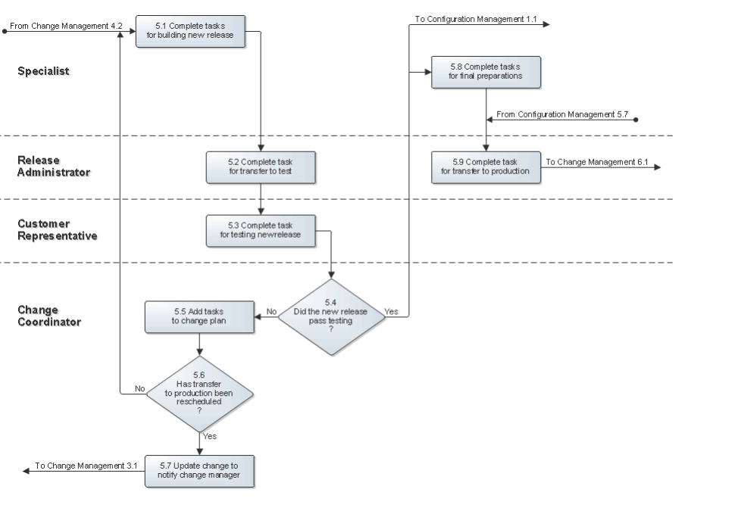

Planned Change Closure
After the change has been put into production, a specialist (with the help of a user if the specialist does not have sufficient access rights) performs the production test to verify the success of the implementation.
The CMDB is updated as needed after the specialist has determined that all the requirements of the change have been met. The change coordinator subsequently informs the requesters and approvers of the change to let them know that it has been implemented successfully. Having done this, the change coordinator closes the change.
If all change requirements have not been fulfilled, however, the specialist who performed the production test determines if the change should be rolled back. If the change does not provide an improvement over the previous situation, or causes a security or data integrity risk, the change is rolled back.
If the change implementation can still be made into a success, the change coordinator creates the necessary additional tasks. However, if it is currently not clear how all change requirements can be met, the change coordinator informs the requesters and approvers of the situation and closes the change.

The Planned Change Closure procedure is presented on the next page.

Procedure 6, Planned Change Closure
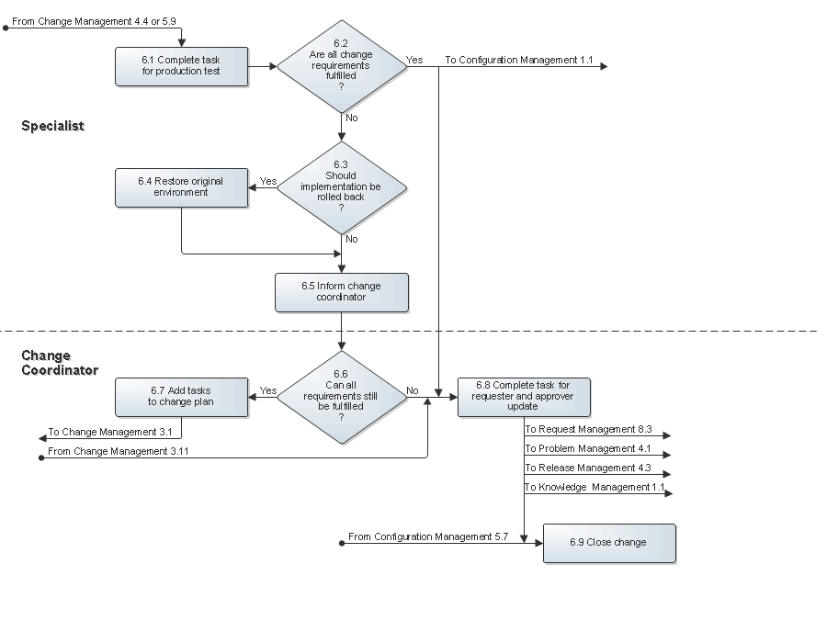

Emergency Change Implementation
After the service owner (or on-duty manager if the service owner was not available) has asked a specialist to resolve an incident by implementing an emergency change, the specialist starts to work on the implementation. If the emergency change concerns an infrastructure change, the specialist performs the implementation as if completing a normal request.
Alternatively, if the emergency change is an application change, the specialist first builds a new release in the development environment and makes sure that it will fix the incident without introducing new bugs. The specialist subsequently asks a release administrator to transfer the new release to the test environment. In the test environment, the specialist tests the new release.
If the new release did not pass the test, the specialist goes back to the development environment to correct it. On the other hand, if the new release passed the tests, the specialist asks the release administrator to transfer it to the production environment.

The Emergency Change Implementation procedure is presented on the next page.

Procedure 7, Emergency Change Implementation
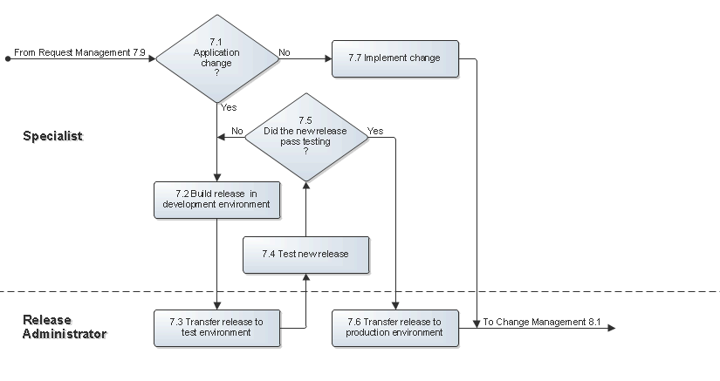

Emergency Change Closure
The specialist performs the production test (with the help of a user if the specialist does not have sufficient access rights) after the implementation has been completed. If the implementation turns out to be unsuccessful, the specialist informs the service owner (or on-duty manager if the service owner is not available) to discuss the situation.
Conversely, if the specialist has determined that the implementation is successful, the specialist completes the request. In addition, the specialist asks the change coordinator of the affected service to register the emergency change.
The change coordinator registers the change and ensures that the CMDB and the Capacity Management information are updated if this is necessary. After that, the change coordinator informs the service owner to let him/her know that the emergency change has been implemented successfully. Finally, the change coordinator closes the emergency change.
The Emergency Change Closure procedure is presented on the next page.

Procedure 8, Emergency Change Closure
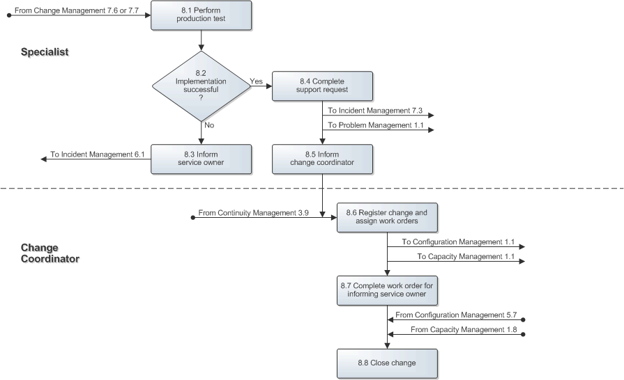

Scope
The scope of the Change Management process is limited to change implementations that will cause:

- A service is unavailable or degraded during service hours
- The functionality of a service changes
- The CMDB requires an update

Roles and Responsibilities
The table below lists the different roles that are involved in the Change Management process, along with their respective responsibilities.

Role | Responsibility
CAB Member | - Approves or rejects changes and their implementation timing upon the request of the change manager.
Change Coordinator | - Assesses change requests that originated from Request Management, Problem Management and Release Management.  - Creates changes as needed to handle change requests.  - Coordinates the risk and impact analysis by creating and assigning risk and impact tasks.  - Answers the risk and impact tasks when possible.  - Develops implementation plans by creating and assigning implementation tasks.  - Monitors the progress of changes.  - Closes changes.
Change Manager | - Reviews the risk and impact analysis to ensure that this has been performed thoroughly.  - Ensures that appropriate actions have been planned to minimize both the risk of failure and the impact on customers during change implementations.  - Ensures that the timing of implementations does not conflict with other planned changes or events.  - Obtains approval for changes by creating approval tasks and assigning them to the appropriate service owners and customer representatives.
Customer Representative | - Ensures that new releases of applications are tested after they have been transferred to the test environment.
Release Administrator | - Transfers new releases of applications after their development in the development environment to the test environment.  - Transfers new releases of applications after they have been tested in the test environment to the production environment.
Specialist | - Answers risk and impact tasks and updates them with relevant information and status changes.  - Completes implementation tasks and updates them with relevant information and status changes.

KPIs
The table below lists the key performance indicators (KPIs) that have been selected for tracking the success of the Change Management process.

KPI | Definition | Frequency | Unit
Successful changes | The number of completed changes with the Closure Category field set to "Implemented", divided by the total number of completed changes. | Monthly | %
Emergency changes | The number of completed changes with the Category field set to "Emergency - Required for Incident Resolution". | Monthly | # of changes
Time to plan | The average time it takes, from the moment a request with the Request Type field set to "Request for Change" has been registered, until the change to which the request is linked gets its Status field set to "To Be Approved". | Monthly | # of work hours per request
Time to approve | The average time it takes for the Status field value of a change to get from "Approval Requested" to "Approved". | Monthly | # of work hours per change
Backlog of changes | The number of changes that do not yet have their Status field set to "Completed". | Daily | # of changes

Beneficiaries
The roles that rely on the Change Management process are listed in the table below, along with their respective requirements for the Change Management process.

Role | Requirement
CAB Member | - Information regarding changes for which the approval of a CAB member is required.
Change Coordinator | - Information regarding the progress of tasks.
Change Manager | - Information regarding the risk and impact analysis to ensure that it was performed thoroughly.  - Information regarding the change implementation plans to ensure that they do not conflict with other changes or events.
Configuration Administrator | - Information regarding tasks for the registration or update of CI information.
Customer Representative | - Information regarding changes that will affect services.
Group Coordinator | - Information regarding tasks (and the changes that they are a part of) that have been assigned to a group.
Operator | - Information regarding planned changes that will cause events to be generated.
Problem Coordinator | - Information regarding the progress of changes that were requested by problem coordinators.
Service Desk Analyst | - Information regarding the progress of changes for which a status update has been requested.
Service Level Administrator | - Information regarding changes for which an update of the Service Level Management information has been requested.  - Cost of effort and cost of supplier information in task, and the link between tasks and the changes for which they were prepared, as well as the link between changes and the services for which they were planned, to facilitate the preparation of a cost overview for each service at the end of a charge term.
Service Level Manager | - Information regarding the status of changes for which the requests were registered by a service level manager after having received the request from a customer representative.  - Information regarding the change implementation performance for change requests that were submitted using web request forms.
Service Owner | - Information regarding changes that will affect services.
Specialist | - Information regarding tasks (and the change that they are a part of) that have been assigned to a specialist.
User | - Information regarding the status of his/her requests for change.  - Information regarding changes that will affect services.

Owner
The owner of the Change Management process is the Service Management CAB.

This CAB is responsible for reviewing, and subsequently approving or rejecting, requests for improvement of the Change Management process and its supporting functionality in the service management application.

