

Knowledge Management

Version: | 20.17.02

Table of Contents

1. Mission 3
2. Description 3
2.1 Knowledge creation 5
2.2 Knowledge Definition 7
2.3 Knowledge Review 9
3. Scope 11
4. Roles & Responsibilities 11
5. Owner 11

Mission
The mission of the Knowledge Management process is to ensure to make reliable data available throughout the service lifecycle.)

Description
The Knowledge Management process consists of three procedures:
Knowledge Creation is used by specialists when new knowledge articles need to be created..
Knowledge Approval is used by the knowledge managers when knowledge articles need to be approved.
Knowledge Review is used by the knowledge manager to review existing articles
A graphical representation of the process is provided on the next page.

Knowledge Management Process
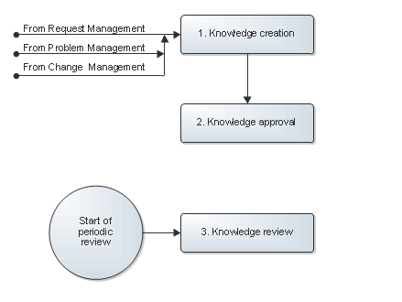

Knowledge creation
If a new Knowledge article is created from the Request Management process the specialist creates a new article with the record type FAQ or How to. When all the necessary information is entered the specialist will save the article to gain an approval for this new knowledge article.
If a new Knowledge article is created from the Problem Management process the specialist creates a new article with the record type Known Error or Problem Solution. When all the necessary information is entered the specialist will save the article to gain an approval for this new knowledge article.
If a new Knowledge article is created from the Change Management process the specialist creates a new article. When all the necessary information is entered the specialist will save the article to gain an approval for this new knowledge article.

The Change Request Handling procedure is presented on the next page.

Procedure 1, Knowledge creation
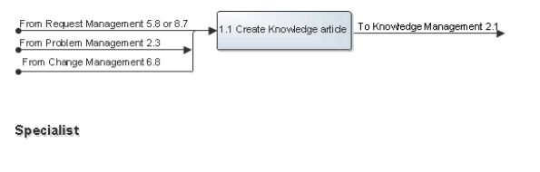

Knowledge Definition
The knowledge manager will receive a notification when approval needs to be given. The knowledge manager will review the new article and make modifications if necessary. If an article should be made available the knowledge manger publishes the article. Otherwise the knowledge manager will retire the article.

The Knowledge Definition procedure is presented on the next page.

Procedure 2, Knowledge Approval
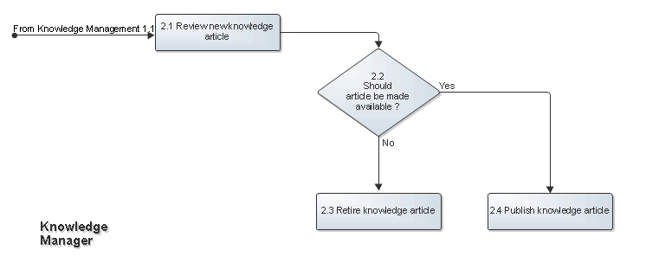

Knowledge Review
The knowledge manager periodically reviews all the knowledge articles within their responsibility. If needed the knowledge manager will modify or retire articles.

The Business Justification procedure is presented on the next page.

Procedure 3, Knowledge Review
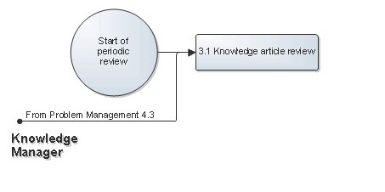

Scope
The scope of the Knowledge Management process is limited to knowledge articles that can be identified in requests, problems and changes.

Roles & Responsibilities
The table below lists the different roles that are involved in the Knowledge Management process, along with their respective responsibilities.

Role | Responsibility
Specialist | - Suggest knowledge articles.
Knowledge Manager | - Review knowledge articles.  - Modifies knowledge articles if needed.  - Publishes knowledge articles  - Retires knowledge articles which are no longer valid.

Owner
The owner of the Knowledge Management process is the Service Management CAB.

This CAB is responsible for reviewing, and subsequently approving or rejecting, requests for improvement of the Knowledge Management process and its supporting functionality in the service management application.

