

Service Level Management

Version: | 20.17.02

Table of Contents

1. Mission 3
2. Description 3
2.1 Service Catalog Maintenance 5
2.2 Service Activation 7
2.3 Customer Information Maintenance 9
2.4 Service Termination 11
2.5 SLA Review and Request Handling 13
3. Scope 15
4. Roles and Responsibilities 15
5. KPIs 16
6. Beneficiaries 17
7. Owner 18

Mission
The mission of the Service Level Management process is to formalize, review and maintain the agreements between the service provider organization and its customers.

Description
The Service Level Management process consists of five procedures.

Service Catalog Maintenance is used by service level administrators when a change coordinator has asked for a new catalog item to be registered.

Service Activation is followed by service level administrators after a customer has selected a catalog item and has decided to subscribe to the service at the level specified by this catalog item.

Customer Information Maintenance is used by service level administrators when they register new customers of the service provider organization. They also use this procedure when they update the contact information that has been registered for these customers.

Service Termination is used by service level administrators when a service, catalog item and/or SLA is discontinued.

SLA Review and Request Handling is used by service level managers when reviewing SLAs at the end of their respective evaluation terms. The service level managers also use this procedure when customer representatives contact them to submit requests.

A graphical representation of the process is provided on the next page.

Service Level Management Process
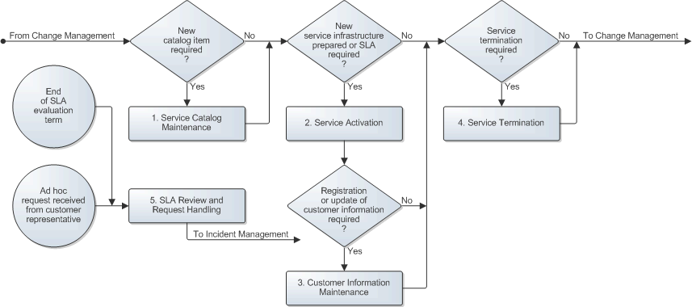

Service Catalog Maintenance
Changes that cause the Service Level Management information to require an update include a task that is assigned to the service level administrator requesting this update to be performed.

When the service level administrator receives such a task, the administrator determines whether a new catalog item is required. If this is not the case, the service level administrator skips the rest of this procedure and goes to Procedure 2, Service Activation. If a new catalog item is required, however, the service level administrator prepares it using the Catalog Item Template, or by copying a similar catalog item.

Having prepared the new catalog item, the service level administrator gets it approved by:

- The service owner who will be responsible for meeting the SLTs specified in the catalog item
- The service level managers of the customer organizations for which the catalog item has been prepared to ensure that the SLRs of the customers are covered by the catalog item
- The financial manager of the service provider organization whose commitment is required for the financial aspects of the catalog item

If the approvers require adjustments to be made before the new catalog item can be signed, the service level administrator adjusts the catalog item as needed until all approval signatures have been collected. If the approvers cannot reach an agreement, however, the service level administrator goes to Procedure 4, Service Termination to indicate in the task why the creation of the new catalog item has failed.

When the approvers have all signed the new catalog item, the service level administrator adds it to the service provider organization's web-based service catalog. If the new catalog item was prepared as a one off to meet the specific SLRs of one customer, the service level manager ensures that the published version of the new catalog item cannot be accessed by customers.

The Service Catalog Maintenance procedure is presented on the next page.

Procedure 1, Service Catalog Maintenance
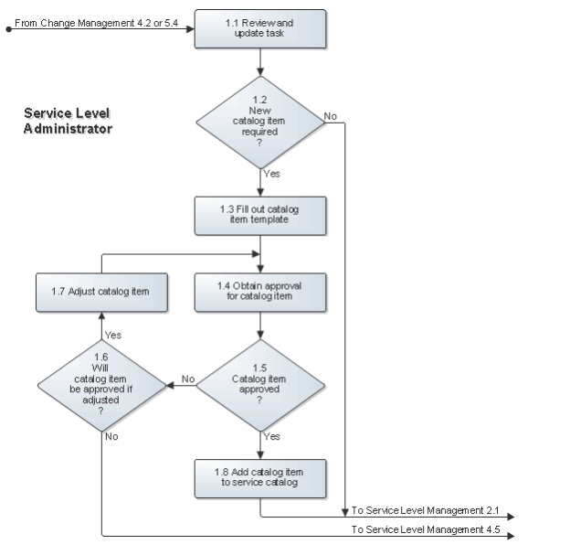

Service Activation
If the task for the Service Level Management information update requests the registration of a new service infrastructure the service level administrator does this by filling out the Service form in the service management application.

If the task requests the preparation of a new SLA, the service level administrator prepares the new SLA by filling out the Service Level Agreement Template, printing two copies, and attaching a printout of the relevant catalog item to each copy. The service level administrator then collects the signatures of both the customer representative and the service owner who will be responsible for meeting the SLTs specified in the SLA.

If either the customer representative or the service owner decided not sign the SLA, the service level administrator goes to Procedure 4, Service Termination to indicate in the task why the new SLA could not be established. On the other hand, if the new SLA was signed, the service level administrator files one copy of the signed SLA and returns the other to the customer representative for his/her files.

Before registering the new SLA, the service level administrator checks the service management application to see if the contact details of the customer are up-to-date. If the customer of the SLA has not yet been registered, or if the contact details of the customer are no longer up-to-date, the service level administrator ensures that the customer information is registered or updated in Procedure 3, Customer Information Maintenance.

When the customer's contact details are up-to-date, the service level administrator registers the new SLA in the service management application and links it to the service infrastructure that will be used to provide the service to the customer.

The Service Activation procedure is presented on the next page.

Procedure 2, Service Activation
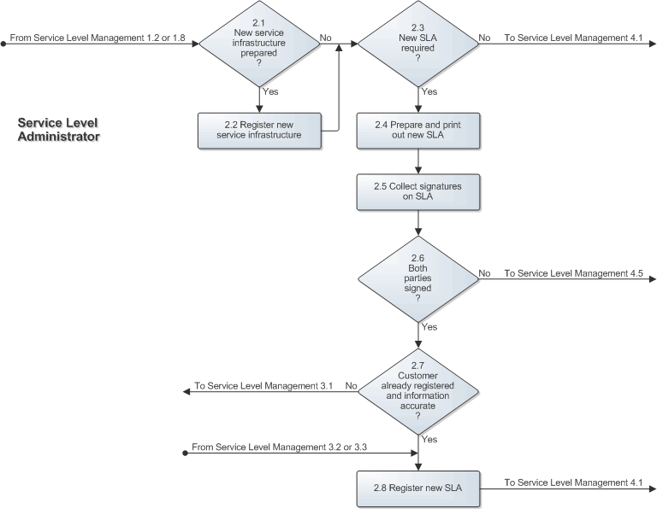

Customer Information Maintenance
The service level administrators are responsible for registering and updating the contact details of the service provider organization's customers.

A service level administrator performs the customer information maintenance tasks when customers subscribe to one of the provider's services for the first time (that is, before registering new SLAs) and whenever updated contact information has been received from an existing customer.

If an individual customer or a customer organization is not already registered, the service level administrator adds this customer. If the customer already exists in the service management application, the service level administrator updates the customer's contact information. All this is done in accordance with the field utilization guidelines for the Organization and Site forms when it concerns a customer organization. If it concerns an individual customer, a customer representative, or a person who works for the customer organization and must be supported by the service provider organization, the service level administrator follows the field utilization guidelines for the Person form.

The Customer Information Maintenance procedure is presented on the next page.

Procedure 3, Customer Information Maintenance
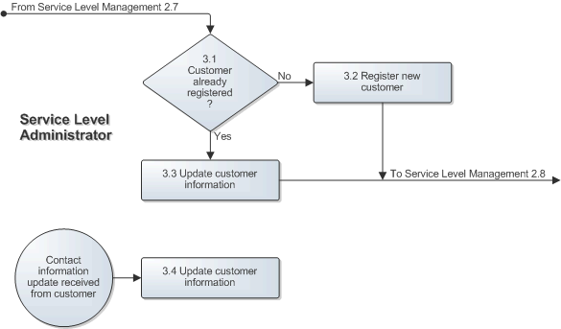

Service Termination
If the task for the Service Level Management information update requests the discontinuation of a catalog item, the service level administrator does this by ensuring that it can no longer be accessed from the service provider organization's web-based service catalog by customers.

If the task requests the termination of one or more SLAs, the service level administrator updates the status of these SLAs to indicate that they have been discontinued. In addition, the service level administrator checks the status of the other SLAs that are linked to the services which SLAs the administrator discontinued. If all SLAs linked to these services are now discontinued, the service level administrator also discontinues these services by updating their status.

When no further action is required from the service level administrator in terms of updating the Service Level Management information, the administrator updates the task. The administrator does this to inform the change coordinator that the task has either been performed successfully or failed (for example, because the requested catalog item was not approved, or because the requested SLA was not signed).

The Service Termination procedure is presented on the next page.

Procedure 4, Service Termination
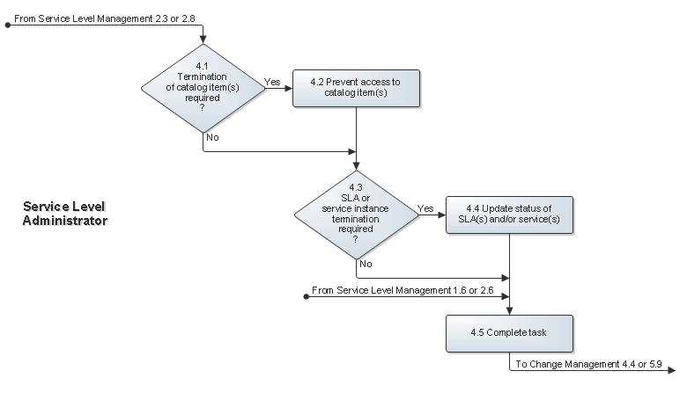

SLA Review and Request Handling
When the SLAs of one of the service level manager's customer organizations have reached the end of their evaluation term, the manager schedules a meeting with the representative for this customer. Next, the service level manager determines the actual level at which the services have been provided over the past term to the customer of the SLAs.

The service level manager subsequently compares the actual service levels with the service level targets (SLTs) specified in the SLAs. If one or more SLTs were violated during the evaluation term, the service level manager contacts the responsible service owners to find out why the SLTs were violated and how the service owners will ensure that these SLTs will not be violated again. The service level manager uses all this information, along with his/her proactive improvement suggestions, to compile a detailed report for the customer representative.

The service level manager reviews the report with the customer representative, preferably within one month after the end of the evaluation term. During the meeting the customer representative informs the service level manager of any requests from the customer organization that the manager represents.

After the meeting the requests are registered as requests by the service level manager and passed to the most appropriate group. The service level manager then documents the minutes of the meeting and references the numbers of these requests. The minutes are distributed to the customer representative, the concerned service owners, and the service desk manager.

Ad hoc requests from customer representatives are also registered by the service level manager and passed to the most appropriate group.

The SLA Review and Request Handling procedure is presented on the next page.

Procedure 5, SLA Review and Request Handling
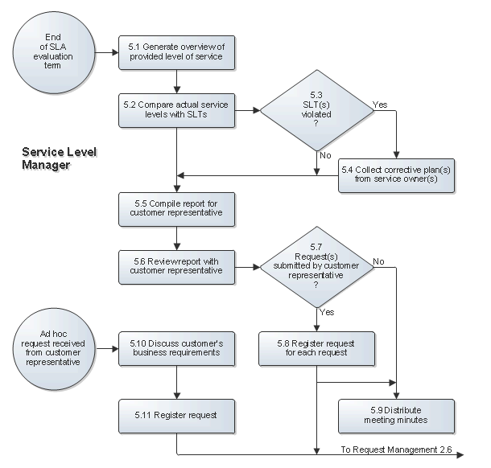

Scope
The scope of the Service Level Management process is limited to the services that are (going to be) provided by the service provider organization to its customers.

Roles and Responsibilities
The table below lists the different roles that are involved in the Service Level Management process, along with their respective responsibilities.

Role | Responsibility
Service Level Administrator | - Maintains the web-based service catalog of the service provider organization by adding and removing catalog items as requested by Change Management.  - Prepares SLAs and gets them signed as requested by Change Management.  - Registers services and SLAs in the service management application to ensure that this information is available to the rest of the service provider organization.  - Registers the contact details of individual customers, customer organizations, and customer representatives when new customers subscribe to the service provider organization's services.  - Updates the information of individual customers, customer organizations, and customer representatives after updated contact information has been received.
Service Level Manager | - Produces reports to compare actual versus agreed upon service levels at the end of an SLA evaluation term.  - Finds out for each SLT that was violated during an SLA evaluation term, why it was violated and which actions the service owner has taken, or plans to take, to ensure that the SLT will not be violated again.  - Proactively adds improvement suggestions to the SLA evaluation report for customer representatives.  - Reviews actual versus agreed upon service levels with the customer representative after the end of an SLA evaluation term.  - Registers the requests from customer representatives as requests in the service management application and passes them to the service desk.  - Writes and distributes the minutes of SLA review meetings.

KPIs
The table below lists the key performance indicators (KPIs) that have been selected for tracking the success of the Service Level Management process.

KPI | Definition | Frequency | Unit
SLA review punctuality | The average number of days from the end date of an SLA evaluation term until the date on which the SLA review was performed. | Once per SLA evaluation term | # of days
Change requests | The number of requests with the category "Request for Change" that has been registered by the service level managers. | Monthly | # of requests
Unregistered users | The number of requests that were linked to the special person with the code NORECORD.  Note: The special person with the code NORECORD is linked to requests by service desk analysts when they cannot find the user in the service management application. | Monthly | # of requests

Beneficiaries
The roles that rely on the Service Level Management process are listed in the table below, along with their respective requirements for the Service Level Management process.

Role | Requirement
Change Coordinator | - Availability of services so that they can be linked to the changes that will affect them.  - The service hours related to SLAs to help determine the most appropriate time for change implementations.
Change Manager | - Availability of the link between service owners and services and the link between customer representatives and SLAs to facilitate the identification of the required approvers for changes.  - The service hours related to SLAs to help determine if approval from customer representatives is required for changes that will impact the availability of a service.
Configuration Administrator | - Availability of services so that they can be linked to the CIs that support them.
Customer Representative | - Information regarding the actual level of service provided.  - Service, service catalog, and SLA information concerning the services that are used by the organization that the customer representative represents.
Problem Coordinator | - Availability of services so that they can be linked to the problems that affect them.
Service Desk Analyst | - Availability of user contact details within the service management application so that they can be linked to the requests they submit.  - Availability of services and their related SLAs, so that they can be linked to requests and to help with the assignment of requests to the appropriate group.  - The business importance level (BIL) related to SLAs to allow automated request prioritization.  - Support hours in SLAs to allow automated target time calculation for request.  - Availability of the link between services and their supporting CIs to assist with the resolution of requests and to help with the assignment of requests to the appropriate group.  - Information about who the service owner is for each service, and who the customer representative and the service level manager are for each SLA, to keep them informed about service outages.
Service Level Administrator | - Charge information in the SLAs to help calculate the service charges for each customer at the end of a charge term.
Service Level Manager | - Service level target (SLT) information so that they can be used for comparison against actual service levels.  - The end date of the SLA evaluation terms so that the SLA review meetings can be scheduled correctly.  - Availability of the link between service owners and services and the link between customer representatives and SLAs so that their email addresses can be found when the minutes of the SLA review meeting need to be distributed.  - Availability of customer representatives within the service management application so that they can be linked to the requests they submit.
Service Owner | - Information regarding the actual level of service provided.  - Service, service catalog, and SLA information concerning the services that the owner is responsible for.  - Availability of the links between services and their supporting CIs so that an overview can be obtained of the supporting infrastructure for each service.
Specialist | - Availability of the link between services and their supporting CIs to assist with the resolution of requests, the identification of root causes, and the completion of tasks (especially risk and impact tasks).

Owner
The owner of the Service Level Management process is the Service Management CAB.

This CAB is responsible for reviewing, and subsequently approving or rejecting, requests for improvement of the Service Level Management process and its supporting functionality in the service management application.

