

Configuration Management

Version: | 20.17.02

Table of Contents

1. Mission 3
2. Description 3
2.1 CI Requisition 5
2.2 CI Receipt 7
2.3 Supplier Information Maintenance 9
2.4 CI Update 11
2.5 Support Contract Administration 13
3. Scope 15
4. Roles & Responsibilities 16
5. KPIs 17
6. Beneficiaries 18
7. Owner 18

Mission
The mission of the Configuration Management process is to make the relevant information about the infrastructure available to the other service management processes in an accurate, complete, and timely fashion.

Description
The Configuration Management process consists of five procedures.

CI Requisition is used by configuration administrators when new CIs need to be ordered.
CI Receipt is used by the Configuration administrators when new CIs have been delivered.
Supplier Information Maintenance is used by the Configuration administrators when they register new suppliers and when they update the contact details of previously registered suppliers.
CI Update is used by configuration administrators when they update the attributes and/or relations of CIs that were already registered in the CMDB.
For more details about these procedures, click on the Process button to return to the graphical representation of this process and click on the box that represents the procedure that you would like to know more about. The graphical representation of this procedure will appear and you will be able to click on the Description button in the upper left-hand corner of your screen to read more about it.

Configuration Management Process
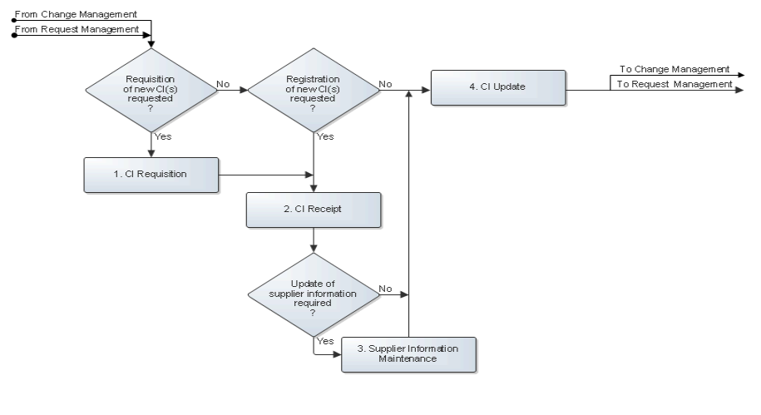

CI Requisition
Whenever new configuration items (CIs) need to be ordered, or when the configuration management database (CMDB) needs to be updated, the responsible configuration administrator receives a task from Change Management or Request Management.
The configuration administrator goes straight to Procedure 2, CI Receipt if the task does not ask for the requisition of any new CIs. On the other hand, if the task asks for one or more new CIs to be ordered, the configuration administrator first submits a purchase requisition for the required CIs. Having submitted a purchase requisition to purchasing, the configuration administrator periodically checks up on its progress.
If the CIs have been ordered by purchasing, the configuration administrator registers the ordered CIs in the CMDB. On the other hand, if the purchase requisition has been rejected, the configuration administrator continues in Procedure 4, CI Update.

The CI Requisition procedure is presented on the next page.

Procedure 1, CI Requisition
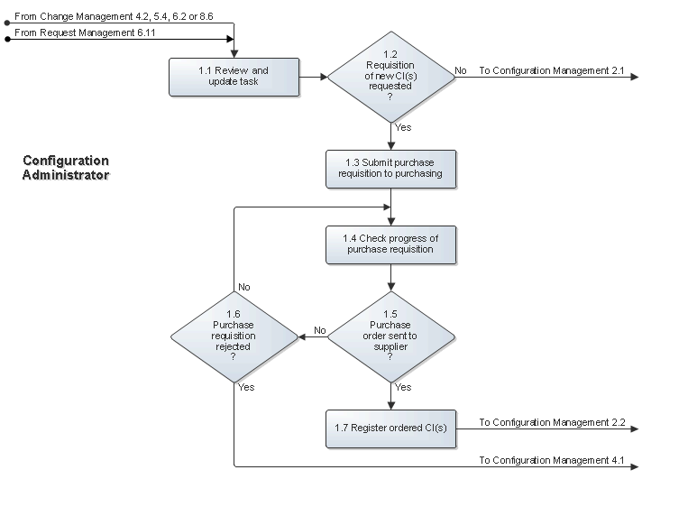

CI Receipt
If the task from Change Management or Request Management does not require any new CIs to be added to the CMDB, the configuration administrator goes directly to Procedure 4, CI Update.
On the other hand, if the task requests the registration of one or more CIs for which a formal purchase requisition was not submitted (for example, in the case of internally developed software), or if one or more new CIs have been ordered, the configuration administrator first checks the CIs after they have been delivered. The configuration administrator does this to ensure that the correct hardware, software, and/or software license certificates have been received, that no items are missing, and that the CIs are not damaged. If the delivery is not whole, the configuration administrator informs the supplier and subsequently informs the change coordinator of the delay by updating the task.
Conversely, if the CIs have been received in good condition, the configuration administrator checks the service management application to see if the contact details of the supplier are up-to-date. If the supplier of the CIs has not yet been registered, or if its contact details are no longer up-to-date, the configuration administrator ensures that the supplier information is registered or updated in Procedure 3, Supplier Information Maintenance.
After this, the configuration administrator updates the status of the new CIs and adds any missing information (for example, the serial number) if the CIs were already registered in Procedure 1, CI Requisition. If a formal purchase requisition was not submitted for the new CIs, however, the configuration administrator registers the new CIs in the CMDB. The configuration administrator ensures that all attributes of the new CIs and the links between the new CIs and other CIs, services and users are correctly registered.
Having ensured that the new CIs are properly registered in the CMDB, the configuration administrator attaches a label with the CI code to each new CI when applicable.

The CI Receipt procedure is presented on the next page.

Procedure 2, CI Receipt
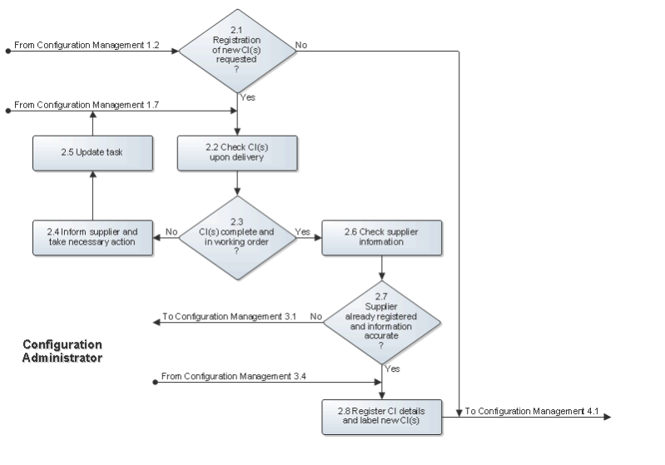

Supplier Information Maintenance
The configuration administrators are responsible for registering and updating the information of organizations that supply configuration items and/or support to the service provider organization.
A configuration administrator performs the supplier information maintenance tasks as needed before registering new configuration items, before registering or updating support contracts, and whenever updated contact information has been received from an existing supplier.
If a supplier organization is not already registered, the configuration administrator adds it. If the supplier organization already exists in the service management application, the configuration administrator updates its contact details.

The Supplier Information Maintenance procedure is presented on the next page.

Procedure 3, Supplier Information Maintenance
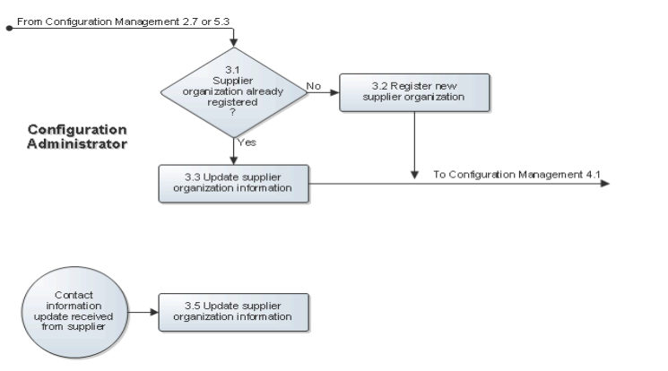

CI Update
If the task from Change Management or Request Management does not require the update of existing CI information, the configuration administrator completes the task. However, if the configuration administrator is dealing with a task that requests the update of CI attributes and/or relations, the configuration administrator checks the actual configuration of the infrastructure to confirm that the requested modifications are really required to bring the CMDB back up to date.
If it turns out that the CMDB should be updated, the configuration administrator performs the update of the necessary CI attributes and/or relations.

The CI Update procedure is presented on the next page.

Procedure 4, CI Update
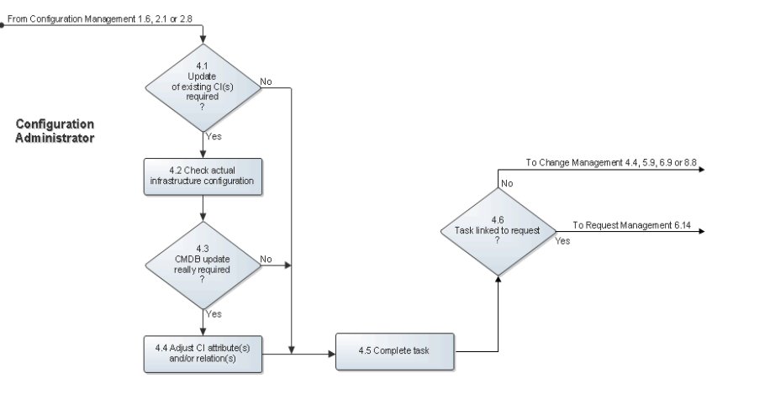

Scope
The scope of the Configuration Management process is limited to the configuration item (CI) categories listed in the table below, and the maintenance and/or support contracts that cover the CIs that fall within these categories.

Element | Element | Element
Communication End Point | Cost | Floppy Drive
IP End Point | Offering | Tape Drive
LAN End Point | Physical Location | Memory
Concrete Collection | Service Level Target | Monitor
Connectivity Segment | Tag | Network Port
IP Connectivity Subnet | Person | Pointing Device
IPX Connectivity Network | NT Domain | Processor
LAN | Application | UPS
WAN | Application Infrastructure | Disk Partition
Organization | Software Server | Database Storage
Role | Cluster | Local File System
User Community | Mainframe | Remote File System
Contract | Printer | Recourse Pool
Contract Line | Storage Subsystem | Share
Equipment | Disk Drive | Patch
Account Configuration Item | Card | Package
Business Process | Chassis | BIOS Element
Transaction | Rack | Operation System
Business Service | Keyboard | Virtual System Enabler
Database | CD ROM Drive | Logical Disk
Storage Volume | MF Coupling Facility | Application Service

Roles & Responsibilities
The table below presents the only role that plays a part in the Configuration Management process, along with its responsibilities.

Role | Responsibility
Configuration Administrator | - Submits purchase requisitions to purchasing for CIs that need to be ordered.  - Ensures that CIs, which fall under the responsibility of the configuration administrator's group, get labeled after they have been delivered.  - Keeps the information of the CIs, for which the group of the configuration administrator is responsible, up to date.  - Maintains the information of external organizations that have supplied, or support, CIs for which the group of the configuration administrator is responsible.  - Registers and updates the support contracts for the CIs for which the configuration administrator's group is responsible.  - Maintains the links of the CIs that the configuration administrator's group is responsible for. These are the links between a CI and other CIs, its supplier, its support contract, and the service infrastructures that it is a part of.

KPIs
The table below lists the key performance indicators (KPIs) that have been selected for tracking the success of the Configuration Management process.

KPI | Definition | Frequency | Unit
Time to update CMDB | The average time it takes for the Status field value of a task, which is based on the task template for updating the CMDB, to get from "Assigned" to "Completed". | Monthly | # of work hours per work order
CIs not found in CMDB | The number of completed requests that were linked to the special CI with the code NORECORD.  Note: The special CI with the code NORECORD is linked to requests by service desk analysts and specialists when they cannot find the appropriate CI in the CMDB even though the CI should have been registered. | Monthly | # of support requests
Hardware CIs without supplier | The number of hardware CIs that do not have a supplier organization linked to them. | Monthly | # of CIs

Beneficiaries
The roles that rely on the Configuration Management process are listed in the table below, along with their respective requirements for the Configuration Management process.

Role | Requirement
Change Coordinator | - Availability of CIs within the service management application so that they can be linked to tasks when CIs are to be changed.
Configuration Administrator | - Availability of CIs within the service management application so that they can be linked together to create a representation of the infrastructure.
Problem Coordinator | - Information regarding CIs that have caused incidents to facilitate the detection of problems in the infrastructure.
Service Desk Analyst | - Availability of CIs within the service management application so that they can be linked to support requests.  - Information regarding CIs and CI relations to facilitate the resolution of support requests, and to assist with the assignment of requests to the correct group.
Service Level Administrator | - Cost information in support contracts, and the link between support contracts and the CIs that they cover, to help determine the total cost of CIs.  - Cost information in CIs, and the link between CIs and the services that they support, to facilitate the preparation of a cost overview for each service at the end of a charge term.
Specialist | - Information regarding CIs and CI relations to facilitate the resolution of support requests, the identification of root causes, and the completion of work orders.  - Contact details of suppliers so that they can be contacted when their assistance is needed to resolve support requests, to identify root causes and to propose structural solutions for problems, and to complete work orders for change implementations.

Owner
The owner of the Configuration Management process is the Service Management CAB.

This CAB is responsible for reviewing, and subsequently approving or rejecting, requests for improvement of the Configuration Management process and its supporting functionality in the service management application.

