

Problem Management

Version: | 20.17.02

Table of Contents

1. Mission 3
2. Description 3
2.1 Request Review 5
2.2 Root Cause Analysis 7
2.3 Analysis Review 9
2.4 Problem Closure 11
3. Scope 13
4. Roles & Responsibilities 13
5. KPIs 14
6. Beneficiaries 15
7. Owner 15

Mission
The mission of the Problem Management process is to minimize the number of incidents.

Description
The Problem Management process consists of four procedures:

Request Review is used by problem coordinators when they review requests to identify problems within the services they are responsible for.

Root Cause Analysis is used by specialists when they analyze a problem.

Analysis Review is followed by problem coordinators when they review the results of a root cause analysis performed by a specialist.

Problem Closure is used by Problem coordinators when they close out problems.

A graphical representation of the process is provided on the next page.

Problem Management Process
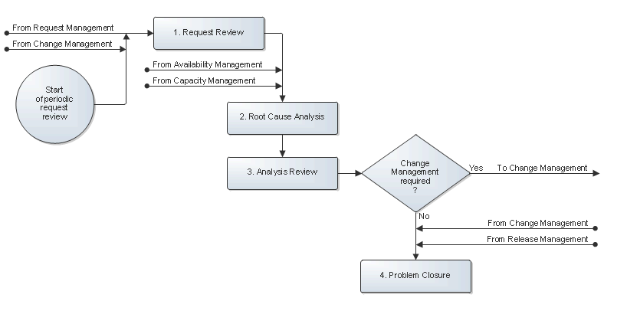

Request Review
The problem coordinator uses request information to identify problems in the services, they are responsible for. The problem coordinator's most important tools for identifying problems are the search and reporting functionality of the service management application. A specialist can also draw the attention of a problem coordinator to certain requests that, in the opinion of the specialist, represent a problem.

After the identification of a problem, the problem coordinator registers the problem in the service management application. The problem coordinator subsequently selects the appropriate severity level and links the requests that were caused by the problem to it.

The problem coordinator then assigns the problem to the most appropriate specialist (in terms of skills, availability and access rights) for analysis.

The service desk is automatically informed via email that a new problem has been identified after the problem has been saved.

When the problem coordinator finds requests that have not yet been linked to a problem, but which were caused by a previously identified problem, he/she links these requests to the problem.

The Request Review procedure is presented on the next page.

Procedure 1, Request Review
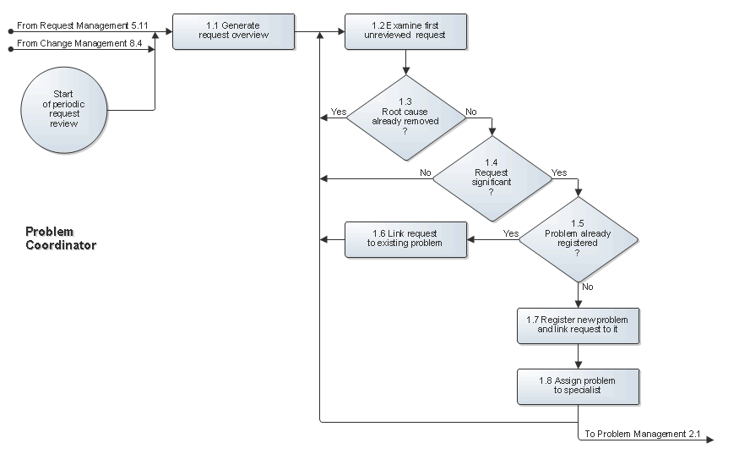

Root Cause Analysis
The specialist reviews the details of the problem. If the problem was identified after one or more incidents were already caused by it, the specialist attempts to provide a temporary workaround. The information about the workaround, and specifically how to implement it, is added in a new knowledge article and a reference to this article is added to the problem. This workaround can be used to resolve future incidents caused by the problem until a structural solution has been found and implemented.

The specialist subsequently starts to track down the root cause of the problem. After having found the root cause, the problem is updated with its description.

Next, the specialist considers possible structural solutions and evaluates them. A description of each option is added to the problem along with the recommendation for the preferred structural solution.

If Change Management is not required to permanently work around or remove the root cause, the specialist implements the preferred structural solution.

If the specialist is not able to find the root cause or is not able to propose a structural solution, he/she specifies the reason in the problem.

Regardless of whether a structural solution was proposed or even already implemented, the specialist updates the status of the problem to inform the problem coordinator that his/her work has been completed.

The Root Cause Analysis procedure is presented on the next page.

Procedure 2, Root Cause Analysis
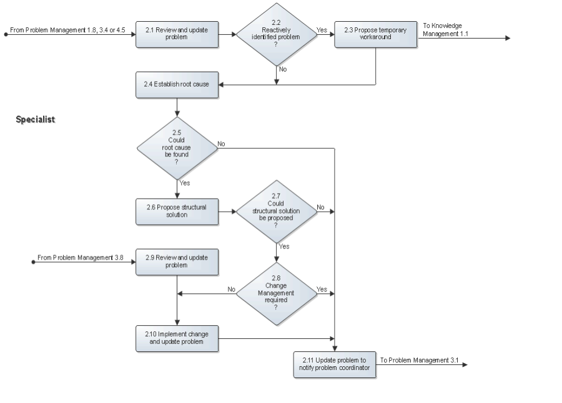

Analysis Review
After a specialist has completed the root cause analysis of a problem, the problem coordinator reviews the results to determine if a structural solution has been proposed or has been implemented already. If the specialist has already solved the problem because Change Management was not required to coordinate the implementation of the structural solution, the problem coordinator goes directly to Procedure 4, Problem Closure.

The problem coordinator also goes to Procedure 4, Problem Closure if the specialist performed a good analysis but was not able to propose a practical structural solution.

If the specialist proposed a practical structural solution, but did not implement it because he/she believed Change Management to be required, the problem coordinator checks to see whether Change Management is really needed. If this is not the case, the problem coordinator assigns the problem to the most appropriate specialist to get the problem solved. If Change Management is really required, the problem coordinator passes the problem to the change coordinator of the affected service.

If the analysis of the specialist is not acceptable, however, the problem coordinator reassigns the problem to the same or another specialist for a better analysis.

The Analysis Review procedure is presented on the next page.

Procedure 3, Analysis Review
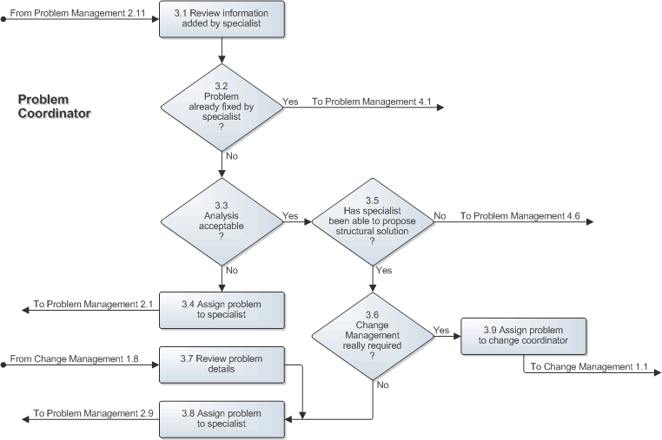

Problem Closure
After a change has been implemented to provide a structural solution for the problem, the problem coordinator verifies whether or not the change has actually solved the problem.

If the implementation appears to have solved the problem, the problem coordinator closes it. If the problem was reactively identified, the service management application subsequently informs the service desk via email that it has been removed from the service.

On the other hand, if the change was not implemented, or if the implementation did not fix the problem, the problem coordinator determines if it might be possible to propose a different structural solution for the problem. If this might be possible, the problem coordinator reassigns the problem to a specialist within the group.

Alternatively, if it is clear that there is currently no practical means available to permanently work around or remove the root cause, the problem coordinator updates the problem to indicate the impasse. Periodically, the problem coordinator will then check for new possibilities and will ask for another analysis when it is likely that a new or different approach or technology could provide a practical structural solution.

If the solution or workaround to the problem should be available in the knowledgebase, a new knowledge article is created.

The Problem Closure procedure is presented on the next page.

Procedure 4, Problem Closure
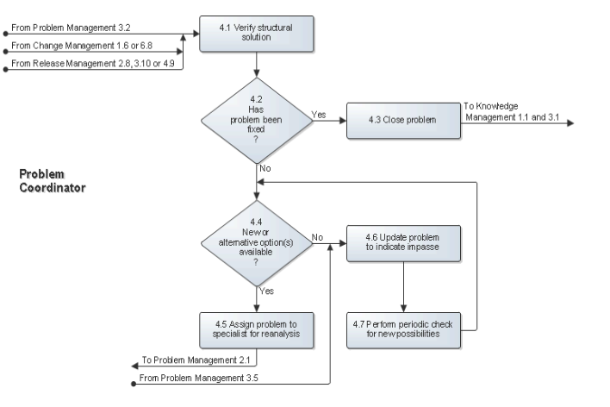

Scope
The scope of the Problem Management process is limited to problems that can be identified using the registered request information.

Roles and Responsibilities
The table below lists the different roles that are involved in the Problem Management process, along with their respective responsibilities.

Role | Responsibility
Problem Coordinator | - Reviews the requests that have been related to the services for which the person acts as the problem coordinator in order to identify problems.  - Ensures that the problems the person coordinates progress through the Problem Management process in a timely and prioritized fashion.  - Ensures that the information entered in the problems that he/she manages is accurate and complete.  - Periodically reviews the problems for which a practical structural solution could not be found.  - Verifies structural solutions and closes problems.
Specialist | - Suggests workarounds for problems.  - Establishes the root causes of identified problems.  - Proposes structural solutions for problems.  - Implements structural solutions for problems if Change Management is not required.  - Updates problems with relevant information and status changes.

KPIs
The table below lists the key performance indicators (KPIs) that have been selected for tracking the success of the Problem Management process.

KPI | Definition | Frequency | Unit
Reported incidents | The number of registered requests with the Category field set to "Incident ". | Monthly | # of requests
Problem Management activity | - The number of new problems identified.  - The number of solved problems. | Monthly | # of problems
Backlog of problems | The number of problems that do not yet have their Status field set to "Solved". | Daily | # of problems

Beneficiaries
The roles that rely on the Problem Management process are listed in the table below, along with their respective requirements for the Problem Management process.

Role | Requirement
Change Coordinator | - Information regarding problems for which the implementation of a structural solution has been requested.
Problem Coordinator | - Information regarding the progress of problems that have been assigned to specialists for analysis.
Service Desk Analyst | - Information regarding the problems that affect the services provided by the organization for which they provide the single point of contact.
Service Level Administrator | - Cost of effort and cost of supplier information in problems, and the link between problems and the services they affect, to facilitate the preparation of a cost overview for each service at the end of a charge term.
Service Level Manager | - Information regarding the problems that affected, affects, or is expected to affect the services that are used by his/her customers.
Service Owner | - Information regarding the problems that affected, affects, or is expected to affect the services that they provide.
Specialist | - Information regarding problems that have been assigned to a specialist for analysis.

Owner
The owner of the Problem Management process is the Service Management CAB.

This CAB is responsible for reviewing, and subsequently approving or rejecting, requests for improvement of the Problem Management process and its supporting functionality in the service management application.

