

Release Management

Version: | 20.17.02

Table of Contents

1. Mission 3
2. Description 3
2.1 Change Request Handling 5
2.2 Release Definition 7
2.3 Business Justification 9
2.4 Release Coordination 11
3. Scope 13
4. Roles and Responsibilities 13
5. KPIs 14
6. Beneficiaries 14
7. Owner 15

Mission
The mission of the Release Management process is to ensure that changes are implemented to keep the functionality and service levels of the services aligned with the ever-changing business needs of their customers.

Description
The Release Management process consists of four procedures.

Change Request Handling is used by the release coordinators to review the requests and problems that have been passed to Release Management.

Release Definition is used by release coordinators to organize CAB meetings and by CAB members when they decide which of the change requests that have been collected for CAB review should be fulfilled by the next release. Release coordinators also use this procedure to split the requirements of releases into logical groups that can be handled efficiently by change coordinators.

Business Justification is used by the release coordinators when additional funding needs to be obtained for the implementation of a release.

Release Coordination is used by Release coordinators to initiate the implementation of releases and to decide on corrective actions as needed.

A graphical representation of the process is provided on the next page.

Release Management Process
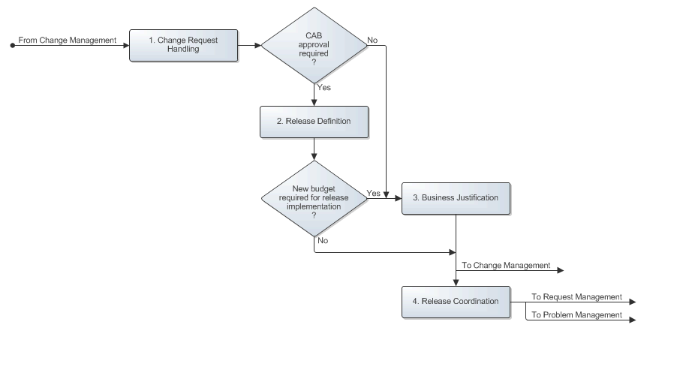

Change Request Handling
After a change coordinator of a service has passed a change request to the release coordinator of the service, the release coordinator reviews the request to gain an understanding of its requirements. The release coordinator passes the change request back to the change coordinator if it does not require the involvement of Release Management. Only change requests that ask for the implementation of a non-standard change must be handled by Release Management, with the exception of change requests that have been submitted for the prevention or fix of a problem, provided that their implementation:

- Can be coordinated by a single change coordinator,
- Will not cause the functionality of a service to become different, and
- Does not require any additional funding.

If the request does require the involvement of Release Management, the release coordinator checks to see if it requires CAB approval. The CAB does not need to review the change request if it asks for the implementation of a change to prevent or fix a problem and if this change will not cause the functionality of a service to become different. If CAB approval is required, however, the release coordinator adds the change request to the list of requests that are waiting to be reviewed during the next meeting of the service's CAB.

The Change Request Handling procedure is presented on the next page.

Procedure 1, Change Request Handling
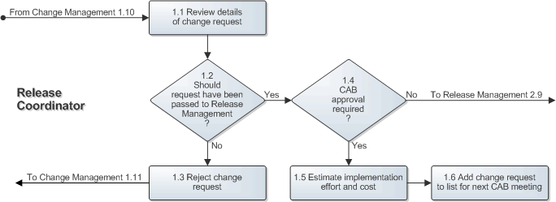

Release Definition
When the next CAB meeting for a service is due, the release coordinator of the service sends out the invitations to the service's CAB members. In the invitation, the release coordinator specifies the deadline until which change requests can be submitted for review during the next CAB meeting. After the change request submission deadline has passed, the release coordinator finalizes the list of change requests that will be reviewed during the next CAB meeting and sends it to the CAB members so that they can discuss the change requests internally before the meeting.

The finalized list of change requests is reviewed during the meeting. After all change requests have been reviewed, each CAB member lets the release coordinator know which change requests would be rejected and which change requests would be included in the next release. A change request is rejected when at least two-thirds of the CAB members agree that it should be rejected. Similarly, a change request is included in the next release when two-thirds or more of the CAB members have asked for it to be included. Change requests that are neither rejected nor included in the next release will be reviewed again during the next CAB meeting. Before closing the CAB meeting, the CAB members agree on the date, time and location of the next CAB meeting.

After the CAB meeting, the release coordinator ensures that the requesters of the rejected change requests are informed by completing these change requests. Having done this, the release coordinator publishes the minutes of the CAB meeting and registers the new release. To this release the person links a change for the coordination of the release and links the change requests that are to be included in the release to this change.

The release coordinator then reviews these change requests with the change coordinator of the service for which the release is to be implemented and the change coordinators of the supporting services that will also need to be changed. Together they divide the requirements of the different change requests amongst them and they draft a high-level implementation plan that indicates the duration of each change, as well as the dependencies between these changes.

The Release Definition procedure is presented on the next page.

Procedure 2, Release Definition
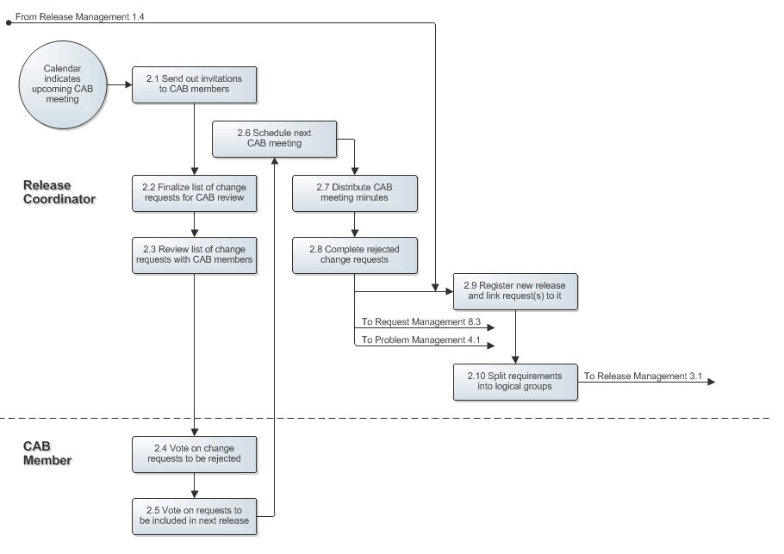

Business Justification
If an approved business case is not required for the release, the release coordinator cancels the business justification task that is part of the change to which the change requests of the release are linked. On the other hand, if the next release cannot be implemented using the budgets already available to the service owner, the release coordinator prepares a business case to justify the release. Having prepared the business case, the release coordinator requests approval for the business case to ensure that a budget will be made available for the implementation of the new release.

If the business case was rejected, the release coordinator adjusts it if this could still get the business case approved. If it is not possible to get the business case approved, the release coordinator lets the requesters of the release know that the business case for the release has been rejected. If the release was defined by the CAB, the release coordinator moves the change requests that are linked to the release back to the change that acts as the placeholder for change requests that are to be reviewed during the next CAB meeting. Before closing the release, the release coordinator also contacts the CAB members to inform them that the business case of their release has been rejected and gives them the option to bring the next CAB meeting forward.

The Business Justification procedure is presented on the next page.

Procedure 3, Business Justification
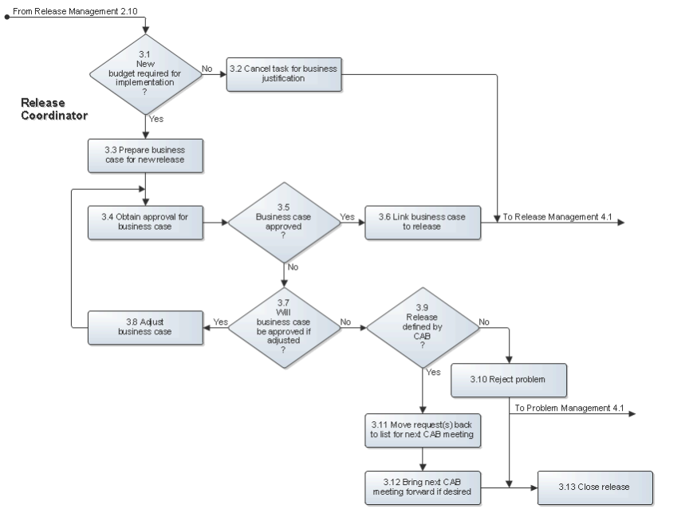

Release Coordination
The release coordinator prepares a document for each change coordinator that details the release requirements that the change coordinator will be responsible for. The release coordinator sends the requirement documents to the change coordinators and ensures that the requested changes are registered and linked to the release.

When a change coordinator has informed the release coordinator that one of the release's changes has been completed, the release coordinator enters a short update in the release.

If the change could not be implemented successfully, the release coordinator works with the coordinators of the changes that are linked to the release to determine how the (partial) failure of the change implementation affects the overall implementation of the release. If it is still possible to implement one or more additional changes to ensure that all or most requirements of the release are fulfilled, or if one or more additional changes are required to ensure that the rollback of the release is completed, the release coordinator documents the requirements for the additional changes before passing them to the appropriate change coordinators.

After the last change that a change coordinator was asked to get implemented for the release has been completed, the release coordinator ensures that the requesters are informed whether or not their requirements were fulfilled by the release implementation. If the release was defined by the CAB, the release coordinator moves any change requests which requirements were not fully met back to the change that acts as the placeholder for change requests that are to be reviewed during the next CAB meeting. The release coordinator also informs the CAB members (if the release was defined by them) and the approvers of the business case (if one had to be prepared for the release).

Having updated the requesters and approvers of the release, the release coordinator continues by organizing and conducting the post-implementation meeting. During this meeting, the release coordinator reviews the entire lifecycle of the release with the service owner of the service for which the release was implemented and the change coordinators who coordinated one or more of the release's changes. After the meeting, the release coordinator publishes the improvement suggestions and decisions that were agreed on by the attendees of the meeting. Finally, the release coordinator closes the release.

The Release Coordination procedure is presented on the next page.

Procedure 4, Release Coordination
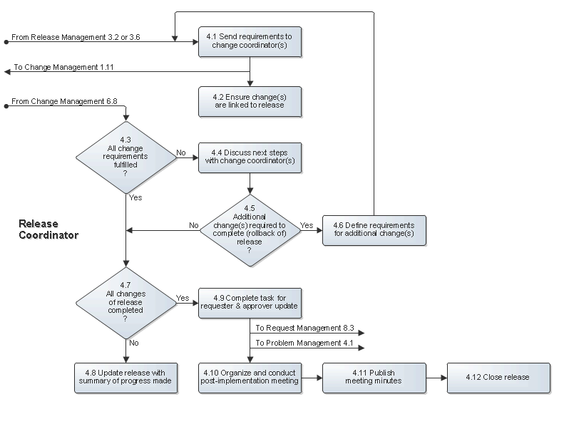

Scope
The scope of the Release Management process is limited to requests for non-standard changes, with the exception of non-standard changes that have been requested for the prevention or fix of a problem, provided that their implementation:

- Can be coordinated by a single change coordinator
- Will not cause the functionality of a service to become different
- Does not require any additional funding

Roles and Responsibilities
The table below lists the different roles that are involved in the Release Management process, along with their respective responsibilities.

Role | Responsibility
CAB Member | - Decides which of the change requests that have been collected for CAB review should be rejected, which should be fulfilled by the next release, and which should be reviewed again during the next CAB meeting.
Release Coordinator | - Reviews the change requests for the services for which the person acts as the release coordinator after they have been passed on from Change Management.  - Organizes and facilitates the CAB meetings for the services for which the person acts as the release coordinator.  - Splits the requirements of releases into logical groups that can be handled efficiently by change coordinators.  - Prepares a business case for a new release when additional funding is needed for its implementation.  - Initiates the implementation of releases and decides on corrective actions as needed.  - Organizes and conducts post-implementation meetings to collect improvement suggestions for future releases.

KPIs
The table below lists the key performance indicators (KPIs) that have been selected for tracking the success of the Release Management process.

KPI | Definition | Frequency | Unit
Successful releases | The number of completed releases with the Closure Category field set to "Implemented", divided by the total number of completed releases. | Monthly | %
Backlog of releases | The number of releases that do not yet have their Status field set to "Closed". | Daily | # of releases

Beneficiaries
The roles that rely on the Release Management process are listed in the table below, along with their respective requirements for the Release Management process.

Role | Requirement
CAB Member | - Information regarding requests that have been passed to Release Management, but which have not yet been rejected or linked to a release.
Change Coordinator | - Detailed descriptions of those requirements of a release that they have been asked to take responsibility for.
Problem Coordinator | - Information regarding the progress of releases which implementation will prevent or fix one or more problems.  - Information added to problems following their rejection during a CAB meeting or the completion of the release to which they are linked.
Service Desk Analyst | - Information regarding the progress of releases so that the requesters of the support requests that have been linked to releases can be kept up-to-date.  - Information added to support requests following their rejection during a CAB meeting or the completion of the release to which they are linked.

Owner
The owner of the Release Management process is the Service Management CAB.

This CAB is responsible for reviewing, and subsequently approving or rejecting, requests for improvement of the Release Management process and its supporting functionality in the service management application.

