

Request Management

Version: | 20.17.02

Table of Contents

1. Mission 3
2. Description 3
2.1 Request Registration 5
2.2 Request Assignment 7
2.3 Complaint and Compliment Handling 9
2.4 Request Tracking 11
2.5 Request Resolution by Specialist 13
2.6 Request Fulfillment Handling 15
2.7 Incident Escalation Handling 17
2.8 Request Closure 19
3. Scope 21
4. Roles and Responsibilities 22
5. KPIs 23
6. Beneficiaries 24
7. Owner 25

Mission
The mission of the Request Management process is to resolve requests after prioritizing the requests.

Description
The Request Management process consists of eight procedures for handling requests.
- Request Registration is used by service desk analysts when they register requests from users.
- Request Assignment is used by service desk analysts when they assign requests to groups and to the service desk manager in case of complaints and compliments. Service desk analysts also use this procedure when they handle requests that are rejected by group coordinators. Group coordinators use this procedure after requests are assigned to their groups. Group coordinators use this procedure to assign these requests to a specific change coordinator or specialist for resolution.
- Compliment and Complaint Handling is used by the service desk manager when the service desk manager satisfactorily completes requests of the Complaint or Compliment categories.
- Request Tracking is used by service desk analysts when they track the progress of requests.
- Request Resolution by Specialist is used by specialists to complete assigned requests.
- Request Fulfillment Handling is used by service desk analysts or specialists to complete requests that can be handled by using a predefined workflow.
- Incident Escalation Handling is used by service owners when an incident is escalated. The service owner of the affected service uses this procedure to determine how the incident can be efficiently resolved.
- Request Closure is used by service desk analysts when they resolve and close completed requests.
The following figure illustrates the Request Management process.

Request Management Process
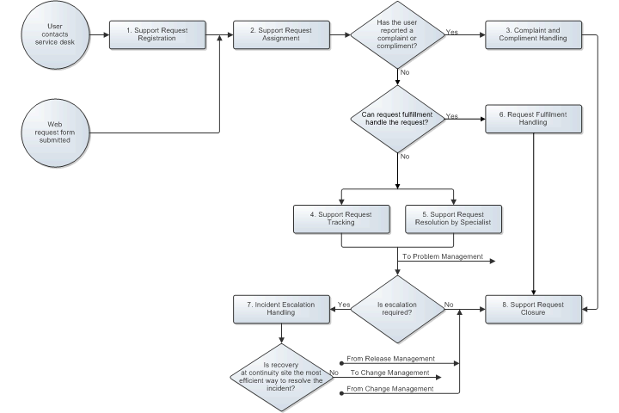

Request Registration
When a user contacts the service desk, the service desk analyst links the user's record to a new request. Next, the service desk analyst determines the nature of the user's request by asking the user how the service desk analyst can help the user if the user contacted the service desk by phone or in person. If the user contacted the service desk in writing (for example, email, fax, paper form, and so on), the service desk analyst determines the nature of the request by reading through the information.
If the user contacted the service desk about an earlier submitted request, the service desk analyst searches for the request. If the request is already completed or set to ClosedMail, but the user is not satisfied with the solution provided, the service desk analyst sets the status to assigned. The request appears in the To Do list of the staff and group that provided the original solution. If the user wants an update on the request's status, the service desk analyst informs the user of the progress.
If the user contacted the service desk to submit a new request, the service desk analyst determines if a request template is available for the request.
If a request template is available, the service desk analyst uses the template to create the request. The service desk analyst reads the instructions from the template and follows them. The instructions specify the information to obtain from the user and how to proceed after receiving the information (for example, how to resolve the request, or assign to which group).
If a request template is not available for the request, the service desk analyst creates the request. The service desk analyst links the applicable service and configuration item to the request.
If the user reports an incident, the service desk analyst determines the impact and urgency level based on the following:
- Information provided by the user
- Information about the configuration of the service instance
- Other incidents that are currently open for the impacted service
The impact and urgency level determine the priority level that is assigned to requests for incident resolution.
If the user reports that a critical or core service has failed for several users, the service desk analyst escalates the incident to the service owner. The service owner activates the Major Incident Team to resolve the Major Incident.
The following figure illustrates the Request Registration process.

Procedure 1: Request Registration
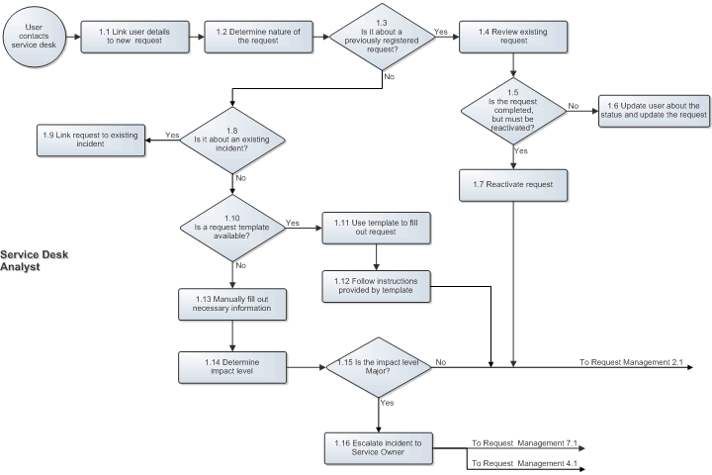

Request Assignment
If the request is a complaint or compliment, the service desk analyst assigns the request to the service desk manager.

If request fulfillment can handle a request, the service desk analyst coordinates implementing the request.

The service desk analyst considers all request categories for resolution. If the service desk analyst cannot resolve the request (in terms of skills, access rights, and time restrictions), the service desk analyst assigns the request to the appropriate group.

The coordinator of the group reviews all requests that are assigned to a group by service desk analysts, operators, continuity managers, and users and customer representatives who submit a web request form.

If the group coordinator determines that a request is assigned to the wrong group or the request does not contain all information that should be provided by the service desk analyst, operator, or continuity manager to complete it, the group coordinator rejects the request and specifies the reason for rejection.

Rejected requests are automatically passed to the service desk. A service desk analyst ensures that the missing information is collected and these rejected requests are reassigned to the appropriate group if the service desk cannot resolve them.

After requests are assigned to the correct group, the requests with the required information are passed to the change coordinator of the related service if the requests are for a change whose implementation is coordinated by Change Management. All other requests are assigned to the appropriate specialist of the group (in terms of skills, availability, and access rights).

The following figure illustrates the Request Assignment procedure.

Procedure 2: Request Assignment
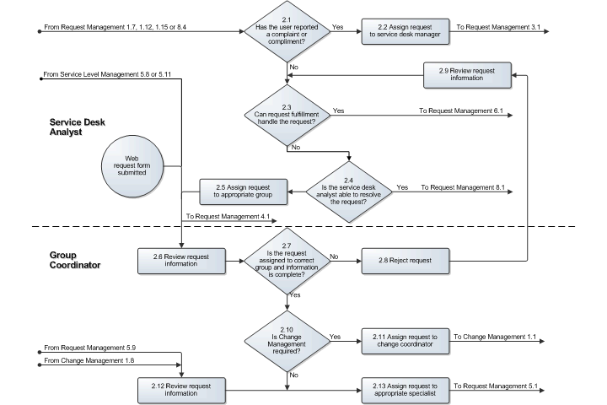

Complaint and Compliment Handling
After a complaint or compliment is registered, the service desk manager reviews its details.

In the case of a complaint, the service desk manager talks to the involved service desk analysts, specialists, service level manager, customer representative, and user to determine the cause of the complaint. After determining the cause, the service desk manager decides on the method to restore the user's faith in the support provided by the service provider organization.

In case of a compliment, the service desk manager informs the employee or department that received the compliment.

After the service desk manager has taken the necessary actions to appease the user or forward the compliment, the service desk manager completes the request.
The following figure illustrates the Complaint and Compliment Handling procedure.

Procedure 3: Complaint and Compliment Handling
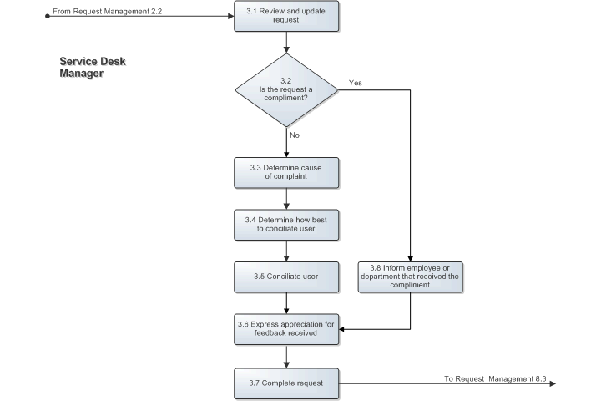

Request Tracking
The service desk tracks open requests by checking their status periodically to ensure that the open requests continue to progress towards completion. When a request is not progressing, the service desk analyst contacts the coordinator of the assigned group and asks the coordinator to ensure that the request is processed.

If a request describes a new service outage that is affecting multiple users, the service desk analyst informs the following concerned people:
- Affected users
- Owner of the affected service
- Customer representatives of the affected service
- Service level managers of the affected customer organizations
- On-duty manager

If half of the available resolution time has passed and the service outage has not been resolved, the service desk analyst provides a progress update to the concerned people.

If the incident is not resolved when the due date and time is reached, the service desk analyst provides another progress update to the concerned people. After the second update, the service desk analyst escalates the incident to the service owner.
The following figure illustrates the Request Tracking procedure.

Procedure 4: Request Tracking
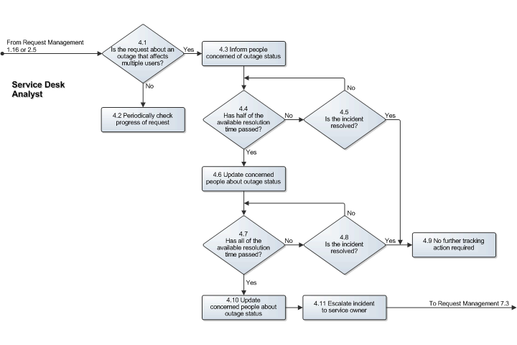

Request Resolution by Specialist
After a request is assigned to a specialist of a group, the specialist reviews the request information and determines how to resolve the request.
If request fulfillment can handle a request, the specialist coordinates implementing the request.
The specialist escalates the request to the service owner when the request concerns an incident that cannot be resolved without Change Management because the resolution causes the following:
- Service to become unavailable or degraded during service hours
- Functionality of a service to change
- CMDB to require an update
A group coordinator cannot determine if Change Management is required to resolve incidents because a specialist must first investigate the incident.

If Change Management is not required and the request is an incident that occurred because a supporting service failed, the specialist registers a related request and waits for the request to complete before continuing to resolve the request.

If the specialist determines that another specialist must resolve the request, the specialist notifies the appropriate group coordinator. Otherwise, the specialist resolves the request and updates the request.

The following figure illustrates the Request Resolution by Specialist procedure.

Procedure 5: Support Request Resolution by Specialist
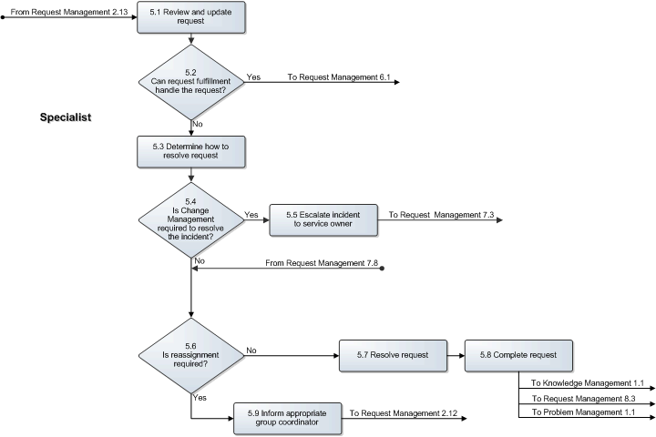

Request Fulfillment Handling
When the request is created by a template that contains the workflow for implementing the request, the service desk analyst or specialist reviews the tasks that are created by the template and determines if additional tasks are required. If required, the additional tasks are created and linked to the request.
Next, the service desk analyst or specialist determines which tasks can be completed without involving others and assigns these tasks to themselves.
For each remaining task, the service desk analyst or specialist determines the appropriate person to complete this task. Tasks that should be completed by other service desk analysts or specialists are assigned to:
- Appropriate staff when the staff is in the same group as the service desk analyst or specialist handling the request
- Group coordinator of the target group if the appropriate specialist is in another group
- Group coordinator of the target group if the appropriate specialist is not known
When assigning the tasks, consider the order of completing these tasks. The order ensures that the assigned tasks do not require other tasks to be completed first.
The service desk analyst or specialist responsible for handling the request completes the tasks assigned to them and monitors the completion of the remaining tasks. When required, they can create additional tasks and assign the tasks. When all tasks are completed successfully, the request is completed.
The following figure illustrates the Request Fulfillment Handling procedure.

Procedure 6: Request Fulfillment Handling
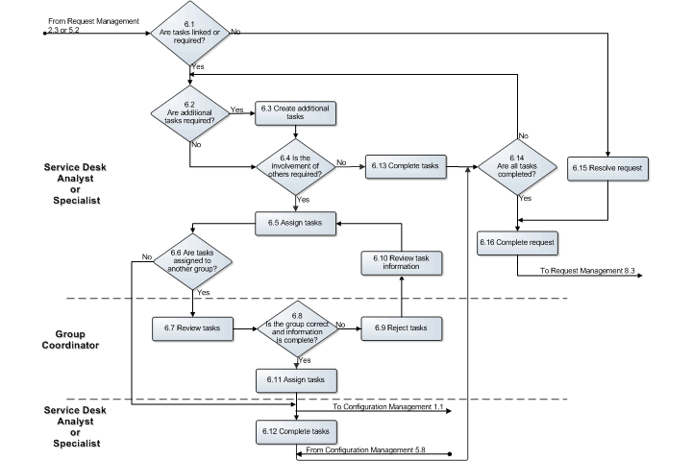

Incident Escalation Handling
After a specialist or a service desk analyst has escalated an incident, the owner of the affected service talks to the specialists who have been dealing with the incident to understand the current situation and determine how the incident can be resolved.

If the incident is a major incident, the service owner activates the Major Incident team. The Major Incident team leader is responsible for coordinating the resolution.

If the recovery of the affected service at its continuity site is the most efficient and reliable way to resolve the incident, the service owner escalates the incident to the on-duty manager to start the service recovery.

In most cases, the recovery of a service at its continuity site is not going to fix the incident (for example, when a bug causes the incident). Implementing a fix in the service's current infrastructure might be more efficient and reliable. In such cases, the service owner determines if Change Management must coordinate the resolution of the incident. Change Management is required when the resolution of the incident causes:
- Service to become unavailable or degraded during service hours
- Functionality of a service to become different
- CMDB to require an update

If Change Management is not required, the service owner ensures that the most appropriate specialists continue to resolve the incident within the Request Management process.

If Change Management is required, the service owner consults with the specialists to understand the risks that could cause the implementation of the change to fail and the impact of the implementation on customers. They figure out the best way to keep the risk and impact of the change implementation at an acceptable level. After they have established how the change should be implemented, the service owner asks the specialists to perform the implementation as an emergency change.

The on-duty manager performs the role of service owner when the service owner of the affected service is not available.
The following figure illustrates the Incident Escalation Handling procedure.

Procedure 7: Incident Escalation Handling
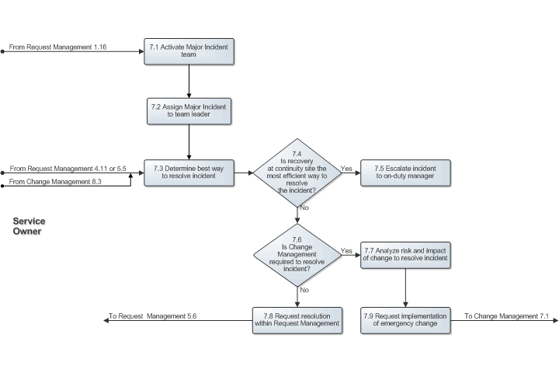

Request Closure
If the service desk analyst can resolve the request (in terms of skills, access rights, and time restrictions), the service desk analyst resolves and completes the request.
After the request is completed, the service desk analyst informs the user who submitted the request and asks the user to verify its solution.
If the user informs the service desk that the request has not been resolved to the user's satisfaction, the service desk analyst again works on resolving the request.
Otherwise, the service desk analyst checks if the request is for a service outage that affects multiple users. In this case, the service desk analyst informs the affected users about how the incident is resolved.
The affected users can be:
- Owner of the affected service
- Customer representatives of the affected service
- Service level managers of the affected customer organizations
- On-duty manager
If the user confirms that the request is satisfactorily resolved or the user does not respond within 28 days, the request is closed.
The following figure illustrates the Request Closure procedure.

Procedure 8: Request Closure
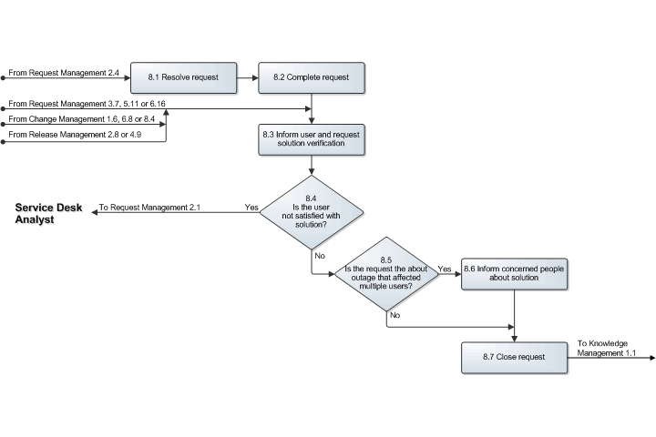

Scope
The scope of the Request Management process is limited to the following support request categories.

Category | Description
Incident | Request from a user to restore a service that is not functioning correctly  Note: Requests for password resets from users who have forgotten their passwords and requests for restoring backup from users who have lost data
Request for Change | Request from a user for modifying, adding, moving, or removing some or all service functionality, access, or components  Note: Requests for copying data (for example, for making a backup or restoring a backup at a different location) and requests for batch job runs belong to this category
Service Request | Request from a user that can be resolved by using a predefined workflow in the following scenarios:  - Template exists for this workflow  - No risk and impact analysis is required  - No approval is required other than approval from the customer
Information Request | Request from a user for an answer to a service-related question
Compliment | Praise or encouragement from a user
Complaint | Request from a user for the improvement of how the service provider organization supports the user.

Roles and Responsibilities
The following table lists the different roles that are involved in the Request Management process and their respective responsibilities.

Role | Responsibility
Group coordinator | Distributes requests assigned to the group between the specialists after taking into account the skills, availability, and access rights of the specialists
On-duty manager | Assumes the Incident Escalation Handling responsibilities of service owners when they are not available
Service desk analyst | - Provides a single point of contact for users of the services provided by the service provider organization  - Obtains the necessary information from users and efficiently, accurately, and completely registers the information in requests  - Resolves as many of the received requests as possible within the limitations of the service desk analyst access rights and time constraints  - Assigns requests that cannot be resolved by the service desk to the appropriate group for resolution  - Monitors the progress of high-impact incidents (for example, service outages that affect multiple users) and informs all concerned people  - Escalates a high-impact incident to the service owner of the affected service when the incident has not been resolved within the available resolution time defined in the related service level agreement (SLA)  - Informs users of the solutions after their requests are resolved and asks them to verify the solution
Service desk manager | - Ensures that users are dealt with courteously  - Handles all support requests of the Complaint and Compliment categories to ensure that users who reported a complaint turn into satisfied users of the service provider organization
Service owner | - Decides whether an escalated incident must be resolved by implementing an emergency change, by recovering the affected service at its continuity site, or by continuing the resolution of the incident within the Request Management process
Specialist | - Resolves requests and tasks  - Updates requests and tasks with relevant information and status changes  - Escalates incidents to the service owner of the affected service for incidents whose resolution can only be implemented through the Change Management process

KPIs
The following table lists the key performance indicators (KPIs) selected for tracking the success of the Request Management process.

KPI | Definition | Frequency | Unit
Complaints | The number of registered requests with the Category field set to Complaint. | Monthly | Number of requests
Incidents resolved within target | The number of completed requests with the Category field set to Incident that are completed before their target date and time, divided by the total number of completed requests for incident resolution. | Monthly | Percent
Service desk resolutions | The number of requests that are both registered and resolved at the service desk without the assistance from another group, divided by the total number of requests registered by service desk analysts. | Monthly | Percent
Rejected solutions | The number of times a request is reopened because the solution is not accepted (for example, the number of times that the value of the Completion Category field is deleted because the Status field changes from Completed or higher to less than Completed), divided by the total number of completed requests. | Monthly | Percent
Incident resolution effort | The total amount of time spent on all closed requests with the Category field set to Incident, divided by the total number of closed requests for incident resolution. | Monthly | Number of minutes per request
Backlog of requests | The number of requests that do not have their Status field set to Completed or higher or that do not have a value specified in their Closure Category field. | Daily | Number of requests

Beneficiaries
The following table lists the roles that rely on the Request Management process and their respective requirements for the Request Management process.

Role | Requirement
Change coordinator | Information from requests that require Change Management to resolve the requests
Configuration administrator | Information about configuration items (CIs) in the scope of the Configuration Management process, but the CIs cannot be linked to a request because they have not been registered
Customer representative | Information updates about service outages
Group coordinator | Information about requests that are assigned to a group
On-duty manager | Information updates about service outages
Operator | Information about the progress of open requests that are generated from events
Problem coordinator | Request information for the identification of problems and determination of root causes
Service desk analyst | - Information about the progress of open requests  - Solution information of previously resolved requests
Service level administrator | - To facilitate the preparation of a cost overview for each service at the end of a charge term, cost of effort and supplier information in requests and the link between requests and the services for which they were requested  - To calculate the service charges for each customer at the end of a charge term, charge for customer information in requests and the link between requests and SLAs
Service level manager | - Information about the actual level of service provided so that this information can be compared with the service level targets (SLTs) that are agreed upon in the SLAs  - Information updates about service outages
Service owner | - Information about the actual level of service provided so that this information can be compared with the SLTs that are agreed upon in the SLAs  - Information about concerning service outages
Specialist | Information about requests that are assigned to a specialist
User | - Ability to submit requests  - Information about the progress and solutions of the user’s requests  - Information updates concerning service outages

Owner
The owner of the Request Management process is the Service Management change advisory board (CAB).

The CAB is responsible for reviewing, and subsequently approving or rejecting, requests for improvement of the Request Management process and its supporting functionality in the service management application.

