**CUSTOMER RELATIONSHIP MANAGEMENT**

**Home Page**

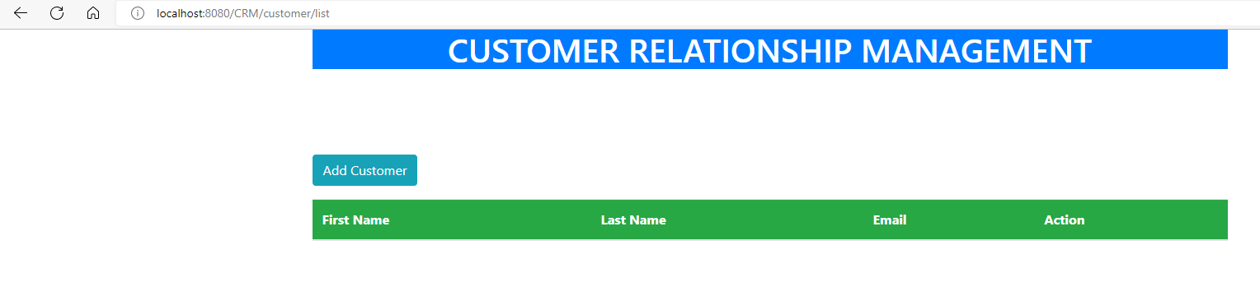

**Clicking on Add Customer**

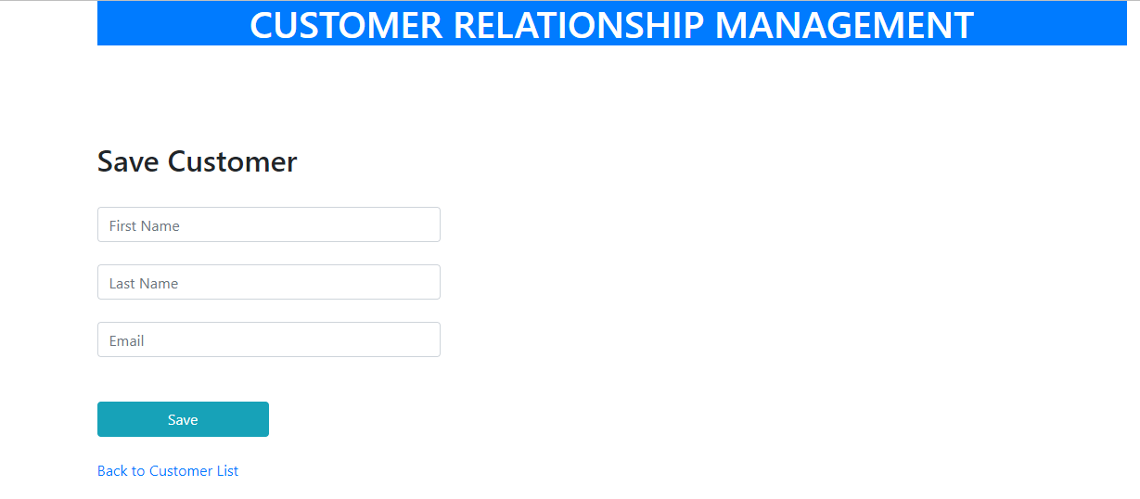

Adding Customer Details

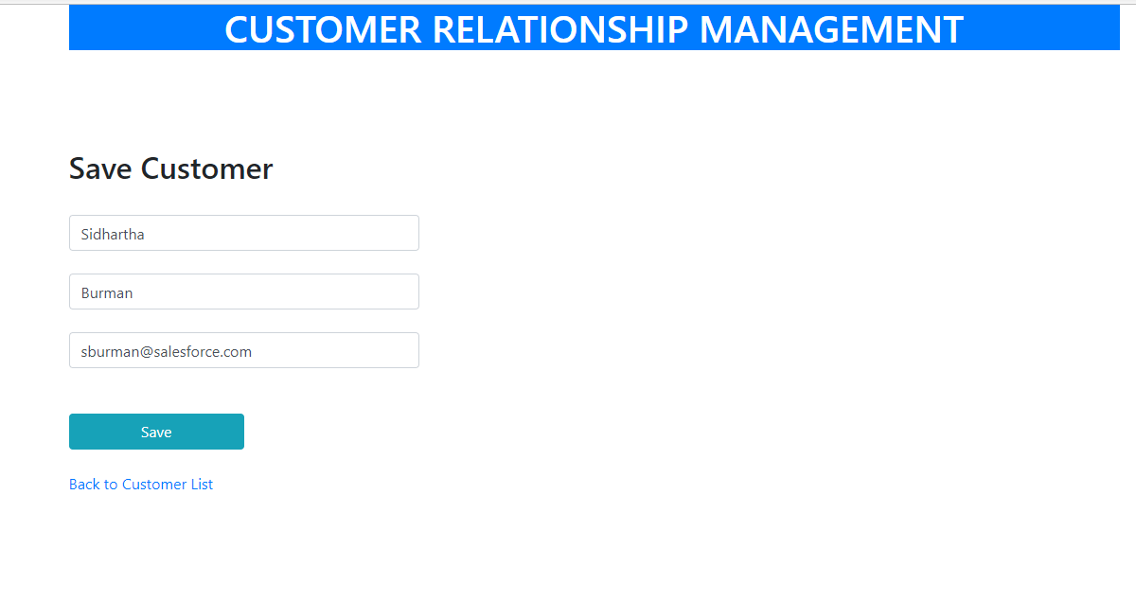

After Clicking on Save

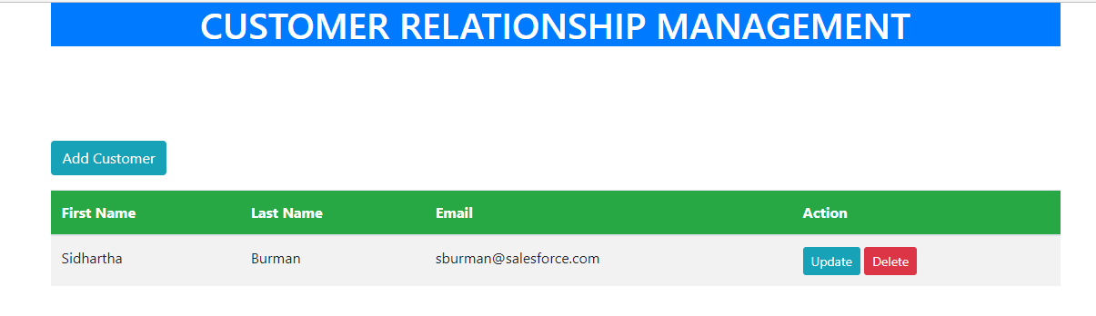

MYSQL Screenshot

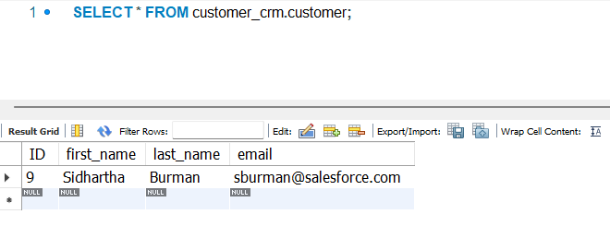

Adding one more customer

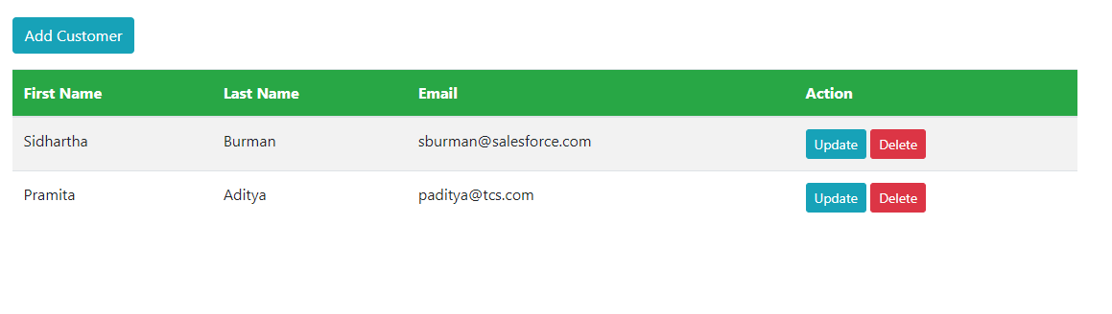

Updating the Customer Email for Pramita Aditya by Clicking on Update Button

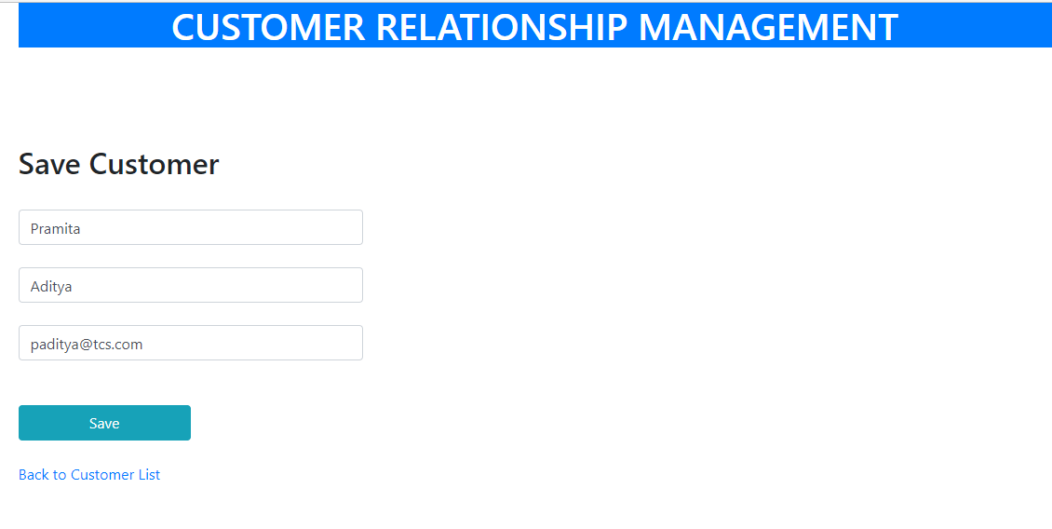

After Email Update and Clicking on Save

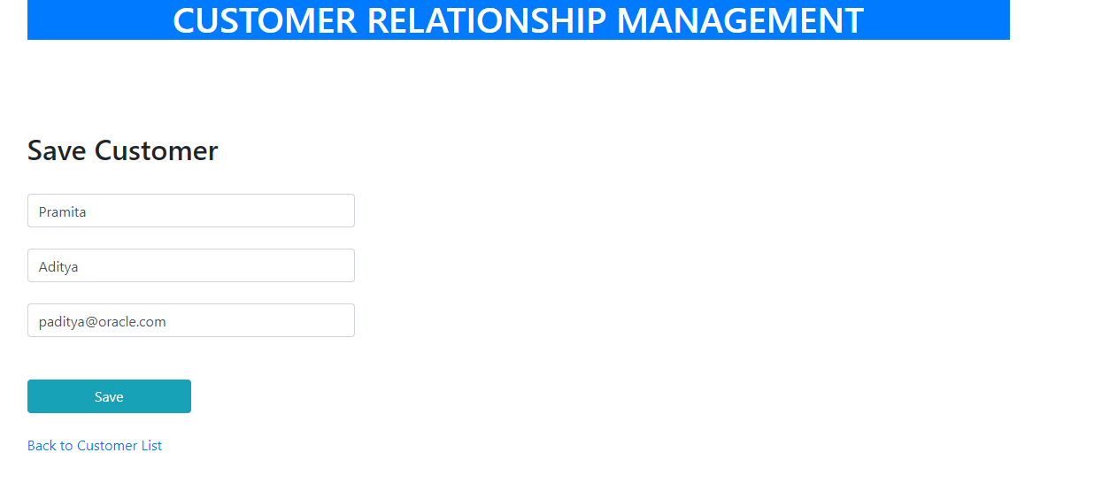

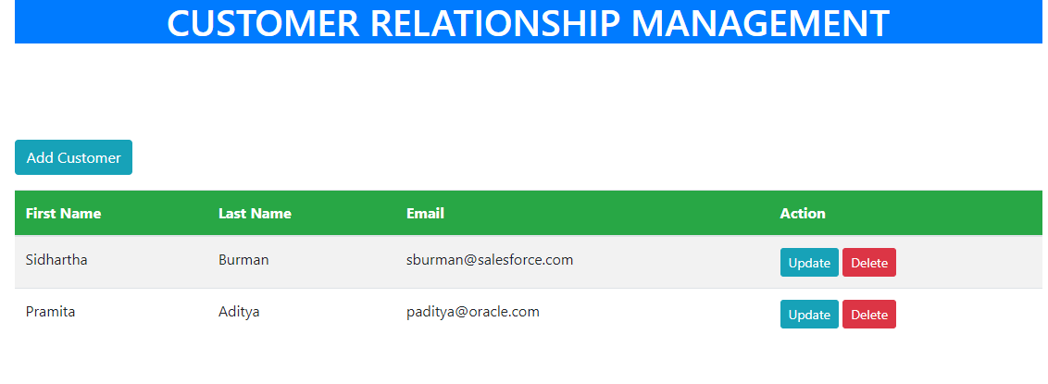

The updated Email address is reflecting in the list of customers

Deleting the Customer by Clicking on Delete Button

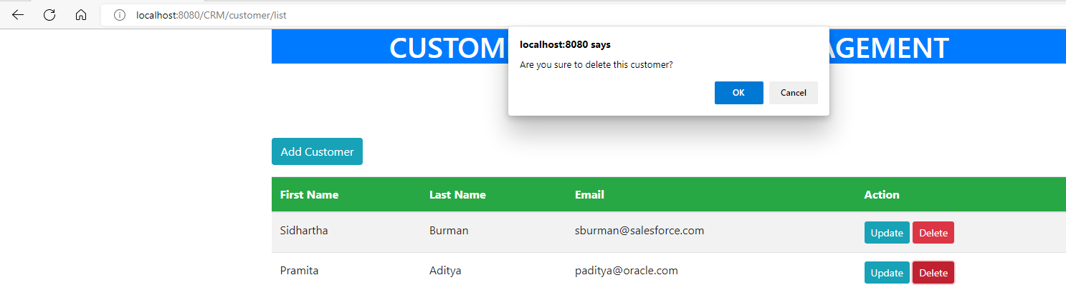

The Pop-Up asks for a confirmation to delete

On Clicking OK the Customer is deleted and doesn’t reflect in the list of customers

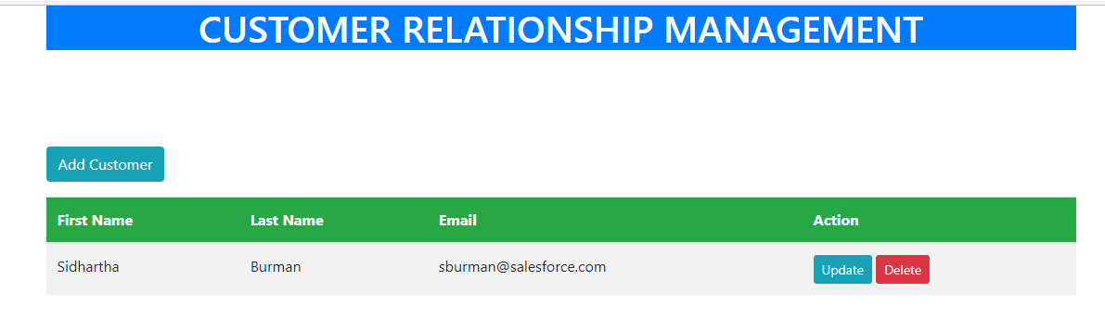

DB Screenshot

