[[1]](#footnote-1)

Technique for Li-Fi range Extension

Sidhartha Singh1, Tanupriya Choudhury2 and Roshan Lal Chhokar3

*Department of Computer Science Engineering, Amity University*

*Uttar Pradesh, India*

1[*sidharthasingh2@gmail.com*](mailto:sidharthasingh2@gmail.com)*, 2*[*tchoudhury@amity.edu*](mailto:tchoudhury@amity.edu) *, 3*[*rchhokar@amity.edu*](mailto:rchhokar@amity.edu)

*Abstract*— Li-Fi is a wireless communication technology that utilizes a duplex communication system. It is a kind of visible light communication. Li-Fi employees LEDs which turn on and off at very high rates, thus, transmitting data to a remote receiver. Li-Fi is thought of as an alternative solution to the RF-bandwidth limitation problem existing in the Wi-Fi. Although Li-Fi provides and unmatchable data transfer speed over other prevailing technologies, there are few limitations and disadvantages of using it which further attribute to cost, maintenance, range etc. The paper provides a theoretical method to implement range expansion of Li-Fi devices.

*Keywords*— LED, Li-Fi, OWC, UV, VLC, Wi-Fi

# INTRODUCTION

L

I-FI is a high speed wireless communication technology similar to Wi-Fi. Li-Fi stands for light fidelity. It is a type of visible light communication and a subset of optical wireless communication. The term was framed by Harald Haas of University of Edinburg in 2011. The technology can be a complement to the RF communication techniques like Wi-Fi or even a replacement in contexts of data broadcasting.

It is wire and UV visible light communication or infrared and near-ultraviolet instead of radio-frequency spectrum, part of wireless communications technology, which carries much more information and has been proposed as a solution to the RF-bandwidth limitations. Since the Li-Fi doesn’t limit its bandwidth, several problems existing in the today’s world can be solved which demand higher bandwidth, more than what existing technology can provide.

# EXISTING TECHNOLOGY

The current scenario consists of methods like Wi-Fi for wireless internets access or wired transmissions like cabled data transmission. Few statistics of the current scenario show the following things:

* The overall population, globally, of people using the internet has grown rapidly since 2011. It has grown 60 percent from 2 billion users to more than 3.4 billion users till 2016.
* By the end of 2016, 90% of the world’s data was created in last two years.
* Every day, users create 2.5 quintillion (1018) bytes of data across the globe.
* 100 GB/day was the average internet traffic in 1992, 100 GB/hour in1997, 100 GB/s in 2002, 28,875 GB/s in 2013 and is estimated to reach 50,000 GB/s till 2018 which is 4.32x107 times the stat of its initial launch. In the graph represented below, the internet traffic value in the year 1992 and 1997 is too small that it seems nothing in respect to other years.

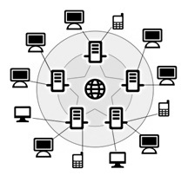

Figure 2 : Diagram representing the internet structure

Graph 1 : Graph representing the year wise internet traffic, globally since last two decades

# Problems with existing technology

With the current scenario in view several predictions have been made about the coming years of the internet. The problems may affect the storage and speed of the internet.

* Bandwidth limitation for the internet traffic.
* Lack of data centers
* With deployment and development platforms growing rapidly in number and versatility, security issues concerning data security is increasing.

Technologies which make the processes faster and compact will save the day when it comes to the problems related with the storage and speed. Some of them are:

* Better data compression algorithms
* Faster bandwidth of data transfer
* Faster data centers

# How li-fi helps

Li-Fi has been tested to reach a speed of over 224 Gbit/s or 28 Gbyte/s when tested in a controlled environment. In general environment, Li-Fi is speculated to attain a speed of above 1 Gb/s.

When the technology is applied in a day to day transfer of data, the data transfer becomes faster. This sets an example for better bandwidth and can be seen as a substitution for a technology of better bandwidth. Few of the advantages of this technology are:

1. **Speed**:Light travels at a greater speed than the sound. The rounded off speed is around 3 x 108m/s whereas the speed of sound on an average is only 3.4 x 102 m/s, thus giving a faster performance to the light based technology.
2. **Efficiency**: Working on visible light technology, Li-Fi is very efficient when compared to others. Homes and offices already have LED bulbs for lighting purposes, from which, the source of light can be used to transmit data. Thus, it is very efficient in terms of costs as well as energy. Light must be on to transmit data, so when there is no need for light, it can be reduced to a point where it appears off to human eye, but is actually still on and working.
3. **Availability**: Every light source present anywhere has the ability to be an internet source. Light bulbs are present everywhere – in homes, offices, shops, malls and even planes, meaning that high-speed data transmission could be available everywhere.
4. **Security**: The biggest advantage that Li-Fi offers is security. Light does not have the ability to pass through opaque structures. Internet provided by Li-Fi is available to users within a room and cannot be breached or interfered by others users in other rooms or buildings. Thus, providing enough physical security to the network. This advantage can also prove to be a disadvantage sometimes, as the Li-Fi source need to be in direct communication with the Li-Fi receiver for proper data transfer.
5. **Cost**: Li-Fi is ten times cheaper than the Wi-Fi and thus, is easily affordable and easy to setup in local environment.

# li-fi - working

Standard LED light bulbs use a constant current, which emits a constant stream of photons perceived by us as visible light. Li-Fi is different because the current it uses varies, meaning that the output intensity of the light fluctuates.

LEDs are semiconductors so the current and the output can be modulated at high speeds, which is picked up via a photo detector device (the equivalent to a Wi-Fi networking card in PC). The optical output is then converted back into an electrical current, which is processed and sent to your device as data. The varying light intensity is invisible to the naked eye, making it about as noticeable as Wi-Fi signals.

The light emitted from various LEDs is used by the OWC technology (Optical wireless communication) as a medium to deliver networked, mobile, high-speed communication in a similar manner to Wi-Fi.

Visible light communications (VLC) incorporates switching the current to the LEDs off and on at a very high rate, too quick to be noticed by the human eye. Although LEDs that act as the Li-Fi source would have to be kept on to transmit data, they could be dimmed to below human visibility while still emitting enough light to carry data. The light waves do not have the ability to penetrate walls which makes a much shorter range, though more secure from hacking, relative to Wi-Fi. Direct line of sight is not necessary for Li-Fi to transmit a signal; light reflected off the walls can achieve 70 Mbit/s.

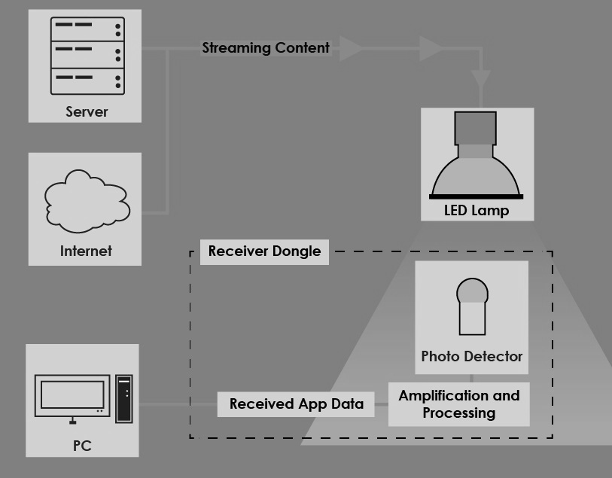

Figure 3 : Diagram showing the functioning of Li-Fi system

# Limitations of Li-Fi

The Li-Fi technology possesses few limitations in term of functionality due to the properties of light. Few of them are:

* Light, as a photon, goes in a straight line. It doesn't really bounce very well. Think of a laser. Laser is essentially invisible except at each endpoint. For this reason, Li-Fi is a "line of sight" technology. Until and unless the receiver is in line of sight of the transmitter, the connection isn’t successful. Due to this, Wi-Fi has the biggest advantage over Li-Fi as radio waves can penetrate through substances and can be accesses without being in the line of sight of the transmitter.
* Without the presence of a light source, internet cannot be used. This stores the tendency to limit the locations and situations in which Li-Fi could be used.
* It is a possibility that the other sources of light may interfere with the signals. One of the biggest potential drawbacks is the interception of signals outdoors. Sunlight will interfere the signals, resulting in interrupted Internet.
* A whole new infrastructure for Li-Fi would need to be constructed.

# Developing a technique for range extension

Since the current prevailing scenario requires an up gradation in terms of technology stack for wireless communication, there exists a need to develop new techniques that increase the range of Li-Fi and possibly overcome the line of sight problem.

From the limitations of Li-Fi, it is clear that the biggest problem that exists in a Li-Fi system is that of finding a method that removes the system dependency on the “line of sight” of the receiver and the transmitter.

Due to the above stated fact, Li-Fi can only be used inside the walls of our home as the light will not be able to penetrate the walls. Few techniques which could be implemented to extend the range of the transmitter are:

* Reflecting devices on doors
* Reflecting floors
* Multi directional lighting system
* Receiver-Transmitter module
* LiFi - WiFi hybrid system

# reflecting devices on doors

This method can be utilized to extend the range of a Li-Fi system of a single room to various other adjacent rooms which are accessible through the doors.

1. **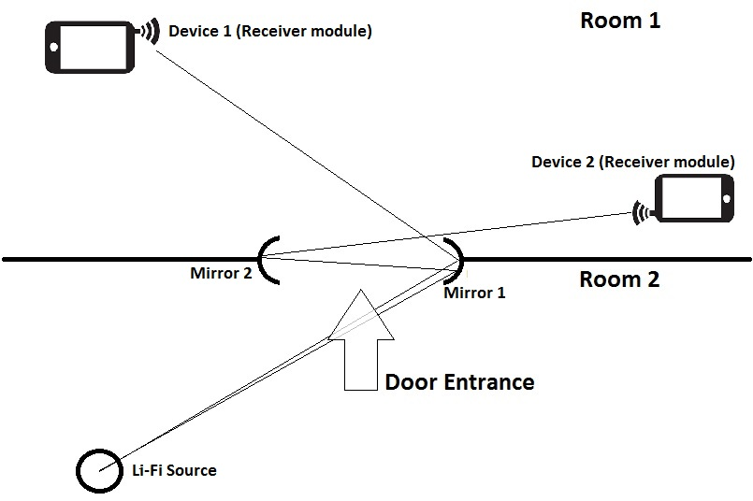Method:** This method consists of fixing two concave mirrors at the two corners of the door. This is done in such a way that the center of the reflective surface of one of the mirrors is in line of sight of the Li-Fi source and the center of the reflective surface of the other mirror is in line of sight of both, the first mirror and the other room. This method provides a cheap alternative to Li-Fi range extension using just mirrors as the means.

Figure 4 : Range extension technique using reflecting devices or door sides

1. **Advantages:** Since the method involves non circuitry device except the Li-Fi source, it has following properties:

* Low installation cost
* Good range extensibility
* Low maintenance cost

1. **Disadvantages:** The proposed method can have several disadvantages as well. The method is based on assumption that the environment is noise free and totally isolated. Several disadvantages that might befall such method implementation are:

* Incomplete range coverage: The extensibility depends on the mechanical properties of the mirrors. If they incur any kind of fault in setup, texture or alignment, possible data loss and connection breaks are possible.
* Noise accumulation: It is possible that the receiver might gather inputs from other light sources present in the room which give out infrared rays but are not Li-Fi devices. This kind of received data with be an error case. Further, it is possible that multiple reflections are taking place in the same room which causes error entries to the Li-Fi receiver.

# **C:\Users\SIDHARTHA\Desktop\fllor_reflection.jpg**Reflecting floors

Figure 5 : Range extension technique utilizing the reflecting floors

The method can be utilized to extend the range of Li-Fi source within a single room. This method increases the range of Li-Fi source in such a way that it can reach in indirect places which are not direct accessible from the source.

1. **Methods:** This method involves laying the flooring of the particular room in which Li-Fi is to be used using a reflective substance. This would help in increasing the range of Li-Fi source that wasn’t directly accessible to the receiver. This method is a bit expensive than the first one.
2. 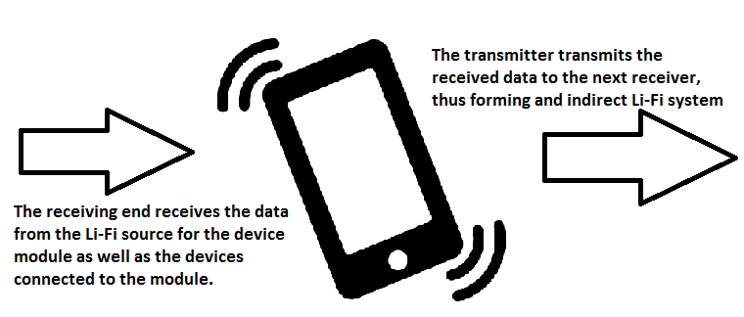**Advantage:** Since this technique of Li-Fi range extension involves a large reflective surface for increasing the range of the source, the efficiency of the technique is better than the previously described technique. The technique has following advantages:

Figure 6 : A receiver - transmitter module functioning

* Better range extensibility
* Low maintenance cost
* Better suited for office environments

1. **Disadvantages:** The techniques has few disadvantages:

* More wear and tear
* Higher installation cost
* Higher noise accumulation

# Multi-directional lighting

This method incorporates a new ceiling system which organizes the LED bulbs in a three dimensional pattern. This way we have the sources of Li-Fi light sending signals in several directions.

1. **Method:** This method involves setting the ceiling design in a manner, different from usual. It involves setting the face of the Li-Fi bulbs in various directions. This way, the Li-Fi signals can be spread throughout the room evenly. This gives an experience just like Wi-Fi as the signals are spread evenly throughout the space.
2. **Advantages:** Since, the signals are spread evenly throughout the room, the system gives an experience just like Wi-Fi.

* Better range extensibility
* Low noise accumulation
* Low data corruption
* Direct connectivity
* Low cost installation
* Easy maintenance

1. **Disadvantages:** Although the techniques increases the range of the Li-Fi source evenly, there are few disadvantages this technique has. They are:

* Due to higher number of LED bulbs, it is possible that connection mismatch may occur.

# Receiver-Transmitter module

In this method, the general Li-Fi system is accompanied by an additional device that helps in extending the Li-Fi source range. The device is a kind of normal device which has an extra inbuilt Li-Fi receiver and transmitter which helps in increasing the range of the system. The device takes data from the source and utilizes it. It passes on the data requested by the other devices connected to it. This system works like a Wi-Fi hotspot,

the difference being, instead of Wi-Fi, Li-Fi is involved and instead of wired input to the module, wireless input takes place.

1. **Method:** In this method a third party device is fixed with an extra pair of receiver and transmitter. This set is used to extend the connection on the receiving end of the device, thus forming a linear chain of connection. This linear chain can accommodate a long number of devices with strong network connectivity.
2. **Advantages:** This method is the one method in which the source of the Li-Fi source has no specific requirement. The advantages of this method are:

* It can accommodate any number of devices.
* Low data loss might occur.
* Solves the “Line of sight” problem
* Easy setup
* Linear setup reduces noise.

1. **Disadvantages:** The disadvantages of this method are:

* Data traffic across a branch may increase and affect the performance.
* Relatively expensive setup

# Li-Fi – Wi-Fi hybrid system

This method combines the pros of both of the systems that are, Wi-Fi and Li-Fi. The combination helps in increasing the data traffic and data traffic processing speed. Since this method involves two technologies in a combination, it can be called as a hybrid system. Li-Fi – Wi-Fi hybrid system is practically easy to design as both the technologies use IEEE 802.11 based protocols.

1. **Method:** In this method we specify our needs before actually creating the system. In this phase, we specify the requirements on the basis of the devices that would use Li-Fi and Wi-Fi. The main connection provider is the Li-Fi unit which is further connected to Wi-Fi connection provider. The receiving end of the Wi-Fi module has Li-Fi receivers and transmitter, which communicate with the internet. The other end consists of Wi-Fi receiver and transmitter to which, the users connect their devices. This way a number of Wi-Fi devices are connected to a single source. Both the device modules would use same standard protocols. This reduces protocol translation efforts.
2. **Advantages:** This method forms a network mesh constituting of various technologies. It has following advantages over the general prevailing system:

* It can easily support high network traffic.
* It would work with all the devices having Wi-Fi antenna.
* It solves the “line of sight issue” of the Li-Fi.
* Easy installation.
* Better networking capabilities for local networks
* No protocol translation, thus giving good speed to all the connected devices.
* Suitable for office use.

1. **Disadvantages:** Since this method involves use of various technology stack in a single system, it is possible that conflicts occur in protocols. Therefore, the system has several disadvantages, which are:

* Costly to setup such a hybrid system.
* Not suitable for home use.

# Discussion and future scope

The Li-Fi technology has been seen as a future replacement for the existing ways of wireless communication. Its high speed is the key feature that make users choose it over any other mode of wireless communication.

There is still a lot to be done in the Li-Fi technology. The paper proposes few techniques which can be used with a more practical approach to extend the range of Li-Fi sources. This would lay down the foundation of future wireless communication. Few modifications in the mentioned techniques can be done to intensify the outcomes.

# Conclusion

The Li-Fi is a technology which is still in its development phase. Developed in 2011, it is taking the market with a boom. It is seen as a replacement for the prevalent and market dominant Wi-Fi technology.

Since, it is a new technology, there exists several issues with its compatibility and use in the local environment. The paper tries to focus on the limitations possessed by the Li-Fi system. The paper also proposes five techniques to overcome few of the limitations. The techniques are theoretical and may have less practical approach. It also develops a method of developing new technique for Li-Fi range extension, i.e. if all the proposed technologies are combined, the practicality of range extension increases.

# References

1. Harald Haas. "Harald Haas: Wireless data from every light bulb". <http://www.ted.com>
2. www.arubanetworks.com/assets/wp/WP\_WiFiCoreIntegration.pdf

1. [↑](#footnote-ref-1)