1. Docker –version – to check which docker version is currently running.

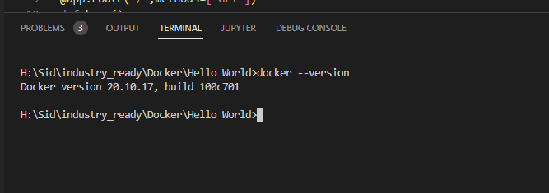

1. Docker ps – to check what all containers are running currently.

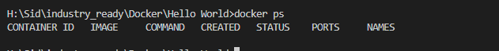

1. Docker ps -a – to check all the containers in the system including non-running.

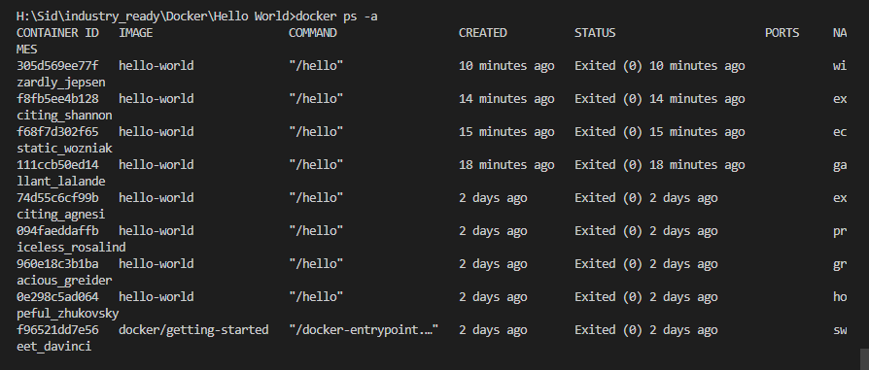

1. docker pull hello-world – this command used to pull the command from the docker repository.

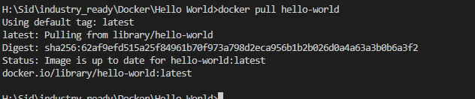

1. docker stop <container ID> - this is used to stop the running container

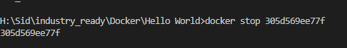

1. docker run -it -d repository name – this command is used to run the repository.

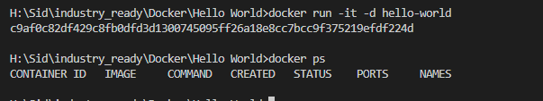

1. docker images – this is used to see all the images id.

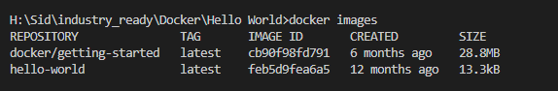

1. docker rmi <container id>- this is used to remove the container



1. docker exec -it <container > bash – this is used to execute the container.



10.docker login – to login into the docker

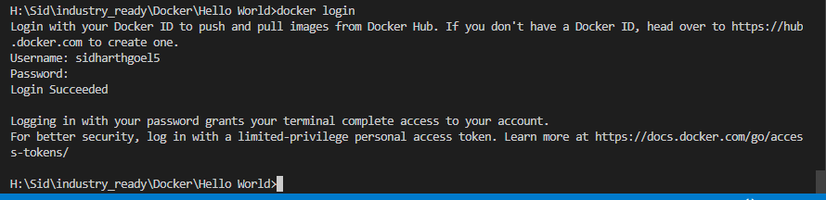

1. docker rm – it removes the specified container id

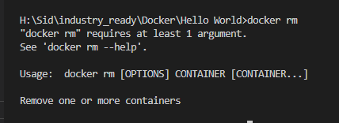

12. docker network ls – list of the all the network in the clusters.

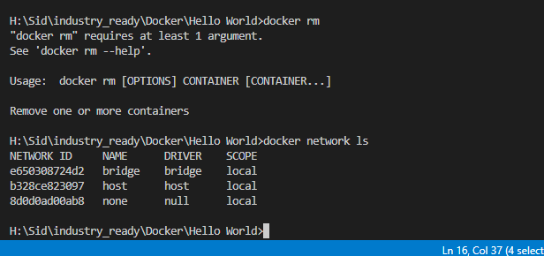

13. docker rm – remove container

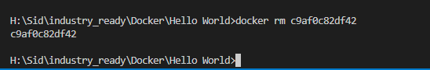

14. docker build -t image-Id . – to create the container in docker

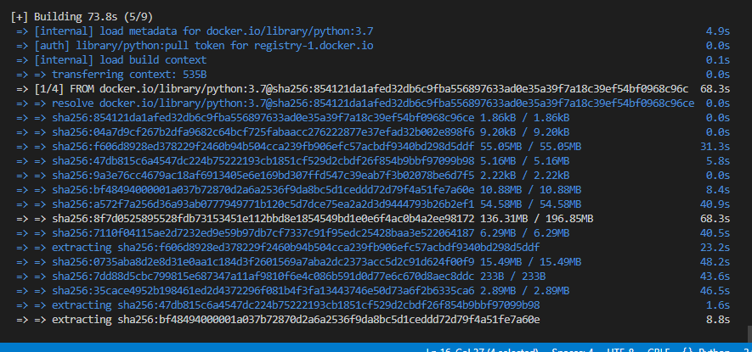

15 docker logout – it will logout from docker