SmartBranch 360 — Fault Testing Report
Evidence log for the 5 required fault-injection / troubleshooting cycles, with before-and-after CLI and host verification for each fault.

Fault 1 — Wrong Default Gateway (Layer 3)
Injection: PC2 was manually set with an incorrect gateway (10.10.10.254 instead of 10.10.10.1).
Symptom observed: PC2 could ping its own gateway-adjacent hosts but pings to the server (10.10.30.10) and to the internet (8.8.8.8) both returned "Request timed out" — consistent with traffic having nowhere to route to off-subnet.
Fix: gateway corrected back to 10.10.10.1 on PC2. Re-test confirmed pings to the server and internet succeeded (small initial packet loss from ARP resolution, then 0% loss on repeat).
Root cause confirmed: incorrect default gateway prevents any off-subnet routing — a Layer 3 addressing fault.

Fault 2 — Missing VLAN on Trunk (Layer 2)
Injection: VLAN 20 (GUEST) was removed from the SW1↔R1 and SW2↔SW1 trunk allowed-list (switchport trunk allowed vlan remove 20 on both switches).
Symptom observed: guest device PC7 could not renew its DHCP lease at all ("DHCP request failed") — guest broadcast traffic had no path to reach R1's DHCP server since VLAN 20 was no longer carried on the trunks.
Fix applied and verified below:
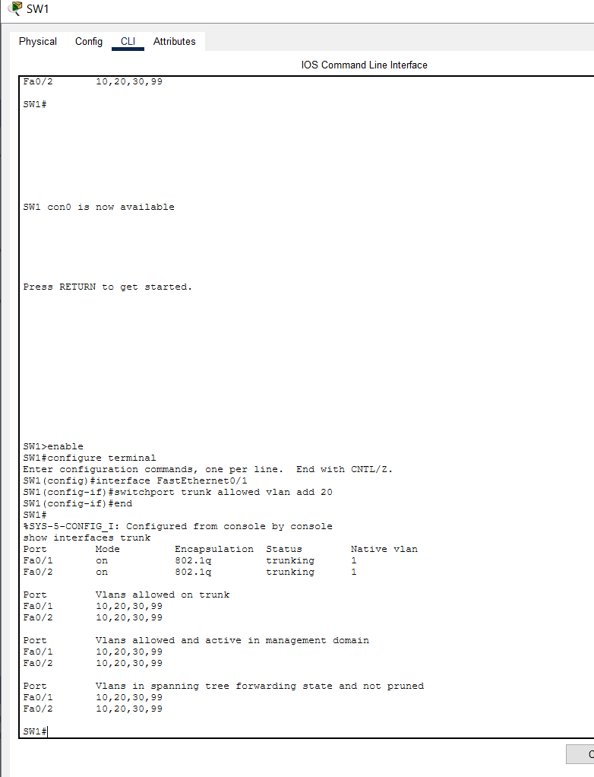
SW1 — switchport trunk allowed vlan add 20; show interfaces trunk now lists VLAN 20 in the allowed list for Fa0/1 and Fa0/2.
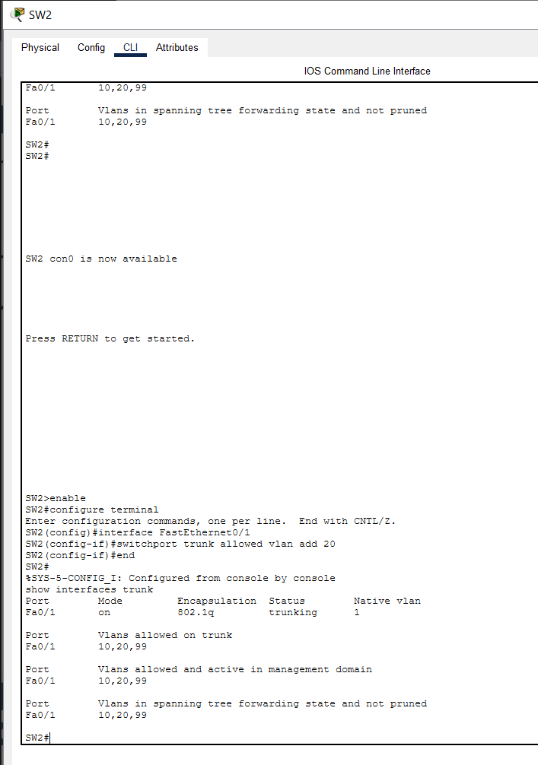
SW2 — same fix applied to Fa0/1; VLAN 20 restored on the SW1↔SW2 trunk.
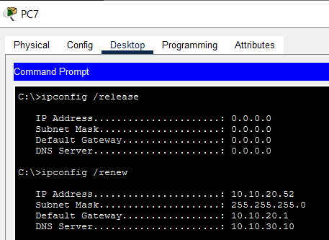
PC7 (guest) — ipconfig /release then /renew now succeeds: 10.10.20.52 assigned, gateway 10.10.20.1, DNS 10.10.30.10.
Root cause confirmed: VLAN 20 missing from the trunk allowed-list blocked all guest broadcast/DHCP traffic — a Layer 2 trunking fault.

Fault 3 — DHCP Pool Exhausted (Layer 3 / DHCP)
Injection: R1's excluded-address range for the EMPLOYEE pool was changed to 10.10.10.1–10.10.10.254, excluding almost the entire /24 and leaving no addresses to lease.
Symptom observed: PC3 (an existing employee host) failed to renew its lease ("DHCP request failed") even though the pool configuration otherwise looked normal.
Fix applied and verified below:
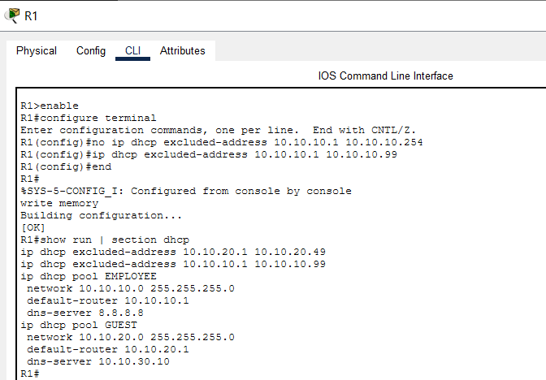
R1 — excluded-address corrected back to 10.10.10.1 10.10.10.99; show run | section dhcp confirms the corrected range for both EMPLOYEE and GUEST pools.
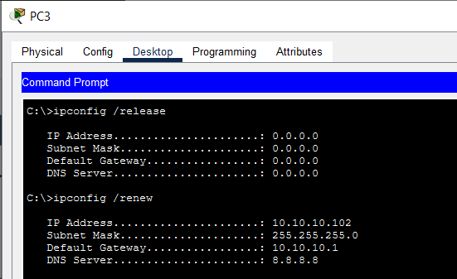
PC3 — DHCP renew now succeeds: 10.10.10.102 assigned, gateway 10.10.10.1, DNS 8.8.8.8.
Root cause confirmed: an overly broad excluded-address range starves the DHCP pool of usable addresses — misconfiguration, not a hardware or link fault.

Fault 4 — ACL Blocking DNS (Layer 4/7)
Injection: the GUEST_ISOLATION ACL contained a broad deny for UDP/53, blocking all DNS resolution for the guest VLAN even though IP-based reachability to the internet still worked.
Symptom observed: nslookup google.com from a guest-reachable host timed out three times before finally resolving, showing intermittent/blocked DNS behaviour.
Fix: the broad deny was removed; an explicit permit for UDP/53 to the internal DNS host (10.10.30.10) was added ahead of the guest-isolation deny rules, and the GUEST DHCP pool's dns-server was pointed at 10.10.30.10 (an internal DNS record for google.com was added on SRV1 for lab-verification purposes). Re-test confirmed nslookup google.com resolved correctly on repeat.
Root cause confirmed: an ACL rule blocking UDP/53 breaks name resolution independent of underlying IP connectivity — an Application/Transport-layer fault.

Fault 5 — NAT ACL Missing Guest Subnet (Layer 3 / NAT)
Injection: the GUEST subnet (10.10.20.0/24) was removed from NAT_ACL, so R1 no longer had a matching rule to translate guest traffic for internet access.
Symptom observed: show ip nat translations showed zero active translations, and guest devices lost internet access entirely while the employee VLAN was unaffected.
Fix applied and verified below:
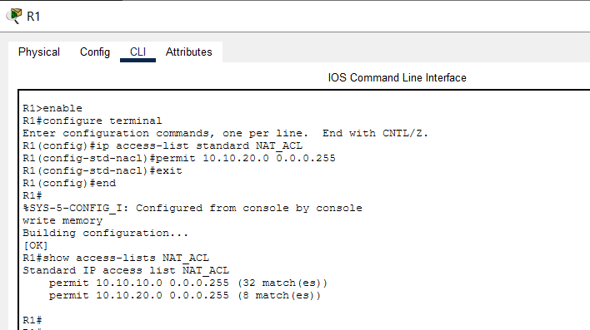
R1 — permit 10.10.20.0 0.0.0.255 re-added to NAT_ACL; show access-lists NAT_ACL confirms both EMPLOYEE and GUEST subnets are now permitted for NAT.
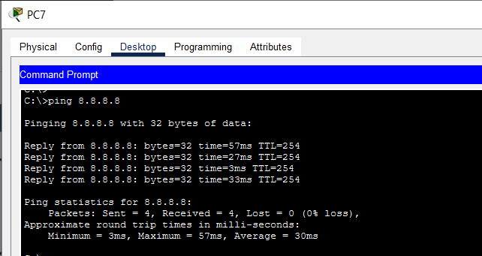
PC7 (guest) — ping 8.8.8.8 now succeeds with 4/4 replies (0% loss), confirming internet access is restored.
Root cause confirmed: NAT only translates traffic matched by NAT_ACL — omitting a subnet there silently blocks its internet access even though routing and the outside interface are otherwise fine.

Python Assurance Tool — Independent Verification
network_checker.py was also run directly against captured show-command output (R1_show_ip_interface_brief.txt, R1_show_ip_nat_translations.txt, SW1/SW2_show_interfaces_trunk.txt) using: python network_checker.py --plan requirements.yaml --show-dir show_outputs
The plan check passed cleanly (no duplicate VLANs, no overlapping subnets, valid gateways, guest isolated). The show-output check flagged GigabitEthernet0/2 and Vlan1 as administratively down — both are unused-by-design interfaces (Gi0/2 has no cable in this topology; Vlan1 is the switch's default management VLAN, intentionally left down since VLAN 99 is used for management instead), so these are expected, not faults.

Summary
Fault | Layer | Status
1. Wrong gateway | Layer 3 | Diagnosed & fixed, re-verified
2. Missing VLAN on trunk | Layer 2 | Diagnosed & fixed, re-verified
3. DHCP pool exhausted | Layer 3/DHCP | Diagnosed & fixed, re-verified
4. ACL blocking DNS | Layer 4/7 | Diagnosed & fixed, re-verified
5. NAT ACL missing subnet | Layer 3/NAT | Diagnosed & fixed, re-verified

