SmartBranch 360
Secure Branch Office Network — Complete Project Report
Cisco AICTE Virtual Internship Program 2026 — Project 1: Networking + Packet Tracer + Python
Student: Sidharth Kumar

1. Objective
Design and build a small branch-office network in Cisco Packet Tracer supporting wired employees, guest Wi-Fi, an internal server, internet access via NAT, and secure out-of-band management — then validate the design with a Python assurance tool and prove resilience through five fault-injection/troubleshooting cycles, all with verified evidence.

2. Topology Overview
The branch uses one ISR router (R1) performing router-on-a-stick inter-VLAN routing and NAT, a two-tier switch layer (SW1 distribution, SW2 access), one wireless access point (AP1) serving the guest SSID, one internal server (SRV1), and 9 endpoints (6 wired employee PCs, 1 wired management PC, 2 wireless guest devices).
- R1 — GigabitEthernet0/0 trunked to SW1 (sub-interfaces per VLAN); GigabitEthernet0/1 faces the Internet cloud, NAT-outside.
- SW1 — Distribution switch; trunks to R1, SW2, AP1; SRV1 and Management PC on access ports.
- SW2 — Access switch; 6 wired employee PCs on access ports; trunk uplink to SW1.
- AP1 — Broadcasts guest SSID 'SmartBranch-Guest' (WPA2-PSK/AES); wired uplink is an access port in VLAN 20.
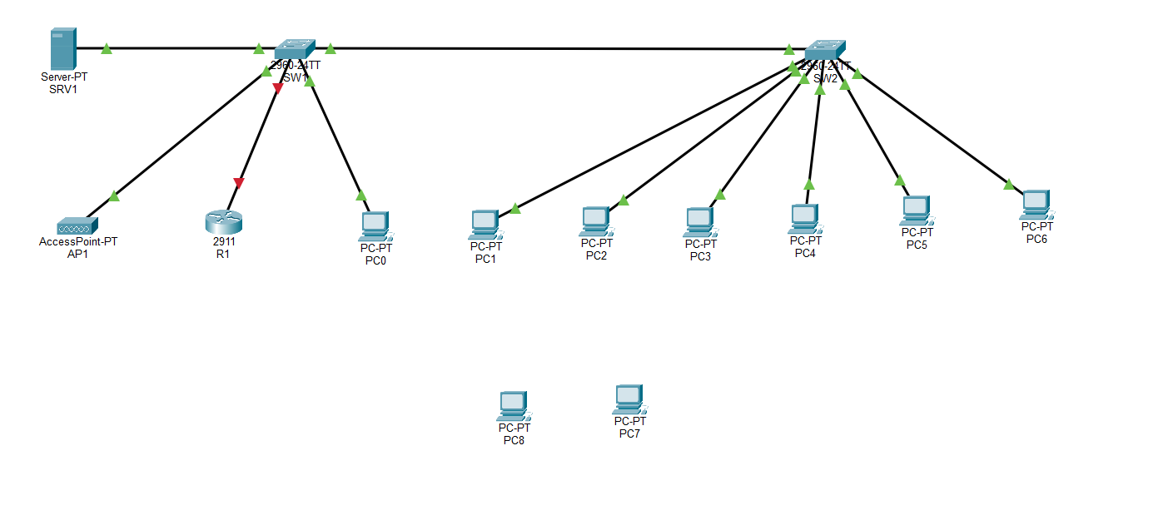
Built topology in Packet Tracer: R1, SW1, SW2, AP1, SRV1, and all 9 endpoints connected.
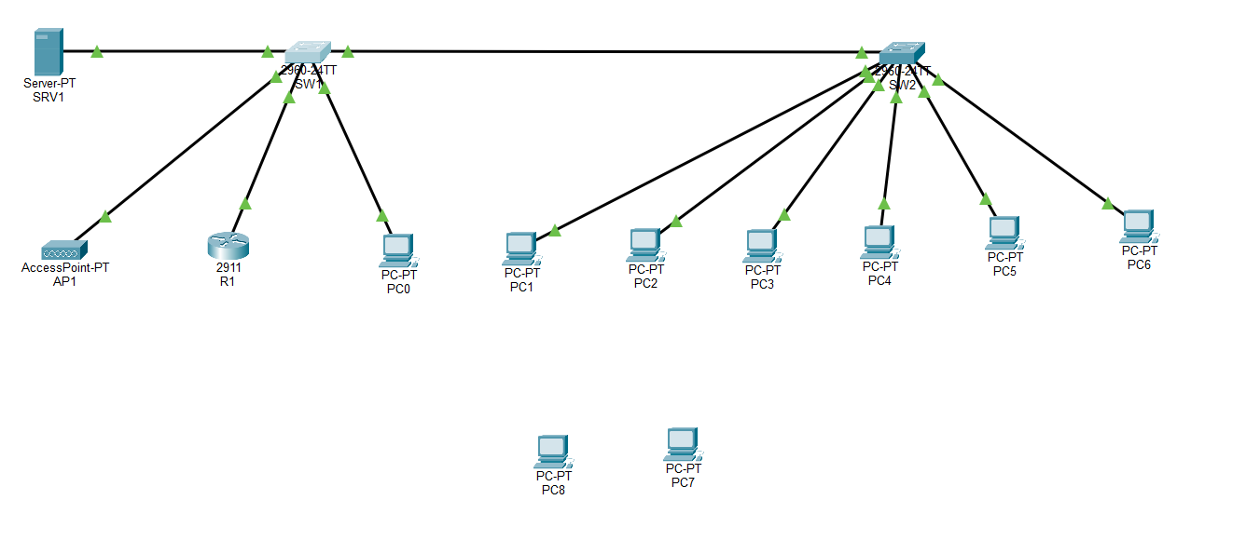
All links verified up (green) after configuration — every port active and forwarding correctly.

3. VLAN and IP Address Plan
VLAN | Name | Subnet | Gateway | Address Method
10 | EMPLOYEE | 10.10.10.0/24 | 10.10.10.1 | DHCP (.100–.200)
20 | GUEST | 10.10.20.0/24 | 10.10.20.1 | DHCP (.50–.150), wireless
30 | SERVER | 10.10.30.0/24 | 10.10.30.1 | Static (SRV1 = .10)
99 | MANAGEMENT | 10.10.99.0/24 | 10.10.99.1 | Static (MgmtPC = .2)

4. Services Configured
- DHCP: per-VLAN pools on R1 for EMPLOYEE and GUEST; SERVER and MANAGEMENT use static addressing.
- DNS: forwarded to 8.8.8.8 by default; an internal DNS record was also added on SRV1 during Fault 4 troubleshooting (see Section 6).
- NAT: PAT (overload) on R1's outside interface (Gi0/1) for EMPLOYEE and GUEST subnets.
- Inter-VLAN routing: router-on-a-stick using dot1Q sub-interfaces Gi0/0.10 / .20 / .30 / .99 on R1.
- Wireless: AP1 broadcasts SSID 'SmartBranch-Guest' with WPA2-PSK/AES authentication, mapped to VLAN 20.
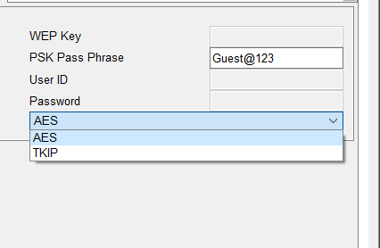
AP1 wireless configuration — SSID and WPA2-PSK/AES authentication set.

5. Security Rules
Rule | Mechanism | Effect
Guest isolation | Extended ACL GUEST_ISOLATION on R1 (Gi0/0.20 inbound) | Denies GUEST -> SERVER and GUEST -> MANAGEMENT; permits internet traffic.
NAT scope | Standard ACL NAT_ACL + 'ip nat inside source list ... overload' | Only EMPLOYEE and GUEST subnets are translated to the internet; SERVER/MANAGEMENT are not exposed.
Wireless security | WPA2-PSK/AES on AP1 | Guest SSID requires authentication, preventing open/unauthenticated wireless access.

6. Verification Testing
Connectivity and isolation were verified directly via ping between hosts on different VLANs.
Test | Result
Employee (PC1/PC2) -> Server (10.10.30.10) | Success — replies received
Employee -> Internet (8.8.8.8) | Success — replies received
Guest (PC7/PC8, wireless) -> Server | Blocked — 'Destination host unreachable' (ACL working as intended)
Guest -> Management (10.10.99.x) | Blocked — 'Destination host unreachable'
Guest -> Internet | Success — replies received (guest is isolated from internal VLANs only, not the internet)
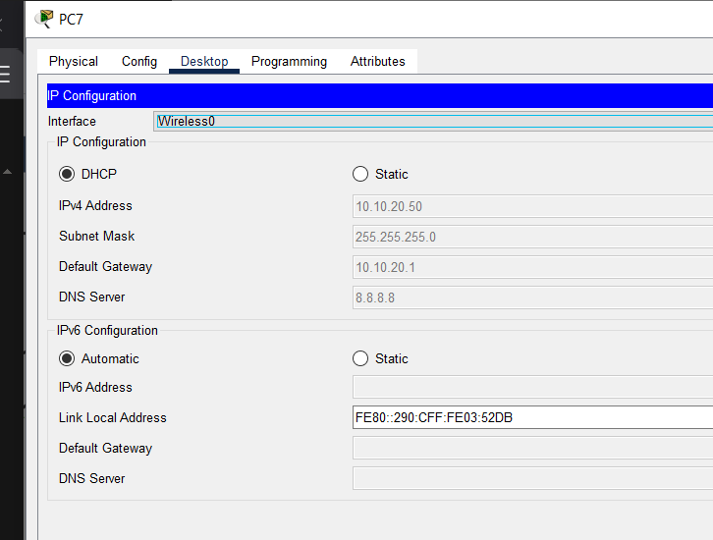
PC7 connected wirelessly to the guest SSID, received 10.10.20.50 via DHCP.
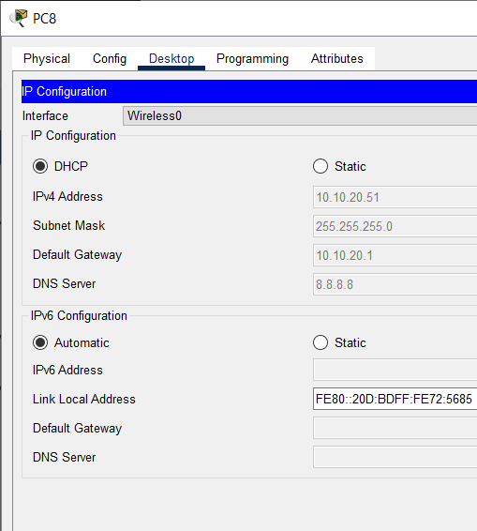
PC8 connected wirelessly to the guest SSID, received 10.10.20.51 via DHCP.
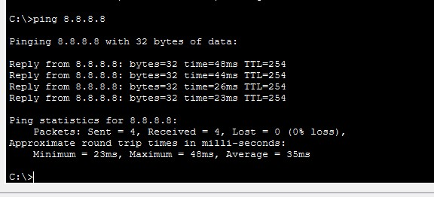
Internet reachability confirmed end-to-end (ping 8.8.8.8, 0% loss) after NAT configuration.
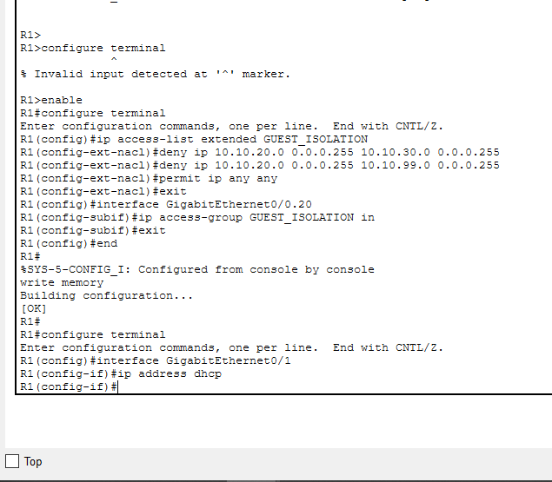
R1 CLI — GUEST_ISOLATION ACL and NAT sub-interface (ip nat inside) configuration on R1.

7. Fault Injection & Troubleshooting (5 Required Faults)
Each fault was deliberately injected, diagnosed from show-command / host evidence, fixed, and re-verified. Full before-and-after evidence follows.

Fault 1 — Wrong Default Gateway (Layer 3)
Injection: PC2 manually set with an incorrect gateway (10.10.10.254 instead of 10.10.10.1).
PC2 IP configuration showing the incorrect gateway 10.10.10.254 (injected fault).
Symptom: pings from PC2 to the server and to the internet both failed.
PC2 — ping 10.10.30.10 and ping 8.8.8.8 both time out with the wrong gateway set.
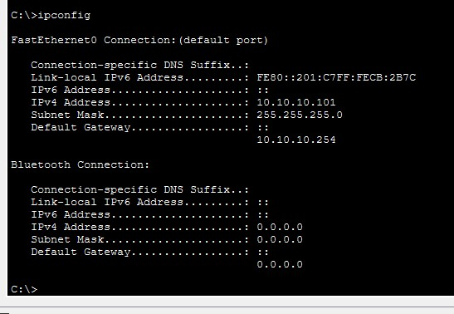
ipconfig confirms the faulty gateway (10.10.10.254) on PC2's FastEthernet0 interface.
Fix: gateway corrected back to 10.10.10.1. Re-test confirmed connectivity restored.
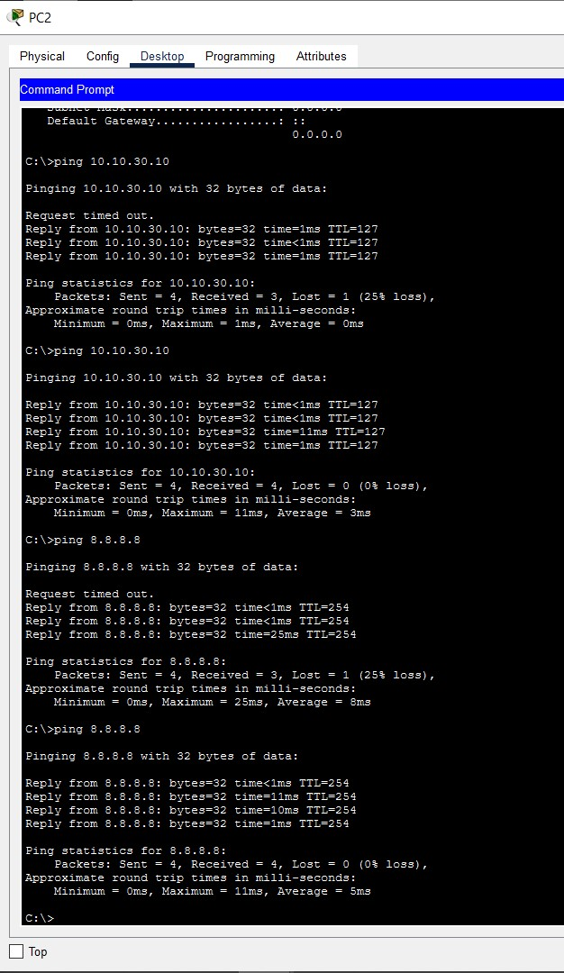
PC2 — after correcting the gateway, ping 10.10.30.10 and ping 8.8.8.8 both succeed (0% loss).
Root cause: incorrect default gateway prevents any off-subnet routing — a Layer 3 addressing fault.

Fault 2 — Missing VLAN on Trunk (Layer 2)
Injection: VLAN 20 (GUEST) removed from the SW1<->R1 and SW2<->SW1 trunk allowed-list on both switches.
SW1 — 'switchport trunk allowed vlan remove 20' applied; VLAN 20 no longer in the trunk allowed list.
SW2 — same fault applied; trunk allowed list now only shows 10,99.
Symptom: guest device PC7 could not renew its DHCP lease at all.
PC7 — DHCP release/renew fails ('DHCP request failed') because guest broadcast traffic has no path to R1.
Fix: VLAN 20 re-added to both trunks.
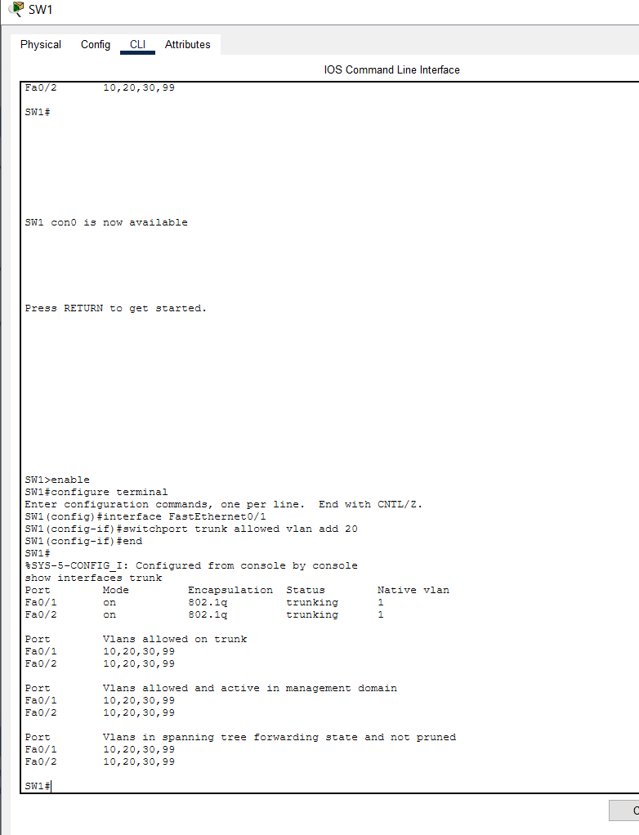
SW1 — VLAN 20 restored; show interfaces trunk now lists 10,20,30,99 on both Fa0/1 and Fa0/2.
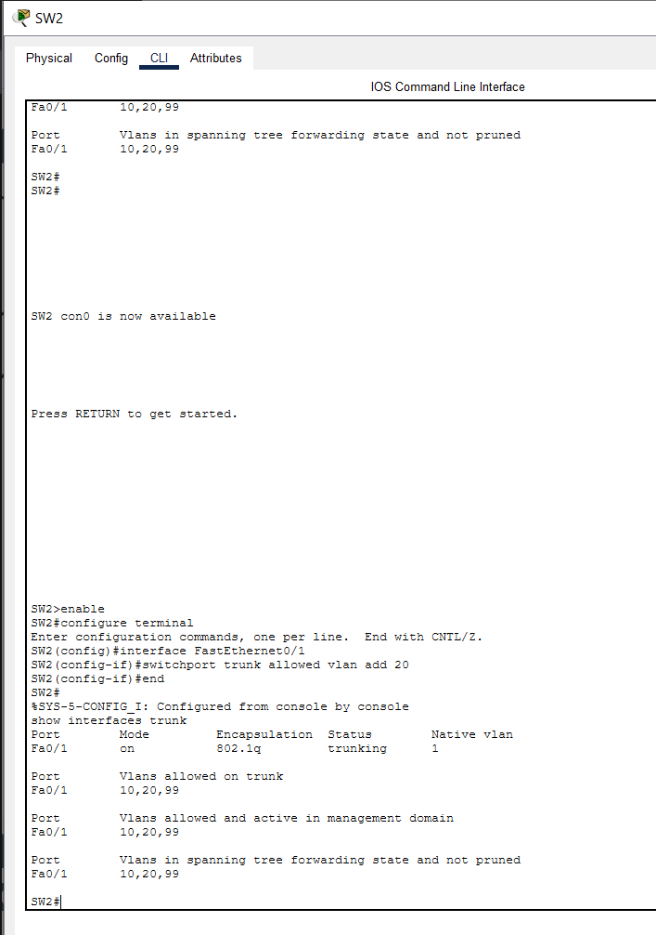
SW2 — VLAN 20 restored on the Fa0/1 trunk to SW1.
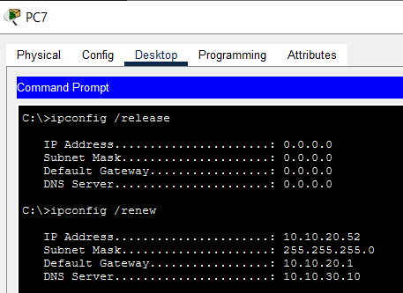
PC7 — DHCP renew now succeeds: 10.10.20.52 assigned, correct gateway and DNS.
Root cause: VLAN 20 missing from the trunk allowed-list blocked all guest traffic — a Layer 2 trunking fault.

Fault 3 — DHCP Pool Exhausted (Layer 3 / DHCP)
Injection: R1's excluded-address range for the EMPLOYEE pool changed to 10.10.10.1-10.10.10.254, leaving almost no addresses to lease.
R1 — excluded-address range widened to 10.10.10.1-10.10.10.254 (injected fault).
Symptom: PC3, an existing employee host, failed to renew its DHCP lease.
PC3 — DHCP renew fails ('DHCP request failed') with the pool exhausted.
Fix: excluded-address range corrected back to 10.10.10.1-10.10.10.99.
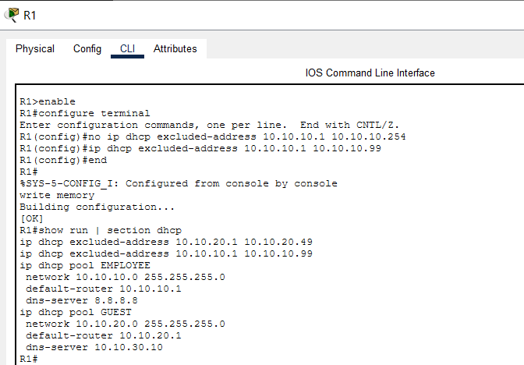
R1 — corrected excluded-address range confirmed via show run | section dhcp.
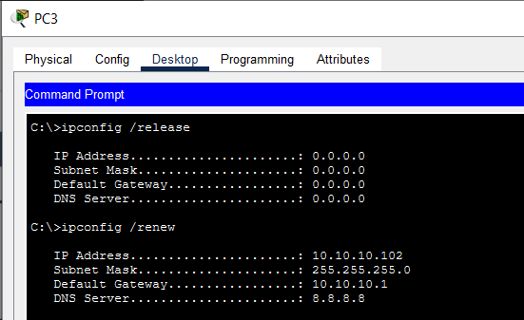
PC3 — DHCP renew now succeeds: 10.10.10.102 assigned with correct gateway.
Root cause: an overly broad excluded-address range starves the DHCP pool — a configuration fault, not a link/hardware fault.

Fault 4 — ACL Blocking DNS (Layer 4/7)
Injection: the GUEST_ISOLATION ACL contained a broad 'deny udp any any eq 53' rule, blocking all DNS resolution for the guest VLAN even though IP-based reachability still worked.
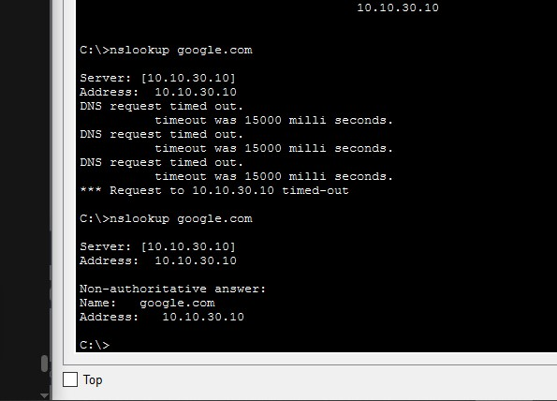
nslookup google.com times out repeatedly before finally resolving — intermittent/blocked DNS behaviour.
Fix: the broad deny was removed; an explicit permit for UDP/53 to an internal DNS host was added ahead of the guest-isolation deny rules, and SRV1 was configured as an internal DNS server (google.com -> 10.10.30.10) for verification.
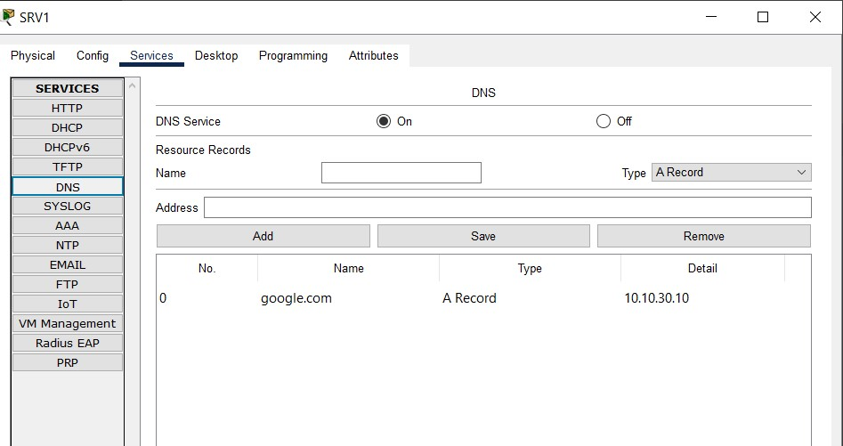
SRV1 — DNS service enabled with an A record for google.com pointing to 10.10.30.10.
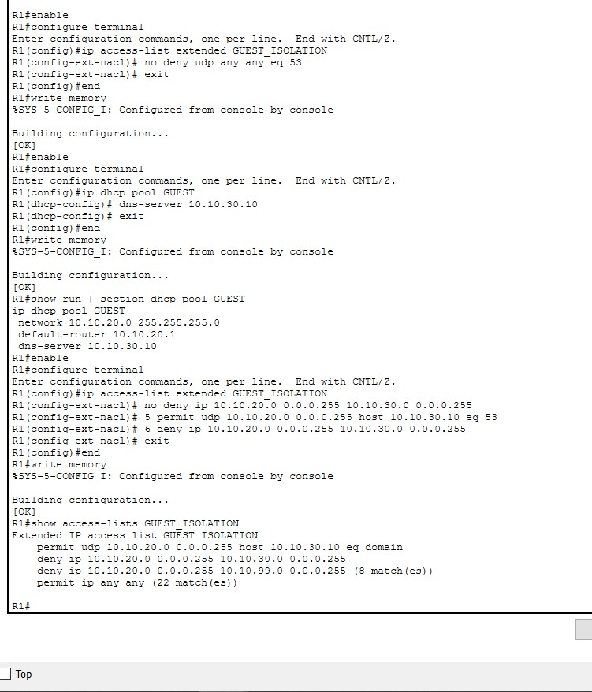
R1 — GUEST_ISOLATION ACL updated: broad DNS deny removed, explicit permit for UDP/53 added; show access-lists confirms the corrected rule order and match counts.
Root cause: an ACL rule blocking UDP/53 breaks name resolution independent of underlying IP connectivity — an Application/Transport-layer fault.

Fault 5 — NAT ACL Missing Guest Subnet (Layer 3 / NAT)
Injection: the GUEST subnet (10.10.20.0/24) removed from NAT_ACL, so R1 no longer translated guest traffic for internet access.
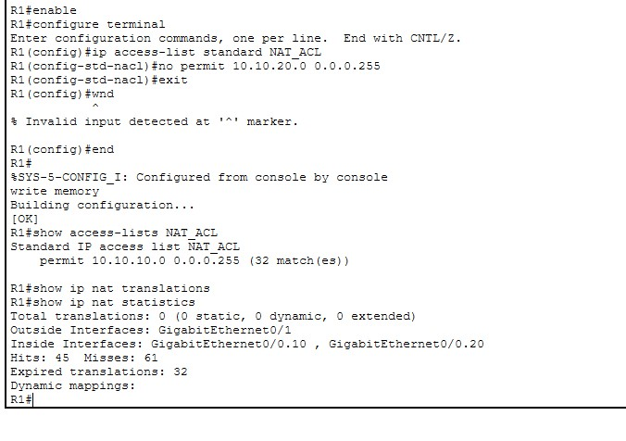
R1 — NAT_ACL no longer permits 10.10.20.0/24; show ip nat translations shows zero active translations.
Symptom: guest devices lost internet access entirely while the employee VLAN was unaffected.
Fix: guest subnet re-added to NAT_ACL.
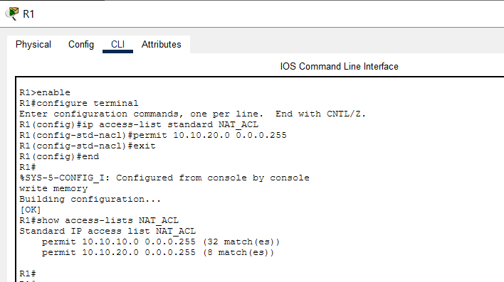
R1 — NAT_ACL corrected; show access-lists confirms both EMPLOYEE and GUEST subnets are now permitted for NAT.
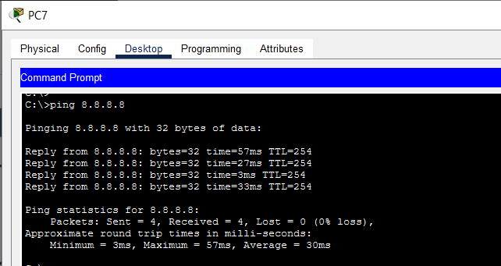
PC7 (guest) — ping 8.8.8.8 now succeeds with 4/4 replies (0% loss), confirming internet access restored.
Root cause: NAT only translates traffic matched by NAT_ACL — omitting a subnet silently blocks its internet access even though routing is otherwise fine.

8. Python Assurance Tool
network_checker.py performs two kinds of validation: (1) static checks of the YAML VLAN/IP plan — duplicate VLAN IDs, overlapping subnets, gateway-in-subnet correctness, guest-isolation policy — and (2) dynamic checks of pasted show-command output — missing VLANs on trunks, interfaces down, duplicate-IP log entries, empty NAT translation tables. It was run against real show-command output captured from the built topology:
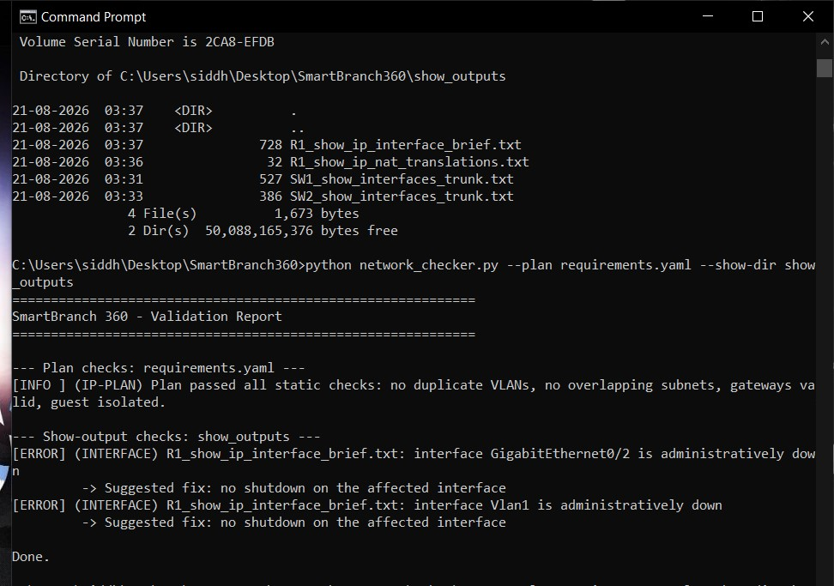
network_checker.py run in a real terminal against captured show-command output from R1, SW1, and SW2. Plan check passed cleanly; two unused interfaces (Gi0/2, Vlan1) were correctly flagged as administratively down — expected, since they are not part of this design (VLAN 99 is used for management instead of the default VLAN1).

9. Summary
Fault | OSI Layer | Status
1. Wrong default gateway | Layer 3 | Diagnosed, fixed, re-verified
2. Missing VLAN on trunk | Layer 2 | Diagnosed, fixed, re-verified
3. DHCP pool exhausted | Layer 3 / DHCP | Diagnosed, fixed, re-verified
4. ACL blocking DNS | Layer 4/7 | Diagnosed, fixed, re-verified
5. NAT ACL missing subnet | Layer 3 / NAT | Diagnosed, fixed, re-verified

All required components are complete: working topology with VLAN segmentation, DHCP, NAT, guest isolation and wireless; 5 fault-injection/fix cycles with full evidence; and an independently working Python assurance tool validated against real captured output. Remaining submission steps: save the Packet Tracer file as SmartBranch360.pkt and record the 5-10 minute demo video walking through this report.

