

Second-Hand Product Price Intelligence System
A PROJECT REPORT
Submitted by
Sidharth Malik (26MCD10110)
in partial fulfillment for the award of the degree of
Masters of Computer Applications
IN
Data science
2026-28

Chandigarh University
2026-28
BONAFIDE CERTIFICATE
Certified that this project report titled “Second-Hand Product Price Intelligence System” is the bonafide work of Sidharth Malik (UID: 26MCD10110) who carried out the project work under my/our supervision in partial fulfillment of the requirements for the award of the degree of Master of Computer Applications at Chandigarh University.
SIGNATURE  Name: Sidharth Malik  UID: 26MCD10110  Class: MCD - 2/A | SIGNATURE  Name: Ms. Prabhjot Bhatti  Designation: Asst. Professor  E-Code:

Submitted for the project viva-voce examination held on ____________________
ACKNOWLEDGEMENT
The successful completion of this project would not have been possible without the guidance, support and encouragement of several people. It is a matter of great pleasure for me to express my sincere gratitude to all those who contributed, directly or indirectly, to the project titled “Second-Hand Product Price Intelligence System.”
First and foremost, I thank Chandigarh University for giving me the opportunity to undertake this project as part of my academic curriculum, and for the learning environment and resources that helped me build practical technical skills.
I convey my deepest appreciation to my project supervisor, Ms. Tanisha Bansal, for constant guidance, constructive suggestions and motivation at every stage of the project. Her insights and willingness to share knowledge played a crucial role in the completion of this work.
I am also thankful to the Head of the Department, the faculty members and the staff of the Department of Computer Applications for their support and cooperation throughout the project. I thank the open-source communities behind Python, NumPy, Pandas, Matplotlib, Seaborn, Streamlit and pytest, whose documentation made this work possible.
Special thanks to my friends and classmates, whose discussions, feedback and moral support helped me improve the project and stay motivated during the challenging phases of implementation.
TABLE OF CONTENTS
Sr. No. | Chapter / Section Name | Page No.
1 | Chapter 1: Introduction | 6
1.1 | Problem Statement & Client Identification | 6
1.2 | Objectives of the Project | 6
1.3 | Scope of the Project | 6
2 | Chapter 2: System Requirements & Specifications | 8
2.1 | Hardware Requirements | 8
2.2 | Software Requirements | 8
2.3 | Functional & Non-Functional Requirements | 9
2.4 | Technology Stack & Method Evaluation | 10
3 | Chapter 3: System Architecture & Design | 11
3.1 | System Architecture Overview | 11
3.2 | Data Flow | 11
3.3 | Data Design & Class Structure | 12
3.4 | Estimation Logic & System Flowchart | 13
4 | Chapter 4: Implementation & Major Modules | 15
4.1 | Modular Implementation | 15
4.2 | Fair Price Estimation Engine | 15
4.3 | Brand and Depreciation Analysis | 16
4.4 | Data Processing and Statistics | 16
4.5 | Validation, Error Handling & Dashboard Integration | 17
5 | Chapter 5: Project Showcase (Visual Walkthrough) | 18
5.1 | Product Management & Price Check Interfaces | 18
5.2 | Analysis Interfaces | 19
5.3 | Backend Console & Dataset Records | 20
6 | Chapter 6: Testing & Validation | 22
6.1 | Unit & Functional Testing | 22
6.2 | Test Cases & Results | 22
6.3 | Course Outcome Mapping | 23
7 | Chapter 7: Future Scope & Conclusion | 24
7.1 | Current Limitations | 24
7.2 | Proposed Enhancements | 24
7.3 | Final Conclusion & References | 24
LIST OF FIGURES / TABLES
Type | Number | Title
Figure | 3.1 | System Architecture Diagram
Figure | 3.2 | Class Structure Diagram
Figure | 3.3 | Overall System Flowchart
Figure | 5.1 | Dashboard Home Page
Figure | 5.2 | Product Management: Add, Update, Delete and Search
Figure | 5.3 | Fair Price Estimate and Verdict
Figure | 5.4 | Price Comparison Chart
Figure | 5.5 | Brand Analysis
Figure | 5.6 | Depreciation Analysis
Figure | 5.7 | Analytics Dashboard
Figure | 5.8 | Terminal: Data Generation, App Launch and Tests
Figure | 5.9 | Dataset File: products.csv
Table | 2.1 | System Hardware Specifications
Table | 2.2 | Software Requirements
Table | 2.3 | Functional Requirements
Table | 2.4 | Technology Stack
Table | 2.5 | Price Estimation Approach Comparison
Table | 3.1 | Dataset Schema: products.csv
Table | 3.2 | Similarity Scoring Weights
Table | 3.3 | Verdict Rules
Table | 4.1 | Project Modules and Responsibilities
Table | 4.2 | Worked Example: Lenovo ThinkPad T480
Table | 4.3 | Error Handling and Safeguards
Table | 6.1 | Functional Test Cases
Table | 6.2 | Course Outcome Mapping

CHAPTER 1: INTRODUCTION

1.1 Problem Statement & Client Identification
Second-hand electronics such as laptops, smartphones and tablets are bought and sold every day on online marketplaces, classified sites and community groups. Listings for the same product are often priced very differently, depending on how much the seller knows about the market. A buyer therefore cannot easily tell whether an asking price is a fair deal, and a seller has no reliable way to price an item sensibly. Many existing approaches either show a plain list of listings or rely on a black-box prediction model whose output cannot be explained.
The problem addressed by this project is how to build a Python application that estimates the fair market price of a second-hand electronic product and flags listings that are potentially overpriced or undervalued, using transparent statistics instead of a black-box model. The clients of the system are buyers, who want to recognise a fair deal, and sellers or small resellers, who want to price their items consistently with the market.

1.2 Objectives of the Project
The primary objective of the Second-Hand Product Price Intelligence System is to replace guesswork in second-hand pricing with a traceable, data-driven estimate that every user can understand. The specific objectives are:
- To manage product listings through add, update, delete and search operations backed by a CSV file.
- To estimate the fair price of a listing from the most similar comparable listings using a weighted median.
- To flag listings that are more than 15% above or below the estimate as potentially overpriced or undervalued.
- To compare an asking price against the distribution of comparable listings.
- To analyse prices by brand (average, median, spread and value retained) and by product age (value retained and estimated yearly depreciation rate).
- To present the results through an interactive analytics dashboard with price distributions, price versus age charts and verdict counts.
- To demonstrate object-oriented programming, modular architecture, exception handling, data analysis, visualization and unit testing in one working Python project.

1.3 Scope of the Project
The functional scope covers product management, fair price estimation, overpricing and undervaluation detection, price comparison, brand analysis, depreciation analysis and an analytics dashboard. The technical scope is a Python application that uses NumPy and Pandas for computation, Matplotlib and Seaborn for charts, Streamlit for the user interface, pytest for unit tests and a CSV file for storage.
Features intentionally excluded from this academic phase are scraping or importing live marketplace listings, machine-learning models, price-trend tracking over time and user accounts. They are listed under future scope. The dataset used in this project is synthetic: it demonstrates the method but does not reflect real market prices.

CHAPTER 2: SYSTEM REQUIREMENTS & SPECIFICATIONS

2.1 Hardware Requirements
The application is light and runs on an ordinary laptop. The following configuration is recommended for development and local use.
Component | Minimum Specification | Recommended Specification
Processor | Dual-core 64-bit processor | Quad-core processor (Intel Core i5 / AMD Ryzen 5 or better)
RAM | 4 GB | 8 GB or higher
Hard Disk Space | 1 GB free space | 2 GB SSD storage
Display | 1366 × 768 | 1920 × 1080

[ Table 2.1 — System Hardware Specifications ]

2.2 Software Requirements
Software / Tool | Version / Edition | Purpose
Operating System | Windows, macOS or Linux (64-bit) | Development and execution environment
Python | Python 3 (3.9 or newer recommended) | Core programming language runtime
Python libraries | NumPy, Pandas, Matplotlib, Seaborn, Streamlit, pytest (see requirements.txt) | Computation, charts, dashboard and testing
Package manager | pip | Installs the libraries with one command
Version control | Git and GitHub | Source code management
IDE / Editor | Visual Studio Code or any Python IDE | Source code editing
Web Browser | Google Chrome / Safari | Displays the Streamlit dashboard

[ Table 2.2 — Software Requirements ]

2.3 Functional & Non-Functional Requirements
Module | Functional requirement
Product management | Add a product listing with validated input
Product management | Update and delete an existing listing
Product management | Search listings by brand, model or category
Price estimation | Estimate the fair price of a listing from the most similar comparable listings
Verdict | Flag a listing as potentially overpriced, undervalued or fairly priced using the 15% threshold
Price comparison | Show the asking price against the distribution of comparable listings
Brand analysis | Show average, median and spread of prices by brand and the value retained
Depreciation analysis | Show value retained by product age and an estimated yearly depreciation rate
Analytics dashboard | Show price distributions, price versus age, verdict counts and the top over- and under-priced listings

[ Table 2.3 — Functional Requirements ]
The non-functional requirements are:
- Transparency: no machine learning is used, so every result can be traced and explained step by step.
- Usability: an interactive dashboard that needs no programming knowledge.
- Reliability: input validation with a custom exception and safe CSV loading with error handling.
- Maintainability: separate packages for data, analytics and utilities, with one responsibility per module.
- Portability: runs on any operating system that has Python and the listed libraries.
- Testability: the statistics, validation and verdict logic are covered by pytest unit tests.

2.4 Technology Stack & Method Evaluation
Component | Technology | Reason for choice
Language | Python | Readable syntax and a strong data-analysis ecosystem
Numerical computing | NumPy | Fast array maths, used for the depreciation fit
Data handling | Pandas | Cleaning, filtering, grouping and aggregation of listings
Visualization | Matplotlib and Seaborn | Statistical charts such as distributions and scatter plots
User interface | Streamlit | Interactive dashboard with very little front-end code
Testing | pytest | Simple unit tests for the statistics and verdict logic
Storage | CSV file | Human-readable, easy to replace with real data

[ Table 2.4 — Technology Stack ]
Four approaches to estimating a fair price were compared before the weighted median of similar listings was selected.
Approach | Advantages | Limitations
Weighted median of similar listings (selected) | Robust to outliers, explainable, works on small datasets and uses model, brand, condition, RAM, storage and age | Fixed similarity weights and threshold that are not tuned on real data
Simple mean of all listings | Very easy to compute | Distorted by extreme prices and ignores differences between products
Median by category or brand | Resistant to outliers | Too coarse: mixes different models, conditions and ages
Machine-learning regression model | Can capture complex patterns on large datasets | Needs a large real dataset, is hard to explain and behaves as a black box

[ Table 2.5 — Price Estimation Approach Comparison ]
Reasons for selecting the weighted median. The median is not pulled by a few extreme listings, and weighting by similarity lets close matches count more than distant ones. Each step can be inspected, which makes the verdict easy to justify to a buyer or seller. Scalability. For larger deployments the CSV file can be replaced by a database, the similarity scoring can be vectorised with NumPy, and the dataset can be refreshed with dated, sourced listings without changing the estimation logic.

CHAPTER 3: SYSTEM ARCHITECTURE & DESIGN

3.1 System Architecture Overview
The application follows a layered architecture. The Streamlit dashboard (app.py) is the presentation layer and receives the user's actions. It calls the business modules in the modules package, which manage inventory, estimate prices, analyse depreciation and prepare data. These modules use the analytics package for the weighted median, the IQR outlier filter and the charts, and the utils package for input validation and CSV file handling. All listings are stored in data/products.csv.
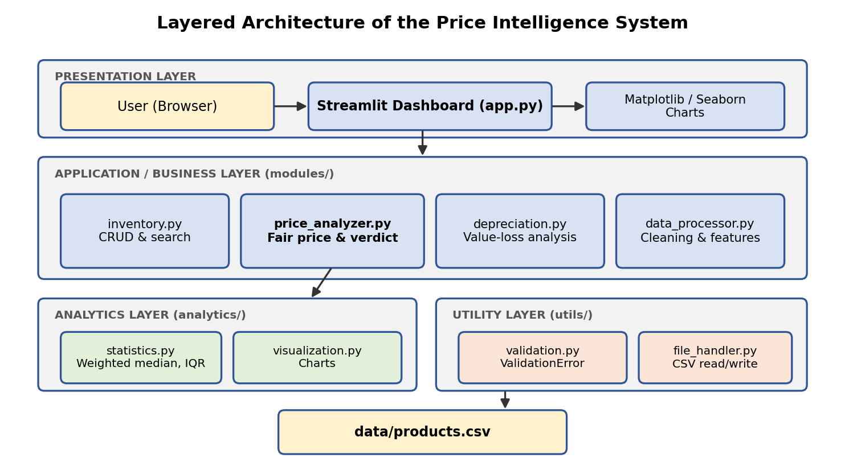
[ Figure 3.1 — System Architecture Diagram ]

3.2 Data Flow
The steps below show how a listing is checked from the moment the application starts.
- The application loads data/products.csv through the file handler, which reports errors safely.
- The data processor cleans the data and derives features such as product age.
- The user selects an existing listing or enters the details of a new one.
- The validation module checks the input and raises a ValidationError if it is invalid.
- The price analyzer keeps only listings of the same category and excludes the listing being checked.
- It scores the similarity of every candidate and keeps the 30 most similar listings.
- The statistics module removes outliers with the IQR rule and computes the weighted median as the fair price.
- The verdict is derived from the difference between the asking price and the fair price, and the dashboard displays the result with charts.

3.3 Data Design & Class Structure
The system stores its data in a single CSV file, data/products.csv, with one row per listing. Each row describes the product, its purchase details and its asking price. The category column holds Laptop, Smartphone or Tablet, and the condition column holds Like New, Good, Fair or Poor. These values are validated before any listing is saved.
In the code, a Product base class holds the attributes common to all listings, and the Laptop, Smartphone and Tablet classes inherit from it. A factory function creates the correct subclass from a row of data, so the rest of the application does not need to know which subclass it is handling.
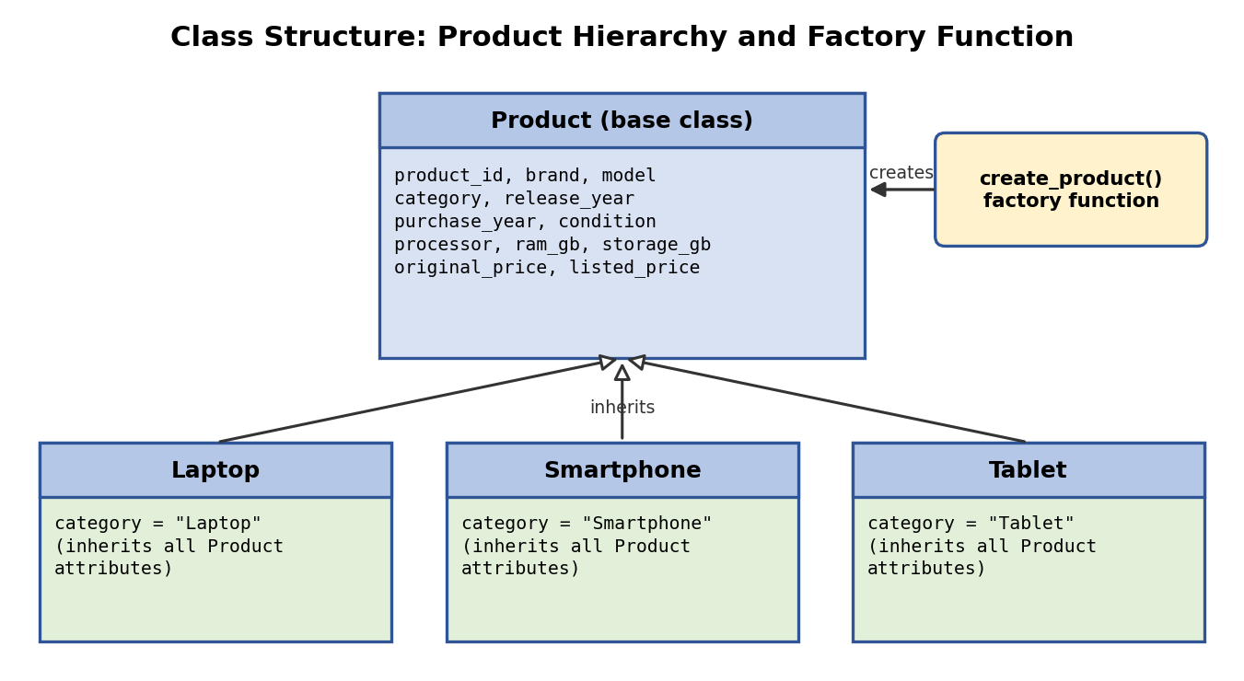
[ Figure 3.2 — Class Structure Diagram ]
Column | Type | Description
product_id | Integer / text | Unique identifier of the listing
brand | Text | Manufacturer, for example Lenovo
model | Text | Product model, for example ThinkPad T480
category | Text | Laptop, Smartphone or Tablet
release_year | Integer | Year the model was released
purchase_year | Integer | Year the item was purchased
condition | Text | Like New, Good, Fair or Poor
processor | Text | Processor of the device, for example Intel i5
ram_gb | Integer | RAM in gigabytes
storage_gb | Integer | Storage in gigabytes
original_price | Number | Original purchase price in rupees
listed_price | Number | Current asking price in rupees

[ Table 3.1 — Dataset Schema: products.csv ]
Real data can be used by replacing the file with real listings in the same format, ideally with a collection date and source added, and restarting the application.

3.4 Estimation Logic & System Flowchart
Every candidate listing receives a similarity score. A match on the same model adds the most, followed by brand, condition, RAM and storage, and a bonus is added when the age is similar. The scores are also used as weights when the fair price is computed.
Feature | Rule | Score added
Model | Same model | +4
Brand | Same brand | +2
Condition | Same condition | +1.5
RAM | Same RAM | +1
Storage | Same storage | +1
Age | Similar age | Bonus

[ Table 3.2 — Similarity Scoring Weights ]
The verdict compares the asking price with the estimated fair price. Because the threshold is a fixed percentage, the same rule applies to every category.
Difference from fair price | Verdict
Above +15% | Potentially overpriced
Below -15% | Potentially undervalued
Between -15% and +15% | Fairly priced

[ Table 3.3 — Verdict Rules ]
The flowchart shows the overall behaviour of the application, from loading the data to displaying the verdict.
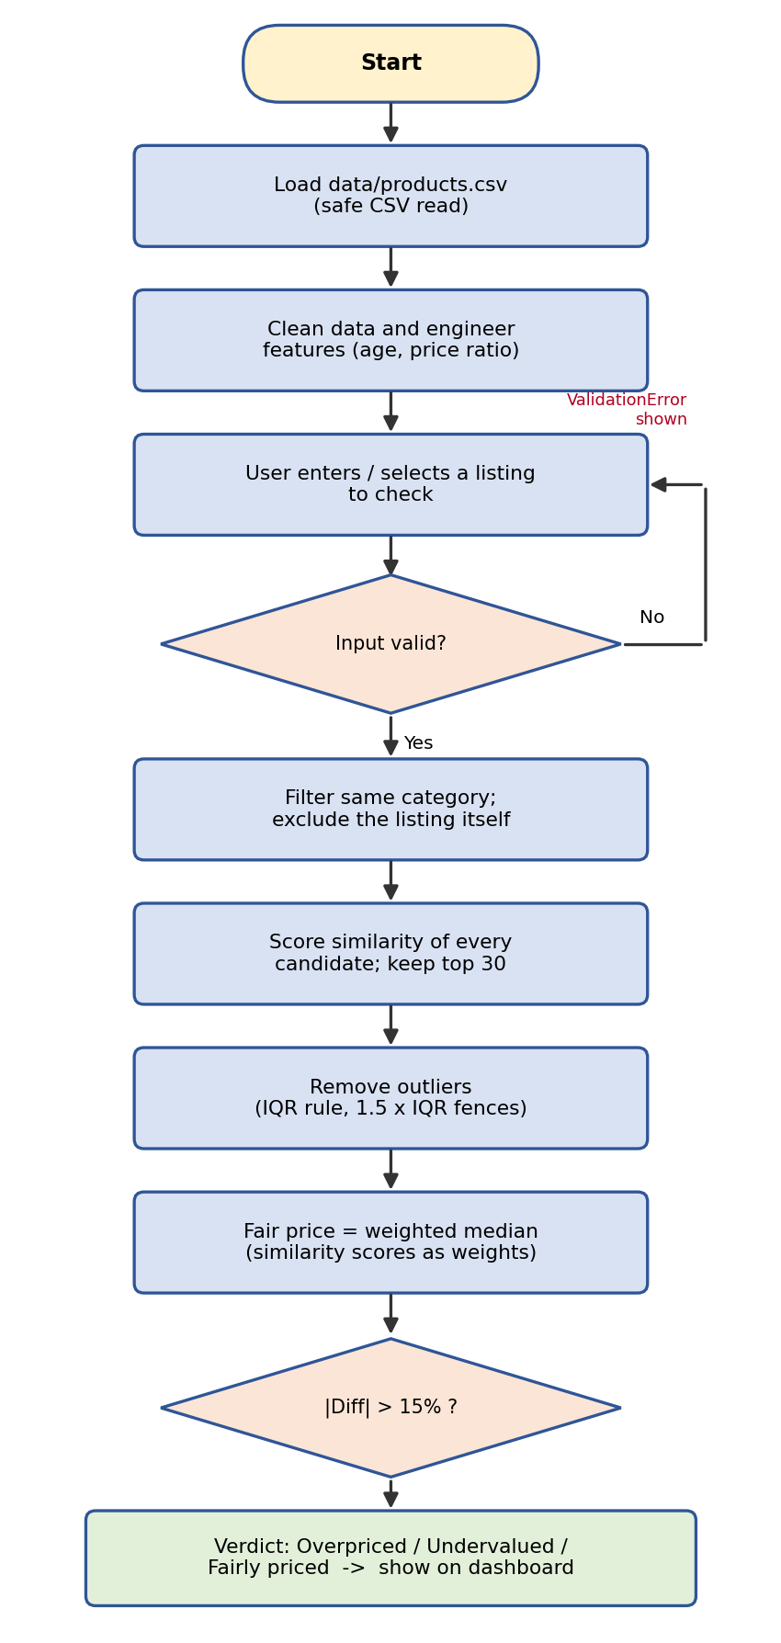
[ Figure 3.3 — Overall System Flowchart ]

CHAPTER 4: IMPLEMENTATION & MAJOR MODULES

4.1 Modular Implementation
The project is organised into packages so that data handling, analytics and utilities stay separate. The Streamlit dashboard in app.py only coordinates user actions and displays results, while each module has a single responsibility.
File | Responsibility
app.py | Streamlit dashboard and navigation between pages
generate_data.py | Generates the synthetic dataset in data/products.csv
modules/product.py | Product base class, Laptop, Smartphone and Tablet classes, and the factory function
modules/inventory.py | CRUD operations and search on the listings
modules/price_analyzer.py | Fair price estimation and the verdict engine
modules/depreciation.py | Value retained by age and the yearly depreciation rate
modules/data_processor.py | Data cleaning and feature engineering
analytics/statistics.py | Weighted median, IQR outlier filter and summary statistics
analytics/visualization.py | Matplotlib and Seaborn charts
utils/validation.py | Input validation and the custom ValidationError
utils/file_handler.py | CSV reading and writing with error handling
tests/test_analyzer.py | pytest unit tests for statistics, validation and verdicts

[ Table 4.1 — Project Modules and Responsibilities ]

4.2 Fair Price Estimation Engine
The price analyzer produces the fair price in five steps. Because the steps are simple and ordered, each result can be traced back to the listings that produced it.
- Filter to listings in the same category, excluding the listing being checked.
- Score the similarity of every candidate using the weights in Table 3.2.
- Take the 30 most similar listings.
- Remove outliers with the IQR rule, using 1.5 × IQR fences.
- Compute the fair price as the weighted median of the remaining prices, using the similarity scores as weights.
The weighted median and the verdict rule are the two core calculations. The sketches below show the idea in simplified form.
def weighted_median(values, weights):
order = np.argsort(values)
values = np.asarray(values)[order]
weights = np.asarray(weights)[order]
cumulative = np.cumsum(weights)
cutoff = cumulative[-1] / 2.0
return values[np.searchsorted(cumulative, cutoff)]
Weighted median (simplified sketch of analytics/statistics.py)
def verdict(asking_price, fair_price, threshold=0.15):
diff = (asking_price - fair_price) / fair_price
if diff > threshold:
return "Potentially overpriced"
if diff < -threshold:
return "Potentially undervalued"
return "Fairly priced"
Verdict rule (simplified sketch of modules/price_analyzer.py)
The worked example below checks a Lenovo ThinkPad T480 (Intel i5, 8 GB RAM, 256 GB SSD, Good condition) listed at Rs 22,000 against the synthetic dataset.
Metric | Result
Asking price | Rs 22,000
Estimated fair price | Rs 16,500
Market average (weighted) | Rs 16,607
Difference | +33.3%
Comparable listings used | 26
Verdict | Potentially overpriced

[ Table 4.2 — Worked Example: Lenovo ThinkPad T480 ]

4.3 Brand and Depreciation Analysis
Brand analysis groups the listings by brand and reports the average, median and spread (standard deviation) of prices, together with the value retained, which is the share of the original price that the listing still holds. This shows which brands keep their value best.
Depreciation analysis measures how value retained falls with product age. It fits the relation retained = exp(k × age) to the log of the price ratios using NumPy, and the fitted rate k gives an approximate yearly value loss of 1 − exp(k). These fits are unreliable for categories where the data covers a narrow range of product ages, which is noted as a limitation.

4.4 Data Processing and Statistics
The data processor cleans the raw CSV data and engineers features such as product age and the ratio of listed to original price. The statistics module implements the weighted median, the IQR outlier filter and the summary statistics (average, median and standard deviation). Keeping these functions separate from the user interface makes them easy to test and to reuse.

4.5 Validation, Error Handling & Dashboard Integration
Input validation lives in utils/validation.py and raises a custom ValidationError, which the dashboard shows as a readable message instead of a crash. CSV reading and writing in utils/file_handler.py is wrapped in error handling, so a missing or unreadable file does not stop the application. The Streamlit dashboard gathers the user's input, calls the modules and renders the metrics and charts produced by analytics/visualization.py.
Situation | Measure in the system
Invalid user input | Validation raises a custom ValidationError with a clear message
Missing or unreadable CSV file | Safe file loading with error handling
Extreme prices among comparable listings | IQR rule removes outliers before the fair price is computed
Listing compared with itself | The listing being checked is excluded from its own comparables
Unfair advantage of distant matches | Similarity scores are used as weights, so close matches count more

[ Table 4.3 — Error Handling and Safeguards ]

CHAPTER 6: TESTING & VALIDATION

6.1 Unit & Functional Testing
Testing verifies that the statistics, the validation rules and the verdict logic behave correctly. The unit tests are written with pytest and are run with the command python -m pytest. Functional checks confirm that listings can be added, updated, deleted and searched, and that the dashboard shows the expected result for a known listing.

6.2 Test Cases & Results
The following test cases are used to validate the system. The result column must be completed after each case is run on the final build.
Test Case ID | Module | Description | Expected Result | Actual Result / Status
TC-01 | Statistics | Weighted median of known values and weights | Matches the hand-calculated value | To record
TC-02 | Statistics | IQR filter on data containing an extreme value | Extreme value is removed | To record
TC-03 | Statistics | Summary statistics on a small sample | Mean, median and standard deviation are correct | To record
TC-04 | Validation | Validate a listing with valid data | Listing is accepted | To record
TC-05 | Validation | Validate a listing with a negative or zero price | ValidationError is raised | To record
TC-06 | Validation | Validate an unknown category or condition | ValidationError is raised | To record
TC-07 | Verdict | Asking price more than 15% above the fair price | Potentially overpriced | To record
TC-08 | Verdict | Asking price more than 15% below the fair price | Potentially undervalued | To record
TC-09 | Verdict | Asking price within 15% of the fair price | Fairly priced | To record
TC-10 | Analyzer | Check an existing listing | Listing is excluded from its own comparables | To record
TC-11 | File handling | Load a missing or corrupt CSV file | Error is handled and the app does not crash | To record
TC-12 | Inventory | Add, update, delete and search a listing | CSV file reflects each change | To record
TC-13 | Depreciation | Run the analysis on the dataset | Value retained falls with age and the yearly rate is positive | To record

[ Table 6.1 — Functional Test Cases ]

6.3 Course Outcome Mapping
CO | Implementation | Evidence
CO1 | Product base class with Laptop, Smartphone and Tablet subclasses and a factory function | Section 3.3 and Table 4.1
CO2 | Modular packages for data, analytics and utilities; custom exception and safe file loading | Section 4.1 and Section 4.5
CO3 | Data cleaning, filtering, grouping, aggregation, weighted median, standard deviation and IQR outlier removal | Section 4.2 to Section 4.4
CO4 | Interactive Streamlit dashboard with Matplotlib and Seaborn charts | Chapter 5
CO5 | Unit tests for statistics, validation and verdict logic, and comparison of estimation approaches | Section 2.4, Table 2.5 and Table 6.1

[ Table 6.2 — Course Outcome Mapping ]

CHAPTER 7: FUTURE SCOPE & CONCLUSION

7.1 Current Limitations
- The estimate is only as good as the dataset. Synthetic data demonstrates the method but does not reflect real prices.
- The 15% verdict threshold and the similarity weights are fixed choices and have not been tuned on real data.
- Depreciation fits are unreliable for categories where the data covers a narrow range of product ages.
- Listings carry no collection date or source, so price trends over time cannot be tracked.

7.2 Proposed Enhancements
- Real data: scrape or import real listings with dates and sources.
- Trend tracking: add price-trend tracking over time.
- Tunable settings: let users tune the verdict threshold and similarity weights in the interface.
- More categories: extend the system to more categories of second-hand products.

7.3 Final Conclusion & References
The Second-Hand Product Price Intelligence System shows how a small, well-structured Python application can estimate a fair second-hand price and explain it with transparent statistics. It combines object-oriented design, a modular architecture, exception handling, data analysis with Pandas and NumPy, interactive visualization and unit testing in one working project. Because no machine learning is used, every result can be traced and explained. The limitations listed above give a clear path for further development with real data.

References
- GitHub repository available at: https://github.com/sidharthmalik/second-hand-price-intelligence
- Python Documentation. https://docs.python.org/3/
- NumPy Documentation. https://numpy.org/doc/
- pandas Documentation. https://pandas.pydata.org/docs/
- Matplotlib Documentation. https://matplotlib.org/stable/
- Seaborn Documentation. https://seaborn.pydata.org/
- Streamlit Documentation. https://docs.streamlit.io/
- pytest Documentation. https://docs.pytest.org/

GitHub Link- https://github.com/sidharthmalik/second-hand-price-intelligence

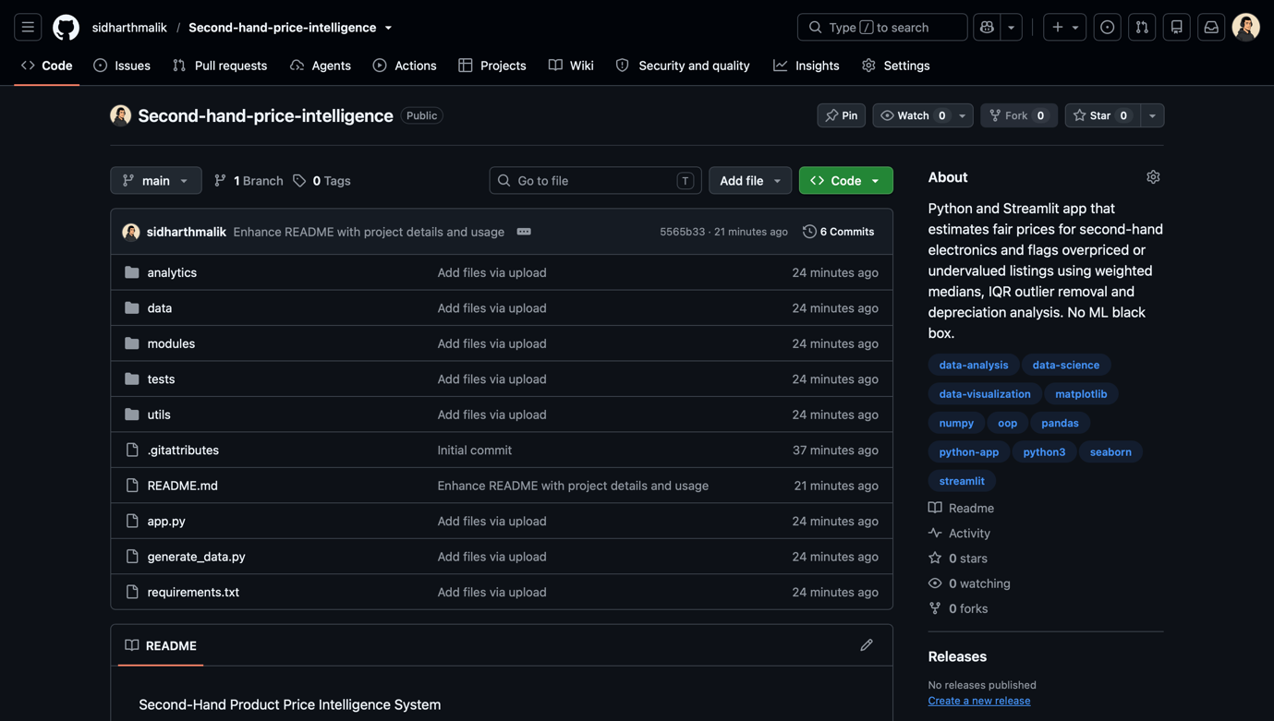
Screenshot of the GitHub repository page

