

Campus Complaint & Helpdesk Management System
A PROJECT REPORT
Submitted by
Sidharth Malik (26MCD10110)
in partial fulfillment for the award of the degree of
Masters of Computer Applications
IN
Data science
2026-28

Chandigarh University
2026-28
BONAFIDE CERTIFICATE
Certified that this project report titled “Campus Complaint & Helpdesk Management System” is the bonafide work of Sidharth Malik (UID: 26MCD10110) who carried out the project work under my/our supervision in partial fulfillment of the requirements for the award of the degree of Master of Computer Applications at Chandigarh University.
SIGNATURE  Name: Sidharth Malik  UID: 26MCD10110  Class: MCD - 2/A | SIGNATURE  Name: Ms. Tanisha Bansal  Designation: Asst. Professor  E-Code: E20679

Submitted for the project viva-voce examination held on ____________________
ACKNOWLEDGEMENT
The successful completion of this project would not have been possible without the guidance, support and encouragement of several people. It is a matter of great pleasure for me to express my sincere gratitude to all those who contributed, directly or indirectly, to the project titled “Campus Complaint & Helpdesk Management System.”
First and foremost, I thank Chandigarh University for giving me the opportunity to undertake this project as part of my academic curriculum, and for the learning environment and resources that helped me build practical technical skills.
I convey my deepest appreciation to my project supervisor, Ms. Tanisha Bansal, for constant guidance, constructive suggestions and motivation at every stage of the project. Her insights and willingness to share knowledge played a crucial role in the completion of this work.
I am also thankful to the Head of the Department, the faculty members and the staff of the Department of Computer Applications for their support and cooperation throughout the project. I thank the open-source communities behind Spring Boot, Thymeleaf, MySQL and Bootstrap, whose documentation made this work possible.
Special thanks to my friends and classmates, whose discussions, feedback and moral support helped me improve the project and stay motivated during the challenging phases of implementation.
TABLE OF CONTENTS
Sr. No. | Chapter / Section Name | Page No.
1 | Chapter 1: Introduction | 6
1.1 | Problem Statement & Client Identification | 6
1.2 | Objectives of the Project | 6
1.3 | Scope of the Project | 6
2 | Chapter 2: System Requirements & Specifications | 7
2.1 | Hardware Requirements | 7
2.2 | Software Requirements | 7
2.3 | Functional & Non-Functional Requirements | 8
2.4 | Technology Stack & Framework Evaluation | 8
3 | Chapter 3: System Architecture & Design | 10
3.1 | System Architecture Overview | 10
3.2 | Request-Response Flow | 10
3.3 | Database Design & Entity Relationships | 10
3.4 | System Flowchart | 13
4 | Chapter 4: Implementation & Major Modules | 14
4.1 | Backend Implementation (Spring Boot & MVC) | 14
4.2 | Session Management & Authentication | 14
4.3 | Database Implementation (MySQL & JDBC) | 15
4.4 | Frontend Integration | 15
4.5 | Security Measures | 15
5 | Chapter 5: Project Showcase (Visual Walkthrough) | 16
5.1 | Student Interfaces & User Experience | 16
5.2 | Administrator Interfaces | 18
5.3 | Backend Console & DBMS Records | 19
6 | Chapter 6: Testing & Validation | 21
6.1 | Functional & Integration Testing | 21
6.2 | Test Cases & Results | 21
6.3 | Course Outcome Mapping | 22
7 | Chapter 7: Future Scope & Conclusion | 23
7.1 | Current Limitations | 23
7.2 | Proposed Enhancements | 23
7.3 | Final Conclusion & References | 23
LIST OF FIGURES / TABLES
Type | Number | Title
Figure | 3.1 | System Architecture Diagram
Figure | 3.2 | Database Entity Relationship (ER) Diagram
Figure | 3.3 | Overall System Flowchart
Figure | 5.1 | Home Page and Student Registration
Figure | 5.2 | Student Login Page
Figure | 5.3 | Student Dashboard
Figure | 5.4 | Complaint Submission Form
Figure | 5.5 | Administrator Login Page
Figure | 5.6 | Administrator Dashboard
Figure | 5.7 | Updating Priority and Status
Figure | 5.8 | Spring Boot Console Output
Figure | 5.9 | MySQL Workbench: students, admin and complaints Tables
Table | 2.1 | System Hardware Specifications
Table | 2.2 | Software Requirements
Table | 2.3 | Functional Requirements
Table | 2.4 | Technology Stack
Table | 2.5 | Backend Framework Comparison
Table | 3.1 | Database Schema: students Table
Table | 3.2 | Database Schema: admin Table
Table | 3.3 | Database Schema: complaints Table
Table | 4.1 | Application Routes and Access Levels
Table | 4.2 | Security Threats and Countermeasures
Table | 6.1 | Functional Test Cases
Table | 6.2 | Course Outcome Mapping

CHAPTER 1: INTRODUCTION

1.1 Problem Statement & Client Identification
Every campus depends on classrooms, laboratories, hostels, libraries, canteens and transport, and faults in any of them directly affect students. Complaints about such faults are usually raised verbally, on paper or through informal messaging groups. As a result a complaint has no unique reference, the student cannot see its progress, staff cannot tell which issue is urgent, and management has no data about which areas fail most often.
The problem addressed by this project is how to build a Java-based web application that centralizes campus complaints, gives every complaint a unique ID and status, lets administrators prioritize and update them, and presents summary statistics. The clients of the system are the students of a campus, who raise complaints, and the administrative and maintenance staff, who resolve them. A companion Case Study document describes the problem context, the stakeholders and an illustrative walkthrough in more detail.

1.2 Objectives of the Project
The primary objective of the Campus Complaint & Helpdesk Management System is to replace informal complaint handling with a structured, transparent and traceable digital process. The specific objectives are:
- To provide students with secure registration and login.
- To let students submit complaints under defined categories and receive a unique complaint ID.
- To let students track the status of every complaint they have raised.
- To let administrators view all complaints, set priority and update status.
- To provide summary analytics: total, pending, in progress, resolved and category-wise counts.
- To demonstrate client-server architecture, server-side programming with Spring MVC, relational database connectivity and session management in a working application.

1.3 Scope of the Project
The functional scope covers student registration and login, complaint submission, complaint tracking, an administrator dashboard with priority and status management, and basic analytics. The technical scope is a Java and Spring Boot backend that talks to a MySQL database through JDBC and serves server-rendered Thymeleaf pages styled with Bootstrap.
Features intentionally excluded from this academic phase are email or SMS notifications, file attachments, multi-department routing, and deployment to a cloud environment. They are listed under future scope.

CHAPTER 2: SYSTEM REQUIREMENTS & SPECIFICATIONS

2.1 Hardware Requirements
The application is light and runs on an ordinary laptop. The following configuration is recommended for development and local deployment.
Component | Minimum Specification | Recommended Specification
Processor | Dual-core 64-bit processor | Quad-core processor (Intel Core i5 / AMD Ryzen 5 or better)
RAM | 4 GB | 8 GB or higher
Hard Disk Space | 2 GB free space | 5 GB SSD storage
Display | 1366 × 768 | 1920 × 1080

[ Table 2.1 — System Hardware Specifications ]

2.2 Software Requirements
Software / Tool | Version / Edition | Purpose
Operating System | Windows, macOS or Linux (64-bit) | Development and hosting environment
Java Development Kit (JDK) | Java 17 or newer | Core programming language runtime
Build tool | Apache Maven 3.x | Dependency management and one-command run
Framework | Spring Boot 3.3.5 (Spring MVC) | Web application framework with embedded Tomcat
Database | MySQL server with MySQL Workbench | Relational storage and database management
IDE / Editor | Visual Studio Code | Source code editing
Web Browser | Google Chrome / Safari | Front-end rendering

[ Table 2.2 — Software Requirements ]

2.3 Functional & Non-Functional Requirements
Role | Functional requirement
Student | Register with name, email, department and password
Student | Log in and log out using session-based authentication
Student | Submit a complaint with a category and description and receive a unique ID
Student | View only their own complaints with priority, status and date
Administrator | Log in through a separate administrator page
Administrator | View all complaints with the student's name and department
Administrator | Update the priority and status of any complaint
Administrator | View counters (total, pending, in progress, resolved) and category-wise counts

[ Table 2.3 — Functional Requirements ]
The non-functional requirements are:
- Security: passwords are stored as salted hashes and protected pages require a valid session.
- Usability: a responsive interface that works on desktop and mobile browsers.
- Reliability: primary keys, a unique email constraint and a foreign key keep the data consistent.
- Maintainability: layered code with controllers, a repository class and templates kept separate.
- Portability: runs on any operating system that has a JDK and MySQL.

2.4 Technology Stack & Framework Evaluation
Component | Technology | Reason for choice
Language | Java 17 | Strong typing and wide industry use
Backend framework | Spring Boot 3.3.5 (Spring MVC) | Embedded server, dependency injection, minimal configuration
View layer | Thymeleaf | Server-side templates with automatic output escaping
Styling | Bootstrap 5.3 | Responsive and professional interface
Database | MySQL | Reliable relational storage
Data access | Spring JDBC (JdbcTemplate) with MySQL Connector/J | Explicit SQL that is easy to explain and test
Password hashing | BCrypt (spring-security-crypto) | Salted, deliberately slow hashing

[ Table 2.4 — Technology Stack ]
Three alternative backend frameworks were compared before Spring Boot was selected.
Framework | Advantages | Limitations
Spring Boot (selected) | Embedded server, dependency injection, strong typing, mature ecosystem, suited to scaling | More boilerplate and a steeper learning curve
Flask (Python) | Lightweight and quick to start | Authentication, validation and structure need manual setup
Django (Python) | Built-in ORM, authentication and admin panel | Heavy for a small project
Node.js with Express | Asynchronous; one language across front end and back end | Needs JavaScript back-end skills and extra libraries for structure

[ Table 2.5 — Backend Framework Comparison ]
Reasons for selecting Spring Boot. A single command runs the whole application on an embedded Tomcat server. The layered controller and repository structure keeps code organized. Java's type checking catches many errors at compile time, and the same code base can grow into a production system. Scalability. For larger deployments the application can be packaged as one JAR, run in Docker behind a load balancer, use a connection pool (HikariCP is included with Spring Boot), move sessions to a shared store such as Redis, and cache dashboard statistics.

CHAPTER 3: SYSTEM ARCHITECTURE & DESIGN

3.1 System Architecture Overview
The application follows a three-tier client-server architecture. The browser provides the user interface through HTML, CSS and Bootstrap pages rendered by Thymeleaf. Spring MVC controllers on an embedded Tomcat server receive the HTTP requests, check the session, validate input and call the repository. The repository sends parameterized SQL to the MySQL database through JDBC.
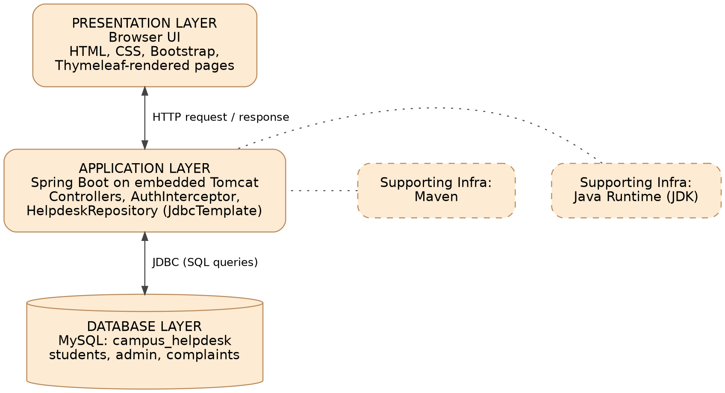
[ Figure 3.1 — System Architecture Diagram ]

3.2 Request-Response Flow
The steps below show how a complaint travels through the system.
- The student submits the complaint form in the browser.
- The browser sends an HTTP POST request to the server.
- The authentication interceptor checks that a valid session exists.
- The controller validates the input and calls the repository.
- The repository runs a parameterized INSERT through JDBC.
- MySQL stores the record and returns the generated key.
- The controller redirects to the dashboard with a confirmation message that includes the complaint ID.

3.3 Database Design & Entity Relationships
The relational design uses three tables. The students table stores account information, the complaints table stores every complaint with its category, description, priority, status and timestamp, and the admin table stores administrator accounts. One student can submit many complaints, and each complaint belongs to exactly one student, enforced by a foreign key. Administrators manage all complaints, so their actions are authorized by role and no foreign key links the admin table to complaints.
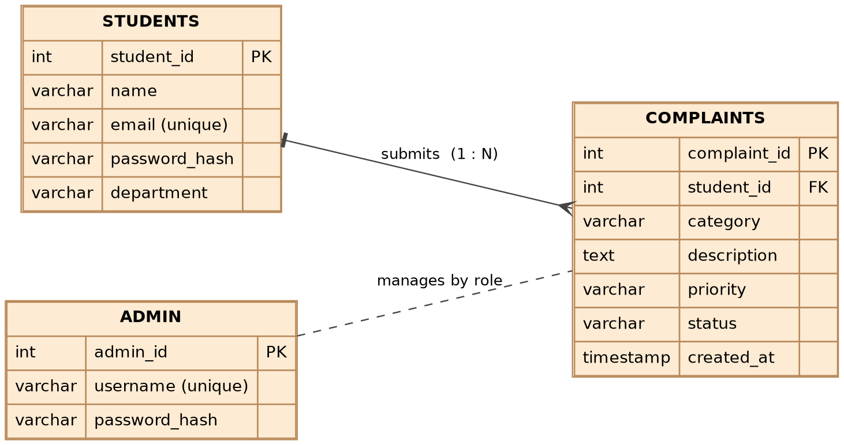
[ Figure 3.2 — Database Entity Relationship (ER) Diagram ]
Field | Type | Constraint
student_id | INT | Primary key, auto increment
name | VARCHAR(100) | Not null
email | VARCHAR(100) | Not null, unique
password_hash | VARCHAR(255) | Not null
department | VARCHAR(100)

[ Table 3.1 — Database Schema: students Table ]
Field | Type | Constraint
admin_id | INT | Primary key, auto increment
username | VARCHAR(100) | Not null, unique
password_hash | VARCHAR(255) | Not null

[ Table 3.2 — Database Schema: admin Table ]
Field | Type | Constraint
complaint_id | INT | Primary key, auto increment
student_id | INT | Foreign key to students, on delete cascade
category | VARCHAR(100) | Not null
description | TEXT | Not null
priority | VARCHAR(20) | Default Medium
status | VARCHAR(30) | Default Pending
created_at | TIMESTAMP | Default current timestamp

[ Table 3.3 — Database Schema: complaints Table ]
The schema is in Third Normal Form. Student details are stored once and referenced by key, which avoids repeating names and departments in every complaint row. Category, status and priority values are controlled by lists in the application and validated on the server before any write.

3.4 System Flowchart
The flowchart shows the overall behaviour of the application for both roles: login, session creation, validation of every input, database access and logout.
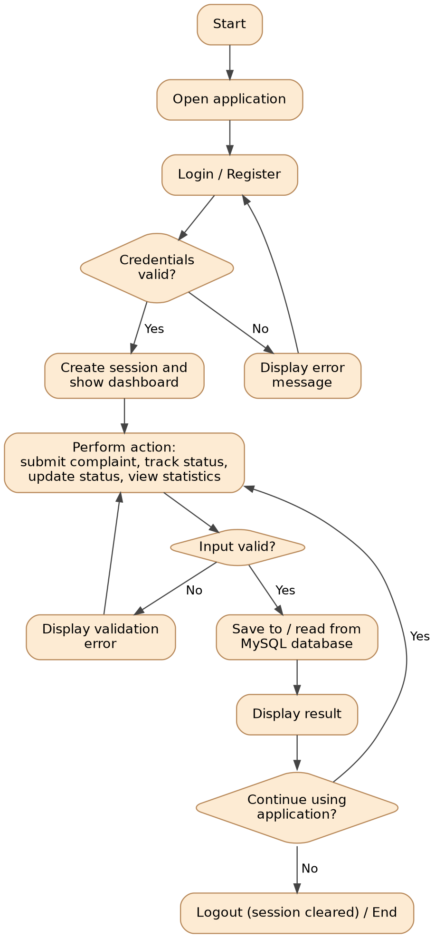
[ Figure 3.3 — Overall System Flowchart ]

CHAPTER 4: IMPLEMENTATION & MAJOR MODULES

4.1 Backend Implementation (Spring Boot & MVC)
The backend is organized by package so that controllers, the repository and the data records stay separate. Spring MVC annotations map each URL to a Java method. AuthController handles registration, login and logout, StudentController handles the student dashboard and complaint submission, and AdminController handles administrator login, the dashboard and complaint updates. HelpdeskRepository contains all SQL, Models holds the record types, and Options holds the fixed lists of categories, statuses and priorities.
Route | Method | Purpose | Access
/ | GET | Home page | Public
/register | GET, POST | Student registration | Public
/login | GET, POST | Student login | Public
/logout | GET | End the session | Any
/dashboard | GET | Student's own complaints | Student
/complaint/new | GET, POST | Submit a complaint | Student
/admin/login | GET, POST | Administrator login | Public
/admin | GET | All complaints and statistics | Admin
/admin/update/{id} | POST | Update status and priority | Admin

[ Table 4.1 — Application Routes and Access Levels ]

4.2 Session Management & Authentication
On successful login the server invalidates any old session, creates a new one with a 30-minute timeout and stores the user's ID and name in it. An interceptor runs before every protected route and redirects to the login page if the session does not hold the expected attribute. Creating a fresh session at login helps prevent session fixation, and logout invalidates the session. Student and administrator sessions use different attributes, so a student session cannot open administrator pages.
public boolean preHandle(HttpServletRequest request,
HttpServletResponse response, Object handler) throws Exception {
HttpSession session = request.getSession(false);
boolean isAdminArea = request.getRequestURI().startsWith("/admin");
String key = isAdminArea ? "adminId" : "studentId";
if (session == null || session.getAttribute(key) == null) {
response.sendRedirect(isAdminArea ? "/admin/login?required"
: "/login?required");
return false;
}
return true;
}
Session check in AuthInterceptor.java

4.3 Database Implementation (MySQL & JDBC)
HelpdeskRepository uses Spring's JdbcTemplate to run SQL against MySQL. Every query uses placeholders, for example UPDATE complaints SET status = ?, priority = ? WHERE complaint_id = ?, so user input is never concatenated into SQL, which protects against SQL injection. New complaints are inserted with a generated-key holder so the new ID can be shown to the student as CMP-0001. The administrator dashboard uses aggregate queries:
SELECT COUNT(*),
COALESCE(SUM(status='Pending'),0),
COALESCE(SUM(status='In Progress'),0),
COALESCE(SUM(status='Resolved'),0)
FROM complaints;

SELECT category, COUNT(*) AS cnt
FROM complaints GROUP BY category ORDER BY cnt DESC;

4.4 Frontend Integration
The user interface is built with Thymeleaf templates and Bootstrap 5. A shared fragments file provides the page head, the navigation bar and the alert box, so every page looks consistent. Status badges are colored: Pending in yellow, In Progress in blue and Resolved in green. The administrator dashboard shows four counters and a category table above the complaint list, and each row has inline controls to change priority and status. Thymeleaf's th:text escapes HTML by default, which prevents stored cross-site scripting when complaint text is displayed.

4.5 Security Measures
Threat | Measure in the system
Password theft from the database | BCrypt salted hashes; the default administrator is also stored as a hash
SQL injection | Parameterized queries only
Cross-site scripting | Thymeleaf escapes output by default
Unauthorized page access | Session check in an interceptor; separate student and admin sessions
Session fixation | New session created at login and the old one invalidated
Forgotten sessions | 30-minute inactivity timeout
Invalid data | Server-side validation against fixed option lists

[ Table 4.2 — Security Threats and Countermeasures ]

CHAPTER 5: PROJECT SHOWCASE (VISUAL WALKTHROUGH)
This chapter presents screenshots of the completed application, showing the connection between the client-side interface, the server-side logic and the stored database records. Replace each placeholder box with the matching screenshot from the running application.

5.1 Student Interfaces & User Experience
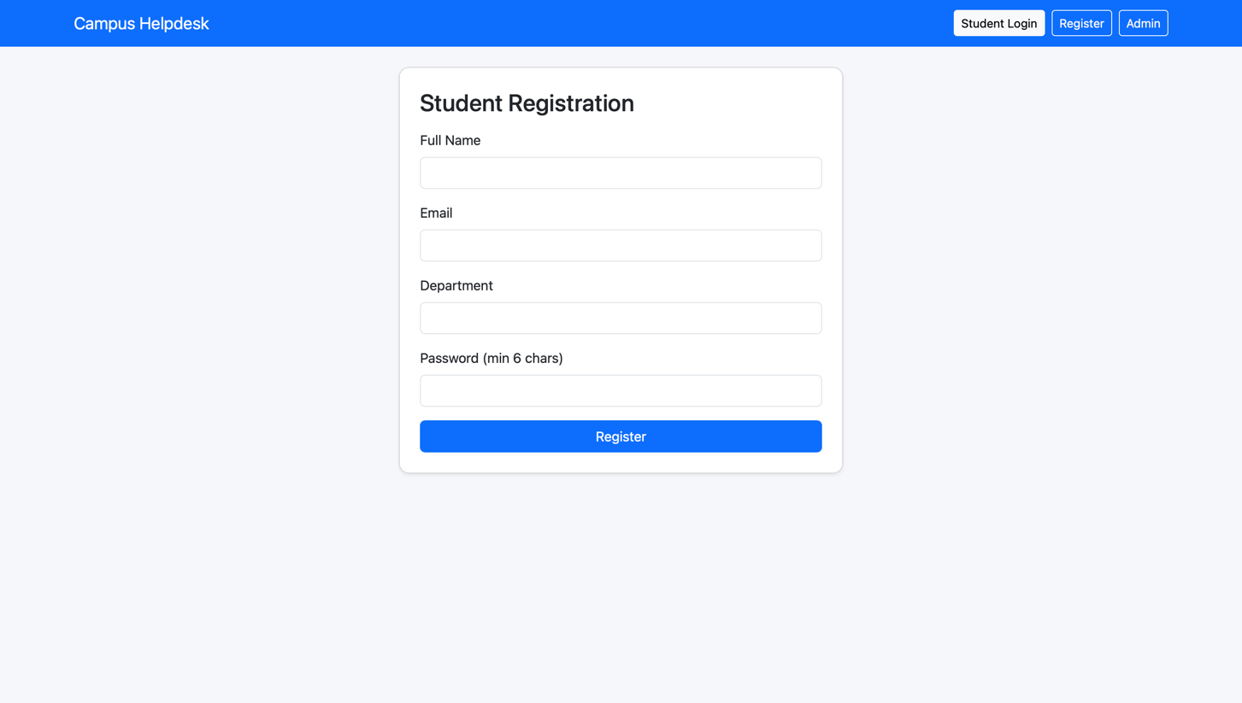

[ Screenshot 5.1 — Home Page and Student Registration ]
Students create an account with name, email, department and password.
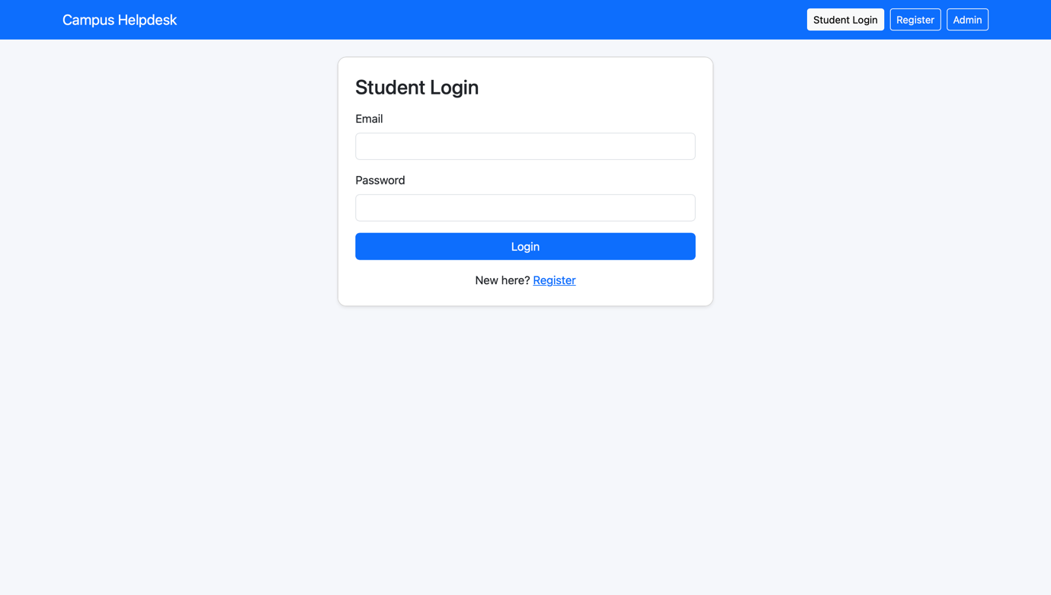

[ Screenshot 5.2 — Student Login Page ]
Secure login that creates a session before any complaint data is shown.
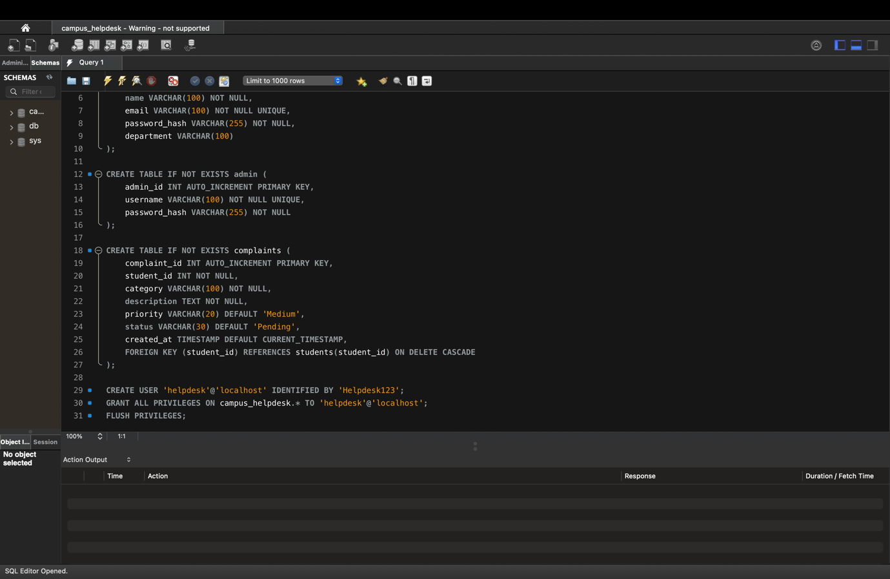

CHAPTER 6: TESTING & VALIDATION

6.1 Functional & Integration Testing
Testing is planned to verify that the backend logic, the database operations and the front-end behaviour work together. Functional testing checks that valid requests produce correct database records and that invalid requests are rejected. Integration testing checks that pages, routes and static resources load correctly and that protected pages cannot be reached without a session.

6.2 Test Cases & Results
The following test cases are used to validate the system. The result column must be completed after each case is run on the final build.
Test Case ID | Module | Description | Expected Result | Actual Result / Status
TC-01 | User Access | Register with valid data | Success message, redirect to login | To record
TC-02 | User Access | Register with a duplicate email | Error: email already registered | To record
TC-03 | User Access | Register with a password under 6 characters | Form is rejected | To record
TC-04 | User Access | Student login with correct credentials | Redirect to dashboard | To record
TC-05 | User Access | Student login with a wrong password | Error message, no session | To record
TC-06 | Session | Open /dashboard without logging in | Redirect to login with a warning | To record
TC-07 | Complaints | Submit a complaint | ID CMP-xxxx shown, status Pending | To record
TC-08 | Complaints | Second student opens dashboard | First student's complaints not visible | To record
TC-09 | Session | Student opens /admin | Redirect to admin login | To record
TC-10 | Admin | Administrator login with valid credentials | Redirect to admin dashboard | To record
TC-11 | Admin | Change priority and status, then save | Row updated; student sees the change | To record
TC-12 | Analytics | Compare counters with the table | Counts match the stored data | To record
TC-13 | Session | Log out, then press browser Back | Protected page is not shown | To record

[ Table 6.1 — Functional Test Cases ]

6.3 Course Outcome Mapping
CO | Implementation | Evidence
CO1 | Three-tier architecture and the HTTP request-response cycle | Section 3.1 and live demonstration
CO2 | Spring MVC controllers and routes for registration, login, complaints and admin operations | Section 4.1, Table 4.1
CO3 | MySQL schema and JDBC create, read and update operations | Section 3.3 and Section 4.3
CO4 | HttpSession, interceptor-based authentication, complaint tracking | Section 4.2 and test cases TC-06, TC-09, TC-13
CO5 | Comparison of Spring Boot, Flask, Django and Express with a scalability discussion | Section 2.4, Table 2.5

[ Table 6.2 — Course Outcome Mapping ]

CHAPTER 7: FUTURE SCOPE & CONCLUSION

7.1 Current Limitations
- No CSRF tokens, because full Spring Security is not used.
- Logout is a GET request.
- No login attempt limits, and no HTTPS in the development setup.
- A default administrator is created on first run, and its password should be changed before real use.
- There is no screen for creating more administrators, and no search, filter or pagination.

7.2 Proposed Enhancements
- Spring Security: adopt CSRF protection and role-based access control.
- Notifications: email or SMS alerts when a complaint's status changes.
- Attachments: photo evidence for complaints stored in cloud storage.
- Search and export: search, filtering, pagination and CSV or PDF export.
- Routing: department-wise routing, staff assignment and service-time tracking.
- Deployment: dashboard charts, Docker packaging and HTTPS.

7.3 Final Conclusion & References
The Campus Complaint & Helpdesk Management System shows how a small, well-structured web application can replace informal complaint handling with a traceable and transparent process. It brings together client-server communication, server-side programming with Spring MVC, relational database connectivity through JDBC, and session-based security in one working project. The design is intentionally simple to explain and extend, and the limitations listed above give a clear path for further development.

References
- GitHub repository available at: https://github.com/sidharthmalik/campus_helpdesk
- Spring Boot Reference Documentation. https://docs.spring.io/spring-boot/
- Spring Framework Reference: Spring MVC and Data Access. https://docs.spring.io/spring-framework/reference/
- Thymeleaf Documentation. https://www.thymeleaf.org/documentation.html
- MySQL Reference Manual. https://dev.mysql.com/doc/
- Bootstrap 5.3 Documentation. https://getbootstrap.com/docs/5.3/
- OWASP Top Ten. https://owasp.org/www-project-top-ten/

Github Link- https://github.com/sidharthmalik/campus_helpdesk



