

Case Study: Complaint Handling on a University Campus
A CASE STUDY REPORT
Submitted by
Sidharth Malik (26MCD10110)
in partial fulfillment for the award of the degree of
Masters of Computer Applications
IN
Data science
2026-28

Chandigarh University
2026-28
BONAFIDE CERTIFICATE
Certified that this case study report titled “Complaint Handling on a University Campus: Designing the Campus Complaint & Helpdesk Management System” is the bonafide work of Sidharth Malik (UID: 26MCD10110) who carried out the work under my/our supervision in partial fulfillment of the requirements for the award of the degree of Master of Computer Applications at Chandigarh University.
SIGNATURE  Name: Sidharth Malik  UID: 26MCD10110  Class: MCD - 2/A | SIGNATURE  Name: Ms. Tanisha Bansal  Designation: Asst. Professor  E-Code: E20679

Submitted for the project viva-voce examination held on ____________________
ACKNOWLEDGEMENT
The successful completion of this case study would not have been possible without the guidance, support and encouragement of several people. It is a matter of great pleasure for me to express my sincere gratitude to all those who contributed, directly or indirectly, to this work.
First and foremost, I thank Chandigarh University for giving me the opportunity to undertake this work as part of my academic curriculum, and for the learning environment and resources it provided.
I convey my deepest appreciation to my supervisor, Ms. Tanisha Bansal, for constant guidance, constructive suggestions and motivation at every stage. Her insights and willingness to share knowledge played a crucial role in completing this study.
I am also thankful to the Head of the Department, the faculty members and the staff of the Department of Computer Applications for their support and cooperation.
Special thanks to my friends and classmates, whose discussions, feedback and moral support helped me improve the study and stay motivated.
TABLE OF CONTENTS
Sr. No. | Chapter / Section Name | Page No.
1 | Chapter 1: Introduction & Background | 6
1.1 | Background and Context | 6
1.2 | How Complaints Are Raised Today | 6
1.3 | Objectives of the Case Study | 6
1.4 | Nature and Scope of the Case | 6
2 | Chapter 2: Problem Identification & Stakeholders | 7
2.1 | Problems with the Existing Process | 7
2.2 | Stakeholders and Their Needs | 7
3 | Chapter 3: Proposed Solution | 8
3.1 | Solution Overview | 8
3.2 | Main Features | 8
3.3 | Status Model | 8
3.4 | Technology in Brief | 8
4 | Chapter 4: Illustrative Walkthrough | 9
4.1 | One Complaint, Start to Finish | 9
4.2 | Complaint Lifecycle Diagram | 9
5 | Chapter 5: Analysis: Benefits, Challenges & Discussion | 10
5.1 | Expected Benefits | 10
5.2 | Challenges and Risks | 10
5.3 | Discussion Questions | 10
6 | Chapter 6: Conclusion & References | 11
6.1 | Final Conclusion | 11
6.2 | References | 11
LIST OF FIGURES / TABLES
Type | Number | Title
Figure | 3.1 | Complaint Status Model
Figure | 4.1 | Complaint Lifecycle: Student, Administrator and Database
Table | 2.1 | Problems in Informal Complaint Handling
Table | 2.2 | Stakeholders and Their Needs
Table | 5.1 | Challenges, Risks and Responses

CHAPTER 1: INTRODUCTION & BACKGROUND

1.1 Background and Context
Consider a mid-sized campus with several academic blocks, laboratories, hostels, a library, a canteen and a transport service. Thousands of students use these facilities every day. Maintenance teams and administrative offices are responsible for keeping them in working order, but they usually learn about a problem only when someone tells them.
Students notice faults first: a projector that does not work, a leaking tap in a hostel, a broken chair, an overcrowded bus, an unclean canteen area. How quickly a fault is fixed depends on how quickly and how clearly it reaches the right person.

1.2 How Complaints Are Raised Today
In the scenario, a student who finds a fault has several informal options. They can tell a lecturer or warden, fill in a paper form at an office, send a message in a class or hostel chat group, or simply stop using the facility. Each route reaches a different person, and none of them leaves a shared, reliable record.

1.3 Objectives of the Case Study
- To identify the problems caused by informal complaint handling on a campus.
- To identify the stakeholders and what each of them needs from a complaint process.
- To describe a web-based helpdesk as a solution and follow one complaint from submission to resolution.
- To discuss the expected benefits, challenges and risks of adopting such a system.

1.4 Nature and Scope of the Case
The situation described is an illustrative scenario that represents common campus practice. It is not data collected from a specific institution, and no figures about real usage are claimed. The solution discussed is the Campus Complaint & Helpdesk Management System, whose design and implementation are documented in the companion Project Report.

CHAPTER 2: PROBLEM IDENTIFICATION & STAKEHOLDERS

2.1 Problems with the Existing Process
Analysis of the informal process shows the following problems.
Area | Observed problem | Consequence
Reporting | Complaints are made verbally, on paper or in chat groups | Requests are forgotten or duplicated
Identification | No unique complaint number | Hard to follow up or refer to a specific issue
Transparency | Student cannot see progress | Repeated visits and follow-up messages
Prioritization | No urgency marking | A safety issue can wait behind a minor one
Accountability | No record of who handled what | Delays cannot be analyzed
Management reporting | No statistics | Recurring problem areas stay invisible

[ Table 2.1 — Problems in Informal Complaint Handling ]
The central problem is the absence of a single, trusted record. Without it, neither students nor staff nor management can tell what has been reported, what is being handled and what has been resolved.

2.2 Stakeholders and Their Needs
Stakeholder | Interest | What they need
Students | Working facilities and quick resolution | An easy way to report faults and see progress without chasing anyone
Administrators and maintenance staff | Handling complaints efficiently | One list of all complaints, with priority and status they can update
Management | Planning and accountability | Summary figures by status and category to spot recurring problems

[ Table 2.2 — Stakeholders and Their Needs ]

CHAPTER 3: PROPOSED SOLUTION

3.1 Solution Overview
The proposed solution is a central web application in which every complaint becomes a database record with a unique ID, a category, a description, a priority, a status and a timestamp. Students see only their own complaints. Administrators see all complaints, update them and view statistics.

3.2 Main Features
- Student registration and login with securely stored passwords.
- Complaint submission under fixed categories: Classroom, Laboratory, Hostel, Library, Infrastructure, Canteen, Transport and Other.
- A unique complaint ID in the format CMP-0001.
- Status tracking through three stages: Pending, In Progress and Resolved.
- An administrator dashboard with priority and status controls.
- Counters and category-wise statistics for management.

3.3 Status Model
Every complaint moves through three statuses. Priority (Low, Medium or High) is set independently of status, so urgent complaints can be identified at any stage.
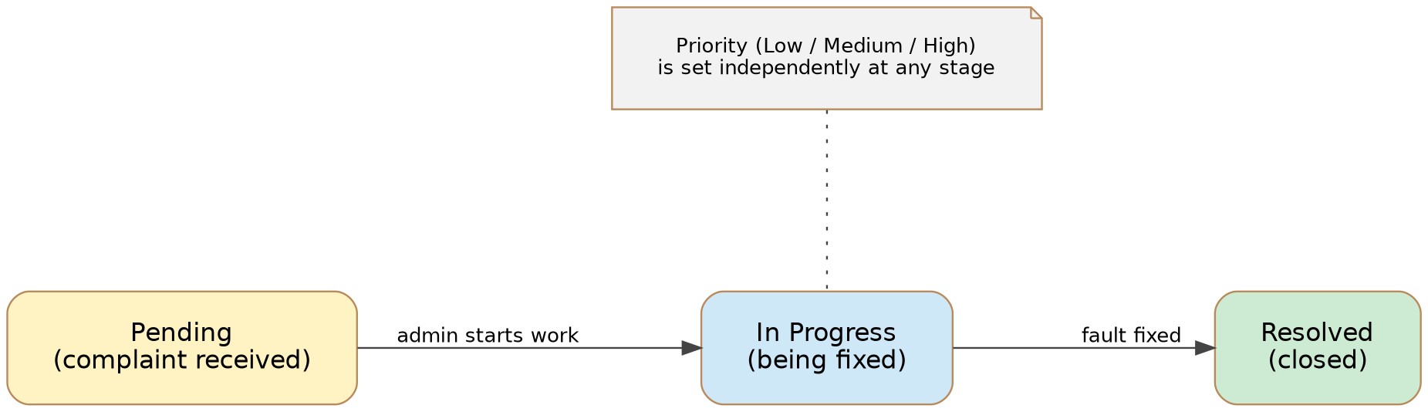
[ Figure 3.1 — Complaint Status Model ]

3.4 Technology in Brief
The application is a three-tier web application built with Java, Spring Boot and Thymeleaf for the application and page layers, and MySQL for storage. Access is controlled with login sessions, and passwords are stored as BCrypt hashes. The design and implementation details are in the Project Report.

CHAPTER 4: ILLUSTRATIVE WALKTHROUGH

4.1 One Complaint, Start to Finish
The following narrative shows how the system changes the experience of a single complaint. The people and the fault are fictional.
- Discovery. A student notices that a projector in a laboratory does not work during a practical session.
- Registration and login. She registers on the portal with her name, email, department and a password, then logs in.
- Submission. She selects the category Laboratory, describes the fault and submits. The system shows the ID CMP-0001, and the complaint starts with status Pending and priority Medium.
- Review. The administrator logs in and sees the complaint together with the student's name and department.
- Prioritization. Because a practical session is affected, the administrator raises the priority to High and sets the status to In Progress.
- Visibility. The student opens her dashboard and sees the updated priority and status without contacting anyone.
- Resolution. When the projector is repaired, the administrator sets the status to Resolved. The dashboard counters and category statistics update automatically.

4.2 Complaint Lifecycle Diagram
The diagram below shows who does what and where the data is stored during the walkthrough.
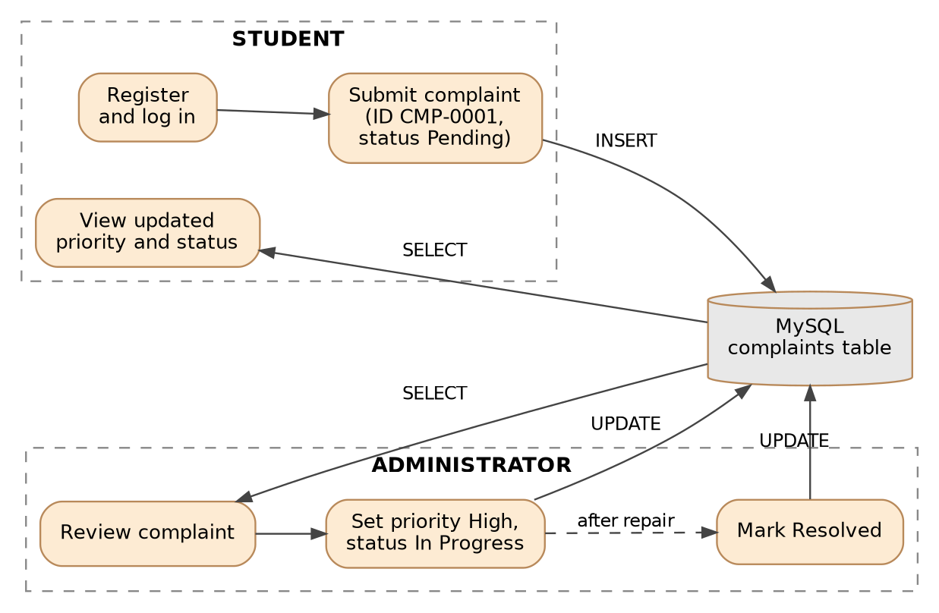
[ Figure 4.1 — Complaint Lifecycle: Student, Administrator and Database ]

CHAPTER 5: ANALYSIS: BENEFITS, CHALLENGES & DISCUSSION

5.1 Expected Benefits
These are expected, qualitative benefits. They would need to be measured after real use before any numerical claim is made.
- Every complaint has a traceable ID and a recorded history.
- Students get visibility without follow-up visits or messages.
- Administrators can sort out urgent issues first.
- Management can see which categories generate the most complaints and plan maintenance accordingly.
- Responsibility becomes clearer, because every status change is made by a logged-in administrator.

5.2 Challenges and Risks
Challenge | Why it matters | Possible response
Adoption | Students and staff may keep using informal channels | Announce the portal officially and accept complaints only through it
Keeping statuses current | Stale statuses destroy trust in the system | Make status updates part of the maintenance routine
Security and privacy | Complaints and accounts hold personal information | Hashed passwords, session checks, HTTPS in deployment
Misuse | Spam or abusive complaints | Future work: moderation tools and rate limits

[ Table 5.1 — Challenges, Risks and Responses ]

5.3 Discussion Questions
- Why is a unique complaint ID important for both students and administrators?
- What could go wrong if students could see other students' complaints? How does the design prevent this?
- Which measures would you collect after launch to judge whether the system is working?
- What additional security features would be required before using the system for a whole university?

CHAPTER 6: CONCLUSION & REFERENCES

6.1 Final Conclusion
The case shows that the core need in campus complaint handling is not complex technology but a reliable record, a clear status model and role-based access. A layered web application with a relational database is a suitable and economical answer to this need. Success will depend as much on adoption and on keeping statuses current as on the software itself, and the limitations and future work identified in the Project Report give a path for improvement.

6.2 References
- Project Report: Campus Complaint & Helpdesk Management System (companion document).
- GitHub repository available at: https://github.com/sidharthmalik/campus_helpdesk
- Spring Boot Reference Documentation. https://docs.spring.io/spring-boot/
- MySQL Reference Manual. https://dev.mysql.com/doc/
- OWASP Top Ten. https://owasp.org/www-project-top-ten/

