PROGRAM:1

AIM: Write a program that prompt the user to enter the first name, last name and then Display the message “Greetings First name Last name”

SOURCE CODE:

fn=input("Enter the first Name: ")
ln=input("Enter the Last Name: ")
print("Greetings ",fn,"",ln)

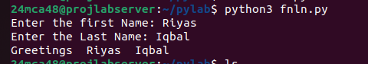

PROGRAM: 2

AIM: Write a program to demonstrate the d ifferent number data type in puthon

SOURCE CODE:

integer_num=24
float_num=45.6
complex_num=3 + 6j
print(f"Floating Value: {float_num} and its type: {type(float_num)}\nInteger Value: {integer_num} and its type: {type(integer_num)}\nComplex Value: {complex_num} {type(complex_num)}")

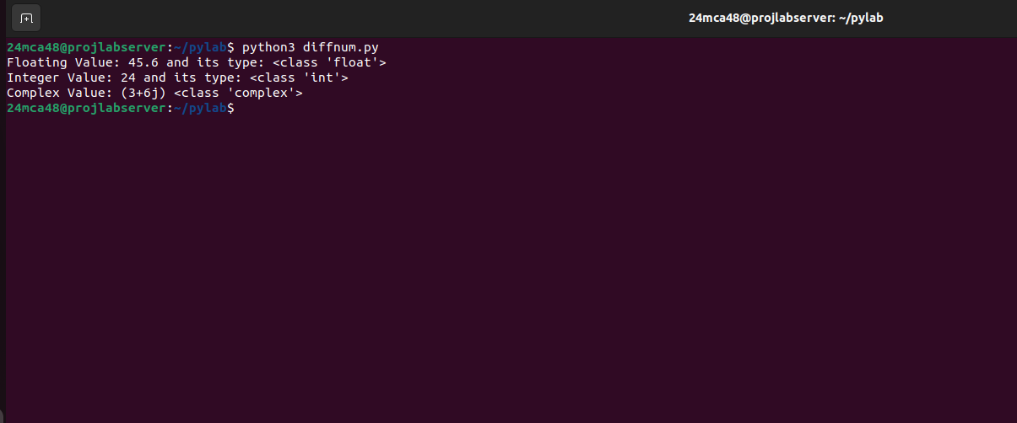

PROGRAM: 3

AIM: Write a Program to Calculate the area of the circle by Reading input from the user

SOURCE CODE:

r=int(input("Enter the Radius of the Circle: "))
pi=3.14
ar=pi*r*r
print("Area of the Circle is: ",ar)

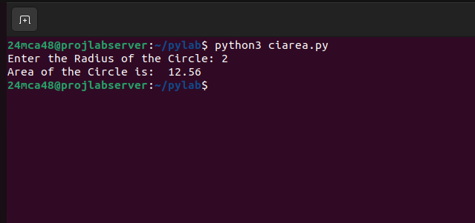

PROGRAM: 4

AIM: Write a program to calculate the salary of employee by given basic pay, HRA=10% of Basic pay, TA=5% of Basic pay

SOURCE CODE:

bp=float(input("Enter your Basic Pay: "))
hra=10/100 *bp
ta=5/100 *bp
sal=bp+hra+ta
print("Salary : ",sal)

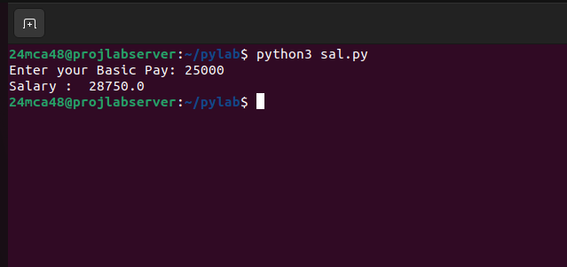

PROGRAM: 5

AIM: Write a prgram to perform arithmetic operations of Integer number

SOURCE CODE:

n1=int(input("Enter the First Number: "))
n2=int(input("Enter the Second Number: "))
print(f"\nSum: {n1+n2}\n\nDifference: {n1-n2}\n\nProducd: {n1*n2}\n\nDivide: {n1/n2}")

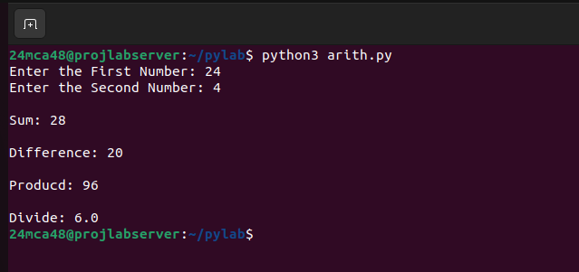

PROGRAM: 6

AIM: Write a program to get string Which is n copies of a given string

SOURCE CODE:

s=input("Enter a String: ")
n=int(input("Enter the number of Repeatation: "))
print(s*n,"\n")

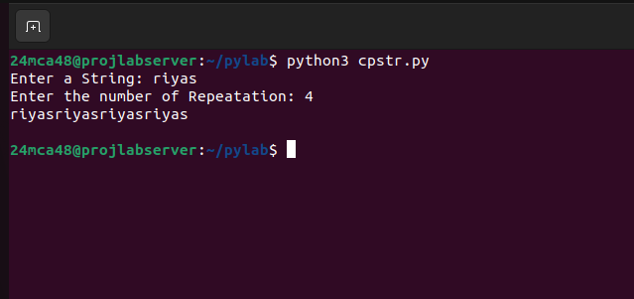

PROGRAM: 7

AIM: Write a Program to Accept an integer ‘n’ and compute n+nn+nnn and find its Sum

SOURCE CODE:

n=input("Enter the Number: ")
print(n,"+",n*2,"+",n*3)
sum=int(n) + int(n*2) + int(n*3)
print("Sum = ",sum)

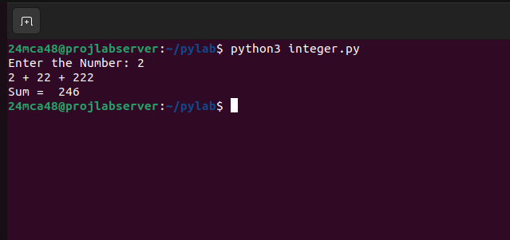

PROGRAM: 8

AIM: Write a program to find the largest among 3 numbers

SOURCE CODE:

a=int(input("Enter the 1st number: "))
b=int(input("Enter the 2nd Number: "))
c=int(input("Enter the 3rd Number: "))
if a>b and a>c:
print(f"{a} is Greater")
elif b>c and b>a:
print(f"{b} is greater")
else:
print(f"{c} is greater")

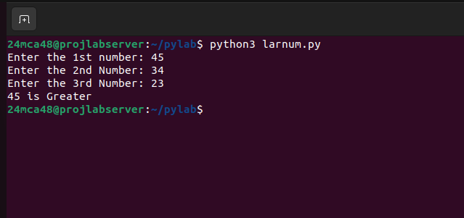

PROGRAM: 9

AIM: Write a program to determine a year is a leap year or not

SOURCE CODE:

yr=int(input("Enter a Year: "))
if yr%4==0 and yr%100!=0:
print(f"{yr} is a Leap Year")
elif yr%400==0:
print(f"{yr} is a Leap year")
else:
print(f"{yr} is not a Leap year")

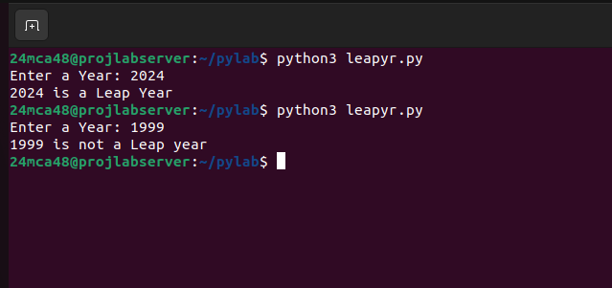

PROGRAM: 10

AIM:Write a program to determine the rate of entry tickets in a trade fair based on ages as follows:

age<10 7rupees
age>=10 and age<60 10 rupees
age>60 5 rupees

SOURCE CODE:

age=int(input("Enter your age: "))
if(age<10):
print("Your Rate of Entry Ticket is 7 Rupees ")
elif(age>=10 and age<60):
print("Your Rate of Entry Ticket is 10 Rupees")
else:
print("Your Rate of Entry Ticket is 5 Rupees")

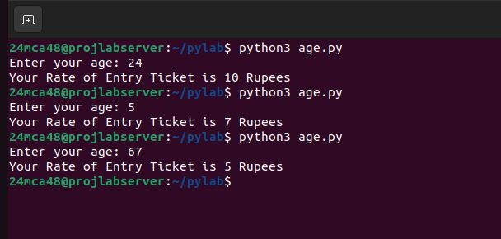

PROGRAM: 11

AIM: Write a Program to solve a quadratic equation

SOURCE CODE:

import math
a=float(input("Enter the first number: "))
b=float(input("Enter the second number: "))
c=float(input("Enter the third number: "))
d=(b**2)-(4*a*c)
if(d>0):
ans1=((-b-math.sqrt(d))/(2*a))
ans2=((-b+math.sqrt(d))/(2*a))
print(f"Real and Distinct roots: {ans1} and {ans2}")
elif(d==0):
root=-b/(2*a)
print("Real and Equal Root: ",root)
else:
re=-b/(2*a)
img=math.sqrt(abs(d))/(2*a)
print(f"Complex and Distinct Roots: {re} and {img}j")

