Assignment 3
Sidharth Sharma
(2014163)

I have made a node subscriber.cpp , that works like the velodyne_height_map is supposed to.

It subscribes to Velodyne_Points and creates an occupancy grid, filled with 1's and 0's.

This occupancy grid is plotted in PyGame in Python using the script newsid.py in /scripts folder.

The subscriber node on getting the points, takes the x,y,z point. And for each (x,y) stores the min and maximum height (z) occuring. I set a particular height_threshold , so whenever the
max[x][y] – min[x][y] > height_threshold I consider that (x,y) as an obstacle.

The new matrix is then plotted.

Part a) Displaying Lidar Scans

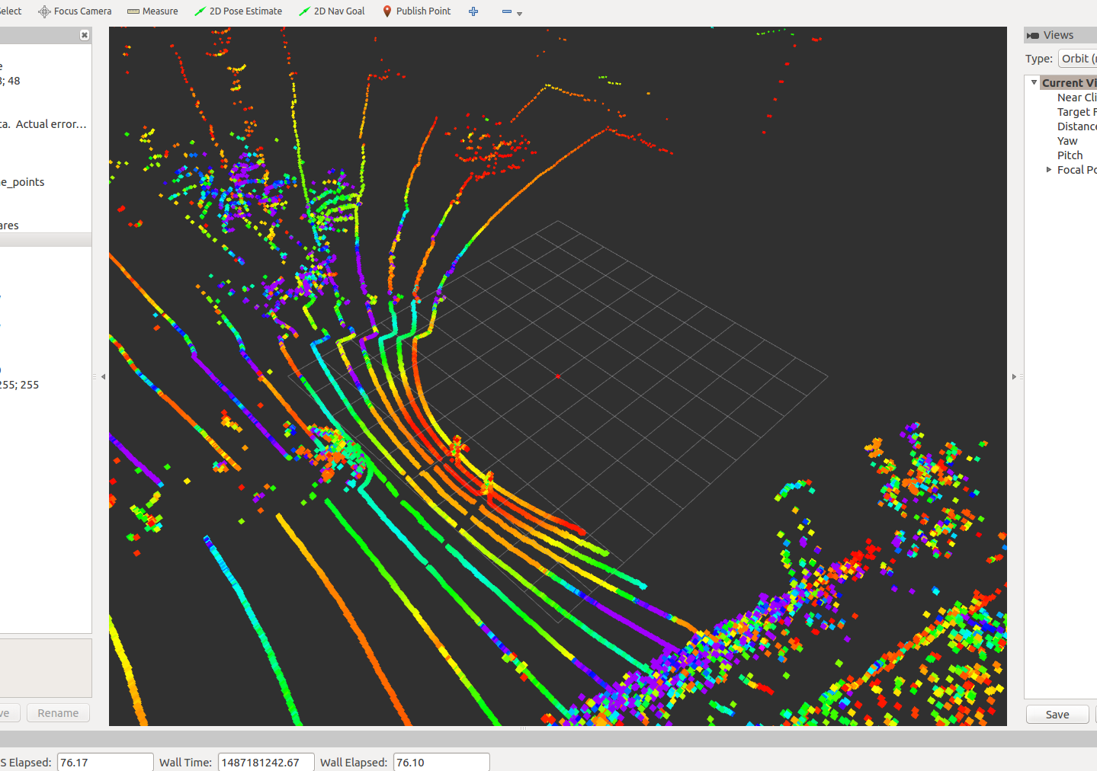

Part b)

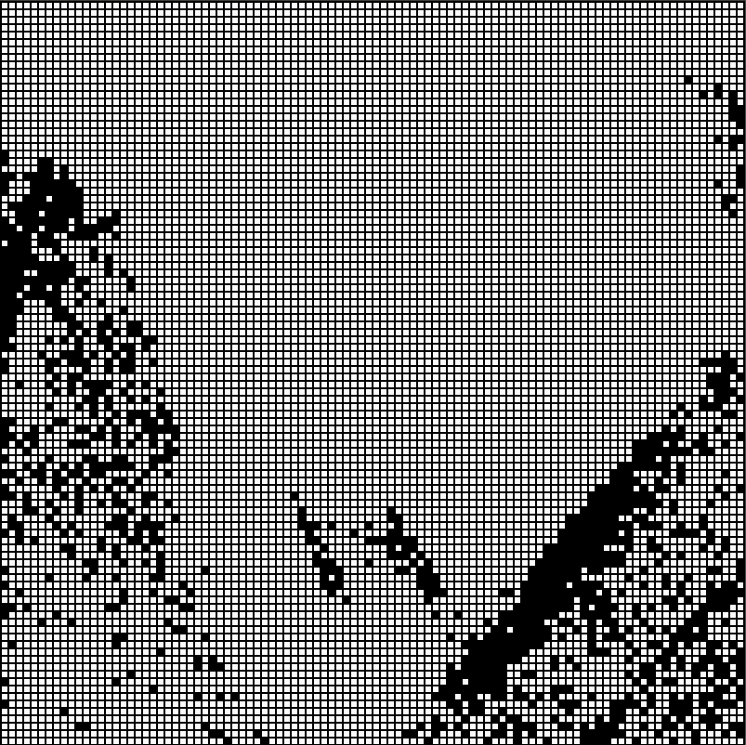
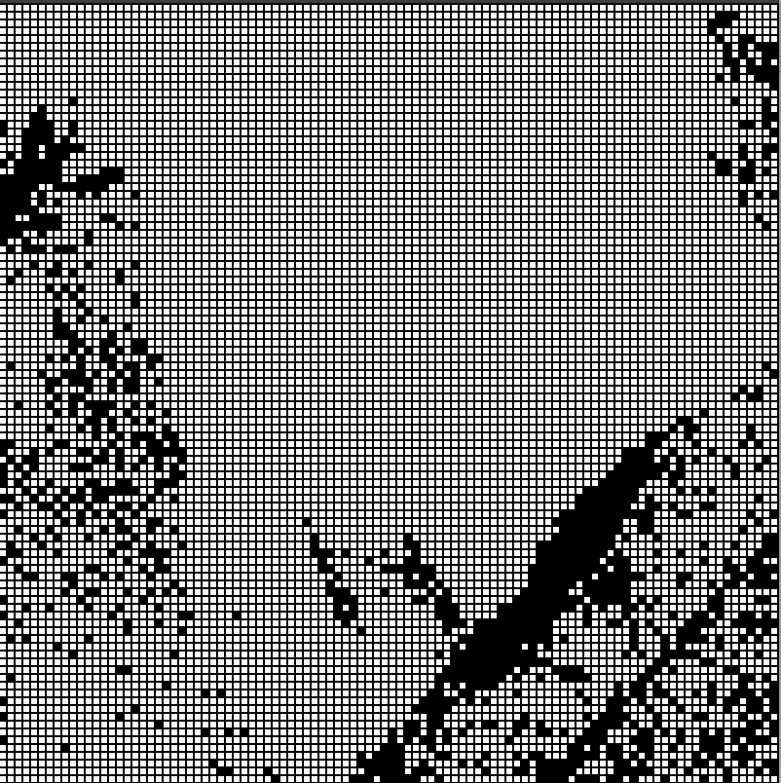

Occupancy maps at particular instances.

Final Occupancy grid - It can be improved by using different value for height_threshold and cell size
